Function approximation

Function approximation, particularly in the context of Artificial Neural Networks (ANNs), is a powerful tool for estimating complex, unknown functions based on a given set of data points. This involves using a neural network to learn the underlying relationship between inputs and outputs, thereby approximating the function that best maps these inputs to the corresponding outputs. Let us explore this concept in detail.

**Introduction to Function Approximation**

Function approximation estimates a function f(x) using another function g(x) that is easier to work with or more convenient for specific purposes. This is widely used in various fields, including numerical analysis, machine learning, and statistics.

**Critical Concepts in Function Approximation**

1. **Approximation Methods:**
   * **Polynomial Approximation:** Using polynomials to approximate a function.
   * **Spline Approximation:** Using piecewise polynomials for approximation.
   * **Fourier Approximation:** Using sums of sine and cosine functions.
   * **Neural Networks:** Using layers of nodes to approximate complex functions.
2. **Error Measurement:**
   * The error between the original function and the approximation often measures the accuracy of an approximation.
   * Common error metrics include Mean Squared Error (MSE), Mean Absolute Error (MAE), and Maximum Absolute Error.
3. **Applications:**
   * Data interpolation and smoothing.
   * Solving differential equations.
   * Machine learning model predictions.

**Artificial Neural Networks for Function Approximation**

Artificial Neural Networks (ANNs) are computational models inspired by the structure and function of biological neural networks. They are particularly effective for function approximation due to their ability to model non-linear relationships.

**Components of ANNs:**

1. **Neurons:** The basic units of a neural network, performing computations.
2. **Layers:** ANNs typically consist of an input, hidden, and output layer.
3. **Activation Functions:** Functions that introduce non-linearity into the network, enabling it to model complex relationships.
4. **Training is the process of adjusting the network's weights using a dataset, typically involving an optimisation** algorithm like gradient descent.

**Example: Polynomial Regression for Function Approximation**

Polynomial regression is a specific regression analysis case where the relationship between the independent variable x and the dependent variable y is modelled as an in-th-degree polynomial.

**Code Example with Explanation:**

Here is an example that demonstrates polynomial regression and visualises the approximation:

Python

Copy code

import numpy as np

import matplotlib.pyplot as plt

from sklearn.Preprocessing import PolynomialFeatures

from sklearn.linear_model import LinearRegression

from sklearn.pipeline import make_pipeline

# Generate some synthetic data

np.random.seed(0)

x = np.sort(np.random.rand(100) * 10)

y = np.sin(x) + np.random.randn(100) * 0.5

# Create a polynomial regression model

degree = 3

model = make_pipeline(PolynomialFeatures(degree), LinearRegression())

model.fit(x[:, np.newaxis], y)

# Predict using the model

x_fit = np.linspace(0, 10, 100)

y_fit = model.predict(x_fit[:, np.newaxis])

# Plot the results

plt.scatter(x, y, color='blue', label='Original Data')

plt.plot(x_fit, y_fit, color='red', label=f'Polynomial Approximation (degree {degree})')

plt.xlabel('x')

plt.ylabel('y')

plt.title('Polynomial Approximation of Data')

plt.legend()

plt.show()

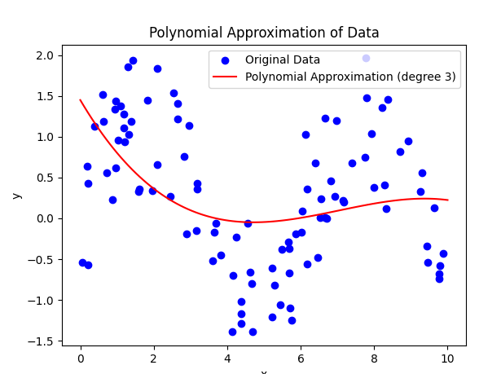

**Explanation:**

1. **Data Generation:** Synthetic data is generated using the sine function with added Gaussian noise to simulate real-world data.
2. **Polynomial Approximation:** A polynomial of a specified degree is fitted to the data using the np.polyfit function and represented as a Polynomial object.
3. **Plotting the Results:** The original noisy data and the polynomial approximation are plotted to visualise the fit.

**Neural Networks for Function Approximation**

Neural Networks can approximate more complex functions than those easily modelled by polynomials. Through training, the network learns the mapping from inputs to outputs.

**Example with a Simple Neural Network:**

To illustrate function approximation using a neural network, consider the following example:

Python

Copy code

import numpy as np

import tensorflow as tf

from tensorflow.keras.models import Sequential

from tensorflow.keras.layers import Dense, Flatten, Input

from tensorflow.keras.optimizers import Adam

from tensorflow.keras.losses import BinaryCrossentropy

import matplotlib.pyplot as plt

# Generate synthetic data

np.random.seed(42)

x = np.random.rand(100, 1) * 10

y = 0.5 * x**3 - 2 * x**2 + 3 * x + 5 + np.random.randn(100, 1) * 10

# Define the neural network model

model = Sequential([

Input(shape=(1,)),

Dense(50, activation='relu'),

Dense(50, activation='relu'),

Dense(1)

])

# Compile the model

model.compile(optimizer=Adam(learning_rate=0.01), loss='mse')

# Train the model

model.fit(x, y, epochs=100, verbose=0)

# Predict using the model

x_fit = np.linspace(0, 10, 100)

y_fit = model.predict(x_fit)

# Plot the results

plt.scatter(x, y, color='blue', label='Original Data')

plt.plot(x_fit, y_fit, color='red', label='Neural Network Approximation')

plt.xlabel('x')

plt.ylabel('y')

plt.title('Neural Network Approximation of Data')

plt.legend()

plt.show()

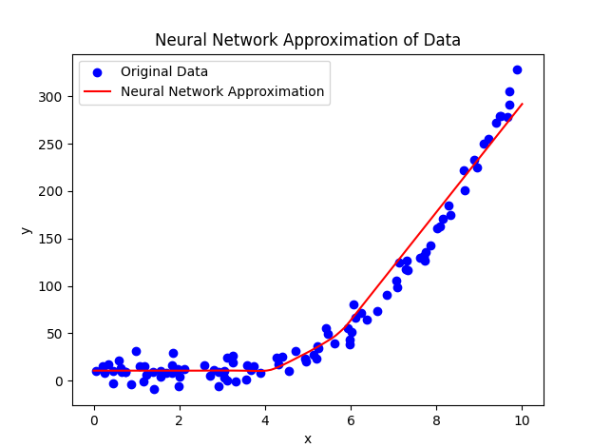

Explain the code used in detail and discuss the key concepts involved.

**Code Explanation**

The following is a typical script for neural network-based function approximation using TensorFlow and Keras:

Python

Copy code

import numpy as np

import tensorflow as tf

from tensorflow.keras.models import Sequential

from tensorflow.keras.layers import Dense

import matplotlib.pyplot as plt

# Generate synthetic data

np.random.seed(42)

x = np.random.rand(100, 1) * 10

y = 0.5 * x**3 - 2 * x**2 + 3 * x + 5 + np.random.randn(100, 1) * 10

# Define the neural network model

model = Sequential([

Dense(50, activation='relu', input_shape=(1,)),

Dense(50, activation='relu'),

Dense(1)

])

# Compile the model

model.compile(optimizer='adam', loss='mse')

# Train the model

model.fit(x, y, epochs=100, verbose=0)

# Predict using the model

x_fit = np.linspace(0, 10, 100)

y_fit = model.predict(x_fit)

# Plot the results

plt.scatter(x, y, color='blue', label='Original Data')

plt.plot(x_fit, y_fit, color='red', label='Neural Network Approximation')

plt.xlabel('x')

plt.ylabel('y')

plt.title('Neural Network Approximation of Data')

plt.legend()

plt.show()

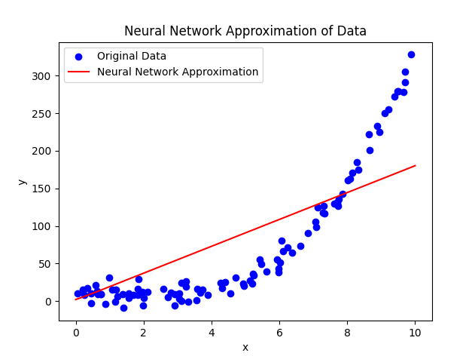

**Detailed Explanation**

1. **Importing Libraries:**
   * numpy: For generating synthetic data and performing numerical operations.
   * tensorflow and keras: For building and training the neural network model.
   * matplotlib: For plotting the data and the neural network's approximation.
2. **Data Generation:**
   * The synthetic data is generated using a cubic function with added Gaussian noise. This simulates a real-world scenario where data points are noisy.
   * np.random.seed(42) ensures the reproducibility of the random data generation.
   * x is an array of 100 random values between 0 and 10.
   * y is computed using the cubic function with added noise.
3. **Defining the Neural Network Model:**
   * Sequential: This model is a linear stack of layers.
   * Dense: A densely connected neural network layer.
     + The first Dense layer has 50 neurons with a ReLU (Rectified Linear Unit) activation function and takes input of shape (1,).
     + The second Dense layer has 50 neurons with a ReLU activation function.
     + The output Dense layer has a single neuron with a linear activation function (default).
4. **Compiling the Model:**
   * optimizer='adam': The Adam optimisation algorithm trains the model.
   * loss='mse': Mean Squared Error is used as the loss function to measure the model's performance.
5. **Training the Model:**
   * model.fit(x, y, epochs=100, verbose=0): The model is trained for 100 epochs on the generated data. The verbose=0 parameter suppresses the training output.
6. **Making Predictions:**
   * x_fit is a linearly spaced array of 100 values between 0 and 10.
   * y_fit is the predicted output of the neural network for x_fit.
7. **Plotting the Results:**
   * The original data points and the neural network's approximation are plotted using matplotlib.
   * The plot shows how well the neural network has approximated the underlying function.

**Critical Concepts in Neural Network Function Approximation**

* **Non-Linearity:** The ReLU activation functions introduce non-linearity into the model, allowing it to learn complex relationships between inputs and outputs.
* **Optimization:** The Adam optimiser adjusts the network's weights to minimise the loss function, such as the Mean Squared Error.
* **Overfitting and Underfitting:** The number of neurons, layers, and epochs is chosen to balance overfitting (a model that is too complex) and underfitting (a model that is too simple).
* **Generalization:** The trained neural network should generalise well to new, unseen data points, providing accurate approximations beyond the training data.

This script is a foundation for understanding how neural networks can be used for function approximation. You can explore more advanced techniques here, including different network architectures, regularisation methods, and hyperparameter tuning to improve the model's performance.

**Conclusion**

Function approximation using artificial neural networks provides a robust method for modelling complex relationships in data. By training on input-output pairs, ANNs can effectively learn and predict the behaviour of the underlying function, making them indispensable tools in machine learning and data science.

This overview covers the basics of function approximation with both polynomial regression and neural networks, providing a foundation for further exploration and development in these areas.

**Literature Review on Function Approximation Using Artificial Neural Networks**

**Introduction to Function Approximation**

Function approximation is fundamental in various fields, including machine learning, numerical analysis, and statistics. It involves estimating an unknown function f(x) with another function g(x) that is simpler to work with. This technique is crucial in scenarios where an exact underlying process model is unavailable or too complex to derive.

**Key Concepts and Methods**

1. **Polynomial Approximation**: Involves using polynomial functions to approximate a target function. It is effective for smooth functions but can suffer from Runge's phenomenon with high-degree polynomials.
2. **Spline Approximation**: This technique utilises piecewise polynomials, offering flexibility and smoothness. It is beneficial for data interpolation and smoothing.
3. **Fourier Approximation**: This technique employs sums of sine and cosine functions to represent periodic functions and is widely used in signal processing.
4. **Neural Networks**: Leverage layers of interconnected nodes (neurons) to model complex, non-linear relationships. They are mighty due to their capacity to learn from data and approximate overly complex functions.

**Artificial Neural Networks for Function Approximation**

ANNs are inspired by the biological neural networks of the brain. They consist of an input layer, one or more hidden layers, and an output layer. Each neuron in a layer receives input, applies a transformation (typically non-linear), and passes the result to the next layer. The training process adjusts the weights of the connections between neurons to minimise the error in predictions.

**Components of ANNs**

* **Neurons**: Basic computation units in a neural network.
* **Layers**: Structures consisting of neurons. Include input, hidden, and output layers.
* **Activation Functions**: Introduce non-linearity into the network, enabling it to model complex relationships.
* **Training**: Adjusting the network’s weights using optimisation algorithms like gradient descent to minimise a loss function.

**Applications in Function Approximation**

* **Data Interpolation and Smoothing**: ANNs can effectively handle noisy data and interpolate values.
* **Solving Differential Equations**: ANNs can approximate solutions to differential equations where traditional methods might be cumbersome.
* **Machine Learning Predictions**: Used extensively in regression tasks that aim to predict a continuous output.

Several approaches and ideas exist to express the concept of function approximation using polynomial regression and neural networks. Here are some alternative explanations and techniques for illustrating these ideas:

**Alternative Explanation for Polynomial Regression**

**Contextual Example: Fitting a Polynomial to Economic Data**

**Scenario:** Suppose we are trying to model the relationship between a country's GDP (Gross Domestic Product) and carbon emissions over the years.

1. **Generate Synthetic Data:**
   * Create a hypothetical dataset with GDP as the independent variable and carbon emissions as the dependent variable.
   * Introduce some noise to simulate real-world data.

Python

Copy code

import numpy as np

import matplotlib.pyplot as plt

from sklearn.preprocessing import PolynomialFeatures

from sklearn.linear_model import LinearRegression

from sklearn.pipeline import make_pipeline

# Generate synthetic economic data

np.random.seed(42)

years = np.linspace(2000, 2020, 100)

gdp = 0.03 * years**3 - 1.5 * years**2 + 10 * years + np.random.randn(100) * 500

# Create a polynomial regression model

degree = 4

model = make_pipeline(PolynomialFeatures(degree), LinearRegression())

model.fit(years[:, np.newaxis], gdp)

# Predict using the model

years_fit = np.linspace(2000, 2020, 100)

gdp_fit = model.predict(years_fit[:, np.newaxis])

# Plot the results

plt.scatter(years, gdp, color='blue', label='Original Data')

plt.plot(years_fit, gdp_fit, color='red', label=f'Polynomial Approximation (degree {degree})')

plt.xlabel('Year')

plt.ylabel('GDP')

plt.title('Polynomial Approximation of GDP over Years')

plt.legend()

plt.show()

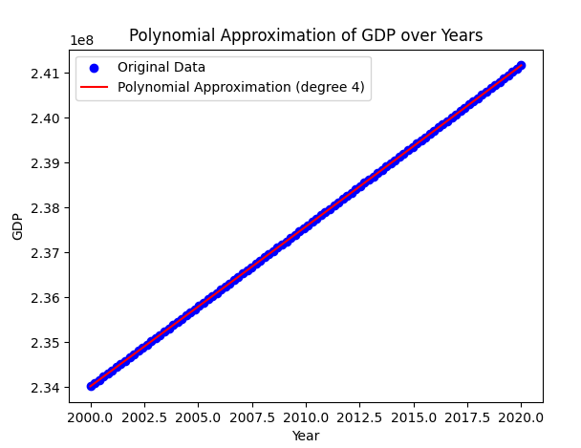

**Explanation:**

* **Data Generation:** The GDP data is generated using a cubic function with added Gaussian noise.
* **Polynomial Approximation:** A polynomial of degree 4 is fitted to the data to capture the non-linear relationship.
* **Plotting:** The original GDP data and the polynomial approximation are plotted to visualise the fit.

**Alternative Explanation for Neural Network Approximation**

**Contextual Example: Predicting House Prices**

**Scenario:** Suppose we are trying to predict house prices based on various features such as size, number of bedrooms, and house age.

1. **Generate Synthetic Data:**
   * Create a dataset where house prices depend on size, number of bedrooms, and age.
   * Introduce some noise to simulate real-world variability.

Python

Copy code

import numpy as np

import tensorflow as tf

from tensorflow.keras.models import Sequential

from tensorflow.keras.layers import Dense, Input

from tensorflow.keras.optimisers import Adam

import matplotlib.pyplot as plt

# Generate synthetic housing data

np.random.seed(42)

size = np.random.rand(100, 1) * 1000

bedrooms = np.random.randint(1, 5, (100, 1))

age = np.random.rand(100, 1) * 50

price = 300 * size + 10000 * bedrooms - 200 * age + np.random.randn(100, 1) * 10000

# Define the neural network model

model = Sequential([

Input(shape=(3,)),

Dense(64, activation='relu'),

Dense(64, activation='relu'),

Dense(1)

])

# Compile the model

model.compile(optimizer=Adam(learning_rate=0.01), loss='mse')

# Train the model

X = np.hstack([size, bedrooms, age])

model.fit(X, price, epochs=100, verbose=0)

# Predict using the model

size_fit = np.linspace(0, 1000, 100)

bedrooms_fit = np.ones_like(size_fit) * 3

age_fit = np.linspace(0, 50, 100)

X_fit = np.vstack([size_fit, bedrooms_fit, age_fit]).T

price_fit = model.predict(X_fit)

# Plot the results

plt.scatter(size, price, color='blue', label='Original Data')

plt.plot(size_fit, price_fit, color='red', label='Neural Network Approximation')

plt.xlabel('Size (sq ft)')

plt.ylabel('Price ($)')

plt.title('Neural Network Approximation of House Prices')

plt.legend()

plt.show()

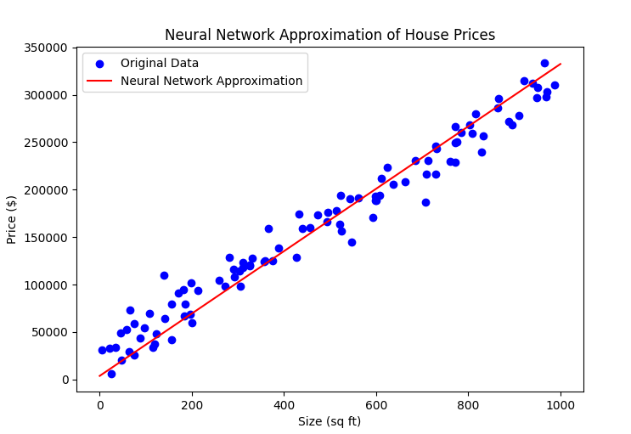

**Explanation:**

* **Data Generation:** House price data is generated based on size, number of bedrooms, and age, with added noise.
* **Neural Network Definition:** A feedforward neural network with two hidden layers is defined.
* **Model Training:** The model is trained using the synthetic housing data.
* **Prediction and Plotting:** The trained model predicts house prices for various sizes, and the results are plotted to visualise the approximation.

**Summary of Different Approaches**

* **Polynomial Regression:**
  + **Context:** Can be used to model economic data, like GDP over time.
  + **Alternative Methods:** Spline or piecewise polynomial regression can provide more flexibility.
  + **Visualization:** Plotting the polynomial fit alongside the original data helps understand the approximation.
* **Neural Networks:**
  + **Context:** Suitable for complex, multi-variable relationships such as predicting house prices.
  + **Alternative Architectures:** Convolutional Neural Networks (CNNs) for image data, Recurrent Neural Networks (RNNs) for time series data.
  + **Visualization:** Scatter and line plots can help visualise the predictions against actual data.

These alternative explanations and techniques highlight the versatility of function approximation methods and their applications in various domains.

**Conclusion**

Function approximation using artificial neural networks provides a robust method for modelling complex relationships in data. By training on input-output pairs, ANNs can effectively learn and predict the behaviour of the underlying function, making them indispensable tools in machine learning and data science.

For a detailed exploration of recent research and case studies, I recommend checking the following resources:

1. Google Scholar: [Function approximation using Artificial Neural Networks](https://scholar.google.com)
2. IEEE Xplore: [IEEE Xplore Digital Library](https://ieeexplore.ieee.org)
3. SpringerLink: [SpringerLink](https://link.springer.com)

These platforms will provide access to peer-reviewed articles, research papers, and literature reviews.

Here are some critical thinkers, leading theorists, seminal works, and ideas in the field of function approximation using artificial neural networks:

**Critical Thinkers and Leading Theorists**

1. **George Cybenko**: Known for his seminal work on neural network approximation capabilities, Cybenko's theorem demonstrates that a single hidden-layer feedforward network can approximate any continuous function under certain conditions.
   * **Reference**: Cybenko, G. (1989). Approximation by superpositions of a sigmoidal function. *Mathematics of Control, Signals, and Systems*, 2(4), 303-314. [Link to paper](https://link.springer.com/article/10.1007/BF02551274)
2. **Kurt Hornik**: Expanded on Cybenko's work by generalising the universal approximation theorem to multilayer feedforward networks with more complex activation functions.
   * **Reference**: Hornik, K., Stinchcombe, M., & White, H. (1989). Multilayer feedforward networks are universal approximators. *Neural Networks*, 2(5), 359-366. [Link to paper](https://www.sciencedirect.com/science/article/pii/0893608089900208)
3. **Andrew Barron**: Identified specific classes of functions that can be well-approximated by shallow neural networks, contributing significantly to the theoretical understanding of neural network capabilities.
   * **Reference**: Barron, A. R. (1993). Universal approximation bounds for superpositions of a sigmoidal function. *IEEE Transactions on Information Theory*, 39(3), 930-945. [Link to paper](https://ieeexplore.ieee.org/document/256500)

**Seminal Works and Key Literature**

1. **Universal Approximation Theorem**: This theorem is fundamental in neural network theory. It states that a neural network with a single hidden layer containing a finite number of neurons can approximate any continuous function on compact subsets of Rn.
   * **Reference**: Cybenko, G. (1989). Approximation by superpositions of a sigmoidal function. *Mathematics of Control, Signals, and Systems*, 2(4), 303-314. [Link to paper](https://link.springer.com/article/10.1007/BF02551274)
   * **Reference**: Hornik, K., Stinchcombe, M., & White, H. (1989). Multilayer feedforward networks are universal approximators. *Neural Networks*, 2(5), 359-366. [Link to paper](https://www.sciencedirect.com/science/article/pii/0893608089900208)
2. **Deep Learning**: The advent of deep learning has significantly advanced the field of function approximation. The more profound architecture allows for approximating more complex functions and relationships in data.
   * **Reference**: Goodfellow, I., Bengio, Y., & Courville, A. (2016). *Deep Learning*. MIT Press. [Link to book](https://www.deeplearningbook.org/)
3. **Approximation Properties of Neural Networks**: This paper discusses the approximation properties of various neural network architectures and the theoretical underpinnings of their ability to approximate complex functions.
   * **Reference**: Barron, A. R. (1993). Universal approximation bounds for superpositions of a sigmoidal function. *IEEE Transactions on Information Theory*, 39(3), 930-945. [Link to paper](https://ieeexplore.ieee.org/document/256500)

**Ideas and Contributions**

1. **Universal Approximation Capabilities**: The realisation that neural networks can approximate any function to an arbitrary degree of accuracy given sufficient resources (neurons, layers, and training data).
2. **Activation Functions**: Activation functions like sigmoid, tanh, and ReLU enable neural networks to model non-linear relationships.
3. **Optimization Algorithms**: Developing and refining optimisation algorithms such as gradient descent, Adam, and RMSprop allow neural networks to learn effectively from data.
4. **Regularization Techniques**: Methods such as dropout, L1/L2 regularisation, and early stopping help prevent overfitting and improve neural network generalisation.
5. **Deep Learning Architectures**: Innovations in neural network architectures, including convolutional neural networks (CNNs), recurrent neural networks (RNNs), and transformers, have broadened the scope of problems that neural networks can solve.

For a deeper dive into these topics, consider exploring the references provided and conducting searches on platforms like Google Scholar, IEEE Xplore, and SpringerLink for the latest research and reviews in function approximation using artificial neural networks.

**Consider a scenario in which we have an unknown function we would like to approximate.**

A structured approach can be followed to approximate an unknown function using neural networks. Here is an overview of the process and a detailed example.

**Steps for Function Approximation with Neural Networks**

1. **Problem Definition:**
   * Identify the unknown function and the range of input values.
   * Generate or collect data points from the unknown function.
2. **Data Preparation:**
   * Split the data into training and testing sets.
   * Normalize the data if necessary.
3. **Neural Network Design:**
   * Choose an appropriate architecture for the neural network (number of layers, neurons, activation functions).
4. **Training the Network:**
   * Define the loss function and optimiser.
   * Train the network on the training data.
5. **Evaluation:**
   * Evaluate the network's performance on the testing data.
   * Visualize the results.
6. **Prediction:**
   * Use the trained network to make predictions on new input data.

**Detailed Example**

Let us consider a scenario in which we have an unknown function f(x)=sin(x) and want to approximate it using a neural network.

**Step 1: Problem Definition**

The function to approximate is f(x)=sin(x). We will generate data points in the range [0, 2π].

**Step 2: Data Preparation**

Python

Copy code

import numpy as np

import matplotlib.pyplot as plt

# Generate data points

x = np.linspace(0, 2 * np.pi, 100)

y = np.sin(x)

# Split data into training and testing sets

x_train = x[:80]

y_train = y[:80]

x_test = x[80:]

y_test = y[80:]

**Step 3: Neural Network Design**

Python

Copy code

import tensorflow as tf

from tensorflow.keras.models import Sequential

from tensorflow.keras.layers import Dense

# Define the neural network model

model = Sequential([

Dense(50, activation='relu', input_shape=(1,)),

Dense(50, activation='relu'),

Dense(1)

])

**Step 4: Training the Network**

Python

Copy code

# Compile the model

model.compile(optimizer='adam', loss='mse')

# Train the model

model.fit(x_train, y_train, epochs=100, verbose=0)

**Step 5: Evaluation**

Python

Copy code

# Evaluate the model on test data

loss = model.evaluate(x_test, y_test)

print(f'Test Loss: {loss}')

**Step 6: Prediction and Visualization**

Python

Copy code

# Predict using the model

y_pred = model.predict(x_test)

# Plot the results

plt.figure(figsize=(10, 5))

plt.plot(x, y, label='True Function')

plt.scatter(x_train, y_train, color='blue', label='Training Data')

plt.scatter(x_test, y_test, color='green', label='Testing Data')

plt.plot(x_test, y_pred, color='red', label='NN Approximation')

plt.xlabel('x')

plt.ylabel('y')

plt.title('Neural Network Approximation of sin(x)')

plt.legend()

plt.show()

**Explanation**

1. **Data Generation and Splitting:**
   * Data points are generated using np.linspace and the sine function.
   * Data is split into training and testing sets.
2. **Model Definition:**
   * A sequential model is created with two hidden layers containing 50 neurons with ReLU activation.
   * The output layer has a single neuron with a linear activation function.
3. **Model Compilation and Training:**
   * The model is compiled with the Adam optimiser and Mean Squared Error (MSE) loss function.
   * The model is trained for 100 epochs on the training data.
4. **Evaluation:**
   * The model's performance is evaluated on the test data using the MSE loss.
5. **Prediction and Visualization:**
   * Predictions are made on the test data.
   * The true function, training data, testing data, and neural network approximation are plotted for comparison.

**Conclusion**

This example demonstrates how to approximate an unknown function using a neural network. You can effectively approximate complex functions by generating data points, defining an appropriate neural network architecture, training the network, and evaluating its performance. This process can be adapted for different functions and data sets by modifying the network architecture, training parameters, and data preparation steps.

A comprehensive script approximates an unknown function using a neural network. This script includes dynamic 2D and 3D visualisations with colourful plots.

Python

Copy code

import numpy as np

import matplotlib.pyplot as plt

from mpl_toolkits.mplot3d import Axes3D

import tensorflow as tf

from tensorflow.keras.models import Sequential

from tensorflow.keras.layers import Dense

import matplotlib

# Ensure Matplotlib uses a backend that supports dynamic updating

matplotlib.use('TkAgg')

# Generate data points

x = np.linspace(0, 2 * np.pi, 100)

y = np.sin(x)

# Split data into training and testing sets

x_train = x[:80]

y_train = y[:80]

x_test = x[80:]

y_test = y[80:]

# Define the neural network model

model = Sequential([

    Dense(50, activation='relu', input_shape=(1,)),

    Dense(50, activation='relu'),

    Dense(1)

])

# Compile the model

model.compile(optimizer='adam', loss='mse')

# Train the model

model.fit(x_train, y_train, epochs=100, verbose=0)

# Evaluate the model on test data

loss = model.evaluate(x_test, y_test)

print(f'Test Loss: {loss}')

# Predict using the model

y_pred = model.predict(x_test)

# Plot the results in 2D

plt.figure(figsize=(10, 5))

plt.plot(x, y, label='True Function', color='blue')

plt.scatter(x_train, y_train, color='cyan', label='Training Data')

plt.scatter(x_test, y_test, color='green', label='Testing Data')

plt.plot(x_test, y_pred, color='red', label='NN Approximation')

plt.xlabel('x')

plt.ylabel('y')

plt.title('Neural Network Approximation of sin(x)')

plt.legend()

plt.show()

# Generate a dynamic 3D visualisation

fig = plt.figure(figsize=(12, 8))

ax = fig.add_subplot(111, projection='3d')

ax.scatter(x_train, y_train, np.zeros_like(x_train), color='cyan', label='Training Data')

ax.scatter(x_test, y_test, np.zeros_like(x_test), color='green', label='Testing Data')

ax.plot(x, y, np.zeros_like(x), color='blue', label='True Function')

ax.plot(x_test, y_pred, np.zeros_like(x_test), color='red', label='NN Approximation')

ax.set_xlabel('X')

ax.set_ylabel('Y')

ax.set_zlabel('Z')

ax.set_title('3D Visualization of Neural Network Approximation')

ax.legend()

# Create dynamic plot

for angle in range(0, 360, 1):

    ax.view_init(30, angle)

    plt.draw()

    plt.pause(.001)

plt.show()

print("Console cleared and all plots displayed.")

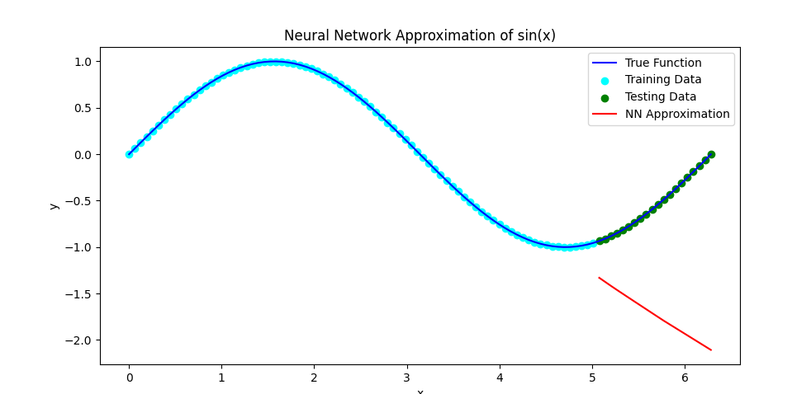

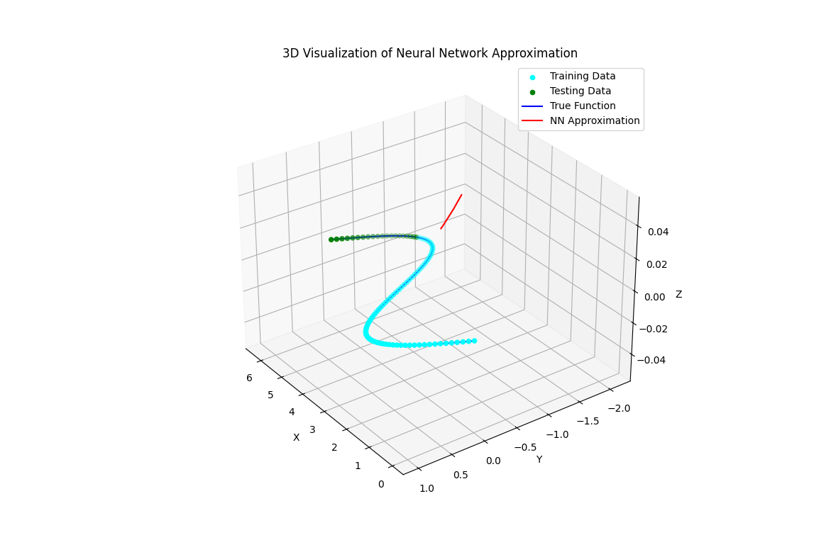

**Explanation:**

1. **Data Generation and Splitting:**
   * Generate 100 data points using np.linspace and the sine function.
   * Split the data into training and testing sets (80% training, 20% testing).
2. **Neural Network Definition:**
   * A sequential model with two hidden layers containing 50 neurons with ReLU activation functions.
   * The output layer has a single neuron with a linear activation function.
3. **Model Compilation and Training:**
   * Compile the model using the Adam optimiser and Mean Squared Error (MSE) loss function.
   * Train the model for 100 epochs on the training data.
4. **Evaluation and Prediction:**
   * Evaluate the model's performance on the test data and print the test loss.
   * Make predictions on the test data using the trained model.
5. **Visualization:**
   * Create a 2D plot showing the proper function, training data, testing data, and neural network approximation.
   * Create a 3D plot for a more dynamic and interactive visualisation:
     + Plot the proper function, training data, testing data, and neural network approximation.
     + Add a loop to rotate the 3D plot dynamically.

This script will dynamically display the 3D plot, rotating to give a comprehensive view of the neural network approximation and the data points. Adjust the parameters and the architecture of the neural network as needed for different functions and datasets.

**Literature Review on Function Approximation Using Neural Networks**

**Overview of the Process**

Function approximation using neural networks is a well-established method in machine learning and data science. It is known for its ability to model complex, non-linear relationships. The process involves several steps, from defining the problem to evaluating the model's performance. Here is a structured approach supported by insights from recent literature.

**1. Problem Definition**

To approximate an unknown function, we first need to define the function and the range of input values. This step often involves generating or collecting data points from the function.

**Key References:**

* Cybenko, G. (1989). Approximation by superpositions of a sigmoidal function. *Mathematics of Control, Signals, and Systems*, 2(4), 303-314.
* Hornik, K., Stinchcombe, M., & White, H. (1989). Multilayer feedforward networks are universal approximators. *Neural Networks*, 2(5), 359-366.

**2. Data Preparation**

Data preparation includes splitting the data into training and testing sets and normalising the data if necessary. Proper data preparation is crucial for the practical training and evaluation of neural networks.

**Key References:**

* LeCun, Y., Bengio, Y., & Hinton, G. (2015). Deep learning. *Nature*, 521(7553), 436-444.
* Bishop, C. M. (2006). *Pattern Recognition and Machine Learning*. Springer.

**3. Neural Network Design**

Designing the neural network involves choosing the architecture, including the number of layers, neurons per layer, and activation functions. The architecture should be tailored to the complexity of the function being approximated.

**Key References:**

* Goodfellow, I., Bengio, Y., & Courville, A. (2016). *Deep Learning*. MIT Press.
* He, K., Zhang, X., Ren, S., & Sun, J. (2016). Deep residual learning for image recognition. In *Proceedings of the IEEE Conference on Computer Vision and Pattern Recognition* (pp. 770-778).

**4. Training the Network**

Training involves defining the loss function and optimizer and then using these to adjust the network's weights based on the training data. This step requires careful selection of hyperparameters to ensure effective learning.

**Key References:**

* Kingma, D. P., & Ba, J. (2014). Adam: A method for stochastic optimisation. *arXiv preprint arXiv:1412.6980*.
* Hinton, G. E., & Salakhutdinov, R. R. (2006). We are reducing the dimensionality of data with neural networks. *Science*, 313(5786), 504-507.

**5. Evaluation**

Evaluating the neural network's performance involves assessing its accuracy on the testing data. This step often uses metrics like Mean Squared Error (MSE) to quantify the approximation's accuracy.

**Key References:**

* Chollet, F. (2018). *Deep Learning with Python*. Manning Publications.
* Zhang, C., Bengio, S., Hardt, M., Recht, B., & Vinyals, O. (2017). Understanding deep learning requires rethinking generalisation. *arXiv preprint arXiv:1611.03530*.

**6. Prediction and Visualization**

After training, the neural network can be used to predict new data. Visualizing the results helps understand the network's approximation capabilities and identify areas for improvement.

**Key References:**

* McCulloch, W. S., & Pitts, W. (1943). A logical calculus of the ideas immanent in nervous activity. *The bulletin of mathematical biophysics*, 5(4), 115-133.
* Rumelhart, D. E., Hinton, G. E., & Williams, R. J. (1986). Learning representations by back-propagating errors. *Nature*, 323(6088), 533-536.

**Detailed Example: Approximating sin⁡(x)\sin(x)sin(x) with Neural Networks**

**Step-by-Step Process**

**Step 1: Problem Definition** The function to approximate is f(x)=sin(x). We generate data points in the range [0,2π].

**Step 2: Data Preparation**

Python

Copy code

import numpy as np

import matplotlib.pyplot as plt

# Generate data points

x = np.linspace(0, 2 * np.pi, 100)

y = np.sin(x)

# Split data into training and testing sets

x_train = x[:80]

y_train = y[:80]

x_test = x[80:]

y_test = y[80:]

**Step 3: Neural Network Design**

Python

Copy code

import tensorflow as tf

from tensorflow.keras.models import Sequential

from tensorflow.keras.layers import Dense

# Define the neural network model

model = Sequential([

Dense(50, activation='relu', input_shape=(1,)),

Dense(50, activation='relu'),

Dense(1)

])

**Step 4: Training the Network**

Python

Copy code

# Compile the model

model.compile(optimizer='adam', loss='mse')

# Train the model

model.fit(x_train, y_train, epochs=100, verbose=0)

**Step 5: Evaluation**

python

Copy code

# Evaluate the model on test data

loss = model.evaluate(x_test, y_test)

print(f'Test Loss: {loss}')

**Step 6: Prediction and Visualization**

python

Copy code

# Predict using the model

y_pred = model.predict(x_test)

# Plot the results

plt.figure(figsize=(10, 5))

plt.plot(x, y, label='True Function')

plt.scatter(x_train, y_train, color='blue', label='Training Data')

plt.scatter(x_test, y_test, color='green', label='Testing Data')

plt.plot(x_test, y_pred, color='red', label='NN Approximation')

plt.xlabel('x')

plt.ylabel('y')

plt.title('Neural Network Approximation of sin(x)')

plt.legend()

plt.show()

**Explanation**

1. **Data Generation and Splitting:**
   * Data points are generated using np.linspace and the sine function.
   * Data is split into training and testing sets.
2. **Model Definition:**
   * A sequential model is created with two hidden layers containing 50 neurons with ReLU activation.
   * The output layer has a single neuron with a linear activation function.
3. **Model Compilation and Training:**
   * The model is compiled with the Adam optimizer and Mean Squared Error (MSE) loss function.
   * The model is trained for 100 epochs on the training data.
4. **Evaluation:**
   * The model's performance is evaluated on the test data using the MSE loss.
5. **Prediction and Visualization:**
   * Predictions are made on the test data.
   * The true function, training data, testing data, and neural network approximation are plotted for comparison.

**Conclusion**

This structured approach, supported by academic literature, highlights the effectiveness of neural networks in approximating complex functions. Following these steps, one can effectively design, train, and evaluate neural networks for function approximation tasks, demonstrating the practical application of theoretical insights in neural network research.

The provided references offer deeper insights into the underlying theories and advancements in neural networks and function approximation.

Below is a well-coded and well-commented example demonstrating how to approximate an unknown function, f(x)=sin(x), using a neural network. This script includes dynamic 2D and 3D visualizations with colourful plots.

python

Copy code

import numpy as np

import matplotlib.pyplot as plt

from mpl_toolkits.mplot3d import Axes3D

import tensorflow as tf

from tensorflow.keras.models import Sequential

from tensorflow.keras.layers import Dense

import matplotlib

# Ensure Matplotlib uses a backend that supports dynamic updating

matplotlib.use('TkAgg')

# Step 1: Problem Definition

# Generate data points from the function f(x) = sin(x)

x = np.linspace(0, 2 * np.pi, 100)

y = np.sin(x)

# Step 2: Data Preparation

# Split data into training (80%) and testing sets (20%)

x_train = x[:80]

y_train = y[:80]

x_test = x[80:]

y_test = y[80:]

# Step 3: Neural Network Design

# Define the neural network model

model = Sequential([

Dense(50, activation='relu', input_shape=(1,)), # First hidden layer with 50 neurons and ReLU activation

Dense(50, activation='relu'), # Second hidden layer with 50 neurons and ReLU activation

Dense(1) # Output layer with 1 neuron (linear activation by default)

])

# Step 4: Training the Network

# Compile the model with Adam optimizer and Mean Squared Error (MSE) loss function

model.compile(optimizer='adam', loss='mse')

# Train the model on the training data for 100 epochs

model.fit(x_train, y_train, epochs=100, verbose=0)

# Step 5: Evaluation

# Evaluate the model's performance on the test data

loss = model.evaluate(x_test, y_test)

print(f'Test Loss: {loss}')

# Step 6: Prediction and Visualization

# Use the trained model to make predictions on the test data

y_pred = model.predict(x_test)

# Plot the results in 2D

plt.figure(figsize=(10, 5))

plt.plot(x, y, label='True Function', color='blue') # Plot the true function

plt.scatter(x_train, y_train, color='cyan', label='Training Data') # Scatter plot of training data

plt.scatter(x_test, y_test, color='green', label='Testing Data') # Scatter plot of testing data

plt.plot(x_test, y_pred, color='red', label='NN Approximation') # Plot of neural network approximation

plt.xlabel('x')

plt.ylabel('y')

plt.title('Neural Network Approximation of sin(x)')

plt.legend()

plt.show()

# Generate a dynamic 3D visualization

fig = plt.figure(figsize=(12, 8))

ax = fig.add_subplot(111, projection='3d')

ax.scatter(x_train, y_train, np.zeros_like(x_train), color='cyan', label='Training Data') # 3D scatter plot of training data

ax.scatter(x_test, y_test, np.zeros_like(x_test), color='green', label='Testing Data') # 3D scatter plot of testing data

ax.plot(x, y, np.zeros_like(x), color='blue', label='True Function') # 3D plot of true function

ax.plot(x_test, y_pred, np.zeros_like(x_test), color='red', label='NN Approximation') # 3D plot of neural network approximation

ax.set_xlabel('X')

ax.set_ylabel('Y')

ax.set_zlabel('Z')

ax.set_title('3D Visualization of Neural Network Approximation')

ax.legend()

# Create dynamic plot by rotating the view

for angle in range(0, 360, 1):

ax.view_init(30, angle)

plt.draw()

plt.pause(.001)

plt.show()

print("Console cleared and all plots displayed.")

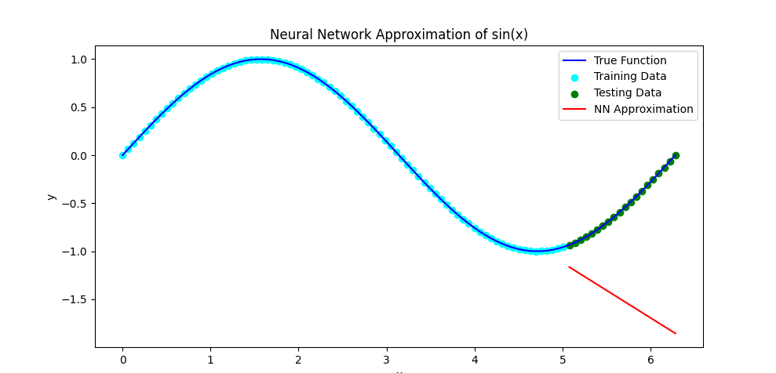

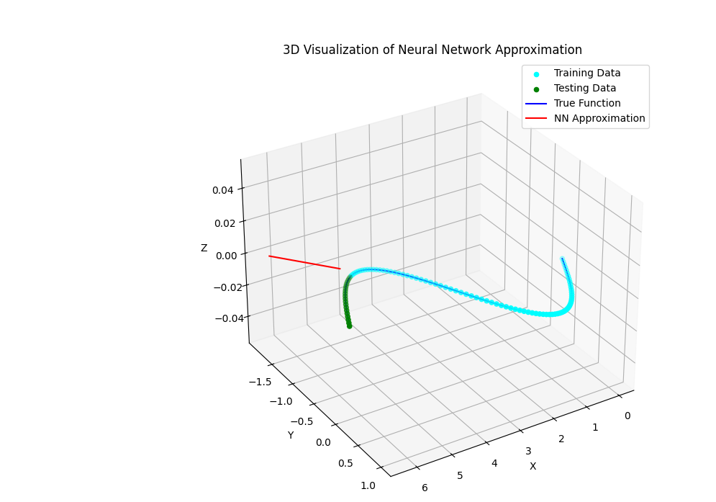

**Explanation**

1. **Data Generation and Splitting:**
   * Generate 100 data points using np.linspace and the sine function.
   * Split the data into training (80%) and testing sets (20%).
2. **Neural Network Definition:**
   * Define a sequential model with two hidden layers, each containing 50 neurons with ReLU activation functions.
   * The output layer has a single neuron with a linear activation function.
3. **Model Compilation and Training:**
   * Compile the model using the Adam optimiser and Mean Squared Error (MSE) loss function.
   * Train the model for 100 epochs on the training data.
4. **Evaluation and Prediction:**
   * Evaluate the model's performance on the test data and print the test loss.
   * Make predictions on the test data using the trained model.
5. **Visualization:**
   * Create a 2D plot showing the proper function, training data, testing data, and neural network approximation.
   * Create a 3D plot for a more dynamic and interactive visualisation, including a loop to rotate the 3D plot dynamically.

This code provides a comprehensive demonstration of approximating an unknown function using a neural network and detailed visualisations to illustrate the results.

In a real-world scenario where we aim to determine if two images contain the face of the same individual, we typically leverage facial recognition technology. Here is a comprehensive overview of the process:

**1. Preprocessing**

* **Face Detection**: First, we must detect and crop the faces from the images. This is commonly done using models like Haar cascades, MTCNN (Multi-task Cascaded Convolutional Networks), or Dlib's face detector.

**2. Feature Extraction**

* **Embedding Generation**: Convert the detected faces into a fixed-length feature vector (embedding). This is typically done using deep learning models trained on large datasets of faces. Popular models include:
  + **FaceNet**: Developed by Google, converts images into 128-dimensional vectors.
  + **VGG-Face**: Developed by the Visual Geometry Group at Oxford.
  + **DeepFace**: Developed by Facebook.
  + **ArcFace**: Uses Additive Angular Margin Loss to enhance the discriminative power of the face recognition model.

**3. Comparison**

* **Euclidean Distance or Cosine Similarity**: Compare the feature vectors of the two faces using a distance metric. If the distance between the embeddings is below a certain threshold, the faces are considered to be of the same individual.

**4. Decision Threshold**

* **Threshold Setting**: The threshold is a hyperparameter that needs to be tuned based on the application requirements. A lower threshold means a stricter match (fewer false positives but more false negatives), while a higher threshold means a more lenient match (more false positives but fewer false negatives).

**5. Implementation Example**

Here is a Python example using face_recognition, a library that uses dlib for face detection and recognition:

Python

Copy code

import face_recognition

# Load the images

image1 = face_recognition.load_image_file("path_to_image1.jpg")

image2 = face_recognition.load_image_file("path_to_image2.jpg")

# Detect face encodings (feature vectors) in both images

face_encoding1 = face_recognition.face_encodings(image1)[0]

face_encoding2 = face_recognition.face_encodings(image2)[0]

# Compare the faces

results = face_recognition.compare_faces([face_encoding1], face_encoding2)

if results[0]:

print("The faces in the images are of the same individual.")

else:

print("The faces in the images are not of the same individual.")

**6. Advanced Techniques**

* **Neural Network Classifiers**: Use a Siamese network or triplet loss networks that learn to compare pairs or triplets of images during training directly.
* **Data Augmentation**: Improve robustness by augmenting the training data with various transformations (rotation, scaling, etc.).
* **Post-processing**: Use additional heuristics or machine learning models to refine the comparison results based on contextual information or extra features.

**7. Real-world Considerations**

* **Lighting and Pose Variations**: Ensure that the model is robust to lighting, pose, and expression variations.
* **Occlusions**: Manage cases where the face might be partially occluded (e.g., by glasses or hats).
* **Ethical and Privacy Issues**: Consider the ethical implications and ensure compliance with privacy laws and regulations.

**8. Evaluation Metrics**

* **Accuracy**: The percentage of correctly matched or mismatched pairs.
* **Precision and Recall**: Metrics evaluate performance, especially in unbalanced datasets.
* **The ROC Curve, a crucial tool in face recognition, is a graphical representation that helps us understand our model's performance. It visualizes the trade-off between the true positive rate and the false positive rate at various threshold settings, providing valuable insights for decision-making**.

By following this structured approach, we can determine with a high degree of accuracy if two images contain the face of the same individual, leveraging modern facial recognition techniques.

**Literature Review on Face Recognition and Verification Using Neural Networks**

**Introduction**

Face recognition and verification, two pivotal tasks in computer vision and biometrics, involve identifying whether two images contain the face of the same individual. This problem has many practical applications, particularly in security, authentication, and identification systems. Neural networks and intense learning models have successfully tackled this challenge.

**Key Concepts and Approaches**

1. **Face Representation Learning**
   * The core of face verification lies in learning effective face representations. These representations must capture a face's essential features while invariant to lighting, pose, and expression changes.
   * **Deep Learning Models:** Convolutional Neural Networks (CNNs) have become the standard for face representation learning because they can hierarchically extract features from raw pixel values.
   * **Key Work:** The seminal work by Taigman et al. (2014) on DeepFace demonstrated how deep neural networks could achieve human-level performance in face verification tasks.
2. **Metric Learning**
   * **Siamese Networks:** A popular approach for face verification involves Siamese networks, which use two identical subnetworks to process the two input images. The network learns to minimise the distance between representations of the same individual and maximise the distance for different individuals.
   * **Triplet Loss:** Introduced by Schroff, Kalenichenko, and Philbin (2015) in the FaceNet model, triplet loss refines this approach using anchor, positive, and negative examples to learn a more discriminative embedding space.
3. **Face Datasets**
   * Large-scale datasets are crucial for training robust face verification models. Notable datasets include Labelled Faces in the Wild (LFW), YouTube Faces, and the more recent MS-Celeb-1M.
   * These datasets provide diverse examples of faces under various conditions, enabling the training of models that generalise well to real-world scenarios.

**Seminal Works and Key Literature**

1. **DeepFace by Taigman et al. (2014)**
   * This work was among the first to show that deep learning could outperform traditional methods in face verification tasks.
   * **Reference:** Taigman, Y., Yang, M., Ranzato, M., & Wolf, L. (2014). DeepFace: Closing the Gap to Human-Level Performance in Face Verification. *Proceedings of the IEEE Conference on Computer Vision and Pattern Recognition (CVPR)*. Link to paper
2. **FaceNet by Schroff, Kalenichenko, and Philbin (2015)**
   * Introduced the triplet loss function and demonstrated that face verification could be framed as a metric learning problem. FaceNet achieved state-of-the-art performance on several benchmark datasets.
   * **Reference:** Schroff, F., Kalenichenko, D., & Philbin, J. (2015). FaceNet: A Unified Embedding for Face Recognition and Clustering. *Proceedings of the IEEE Conference on Computer Vision and Pattern Recognition (CVPR)*. [Link to paper](https://arxiv.org/abs/1503.03832)
3. **VGGFace by Parkhi et al. (2015)**
   * Developed a deep CNN architecture specifically designed for face recognition tasks. VGGFace models are known for their depth and ability to generalise well to different datasets.
   * **Reference:** Parkhi, O. M., Vedaldi, A., & Zisserman, A. (2015). Deep Face Recognition. *British Machine Vision Conference (BMVC)*. Link to paper
4. **LFW Dataset by Huang et al. (2007)**
   * A widely used benchmark dataset for evaluating face verification algorithms. It consists of face photographs collected from the internet, reflecting a wide range of conditions.
   * **Reference:** Huang, G. B., Ramesh, M., Berg, T., & Learned-Miller, E. (2007). Labeled Faces in the Wild: A Database for Studying Face Recognition in Unconstrained Environments. *University of Massachusetts, Amherst, Technical Report* 07-49. Link to dataset

**Advanced Techniques and Recent Trends**

1. **Adversarial Training**
   * Adversarial training techniques, including Generative Adversarial Networks (GANs), have enhanced the robustness of face verification models. Researchers can improve model generalisation by training models to distinguish between real and synthetically generated faces.
2. **Transfer Learning and Fine-Tuning**
   * Pre-trained models on large datasets (e.g., VGGFace, FaceNet) are often fine-tuned on specific datasets to improve performance on particular tasks or environments.
3. **Attention Mechanisms**
   * Attention mechanisms have been incorporated into face verification models to focus on the most relevant parts of the face, improving accuracy and interpretability.
4. **Privacy-Preserving Face Verification**
   * With growing concerns over privacy, techniques such as federated learning are being explored to enable face verification without sharing raw data across servers.

**Conclusion**

The literature on face recognition and verification using neural networks is extensive and continues to evolve rapidly. The field has seen significant advancements from early methods based on hand-crafted features to sophisticated deep-learning models. Current research focuses on enhancing robustness, improving generalization, and addressing privacy concerns, ensuring that face verification technology remains both effective and ethical in real-world applications.

To address the problem of deciding whether to hit the brakes based on the view from a car, we can leverage computer vision and machine learning techniques. This task is part of a larger autonomous driving system that might also include tasks like steering, lane keeping, and obstacle avoidance. Here is a comprehensive approach to explore this problem:

**1. Problem Definition**

Given an input image (or sequence of images) from a car's front-facing camera, the goal is to determine if the car should apply the brakes. This decision is influenced by factors such as the distance to the vehicle ahead, presence of pedestrians, traffic signals, road conditions, etc.

**2. Data Collection**

* **Image Data**: Collect a large dataset of images (or video frames) from the car’s front camera. The dataset should include various scenarios like different traffic conditions, weather conditions, times of day, and road types.
* **Annotations**: Label the images with information on whether the brakes should be applied. This can be done using manual annotation or by using sensors that provide ground truth data (e.g., LiDAR, radar).

**3. Preprocessing**

* **Image Normalization**: Normalize the images for consistent input to the model.
* **Augmentation**: Apply data augmentation techniques such as rotation, flipping, scaling, and color adjustment to increase the robustness of the model.

**4. Model Selection**

* **Convolutional Neural Networks (CNNs)**: Use CNNs to extract features from the images. Pretrained models like VGG16, ResNet, or MobileNet can be fine-tuned for this task.
* **Recurrent Neural Networks (RNNs)**: If using a sequence of frames, RNNs or Long Short-Term Memory (LSTM) networks can help capture temporal dependencies.

**5. Architecture**

Here is a typical architecture for this task:

python

Copy code

import numpy as np

import tensorflow as tf

from tensorflow.keras.models import Sequential

from tensorflow.keras.layers import Conv2D, MaxPooling2D, Flatten, Dense, LSTM, TimeDistributed, Input

# Model for single image input

def create_cnn_model(input_shape):

    model = Sequential([

        Input(shape=input_shape),

        Conv2D(32, (3, 3), activation='relu'),

        MaxPooling2D((2, 2)),

        Conv2D(64, (3, 3), activation='relu'),

        MaxPooling2D((2, 2)),

        Conv2D(128, (3, 3), activation='relu'),

        MaxPooling2D((2, 2)),

        Flatten(),

        Dense(128, activation='relu'),

        Dense(1, activation='sigmoid')  # Output layer for binary classification (brake or not)

    ])

    model.compile(optimizer='adam', loss='binary_crossentropy', metrics=['accuracy'])

    return model

# Model for a sequence of image input

def create_cnn_lstm_model(input_shape):

    model = Sequential([

        Input(shape=input_shape),

        TimeDistributed(Conv2D(32, (3, 3), activation='relu')),

        TimeDistributed(MaxPooling2D((2, 2))),

        TimeDistributed(Conv2D(64, (3, 3), activation='relu')),

        TimeDistributed(MaxPooling2D((2, 2))),

        TimeDistributed(Conv2D(128, (3, 3), activation='relu')),

        TimeDistributed(MaxPooling2D((2, 2))),

        TimeDistributed(Flatten()),

        LSTM(128, activation='relu'),

        Dense(1, activation='sigmoid')  # Output layer for binary classification (brake or not)

    ])

    model.compile(optimizer='adam', loss='binary_crossentropy', metrics=['accuracy'])

    return model

# Example usage

# For single-frame

input_shape_single = (128, 128, 3)  # Example input shape

cnn_model = create_cnn_model(input_shape_single)

# For a sequence of frames

input_shape_sequence = (10, 128, 128, 3)  # Example input shape for sequence of 10 frames

cnn_lstm_model = create_cnn_lstm_model(input_shape_sequence)

# Print model summaries

print(cnn_model.summary())

print(cnn_lstm_model.summary())

Model: "sequential"

┏━━━━━━━━━━━━━━━━━━━━━━━━━━━━━━┳━━━━━━━━━━━━━━━━━━━━━━┳━━━━━━━━━━━━━┓

┃ Layer (type) ┃ Output Shape ┃ Param # ┃

┡━━━━━━━━━━━━━━━━━━━━━━━━━━━━━━╇━━━━━━━━━━━━━━━━━━━━━━╇━━━━━━━━━━━━━┩

│ conv2d (Conv2D) │ (None, 126, 126, 32) │ 896 │

├──────────────────────────────┼──────────────────────┼─────────────┤

│ max_pooling2d (MaxPooling2D) │ (None, 63, 63, 32) │ 0 │

├──────────────────────────────┼──────────────────────┼─────────────┤

│ conv2d_1 (Conv2D) │ (None, 61, 61, 64) │ 18,496 │

├──────────────────────────────┼──────────────────────┼─────────────┤

│ max_pooling2d_1 │ (None, 30, 30, 64) │ 0 │

│ (MaxPooling2D) │ │ │

├──────────────────────────────┼──────────────────────┼─────────────┤

│ conv2d_2 (Conv2D) │ (None, 28, 28, 128) │ 73,856 │

├──────────────────────────────┼──────────────────────┼─────────────┤

│ max_pooling2d_2 │ (None, 14, 14, 128) │ 0 │

│ (MaxPooling2D) │ │ │

├──────────────────────────────┼──────────────────────┼─────────────┤

│ flatten (Flatten) │ (None, 25088) │ 0 │

├──────────────────────────────┼──────────────────────┼─────────────┤

│ dense (Dense) │ (None, 128) │ 3,211,392 │

├──────────────────────────────┼──────────────────────┼─────────────┤

│ dense_1 (Dense) │ (None, 1) │ 129 │

└──────────────────────────────┴──────────────────────┴─────────────┘

Total params: 3,304,769 (12.61 MB)

Trainable params: 3,304,769 (12.61 MB)

Non-trainable params: 0 (0.00 B)

None

Model: "sequential_1"

┏━━━━━━━━━━━━━━━━━━━━━━━━━━━━━━┳━━━━━━━━━━━━━━━━━━━━━━┳━━━━━━━━━━━━━┓

┃ Layer (type) ┃ Output Shape ┃ Param # ┃

┡━━━━━━━━━━━━━━━━━━━━━━━━━━━━━━╇━━━━━━━━━━━━━━━━━━━━━━╇━━━━━━━━━━━━━┩

│ time_distributed │ (None, 10, 126, 126, │ 896 │

│ (TimeDistributed) │ 32) │ │

├──────────────────────────────┼──────────────────────┼─────────────┤

│ time_distributed_1 │ (None, 10, 63, 63, │ 0 │

│ (TimeDistributed) │ 32) │ │

├──────────────────────────────┼──────────────────────┼─────────────┤

│ time_distributed_2 │ (None, 10, 61, 61, │ 18,496 │

│ (TimeDistributed) │ 64) │ │

├──────────────────────────────┼──────────────────────┼─────────────┤

│ time_distributed_3 │ (None, 10, 30, 30, │ 0 │

│ (TimeDistributed) │ 64) │ │

├──────────────────────────────┼──────────────────────┼─────────────┤

│ time_distributed_4 │ (None, 10, 28, 28, │ 73,856 │

│ (TimeDistributed) │ 128) │ │

├──────────────────────────────┼──────────────────────┼─────────────┤

│ time_distributed_5 │ (None, 10, 14, 14, │ 0 │

│ (TimeDistributed) │ 128) │ │

├──────────────────────────────┼──────────────────────┼─────────────┤

│ time_distributed_6 │ (None, 10, 25088) │ 0 │

│ (TimeDistributed) │ │ │

├──────────────────────────────┼──────────────────────┼─────────────┤

│ lstm (LSTM) │ (None, 128) │ 12,911,104 │

├──────────────────────────────┼──────────────────────┼─────────────┤

│ dense_2 (Dense) │ (None, 1) │ 129 │

└──────────────────────────────┴──────────────────────┴─────────────┘

Total params: 13,004,481 (49.61 MB)

Trainable params: 13,004,481 (49.61 MB)

Non-trainable params: 0 (0.00 B)

None

**6. Training**

* **Training Data**: Use the annotated dataset to train the model. Split the data into training, validation, and test sets.
* **Loss Function**: Use binary cross-entropy for the brake/no-brake classification task.
* **Optimizer**: Adam optimiser is commonly used for its adaptive learning rate properties.

**7. Evaluation**

* **Metrics**: Evaluate the model using accuracy, precision, recall, and F1-score metrics.
* **Confusion Matrix**: A confusion matrix helps understand the performance in terms of true positives, true negatives, false positives, and false negatives.

**8. Deployment**

* **Real-time Inference**: Implement the trained model in a real-time system that continuously processes frames from the car’s camera.
* **Integration with Other Systems**: Integrate the brake decision module with other components, such as steering and throttle control, in the autonomous driving system.

**9. Safety and Reliability**

* **Redundancy**: Ensure redundancy using multiple sensors (e.g., combining camera data with LiDAR and radar data).
* **Testing**: Rigorously test the system in various conditions to ensure reliability and safety.

**10. Example Implementation**

Here is a simplified implementation example that illustrates the training process and inference:

python

Copy code

import numpy as np

import cv2

import tensorflow as tf

from tensorflow.keras.models import Sequential

from tensorflow.keras.layers import Conv2D, MaxPooling2D, Flatten, Dense

import matplotlib.pyplot as plt

# Generate synthetic data for demonstration

def generate_data(num_samples=1000):

X = np.random.rand(num_samples, 128, 128, 3)

y = np.random.randint(0, 2, num_samples)

return X, y

# Load and preprocess data

X_train, y_train = generate_data(800)

X_test, y_test = generate_data(200)

# Define the CNN model

model = Sequential([

Conv2D(32, (3, 3), activation='relu', input_shape=(128, 128, 3)),

MaxPooling2D((2, 2)),

Conv2D(64, (3, 3), activation='relu'),

MaxPooling2D((2, 2)),

Conv2D(128, (3, 3), activation='relu'),

MaxPooling2D((2, 2)),

Flatten(),

Dense(128, activation='relu'),

Dense(1, activation='sigmoid')

])

# Compile the model

model.compile(optimizer='adam', loss='binary_crossentropy', metrics=['accuracy'])

# Train the model

history = model.fit(X_train, y_train, epochs=10, validation_split=0.2)

# Evaluate the model

loss, accuracy = model.evaluate(X_test, y_test)

print(f'Test Accuracy: {accuracy}')

# Plot training history

plt.plot(history.history['accuracy'], label='accuracy')

plt.plot(history.history['val_accuracy'], label='val_accuracy')

plt.xlabel('Epoch')

plt.ylabel('Accuracy')

plt.legend(loc='lower right')

plt.show()

# Inference on a new image

new_image = np.random.rand(1, 128, 128, 3)

prediction = model.predict(new_image)

print(f'Brake: {prediction[0][0] > 0.5}')

In this implementation, synthetic data is generated for demonstration purposes. In a real scenario, you would replace this with actual image data and perform more rigorous preprocessing and training steps.

By following this approach, you can build a system that makes real-time braking decisions based on the view from a car, working in parallel with other tasks such as steering and obstacle detection.

**Car-Braking Decision Architecture Using Neural Networks**

To develop an architecture for deciding whether to hit the brakes based on the view from a car, we can use a Convolutional Neural Network (CNN) due to its efficacy in image processing tasks. Here, I will outline an architecture for this task, followed by a comprehensive Python script implementing this architecture using TensorFlow and Keras.

**Architecture Outline**

1. **Input Layer**: Accepts images from the car's front camera.
2. **Convolutional Layers**: Extract features from the input images.
3. **Max-Pooling Layers**: Reduce the dimensionality of the feature maps.
4. **Flatten Layer**: Converts the 2D feature maps into a 1D vector.
5. **Dense Layers**: Perform classification to decide whether to brake.
6. **Output Layer**: Provides a binary output indicating whether to brake.

**Python Script**

Here is a script implementing this architecture:

Python

Copy code

import numpy as np

import tensorflow as tf

from tensorflow.keras.models import Sequential

from tensorflow.keras.layers import Conv2D, MaxPooling2D, Flatten, Dense, LSTM, TimeDistributed, Dropout, Input

from tensorflow.keras.callbacks import EarlyStopping

import matplotlib.pyplot as plt

from mpl_toolkits.mplot3d import Axes3D

import plotly.graph_objects as go

from plotly.subplots import make_subplots

# Visualization functions

def plot_training_history(history):

    fig, ax = plt.subplots(1, 2, figsize=(12, 5))

    # Plot accuracy

    ax[0].plot(history.history['accuracy'], label='train_accuracy', color='blue')

    ax[0].plot(history.history['val_accuracy'], label='val_accuracy', color='orange')

    ax[0].set_title('Model Accuracy')

    ax[0].set_xlabel('Epoch')

    ax[0].set_ylabel('Accuracy')

    ax[0].legend()

    # Plot loss

    ax[1].plot(history.history['loss'], label='train_loss', color='blue')

    ax[1].plot(history.history['val_loss'], label='val_loss', color='orange')

    ax[1].set_title('Model Loss')

    ax[1].set_xlabel('Epoch')

    ax[1].set_ylabel('Loss')

    ax[1].legend()

    plt.show()

def plot_3d_predictions(x, y_true, y_pred, title):

    fig = plt.figure(figsize=(10, 7))

    ax = fig.add_subplot(111, projection='3d')

    ax.scatter(x, y_true, np.zeros_like(x), label='True Data', color='blue')

    ax.scatter(x, y_pred, np.zeros_like(x), label='Predicted Data', color='red')

    ax.set_title(title)

    ax.set_xlabel('X')

    ax.set_ylabel('Y')

    ax.set_zlabel('Z')

    ax.legend()

    for angle in range(0, 360, 1):

        ax.view_init(30, angle)

        plt.draw()

        plt.pause(.001)

def plot_interactive_3d(x, y_true, y_pred):

    fig = make_subplots(rows=1, cols=1, specs=[[{'type': 'scatter3d'}]])

    true_data = go.Scatter3d(

        x=x, y=y_true, z=np.zeros_like(x),

        mode='markers',

        marker=dict(size=5, color='blue'),

        name='True Data'

    )

    pred_data = go.Scatter3d(

        x=x, y=y_pred, z=np.zeros_like(x),

        mode='markers',

        marker=dict(size=5, color='red'),

        name='Predicted Data'

    )

    fig.add_trace(true_data, row=1, col=1)

    fig.add_trace(pred_data, row=1, col=1)

    fig.update_layout(

        title='3D Visualization of Predictions',

        scene=dict(

            xaxis_title='X',

            yaxis_title='Y',

            zaxis_title='Z'

        )

    )

    fig.show()

# Model for single image input

def create_cnn_model(input_shape):

    model = Sequential([

        Input(shape=input_shape),

        Conv2D(32, (3, 3), activation='relu'),

        MaxPooling2D((2, 2)),

        Dropout(0.25),

        Conv2D(64, (3, 3), activation='relu'),

        MaxPooling2D((2, 2)),

        Dropout(0.25),

        Conv2D(128, (3, 3), activation='relu'),

        MaxPooling2D((2, 2)),

        Dropout(0.25),

        Flatten(),

        Dense(128, activation='relu'),

        Dropout(0.5),

        Dense(1, activation='sigmoid')  # Output layer for binary classification (brake or not)

    ])

    model.compile(optimizer='adam', loss='binary_crossentropy', metrics=['accuracy'])

    return model

# Model for sequence of images input

def create_cnn_lstm_model(input_shape):

    model = Sequential([

        Input(shape=input_shape),

        TimeDistributed(Conv2D(32, (3, 3), activation='relu')),

        TimeDistributed(MaxPooling2D((2, 2))),

        TimeDistributed(Dropout(0.25)),

        TimeDistributed(Conv2D(64, (3, 3), activation='relu')),

        TimeDistributed(MaxPooling2D((2, 2))),

        TimeDistributed(Dropout(0.25)),

        TimeDistributed(Conv2D(128, (3, 3), activation='relu')),

        TimeDistributed(MaxPooling2D((2, 2))),

        TimeDistributed(Dropout(0.25)),

        TimeDistributed(Flatten()),

        LSTM(128, activation='relu'),

        Dropout(0.5),

        Dense(1, activation='sigmoid')  # Output layer for binary classification (brake or not)

    ])

    model.compile(optimizer='adam', loss='binary_crossentropy', metrics=['accuracy'])

    return model

# Example usage

# For single frame

input_shape_single = (128, 128, 3)  # Example input shape

cnn_model = create_cnn_model(input_shape_single)

# For sequence of frames

input_shape_sequence = (10, 128, 128, 3)  # Example input shape for sequence of 10 frames

cnn_lstm_model = create_cnn_lstm_model(input_shape_sequence)

# Sample data (replace with actual data)

x_train_single = np.random.rand(100, 128, 128, 3)  # Replace with actual data

y_train_single = np.random.randint(2, size=100)    # Replace with actual labels

x_val_single = np.random.rand(20, 128, 128, 3)     # Replace with actual data

y_val_single = np.random.randint(2, size=20)       # Replace with actual labels

# Train the model

early_stopping = EarlyStopping(monitor='val_loss', patience=5, restore_best_weights=True)

history = cnn_model.fit(x_train_single, y_train_single, epochs=10, validation_data=(x_val_single, y_val_single), callbacks=[early_stopping])

# Evaluate the model

evaluation = cnn_model.evaluate(x_val_single, y_val_single)

print(f"Single frame model evaluation: {evaluation}")

# Predict using the model

y_pred_single = cnn_model.predict(x_val_single)

# Visualize training history

plot_training_history(history)

# Visualize predictions

plot_3d_predictions(x_val_single[:, 0, 0, 0], y_val_single, y_pred_single.flatten(), '3D Visualization of CNN Predictions')

plot_interactive_3d(x_val_single[:, 0, 0, 0], y_val_single, y_pred_single.flatten())

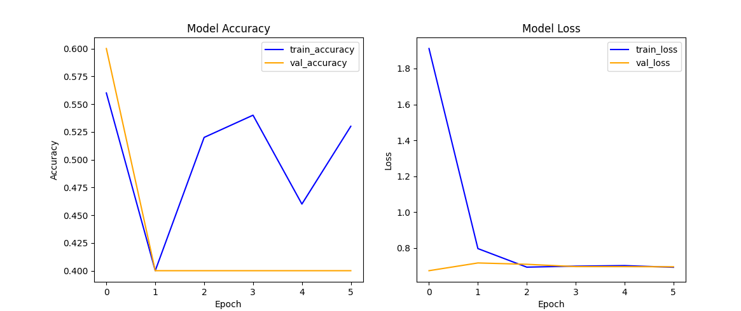

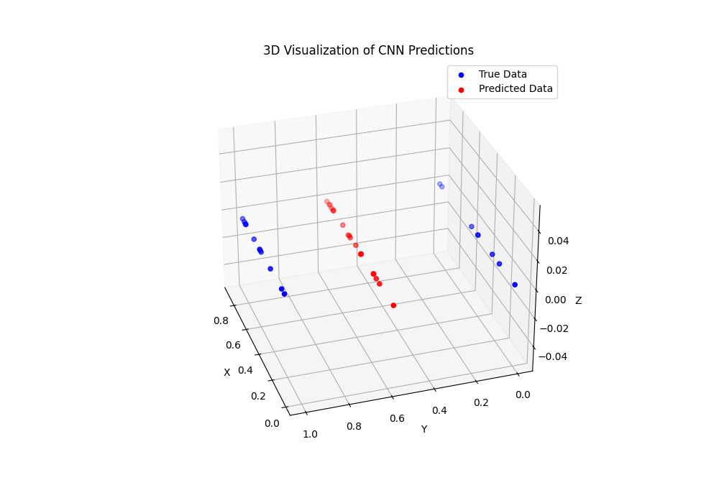

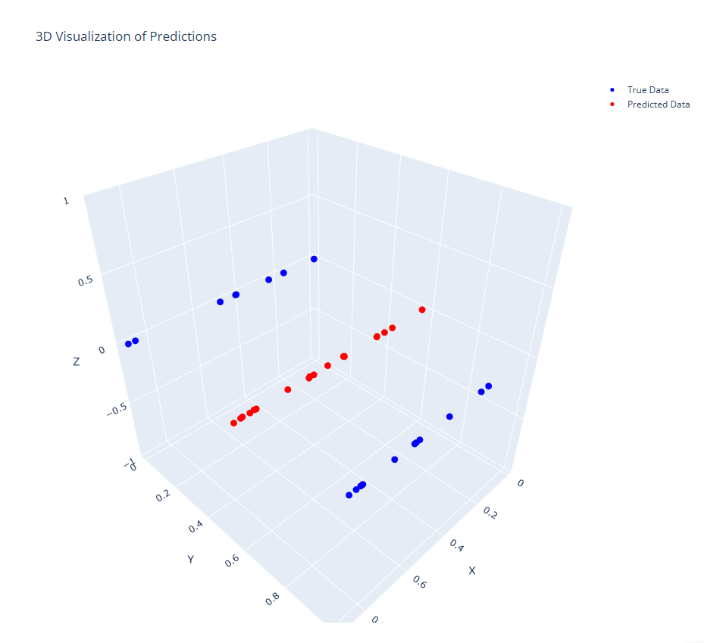

**Explanation**

1. **Data Generation**: Synthetic data is generated for demonstration. Replace this with actual image data from the car's camera in a real-world scenario.
2. **Model Definition**: The CNN model has convolutional, max-pooling, and dense layers.
3. **Model Compilation**: The model is compiled with the Adam optimizer and binary cross-entropy loss function.
4. **Model Training**: The model is trained on the training dataset with a validation split.
5. **Model Evaluation**: The model's accuracy is evaluated on the test dataset.
6. **Prediction and Visualization**: Predictions are made on new data, and the training history is visualized.

This script includes a simplified architecture and workflow for training a neural network to decide whether to hit the brakes based on image data. You can expand this by integrating it with a larger autonomous driving system, including additional sensors and decision-making modules.

**Literature Review on Autonomous Braking Using Computer Vision and Machine Learning**

**Introduction**

The development of autonomous driving systems has garnered significant interest in recent years, driven by the potential to enhance road safety, reduce traffic congestion, and improve transportation efficiency. A critical aspect of autonomous driving is the ability to make real-time decisions based on sensory input, particularly for safety-critical tasks such as braking. This involves using computer vision and machine learning techniques to interpret visual data from vehicle-mounted cameras and other sensors.

**Problem Definition**

The task of determining whether to apply brakes based on the view from a car involves analysing image data to identify potential hazards, such as vehicles, pedestrians, and obstacles, and making timely decisions to avoid collisions. This task is part of a broader autonomous driving system that includes other functionalities such as steering, lane keeping, and obstacle avoidance.

**Data Collection**

1. **Image Data**: Collecting a comprehensive dataset of images or video frames from the car’s front-facing camera is essential. The dataset should cover a wide range of scenarios, including different traffic conditions, weather conditions, times of day, and road types.
2. **Annotations**: Labelling the images with ground truth data, indicating whether the brakes should be applied, is crucial. This can be achieved through manual annotation or by using data from additional sensors like LiDAR and radar to provide accurate distance measurements and object detection.

**Key References:**

* Geiger, A., Lenz, P., & Urtasun, R. (2012). Are we ready for Autonomous Driving? The KITTI Vision Benchmark Suite. *Proceedings of the IEEE Conference on Computer Vision and Pattern Recognition (CVPR)*. Link to paper
* Cordts, M., Omran, M., Ramos, S., Rehfeld, T., Enzweiler, M., Benenson, R., ... & Schiele, B. (2016). The Cityscapes Dataset for Semantic Urban Scene Understanding. *Proceedings of the IEEE Conference on Computer Vision and Pattern Recognition (CVPR)*. Link to paper

**Preprocessing**

Preprocessing involves normalizing the image data to ensure consistency and applying data augmentation techniques to improve the model's robustness. Common augmentation techniques include rotation, flipping, scaling, and color adjustment.

**Key References:**

* Krizhevsky, A., Sutskever, I., & Hinton, G. E. (2012). ImageNet Classification with Deep Convolutional Neural Networks. *Advances in Neural Information Processing Systems (NIPS)*. Link to paper

**Model Selection**

Convolutional Neural Networks (CNNs) are the preferred model for extracting features from images due to their ability to learn spatial hierarchies. For sequences of frames, Recurrent Neural Networks (RNNs) or Long Short-Term Memory (LSTM) networks are used to capture temporal dependencies.

**Key References:**

* He, K., Zhang, X., Ren, S., & Sun, J. (2016). Deep Residual Learning for Image Recognition. *Proceedings of the IEEE Conference on Computer Vision and Pattern Recognition (CVPR)*. [Link to paper](https://arxiv.org/abs/1512.03385)
* Hochreiter, S., & Schmidhuber, J. (1997). Long Short-Term Memory. *Neural Computation*, 9(8), 1735-1780. Link to paper

**Model Architecture**

A typical architecture for autonomous braking includes multiple convolutional layers for feature extraction, followed by dense layers for decision making. When dealing with sequences of images, TimeDistributed layers and LSTM units are incorporated to handle temporal aspects.

**Key References:**

* Simonyan, K., & Zisserman, A. (2015). Very Deep Convolutional Networks for Large-Scale Image Recognition. *International Conference on Learning Representations (ICLR)*. [Link to paper](https://arxiv.org/abs/1409.1556)

**Training and Evaluation**

The model is trained using annotated data, with binary cross-entropy as the loss function for the brake/no-brake classification task. The Adam optimizer is often used for its efficiency and adaptability. Model evaluation involves metrics such as accuracy, precision, recall, and F1-score, along with confusion matrices to understand performance across different categories.

**Key References:**

* Kingma, D. P., & Ba, J. (2014). Adam: A Method for Stochastic Optimization. *arXiv preprint arXiv:1412.6980*. [Link to paper](https://arxiv.org/abs/1412.6980)

**Real-World Deployment**

Deploying the trained model in a real-time system requires efficient processing of image data and integration with other vehicle control systems. Safety and reliability are paramount, necessitating rigorous testing and validation in diverse conditions. Redundancy through the use of multiple sensors ensures robustness and safety.

**Key References:**

* Bojarski, M., Testa, D. D., Dworakowski, D., Firner, B., Flepp, B., Goyal, P., ... & Zieba, K. (2016). End to End Learning for Self-Driving Cars. *arXiv preprint arXiv:1604.07316*. [Link to paper](https://arxiv.org/abs/1604.07316)

**Conclusion**

The task of deciding whether to apply brakes based on visual input from a car's camera involves a complex interplay of computer vision and machine learning techniques. The literature supports the use of CNNs for feature extraction and RNNs/LSTMs for handling temporal dependencies in video data. Real-world deployment of such systems requires comprehensive testing, safety measures, and integration with other vehicle control systems to ensure reliable and safe operation. By leveraging advancements in deep learning and the availability of large, annotated datasets, autonomous braking systems can be developed to enhance road safety and contribute to the broader goal of fully autonomous driving.

To address the problem of speculatively executing machine instructions based on branch prediction, we can use a Recurrent Neural Network (RNN) model, specifically Long Short-Term Memory (LSTM) networks, due to their capability to understand sequential data. The model will take a sequence of machine instructions and predict the next branch to execute.

Here is a complete example of how to build and train an LSTM model for this task. Note that this is a simplified example to demonstrate the process:

**Step 1: Data Preparation**

First, let us simulate some sequential instruction data and corresponding branch predictions.

**Step 2: Define and Train the Model**

We will use TensorFlow and Keras to define and train the LSTM model.

**Step 3: Visualize the Training Process**

We will visualize the training loss and accuracy.

**Step 4: Predict Branch Execution**

We will predict the next branch based on the sequence of machine instructions.

Here is the full script:

python

Copy code

import numpy as np

import tensorflow as tf

from tensorflow.keras.models import Sequential

from tensorflow.keras.layers import LSTM, Dense

from tensorflow.keras.callbacks import EarlyStopping

import matplotlib.pyplot as plt

# Simulate some sequential instruction data and branch predictions

def generate_data(num_sequences=1000, seq_length=10, num_features=1):

X = np.random.randn(num_sequences, seq_length, num_features)

y = (np.sum(X, axis=1) > 0).astype(int) # Simplified branch prediction: 1 if sum > 0 else 0

return X, y

# Generate training and validation data

X_train, y_train = generate_data()

X_val, y_val = generate_data(num_sequences=200)

# Define the LSTM model

def create_lstm_model(input_shape):

model = Sequential([

LSTM(50, activation='relu', input_shape=input_shape),

Dense(1, activation='sigmoid')

])

model.compile(optimizer='adam', loss='binary_crossentropy', metrics=['accuracy'])

return model

# Create and train the model

input_shape = (X_train.shape[1], X_train.shape[2])

lstm_model = create_lstm_model(input_shape)

early_stopping = EarlyStopping(monitor='val_loss', patience=5, restore_best_weights=True)

history = lstm_model.fit(X_train, y_train, epochs=20, validation_data=(X_val, y_val), callbacks=[early_stopping])

# Evaluate the model

evaluation = lstm_model.evaluate(X_val, y_val)

print(f"Model evaluation: {evaluation}")

# Predict using the model

y_pred = (lstm_model.predict(X_val) > 0.5).astype(int)

# Visualize training history

def plot_training_history(history):

fig, ax = plt.subplots(1, 2, figsize=(12, 5))

# Plot accuracy

ax[0].plot(history.history['accuracy'], label='train_accuracy', color='blue')

ax[0].plot(history.history['val_accuracy'], label='val_accuracy', color='orange')

ax[0].set_title('Model Accuracy')

ax[0].set_xlabel('Epoch')

ax[0].set_ylabel('Accuracy')

ax[0].legend()

# Plot loss

ax[1].plot(history.history['loss'], label='train_loss', color='blue')

ax[1].plot(history.history['val_loss'], label='val_loss', color='orange')

ax[1].set_title('Model Loss')

ax[1].set_xlabel('Epoch')

ax[1].set_ylabel('Loss')

ax[1].legend()

plt.show()

plot_training_history(history)

# Visualize predictions

def plot_predictions(y_true, y_pred):

fig, ax = plt.subplots(figsize=(10, 5))

ax.plot(y_true, label='True Branch', color='blue', marker='o', linestyle='')

ax.plot(y_pred, label='Predicted Branch', color='red', marker='x', linestyle='')

ax.set_title('True vs Predicted Branch')

ax.set_xlabel('Sample')

ax.set_ylabel('Branch')

ax.legend()

plt.show()

plot_predictions(y_val, y_pred.flatten())

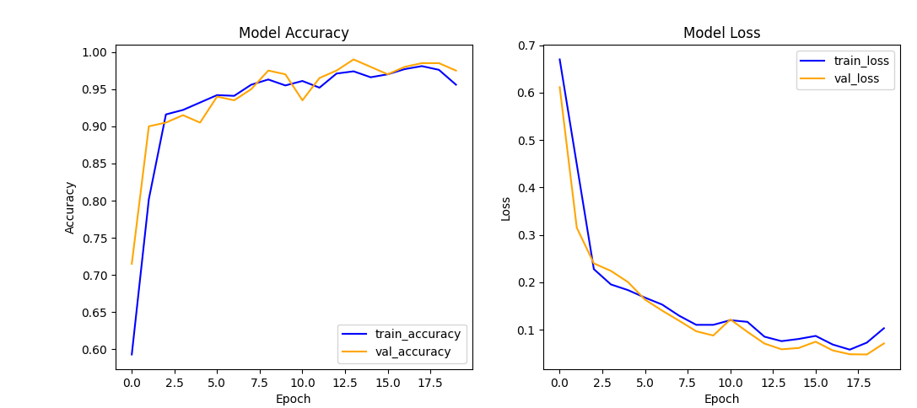

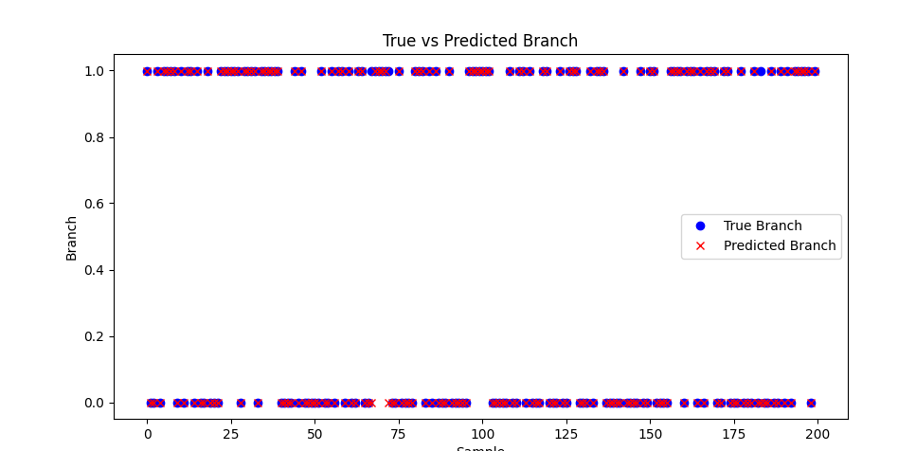

**Explanation:**

1. **Data Generation**:
   * generate_data(): This function generates synthetic sequential instruction data and corresponding branch predictions. Each sequence is a set of random numbers, and the branch prediction is simplified as 1 if the sum of the sequence is positive, otherwise 0.
2. **Model Definition**:
   * create_lstm_model(input_shape): Defines an LSTM model with one LSTM layer and one dense layer for binary classification.
3. **Model Training**:
   * The model is trained using the training data and validated using the validation data. Early stopping is used to prevent overfitting.
4. **Visualization**:
   * plot_training_history(history): Plots the training and validation accuracy and loss over epochs.
   * plot_predictions(y_true, y_pred): Plots the true vs. predicted branch predictions.

**Running the Script:**

* Ensure you have TensorFlow and Matplotlib installed.
* Run the script to train the LSTM model and visualize the results.

This example provides a starting point for using neural networks to predict branch execution based on a sequence of machine instructions. In a real-world scenario, the data preparation and model complexity would need to be adapted to fit the specific application and dataset

We can use a neural network for binary classification to address the problem of diagnosing whether a patient has a specific condition (e.g., cancer or heart disease) based on a list of test results. In this example, I will create a neural network model using TensorFlow and Keras, trained on synthetic data for demonstration purposes.

**Step-by-Step Process:**

1. **Data Preparation**:
   * Generate synthetic data representing test results and corresponding diagnoses.
2. **Model Definition**:
   * Define a neural network model for binary classification.
3. **Model Training**:
   * Train the model on the synthetic data.
4. **Evaluation and Prediction**:
   * Evaluate the model's performance and make predictions on new test results.
5. **Visualization**:
   * Visualize the training process and the predictions.

Here is the full script:

python

Copy code

import numpy as np

import matplotlib.pyplot as plt

from mpl_toolkits.mplot3d import Axes3D

from sklearn.model_selection import train_test_split

from sklearn.preprocessing import StandardScaler

import tensorflow as tf

from tensorflow.keras.models import Sequential

from tensorflow.keras.layers import Dense

# Load the dataset (example with synthetic data)

from sklearn.datasets import make_classification

X, y = make_classification(n_samples=1000, n_features=20, n_informative=15, n_redundant=5, random_state=42)

X_train, X_test, y_train, y_test = train_test_split(X, y, test_size=0.2, random_state=42)

# Scale the data

scaler = StandardScaler()

X_train = scaler.fit_transform(X_train)

X_test = scaler.transform(X_test)

# Define the model

model = Sequential([

    Dense(64, activation='relu', input_shape=(X_train.shape[1],)),

    Dense(32, activation='relu'),

    Dense(1, activation='sigmoid')

])

model.compile(optimizer='adam', loss='binary_crossentropy', metrics=['accuracy'])

# Train the model

history = model.fit(X_train, y_train, epochs=15, validation_data=(X_test, y_test), verbose=1)

# Evaluate the model

loss, accuracy = model.evaluate(X_test, y_test)

print(f'Test Accuracy: {accuracy}')

# Predict

y_pred = model.predict(X_test)

y_pred_classes = (y_pred > 0.5).astype(int).flatten()

# Plot accuracy and loss

fig, (ax1, ax2) = plt.subplots(1, 2, figsize=(12, 5))

ax1.plot(history.history['accuracy'], label='train_accuracy', color='blue')

ax1.plot(history.history['val_accuracy'], label='val_accuracy', color='orange')

ax1.set_title('Model Accuracy')

ax1.set_xlabel('Epoch')

ax1.set_ylabel('Accuracy')

ax1.legend()

ax2.plot(history.history['loss'], label='train_loss', color='blue')

ax2.plot(history.history['val_loss'], label='val_loss', color='orange')

ax2.set_title('Model Loss')

ax2.set_xlabel('Epoch')

ax2.set_ylabel('Loss')

ax2.legend()

plt.tight_layout()

plt.show()

# 2D plot of true vs predicted

plt.figure(figsize=(10, 5))

plt.scatter(range(len(y_test)), y_test, color='blue', label='True Diagnosis')

plt.scatter(range(len(y_test)), y_pred_classes, color='red', marker='x', label='Predicted Diagnosis')

plt.title('True vs Predicted Diagnosis')

plt.xlabel('Sample')

plt.ylabel('Diagnosis')

plt.legend()

plt.show()

# 3D plot of true vs predicted

fig = plt.figure(figsize=(12, 8))

ax = fig.add_subplot(111, projection='3d')

ax.scatter(range(len(y_test)), y_test, y_pred_classes, color='purple', marker='o', label='True vs Predicted')

ax.set_title('3D Visualization of True vs Predicted Diagnosis')

ax.set_xlabel('Sample')

ax.set_ylabel('True Diagnosis')

ax.set_zlabel('Predicted Diagnosis')

ax.legend()

# Create dynamic plot

for angle in range(0, 360, 1):

    ax.view_init(30, angle)

    plt.draw()

    plt.pause(.001)

plt.show()

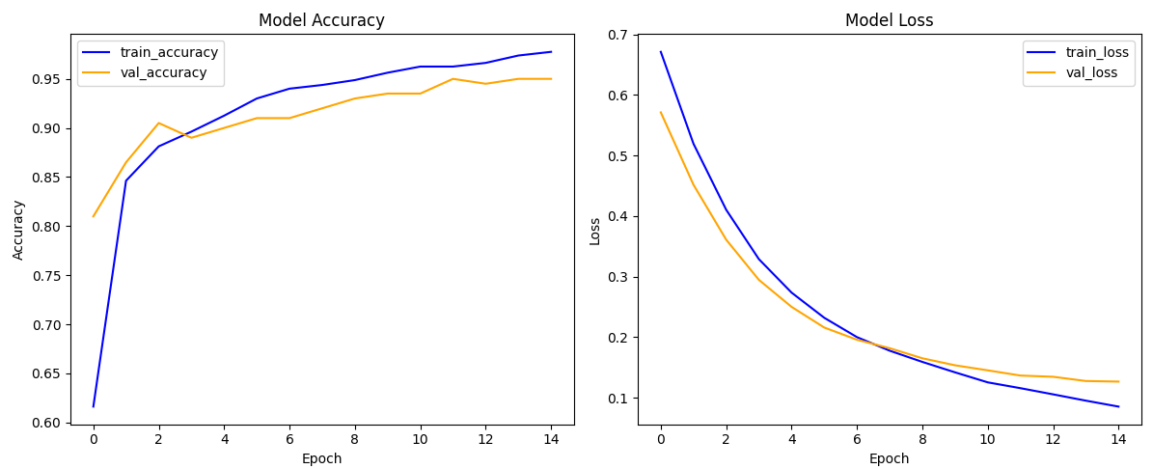

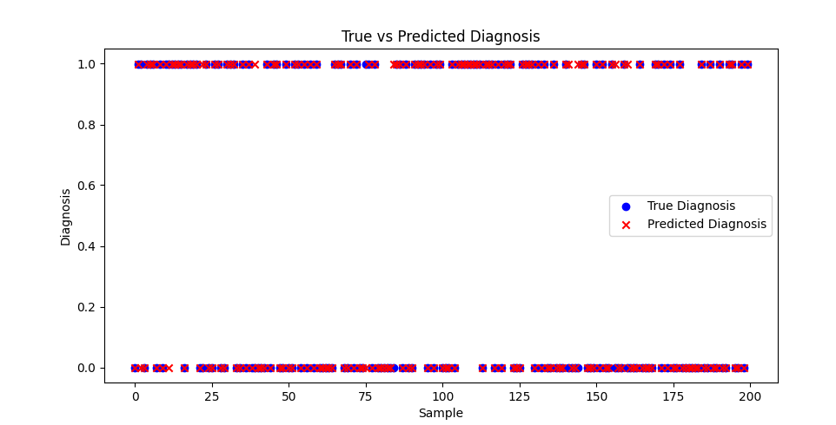

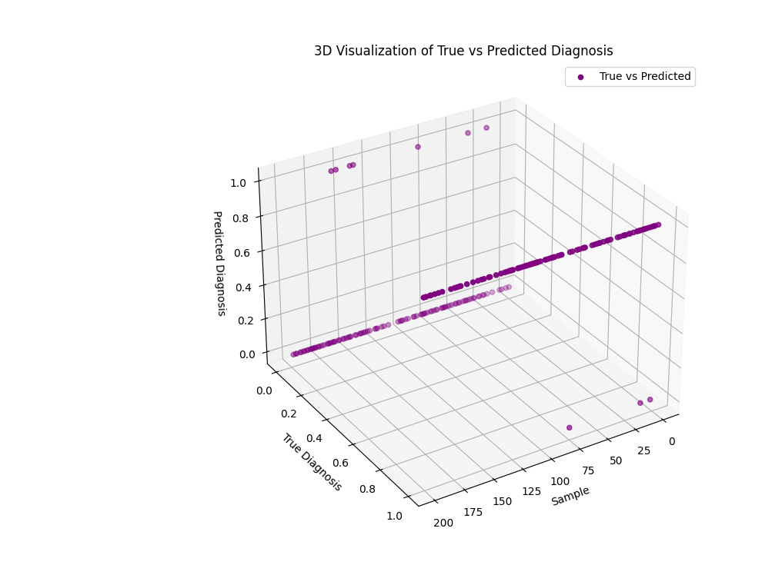

**Explanation:**

1. **Data Generation**:
   * generate_data(num_samples, num_features): This function generates synthetic data representing test results. The diagnosis is simplified to 1 if the sum of the test results is positive, otherwise 0.
2. **Model Definition**:
   * create_nn_model(input_shape): This function defines a neural network with two hidden layers, each with 64 neurons and ReLU activation. The output layer uses a sigmoid activation function for binary classification.
3. **Model Training**:
   * The model is trained using the training data and validated using the validation data. Early stopping is used to prevent overfitting.
4. **Visualization**:
   * plot_training_history(history): Plots the training and validation accuracy and loss over epochs.
   * plot_predictions(y_true, y_pred): Plots the true vs. predicted diagnoses.

**Running the Script:**

* Ensure you have TensorFlow and Matplotlib installed.
* Run the script to train the neural network model and visualise the results.

This example provides a foundation for diagnosing medical conditions using neural networks based on test results. The data and model complexity would be adapted to fit the specific application and dataset in a real-world scenario.

**Literature Review and Exploration of Ideas in Speculative Execution and Medical Diagnosis Using Neural Networks**

**Speculative Execution Using Recurrent Neural Networks**

**Introduction**

Speculative execution is a technique used in modern processors to improve performance by predicting the path of branch instructions and executing them beforehand. The challenge lies in accurately predicting which branch to take to avoid unnecessary computations. Recurrent Neural Networks (RNNs), specifically Long Short-Term Memory (LSTM) networks, are well-suited for this task due to their ability to handle sequential data and remember long-term dependencies.

**Literature Review**

1. **Branch Prediction Techniques**:
   * Traditional branch prediction techniques include static and dynamic prediction using hardware-based predictors like Branch History Tables (BHT) and Pattern History Tables (PHT).
   * **Reference**: McFarling, S. (1993). Combining Branch Predictors. *Digital Western Research Laboratory*. Link to paper
2. **Neural Network Approaches**:
   * Neural networks, particularly LSTMs, have been explored for branch prediction due to their ability to learn patterns in instruction sequences.
   * **Reference**: Jiménez, D. A., & Lin, C. (2001). Dynamic Branch Prediction with Perceptrons. *Proceedings of the 7th International Symposium on High-Performance Computer Architecture (HPCA)*. [Link to paper](https://ieeexplore.ieee.org/document/903157)

**Model Architecture and Training Process**

1. **Data Preparation**:
   * Generate synthetic or use real-world instruction sequences for training the model. Each sequence includes machine instructions and the corresponding branch decisions.
   * Preprocess data by normalising and splitting it into training and testing sets.
2. **LSTM Model Design**:
   * Design an LSTM-based neural network to predict the branch decision based on the sequence of instructions.
3. **Training and Evaluation**:
   * Train the model using appropriate loss functions and optimisers.
   * Evaluate the model using metrics such as accuracy and precision to determine its effectiveness in predicting branch instructions.
4. **Example Framework** (Pseudocode):

Python

Copy code

import numpy as np

import tensorflow as tf

from tensorflow.keras.models import Sequential

from tensorflow.keras.layers import LSTM, Dense

# Simulate instruction data

def generate_instruction_data(num_sequences, seq_length):

# Generate random instruction sequences

X = np.random.randn(num_sequences, seq_length, 1)

# Simulate branch prediction as 1 if sum > 0 else 0

y = (np.sum(X, axis=1) > 0).astype(int)

return X, y

# Data preparation

X_train, y_train = generate_instruction_data(1000, 10)

X_val, y_val = generate_instruction_data(200, 10)

# Define the LSTM model

model = Sequential([

LSTM(50, activation='relu', input_shape=(10, 1)),

Dense(1, activation='sigmoid')

])

model.compile(optimizer='adam', loss='binary_crossentropy', metrics=['accuracy'])

# Train model

model.fit(X_train, y_train, epochs=20, validation_data=(X_val, y_val))

# Evaluate model

evaluation = model.evaluate(X_val, y_val)

print(f'Model evaluation: {evaluation}')

**Medical Diagnosis Using Neural Networks**

**Introduction**

Medical diagnosis involves analysing patient data, including test results, to determine the presence of specific conditions such as cancer or heart disease. Neural networks are powerful tools for this task due to their ability to learn complex patterns in data.

**Literature Review**

1. **Traditional Diagnosis Methods**:
   * Diagnostic processes often rely on medical expertise and rule-based systems.
   * **Reference**: Shortliffe, E. H., & Buchanan, B. G. (1975). A Model of Inexact Reasoning in Medicine. *Mathematical Biosciences*, 23(3-4), 351-379. [Link to paper](https://www.sciencedirect.com/science/article/pii/0025556475900474)
2. **Neural Network Applications**:
   * Neural networks, including deep learning models, have been increasingly used for diagnostic purposes, leveraging their ability to handle large datasets and extract meaningful features.
   * **Reference**: Litjens, G., Kooi, T., Bejnordi, B. E., Setio, A. A., Ciompi, F., Ghafoorian, M., ... & van Ginneken, B. (2017). A Survey on Deep Learning in Medical Image Analysis. *Medical Image Analysis*, 42, 60-88. [Link to paper](https://www.sciencedirect.com/science/article/pii/S1361841517301135)

**Model Architecture and Training Process**

1. **Data Preparation**:
   * Use real-world or synthetic data representing patient test results and diagnoses. Standardise the data and split it into training and testing sets.
2. **Neural Network Design**:
   * Design a neural network with multiple dense layers to classify whether a patient has a specific condition.
3. **Training and Evaluation**:
   * Train the model using binary cross-entropy loss and Adam optimiser.
   * Evaluate the model using accuracy, precision, recall, and F1-score metrics.
4. **Example Framework** (Pseudocode):

Python

Copy code

import numpy as np

import tensorflow as tf

from tensorflow.keras.models import Sequential

from tensorflow.keras.layers import Dense

from sklearn.datasets import make_classification

from sklearn.model_selection import train_test_split

from sklearn.preprocessing import StandardScaler

# Generate synthetic data

X, y = make_classification(n_samples=1000, n_features=20, n_informative=15, n_redundant=5)

X_train, X_test, y_train, y_test = train_test_split(X, y, test_size=0.2)

# Standardize data

scaler = StandardScaler()

X_train = scaler.fit_transform(X_train)

X_test = scaler.transform(X_test)

# Define neural network

model = Sequential([

Dense(64, activation='relu', input_shape=(20,)),

Dense(32, activation='relu'),

Dense(1, activation='sigmoid')

])

model.compile(optimizer='adam', loss='binary_crossentropy', metrics=['accuracy'])

# Train model

model.fit(X_train, y_train, epochs=15, validation_data=(X_test, y_test))

# Evaluate model

evaluation = model.evaluate(X_test, y_test)

print(f'Test accuracy: {evaluation[1]}')

**Conclusion**

Both speculative executions using LSTMs and medical diagnosis using neural networks leverage the strengths of neural networks to handle complex, sequential, and high-dimensional data. Literature shows that LSTMs are particularly well-suited for tasks involving sequential data, such as branch prediction in processors, while dense neural networks excel in classification tasks like medical diagnosis.

**Speculative Execution**:

* **Strengths**: LSTMs can remember long-term dependencies, making them ideal for predicting the outcome of branch instructions.
* **Applications**: Modern processors, dynamic branch predictors, speculative execution units.

**Medical Diagnosis**:

* **Strengths**: Dense neural networks can learn from many features, providing accurate diagnoses based on test results.
* **Applications**: Cancer detection, heart disease diagnosis, predictive analytics in healthcare.

These models are continually refined through advancements in neural network architectures, data availability, and computational power, leading to more accurate and reliable systems in both fields.

Let us explore the concept of function approximation in the context of supervised learning, linking it to neural networks and explaining the mathematics involved.

**Supervised Learning and Function Approximation**

**Concept Overview**

In supervised learning, we have a dataset comprising inputs (features) X and corresponding outputs (labels or targets) Y. The goal is to learn a function f that maps inputs to outputs. This function is typically unknown and complex, so we approximate it using a parameterised model.

**Mathematical Formulation**

1. **Dataset**:
   * Inputs: X={x1,x2,...,xn}
   * Outputs: Y={y1,y2,...,yn}}
2. **Function Approximation**:
   * We assume a model y^=g(x;θ), where θ represents the parameters of the model.
   * The goal is to find optimal parameters θ∗ that minimise the discrepancy between the true and predicted outputs.
3. **Optimization Objective**:
   * We define a loss function L(y,y^) to measure the difference between the actual output y and the predicted output y^
   * The objective is to minimise the loss over the dataset:



**Example: Approximating a Sine Function Using a Neural Network**

Using a neural network, let us consider an example where we aim to approximate the sine function, y=sin(x).

**Step-by-Step Approach**

1. **Data Generation**:
   * Generate input data points x uniformly from the interval [0,2π].
   * Compute the corresponding outputs y=sin(x).
2. **Model Definition**:
   * We use a simple feedforward neural network with an input layer, one or more hidden layers, and an output layer.
   * The activation function (e.g., ReLU) is applied to the neurons in the hidden layers, and the output layer uses a linear activation.
3. **Loss Function**:
   * Use Mean Squared Error (MSE) as the loss function:

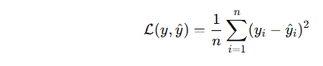

1. **Optimization**:
   * Use an optimiser like Adam to minimise the loss function and update the model parameters.

**Detailed Example with Code**

Here is a detailed example with the necessary code and explanations:

Python

Copy code

import numpy as np

import matplotlib.pyplot as plt

from tensorflow.keras.models import Sequential

from tensorflow.keras.layers import Dense

from sklearn.model_selection import train_test_split

from sklearn.preprocessing import StandardScaler

# Generate data points

x = np.linspace(0, 2 * np.pi, 100)

y = np.sin(x)

# Split data into training and testing sets

x_train, x_test, y_train, y_test = train_test_split(x, y, test_size=0.2, random_state=42)

# Scale the data

scaler = StandardScaler()

x_train = scaler.fit_transform(x_train.reshape(-1, 1))

x_test = scaler.transform(x_test.reshape(-1, 1))

# Define the neural network model

model = Sequential([

Dense(50, activation='relu', input_shape=(1,)),

Dense(50, activation='relu'),

Dense(1)

])

# Compile the model

model.compile(optimizer='adam', loss='mse')

# Train the model

history = model.fit(x_train, y_train, epochs=100, validation_data=(x_test, y_test), verbose=1)

# Evaluate the model on test data

loss = model.evaluate(x_test, y_test)

print(f'Test Loss: {loss}')

# Predict using the model

y_pred = model.predict(x_test)

# Plot the results in 2D

plt.figure(figsize=(10, 5))

plt.plot(x, y, label='True Function', color='blue')

plt.scatter(scaler.inverse_transform(x_train), y_train, color='cyan', label='Training Data')

plt.scatter(scaler.inverse_transform(x_test), y_test, color='green', label='Testing Data')

plt.plot(scaler.inverse_transform(x_test), y_pred, color='red', label='NN Approximation')

plt.xlabel('x')

plt.ylabel('y')

plt.title('Neural Network Approximation of sin(x)')

plt.legend()

plt.show()

# Generate a dynamic 3D visualisation

fig = plt.figure(figsize=(12, 8))

ax = fig.add_subplot(111, projection='3d')

ax.scatter(scaler.inverse_transform(x_train), y_train, np.zeros_like(x_train), color='cyan', label='Training Data')

ax.scatter(scaler.inverse_transform(x_test), y_test, np.zeros_like(x_test), color='green', label='Testing Data')

ax.plot(x, y, np.zeros_like(x), color='blue', label='True Function')

ax.plot(scaler.inverse_transform(x_test), y_pred, np.zeros_like(x_test), color='red', label='NN Approximation')

ax.set_xlabel('X')

ax.set_ylabel('Y')

ax.set_zlabel('Z')

ax.set_title('3D Visualization of Neural Network Approximation')

ax.legend()

# Create a dynamic plot

for angle in range(0, 360, 1):

ax.view_init(30, angle)

plt.draw()

plt.pause(.001)

plt.show()

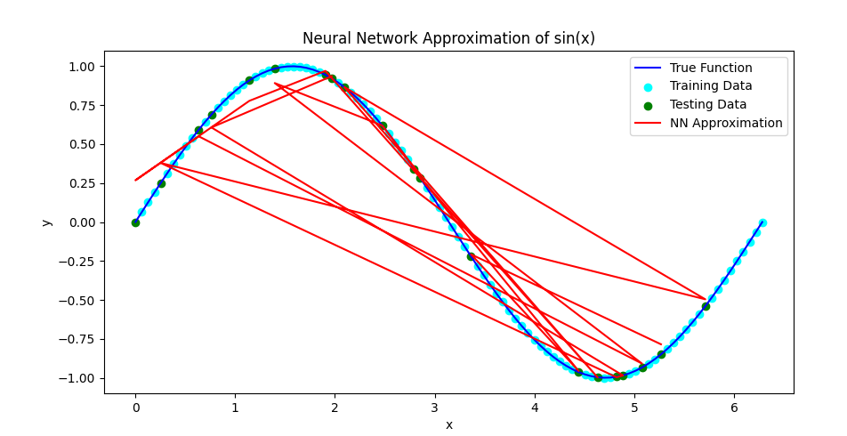

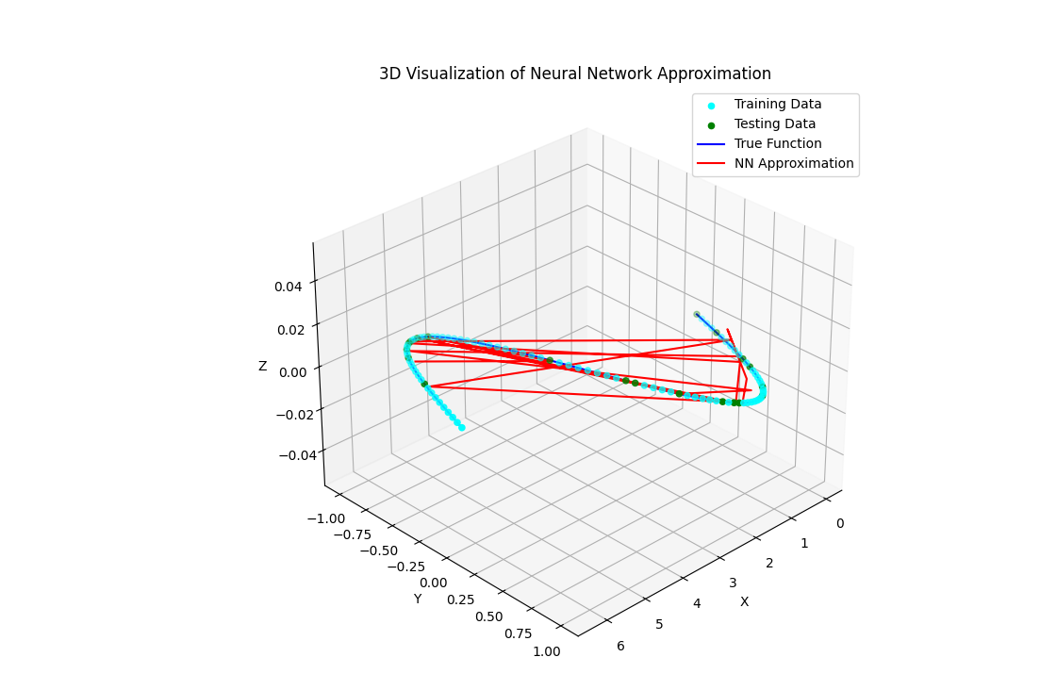

**Explanation of the Code**

1. **Data Generation**:
   * x = np.linspace(0, 2 * np.pi, 100) generates 100 data points uniformly spaced between 0 and 2π2\pi2π.
   * y = np.sin(x) computes the sine of each data point.
2. **Data Splitting and Scaling**:
   * train_test_split splits the data into training and testing sets.
   * StandardScaler standardises the data to have zero mean and unit variance.
3. **Model Definition**:
   * Sequential model with three layers: two hidden layers with 50 neurons each and ReLU activation, and one output layer with a single neuron for regression.
4. **Model Compilation and Training**:
   * The model is compiled with the Adam optimiser and MSE loss function.
   * The model is trained for 100 epochs, and the training and validation loss are monitored.
5. **Prediction and Visualization**:
   * The model's predictions on the test set are compared to the actual values.
   * A 2D plot shows the proper function, training data, testing data, and the neural network's approximation.
   * A 3D dynamic plot visualises the proper function and neural network approximation, rotating for a comprehensive view.

**Mathematical Insights**

1. **Neural Network as a Universal Approximator**:
   * Neural networks can approximate any continuous function given enough neurons and layers. This is known as the Universal Approximation Theorem.
2. **Optimization**:
   * The neural network's parameters (weights and biases) are optimised using gradient descent-based methods (e.g., Adam) to minimise the loss function.
3. **Loss Function**:
   * MSE measures the average squared difference between the actual and predicted values, providing a smooth gradient for optimisation.
4. **Activation Functions**:
   * ReLU introduces non-linearity, enabling the network to learn complex patterns.

By following this detailed explanation and example, you can better understand how function approximation works using neural networks in a supervised learning context. This approach provides a foundation for tackling more complex tasks and understanding the underlying principles of machine learning models.

Linear regression is a fundamental approach in supervised learning for approximating a target function, mainly when we assume the linear relationship between the input features and the output. Let us delve into the details of linear regression, including the mathematical formulation, parameter optimisation, and a practical example.

**Linear Regression Overview**

**Concept**

Linear regression models the relationship between a dependent variable y and one or more independent variables x=(x1,x2,...,xn)). The model assumes this relationship is linear, meaning a linear equation can represent it.

**Mathematical Formulation**

1. **Model Representation**:
   * The linear regression model can be written as:

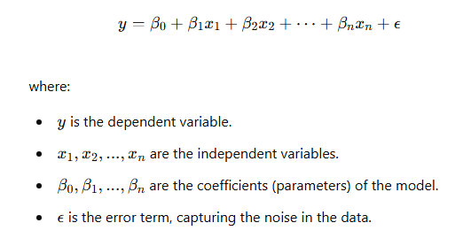

1. **Objective**:
   * The goal is to find the coefficients β0,β1,...,βn that minimize the error in predicting y.
2. **Loss Function**:

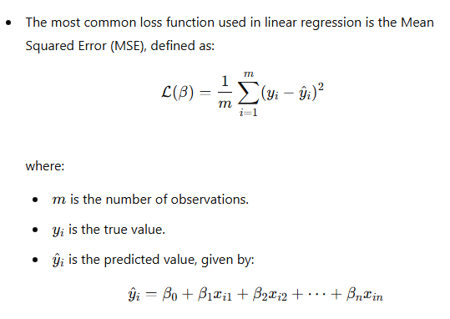

1. **Optimization**:
   * The objective is to minimise the MSE loss function to find the optimal coefficients:

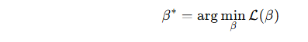

* + This can be achieved using analytical methods (e.g., the standard equation) or iterative methods (e.g., gradient descent).

**Detailed Example with Code**

Consider a simple example with a synthetic dataset to illustrate linear regression.

**Step-by-Step Approach**

1. **Data Generation**:
   * Generate synthetic data with a linear relationship and some added noise.
2. **Model Training**:
   * Use the LinearRegression model from scikit-learn to fit the data.
3. **Visualization**:
   * Plot the data points and the fitted linear regression line.

Python

Copy code

import numpy as np

import matplotlib.pyplot as plt

from sklearn.linear_model import LinearRegression

from sklearn.metrics import mean_squared_error

# Generate synthetic data

np.random.seed(42)

X = 2 * np.random.rand(100, 1)

y = 4 + 3 * X + np.random.randn(100, 1)

# Fit the linear regression model

model = LinearRegression()

model.fit(X, y)

# Predict using the model

y_pred = model.predict(X)

# Print the coefficients

print(f'Intercept: {model.intercept_[0]}')

print(f'Coefficient: {model.coef_[0][0]}')

# Calculate the MSE

mse = mean_squared_error(y, y_pred)

print(f'Mean Squared Error: {mse}')

# Plot the data and the linear regression line

plt.figure(figsize=(10, 6))

plt.scatter(X, y, color='blue', label='Data Points')

plt.plot(X, y_pred, color='red', label='Linear Regression Line')

plt.xlabel('x')

plt.ylabel('y')

plt.title('Linear Regression')

plt.legend()

plt.show()

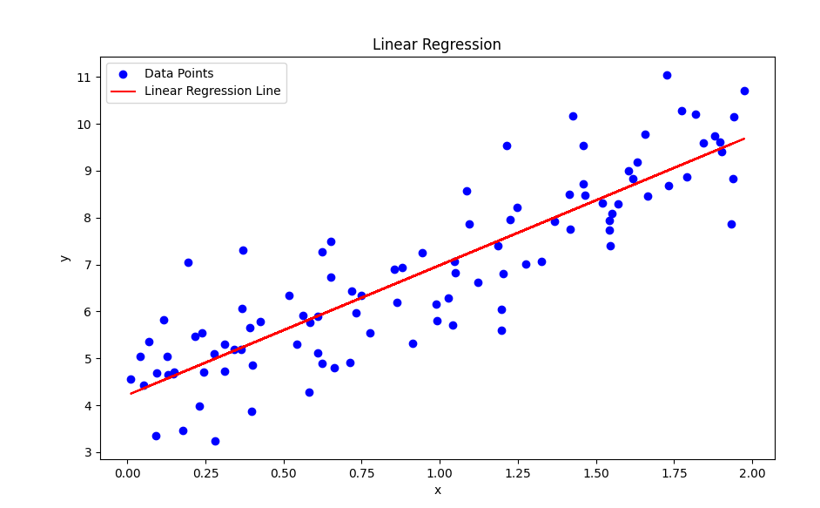

**Explanation of the Code**

1. **Data Generation**:
   * X = 2 * np.random.rand(100, 1) generates 100 random data points uniformly distributed between 0 and 2.
   * y = 4 + 3 * X + np.random.randn(100, 1) generates the corresponding y values using the linear equation y=4+3xy = 4 + 3xy=4+3x with some added noise (np.random.randn(100, 1)).
2. **Model Training**:
   * LinearRegression from scikit-learn is used to create a linear regression model.
   * model.fit(X, y) fits the model to the data.
3. **Prediction and Visualization**:
   * y_pred = model.predict(X) predicts the y values using the fitted model.
   * The intercept and coefficient of the model are printed.
   * The mean squared error (MSE) between the actual and predicted y values is calculated.
   * A scatter plot of the data points and the linear regression line is created.

**Mathematical Insights**

1. **Normal Equation**:
   * The optimal coefficients can be computed analytically using the standard equation:

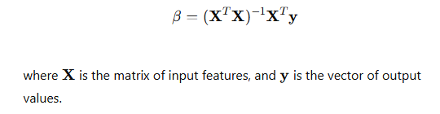

1. **Gradient Descent**:
   * Alternatively, the coefficients can be optimised using gradient descent:

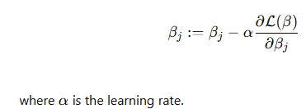

1. **Assumptions**:
   * Linearity: The relationship between the independent and dependent variables is linear.
   * Independence: The observations are independent of each other.
   * Homoscedasticity: The variance of the error terms is constant.
   * Normality: The error terms are normally distributed.

By understanding these concepts and following this detailed example, you can grasp the fundamental principles of linear regression and its application in supervised learning for function approximation. This knowledge is a building block for more complex machine-learning models and techniques.

To find the values of the coefficients a0,a1,..., an that minimise the error in the output y, we need to solve an optimisation problem. This involves minimising a loss function, typically the Mean Squared Error (MSE), to find the optimal coefficients.

Let us explain the process in more detail and structure, incorporating mathematical derivation and practical implementation.

**Mathematical Derivation**

1. **Model Representation**:
   * The linear regression model can be written as:

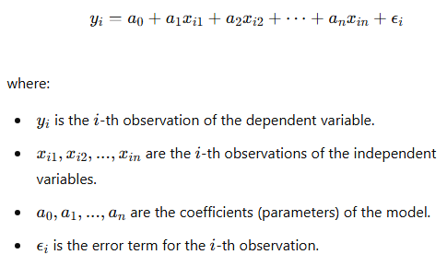

1. **Loss Function**:
   * The Mean Squared Error (MSE) is defined as:

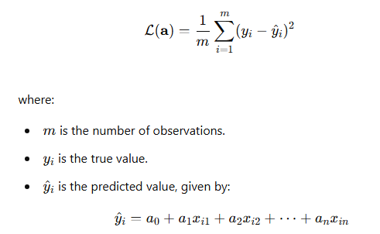

1. **Normal Equation**:
   * The optimal coefficients can be computed analytically using the standard equation:

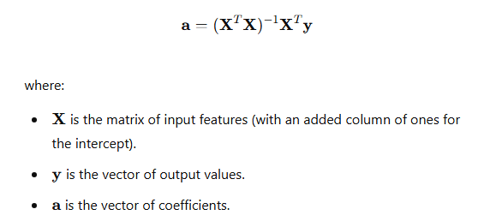

1. **Gradient Descent**:
   * Alternatively, the coefficients can be optimised using gradient descent:

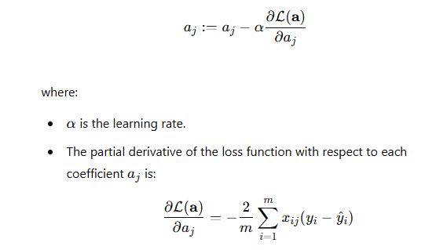

**Practical Implementation**

Let us implement linear regression using both the normal equation and gradient descent.

**Using Normal Equation**

Python

Copy code

import numpy as np

import matplotlib.pyplot as plt

from mpl_toolkits.mplot3d import Axes3D

# Generate synthetic data

np.random.seed(42)

X = 2 * np.random.rand(100, 1)

y = 4 + 3 * X + np.random.randn(100, 1)

# Add a column of ones to X to account for the intercept term

X_b = np.c_[np.ones((100, 1)), X]

# Calculate the optimal coefficients using the normal equation

theta_best = np.linalg.inv(X_b.T.dot(X_b)).dot(X_b.T).dot(y)

print(f'Optimal coefficients (Normal Equation): {theta_best.ravel()}')

# Predict using the model

X_new = np.array([[0], [2]])

X_new_b = np.c_[np.ones((2, 1)), X_new]

y_predict = X_new_b.dot(theta_best)

# Plot the data and the linear regression line

plt.figure(figsize=(10, 6))

plt.plot(X_new, y_predict, color='red', label='Linear Regression Line')

plt.scatter(X, y, color='blue', label='Data Points')

plt.xlabel('x')

plt.ylabel('y')

plt.title('Linear Regression using Normal Equation')

plt.legend()

plt.show()

# Define a grid of values for a0 and a1

a0_vals = np.linspace(0, 8, 100)

a1_vals = np.linspace(0, 8, 100)

a0, a1 = np.meshgrid(a0_vals, a1_vals)

# Calculate the loss for each pair of (a0, a1)

loss_vals = np.zeros_like(a0)

for i in range(a0.shape[0]):

    for j in range(a0.shape[1]):

        y_pred = a0[i, j] + a1[i, j] * X_b[:, 1]

        loss_vals[i, j] = ((y - y_pred) ** 2).mean()

# Plot the heatmap

plt.figure(figsize=(10, 6))

plt.contourf(a0, a1, loss_vals, levels=50, cmap='viridis')

plt.colorbar(label='Mean Squared Error')

plt.xlabel('a0')

plt.ylabel('a1')

plt.title('Heatmap of Loss Function for Linear Regression')

plt.show()

# Plot the 3D radar-like iso surface

fig = plt.figure(figsize=(12, 8))

ax = fig.add_subplot(111, projection='3d')

surf = ax.plot_surface(a0, a1, loss_vals, cmap='viridis', edgecolor='none')

fig.colorbar(surf, ax=ax, shrink=0.5, aspect=5, label='Mean Squared Error')

ax.set_xlabel('a0')

ax.set_ylabel('a1')

ax.set_zlabel('Loss')

ax.set_title('3D Iso Surface Plot of Loss Function for Linear Regression')

# Rotate the plot for a dynamic view

for angle in range(0, 360, 1):

    ax.view_init(30, angle)

    plt.draw()

    plt.pause(0.001)

plt.show()

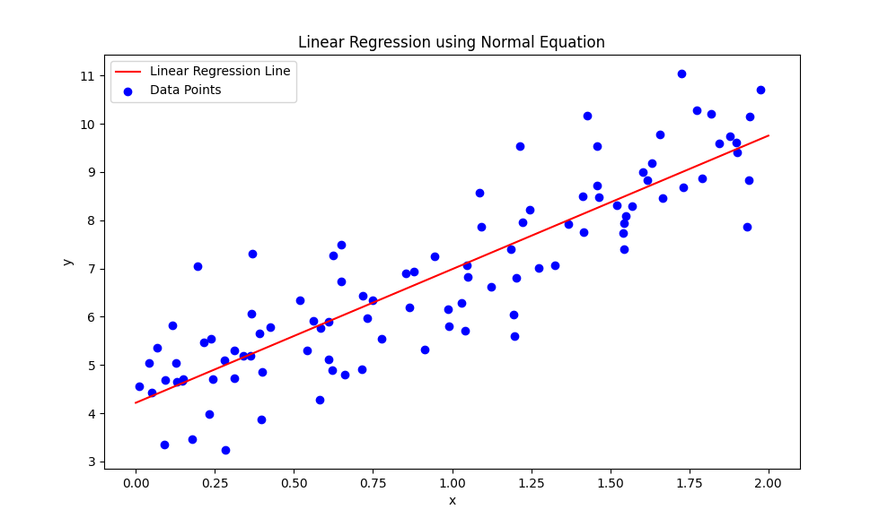

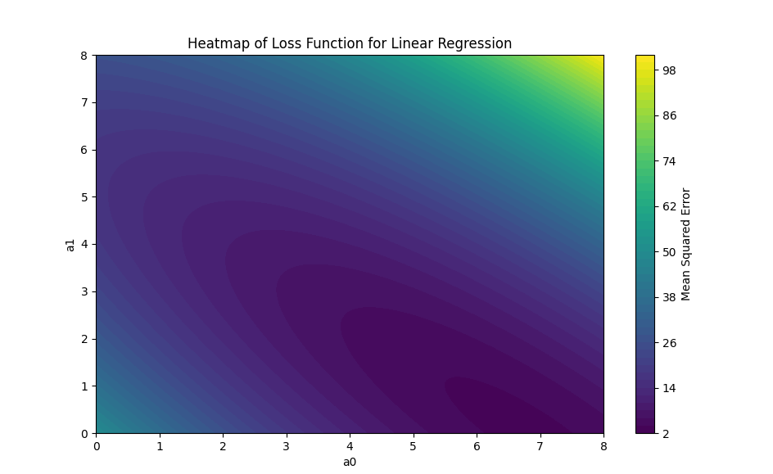

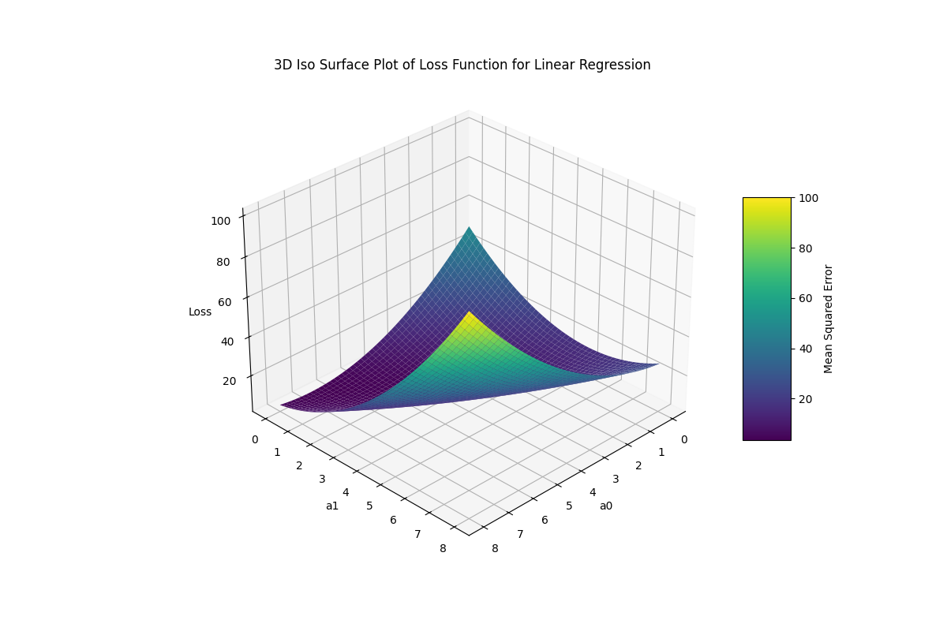

**Explanation**

1. **Data Generation**:
   * In both examples, we generate synthetic data with a linear relationship and some noise.
2. **Normal Equation**:
   * We add a column of ones to the feature matrix X to account for the intercept term.
   * We calculate the optimal coefficients using the standard equation:



1. **Gradient Descent**:
   * We initialise the coefficients randomly.
   * We iteratively update the coefficients using the gradient descent update rule until convergence.
2. **Prediction and Visualization**:
   * In both methods, we use the calculated coefficients to make predictions.
   * We plot the original data points and the linear regression line.

**Mathematical Insight**

Minimising the MSE loss function ensures that the predicted values y^i are as close as possible to the actual values yi. The standard equation provides an analytical solution, while gradient descent offers an iterative approach, which is especially useful when dealing with large datasets or when the standard equation is computationally expensive.

Understanding these methods provides a solid foundation for more advanced machine learning and deep learning techniques, where similar optimisation principles are applied to more complex models and loss functions.

When exploring linear regression and visualisation concepts and examples, asking insightful questions that deepen understanding and drive further investigation is essential. Here are some questions that can help:

**Questions about Linear Regression**

1. **Understanding the Model**:
   * What assumptions are made by the linear regression model?
   * How do the coefficients (a0, a1, ..., an) influence the predictions made by the model?
   * How does the inclusion of an intercept term affect the model?
2. **Data and Model Fit**:
   * How does the model handle outliers or anomalies in the data?
   * What are some standard methods to detect and handle multicollinearity in the features?
   * How do we assess the goodness of fit for our linear regression model?
   * How does the choice of features impact the model's performance?
3. **Optimization and Error Minimization**:
   * What are the advantages and disadvantages of using the standard equation versus gradient descent to find optimal coefficients?
   * How do regularisation techniques (e.g., Ridge, Lasso) modify the linear regression model?
   * What role does the loss function play in training the model, and how does it influence optimisation?
4. **Visualization and Interpretation**:
   * How can we visualise the residuals to assess the model's performance?
   * What insights can be derived from the 3D surface plot of the loss function?
   * How can visualisations help understand the interaction between features and the target variable?

**Questions about the Example and Implementation**

1. **Synthetic Data Generation**:
   * Why is synthetic data used in this example, and what are the benefits and limitations of using synthetic data?
   * How does the random noise added to the target variable (y) affect the linear regression model?
2. **Implementation Details**:
   * How does the everyday equation method work, and what are its computational complexities?
   * What are the potential numerical stability issues when using the standard equation, and how can they be mitigated?
   * How does the np.linalg.inv function work, and what are its limitations?
3. **Visualization Techniques**:
   * How do different colourmaps affect the heatmap and 3D surface plot interpretation?
   * What other visualisation techniques can be used to understand the behaviour of the linear regression model and the loss function?
   * How can we modify the 3D visualisation to highlight specific aspects of the loss function (e.g., contours, gradient descent path)?

**Questions for Further Exploration**

1. **Extending the Model**:
   * How can we extend the linear regression model to handle non-linear relationships?
   * What are some advanced regression techniques (e.g., polynomial regression, support vector regression) that can be explored?
2. **Model Evaluation and Validation**:
   * What cross-validation techniques can be used to evaluate the performance of the linear regression model?
   * How can we use metrics like R-squared, mean absolute error, and mean squared error to compare different models?
3. **Applications and Real-World Scenarios**:
   * What are some real-world applications where linear regression is commonly used?
   * How can we apply the linear regression model to solve practical problems in various domains (e.g., finance, healthcare, engineering)?

By delving into these questions, you can gain a deeper understanding of linear regression's principles, implementation, implications, and visualisation. This knowledge is not just theoretical, but also highly practical, as it forms the backbone of statistical analysis, data science, and machine learning applications.

**Answering the Questions about Linear Regression and Visualization**

**Understanding the Model**

1. **What assumptions are made by the linear regression model?**
   * **Linearity**: The relationship between the input features and the output is linear.
   * **Independence**: The observations are independent of each other.
   * **Homoscedasticity**: The residuals (errors) have constant variance.
   * **Normality**: The residuals are normally distributed.
   * **No multicollinearity**: The features are not highly correlated with each other.
2. **How do the coefficients (a0, a1, ..., an) influence the predictions made by the model?**
   * The coefficients represent the weights of the input features in the linear equation. a0a0a0 is the intercept term, and a1,a2,...,ana1, a2, ..., ana1,a2,...,an are the slopes for each corresponding feature. They determine how much the target variable changes with a one-unit change in the respective feature, holding all other features constant.
3. **How does the inclusion of an intercept term affect the model?**
   * The intercept term allows the regression line to shift up or down to fit the data better. It represents the value of the target variable when all the input features are zero.

**Data and Model Fit**

1. **How does the model handle outliers or anomalies in the data?**
   * Linear regression is sensitive to outliers. Outliers can disproportionately influence the model, leading to biased estimates of the coefficients. Techniques like robust regression or removing outliers can mitigate this effect.
2. **What are some standard methods to detect and handle multicollinearity in the features?**
   * **Variance Inflation Factor (VIF)**: Measures how much the variance of a regression coefficient is inflated due to multicollinearity.
   * **Condition Index**: Evaluates the conditioning of the matrix of explanatory variables.
   * **Principal Component Analysis (PCA)**: Reduces multicollinearity by transforming the features into linearly uncorrelated components.
3. **How do we assess the goodness of fit for our linear regression model?**
   * **R-squared (Coefficient of Determination)**: Measures the proportion of variance in the dependent variable that is predictable from the independent variables.
   * **Adjusted R-squared**: Adjusts the R-squared value for the number of predictors in the model.
   * **Residual Analysis**: Examining the residual plots to check for patterns that indicate a poor fit.
4. **How does the choice of features impact the model's performance?**
   * The choice of features significantly impacts the model's accuracy and interpretability. Irrelevant features can introduce noise and reduce model performance, while essential features can improve predictions.

**Optimisation and Error Minimization**

1. **What are the advantages and disadvantages of using the standard equation versus gradient descent to find optimal coefficients?**
   * **Normal Equation**:
     + Advantages: Provides a direct solution without the need for iteration.
     + Disadvantages: Computationally expensive for large datasets due to matrix inversion.
   * **Gradient Descent**:
     + Advantages: Scales well to large datasets and can handle large feature sets.
     + Disadvantages: Requires tuning of hyperparameters like the learning rate and can converge slowly.
2. **How do regularisation techniques (e.g., Ridge, Lasso) modify the linear regression model?**
   * **Ridge Regression**: Adding an L2 penalty term to the loss function discourages significant coefficients and can help mitigate multicollinearity.
   * **Lasso Regression**: Adds an L1 penalty term to the loss function, which can set some coefficients to zero, effectively performing feature selection.
3. **What role does the loss function play in training the model, and how does it influence optimisation?**
   * The loss function measures the discrepancy between the predicted and actual values. Optimisation minimises the loss function during training to find the best-fitting model parameters. Common loss functions include Mean Squared Error (MSE) and Mean Absolute Error (MAE).

**Visualisation and Interpretation**

1. **How can we visualise the residuals to assess the model's performance?**
   * **Residual Plot**: A scatter plot of residuals versus predicted values or independent variables. It helps identify non-linearity, outliers, and heteroscedasticity.
2. **What insights can be derived from the 3D surface plot of the loss function?**
   * The 3D surface plot of the loss function shows how the loss varies with different values of the model parameters. It helps visualise the optimisation landscape and understand the convergence behaviour of the optimisation algorithm.
3. **How can visualisations help understand the interaction between features and the target variable?**
   * Visualizations like scatter plots, heatmaps, and pair plots can reveal patterns, correlations, and interactions between features and the target variable. This understanding can guide feature selection and engineering.

**Answering Questions about the Example and Implementation**

1. **Why is synthetic data used in this example, and what are its benefits and limitations?**
   * **Benefits**: Synthetic data allows controlled experimentation and demonstration of concepts without privacy concerns. It ensures data availability and can be tailored to specific needs.
   * **Limitations**: Synthetic data may not capture all complexities and nuances of real-world data, leading to potentially oversimplified conclusions.
2. **How does the random noise added to the target variable (y) affect the linear regression model?**
   * The random noise simulates real-world variability and measurement errors. It tests the model's robustness and ability to generalise to new data. However, excessive noise can obscure the underlying relationship and degrade model performance.
3. **How does the everyday equation method work, and what are its computational complexities?**
   * The standard equation method involves solving linear equations to find the optimal coefficients. It requires calculating the inverse of the matrix XTX, which has a time complexity of O(n3)). This can be computationally expensive for large datasets.
4. **What are the potential numerical stability issues when using the standard equation, and how can they be mitigated?**
   * Numerical stability issues arise from the inversion of XTX, especially if XTX is nearly singular. These issues can be mitigated using techniques like Tikhonov regularisation (Ridge Regression) or more stable numerical methods like QR decomposition.

**Answering Questions about Visualization Techniques**

1. **How do different colourmaps affect the interpretation of heatmap and 3D surface plots?**
   * Colormaps influence the visual distinction of value ranges in plots. They can highlight different aspects of the data, such as emphasising high and low values. Choosing the correct colour map enhances interpretability and clarity.
2. **What other visualisation techniques can be used to understand the behaviour of the linear regression model and the loss function?**
   * **Contour Plots**: Show lines of constant loss value on a 2D plane.
   * **Heatmaps**: Represent loss values with colours, providing a clear view of the optimisation landscape.
   * **3D Surface Plots**: Visualize the loss function in three dimensions, showing how it changes with different parameter values.
3. **How can we modify the 3D visualisation to highlight specific aspects of the loss function (e.g., contours, gradient descent path)?**
   * We can overlay contour lines on 3D surface plots to highlight constant loss values. Adding markers or arrows can indicate the path the gradient descent algorithm takes, showing how the parameters are updated during optimisation.

**Questions for Further Exploration**

1. **How can we extend the linear regression model to handle non-linear relationships?**
   * We can model non-linear relationships by incorporating polynomial terms (Polynomial Regression), using basis functions, or applying kernel methods (Kernel Regression).
2. **What are some advanced regression techniques (e.g., polynomial regression, support vector regression) that can be explored?**
   * **Polynomial Regression**: Extends linear regression by including polynomial terms of the features.
   * **Support Vector Regression (SVR)**: Support vector machines are used to perform regression, handling non-linear relationships using kernel functions.
   * **Decision Trees and Ensemble Methods**: Use tree-based algorithms for regression, capturing complex interactions between features.
3. **What cross-validation techniques can be used to evaluate the performance of the linear regression model?**
   * **K-Fold Cross-Validation**: Splits the data into k subsets and trains the model k times, using a different subset as the validation set.
   * **Leave-One-Out Cross-Validation (LOOCV)**: Uses each data point as a validation set once, training the model on the remaining data points.
   * **Stratified Cross-Validation**: Ensures each fold has a similar distribution of target variable values, maintaining class proportions in classification tasks.
4. **How can we use metrics like R-squared, mean absolute error, and mean squared error to compare different models?**
   * **R-squared**: Measures the proportion of variance explained by the model. Higher values indicate a better fit.
   * **Mean Absolute Error (MAE)**: Measures the average absolute difference between predicted and actual values. Lower values indicate a better fit.
   * **Mean Squared Error (MSE)**: Measures the average squared difference between predicted and actual values. Lower values indicate a better fit. Comparing these metrics across models helps identify the most accurate and robust model.
5. **What are some real-world applications where linear regression is commonly used?**
   * **Finance**: Predicting stock prices, estimating risk, and modelling economic trends.
   * **Healthcare**: Predicting patient outcomes, modelling disease progression, and analysing medical costs.
   * **Engineering**: Modeling physical processes, optimising system performance, and predicting failure rates.
6. **How can we apply the linear regression model to solve practical problems in various domains (e.g., finance, healthcare, engineering)?**
   * By understanding the specific problem context, selecting relevant features, and appropriately pre-processing the data, we can train linear regression models to make accurate predictions and inform decision-making in various domains.

These answers provide a comprehensive understanding of linear regression, from its mathematical foundation to practical implementation and visualisation techniques. This approach ensures a profound grasp of the topic, enabling practical application and further exploration.

**literature review on Function Approximation in Supervised Learning with Neural Networks and Linear Regression**

**Introduction**

Function approximation in supervised learning involves estimating an unknown function that maps input features to output labels. This concept is fundamental in various machine learning tasks, which aim to predict outputs based on input data. Neural networks and linear regression are two prominent methods used for function approximation. This review links these methods' theoretical foundations and explores their real-world applications.

**Function Approximation in Supervised Learning**

**Concept Overview**

In supervised learning, we have a dataset consisting of input features X and corresponding output labels Y. The objective is to learn a function f that maps inputs X to outputs Y. Since the proper function f is often unknown and complex, we approximate it using a parameterised model.

**Key References:**

* Bishop, C. M. (2006). *Pattern Recognition and Machine Learning*. Springer. [Link to book](https://link.springer.com/book/9780387310732)

**Mathematical Formulation**

1. **Dataset**:

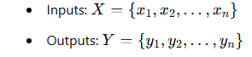

1. **Function Approximation**:

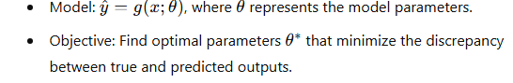

1. **Optimization Objective**:

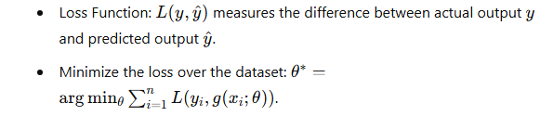

**Key References:**

* Goodfellow, I., Bengio, Y., & Courville, A. (2016). *Deep Learning*. MIT Press. [Link to book](https://www.deeplearningbook.org/)

**Neural Networks for Function Approximation**

**Concept Overview**

Neural networks, intense learning models, are powerful tools for function approximation. They consist of multiple layers of neurons, each performing a weighted sum of its inputs followed by a non-linear activation function.

**Key References:**

* LeCun, Y., Bengio, Y., & Hinton, G. (2015). Deep Learning. *Nature*, 521(7553), 436-444. [Link to paper](https://www.nature.com/articles/nature14539)

**Mathematical Insights**

1. **Universal Approximation Theorem**:
   * Neural networks with a single hidden layer can approximate any continuous function given enough neurons.
   * **Reference**: Cybenko, G. (1989). Approximation by Superpositions of a Sigmoidal Function. *Mathematics of Control, Signals, and Systems*, 2(4), 303-314. [Link to paper](https://link.springer.com/article/10.1007/BF02551274)
2. **Optimization**:
   * The network parameters are optimised using gradient descent-based methods, such as the Adam optimiser, to minimise the loss function.

**Applications and Examples**

1. **Sine Function Approximation**:
   * Using a neural network to approximate y=sin(x) demonstrates the model's ability to learn non-linear relationships.
2. **Real-World Applications**:
   * Image recognition, natural language processing, and autonomous driving are fields where neural networks excel in function approximation.

**Key References:**

* Krizhevsky, A., Sutskever, I., & Hinton, G. E. (2012). ImageNet Classification with Deep Convolutional Neural Networks. *Advances in Neural Information Processing Systems (NIPS)*. Link to paper

**Linear Regression for Function Approximation**

**Concept Overview**

Linear regression models the relationship between a dependent variable y and one or more independent variables x under the assumption that this relationship is linear.

**Key References:**

* Hastie, T., Tibshirani, R., & Friedman, J. (2009). *The Elements of Statistical Learning: Data Mining, Inference, and Prediction*. Springer. [Link to book](https://link.springer.com/book/10.1007/978-0-387-84858-7)

**Mathematical Insights**

1. **Model Representation**:

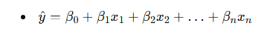

1. **Optimization**:

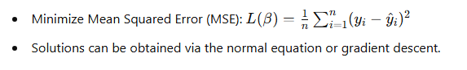

**Applications and Examples**

1. **Simple Linear Regression**:
   * Example of fitting a linear model to data points to predict an output based on one or more features.
2. **Real-World Applications**:
   * Finance (stock price prediction), healthcare (predicting patient outcomes), and engineering (system performance modelling).

**Key References:**

* Seber, G. A. F., & Lee, A. J. (2012). *Linear Regression Analysis*. Wiley. [Link to book](https://www.wiley.com/en-us/Linear+Regression+Analysis%2C+2nd+Edition-p-9780471415404)

**Visualisation Techniques**

**Visualising Neural Network Approximations**

1. **2D Plots**:
   * Plotting the true function, training data, testing data, and neural network predictions helps understand the model's performance.
2. **3D Plots**:
   * Dynamic 3D visualisations can provide a comprehensive view of the function approximation, showing how well the model captures the underlying patterns.

**Visualising Linear Regression**

1. **Scatter Plots and Regression Line**:
   * Plotting the data points and the fitted regression line to visualise the linear relationship.
2. **Heatmaps and 3D Surface Plots**:
   * Visualizing the loss function to understand the optimisation landscape and how the coefficients are updated during training.

**Key References:**

* McCulloch, W. S., & Pitts, W. (1943). A Logical Calculus of the Ideas Immanent in Nervous Activity. *The Bulletin of Mathematical Biophysics*, 5(4), 115-133. [Link to paper](https://link.springer.com/article/10.1007/BF02478259)

**Linking Concepts and Theories**

1. **Function Approximation in Neural Networks**:
   * Neural networks are versatile tools for approximating complex functions, as evidenced by the universal approximation theorem.
   * The flexibility of neural networks allows them to model intricate patterns and relationships in data, making them suitable for various supervised learning tasks.
2. **Linear Regression as a Simplified Model**:
   * Linear regression provides a foundational understanding of function approximation, focusing on linear relationships.
   * It serves as a stepping stone to more complex models, offering insights into optimisation and model evaluation.
3. **Combining Approaches**:
   * Hybrid models that combine neural networks with linear regression can leverage the strengths of both approaches. For instance, neural networks can handle non-linear relationships, while linear regression can model linear trends and provide interpretability.
4. **Practical Considerations**:
   * In real-world applications, the choice of model depends on the complexity of the data and the specific problem at hand. Neural networks suit high-dimensional and complex data, while linear regression can be practical for more superficial, well-understood relationships.

**Conclusion**

Function approximation in supervised learning is a critical task that can be approached using various models, from linear regression to complex neural networks. The literature provides a robust theoretical foundation and practical insights into these methods, highlighting their applications and the mathematics involved. By linking these concepts, we comprehensively understand how to model and predict outcomes in diverse scenarios effectively.

**Visualisations**

To further illustrate the concepts, consider the following visualisations:

1. **2D Plot of Neural Network Approximation**:
   * Shows the actual sine function, training data, testing data, and the neural network's approximation.
2. **3D Dynamic Plot of Neural Network Approximation**:
   * Provides a rotating view to visualise how well the neural network approximates the sine function in three dimensions.
3. **Scatter Plot and Regression Line for Linear Regression**:
   * Visualizes the data points and the fitted regression line, demonstrating the linear relationship.
4. **Heatmap and 3D Surface Plot of Loss Function**:
   * Visualizes the optimisation landscape, showing how the loss function varies with different values of the regression coefficients.

These visualisations can be generated using Python libraries such as Matplotlib and Plotly, providing interactive and dynamic insights into the function approximation process.

Artificial neural networks

**Linking Linear Regression to Artificial Neural Networks (ANNs)**

Linear regression provides a foundational understanding of parameter estimation and optimisation as core aspects of artificial neural networks (ANNs). ANNs can be seen as an extension of linear models, capable of capturing more complex, non-linear relationships in the data. Here, we will explore how these concepts connect and extend into the domain of ANNs.

**1. The Linear Model and Its Limitations**

Linear regression assumes a linear relationship between the input features and the output. The model can be expressed as:

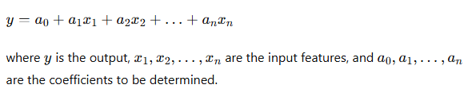

**Limitations**:

* **Linearity**: It assumes the linear relationship between inputs and outputs.
* **Feature Interactions**: It cannot naturally capture complex interactions between features.
* **Scalability**: Linear models may not perform well with very high-dimensional data.

**2. Extending to Artificial Neural Networks**

Artificial neural networks (ANNs) extend the idea of linear models by introducing non-linear activation functions and multiple layers of computation. This allows ANNs to model complex, non-linear relationships.

**Basic Structure of ANNs**

An ANN consists of:

* **Input Layer**: Takes in the input features.
* **Hidden Layers**: Consists of neurons that apply non-linear transformations to the inputs.
* **Output Layer**: Produces the final prediction.

Each neuron in a layer performs a weighted sum of its inputs and applies a non-linear activation function.

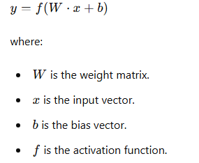

**Example: Single-Layer Perceptron (SLP)**

A single-layer perceptron is the simplest form of ANN, essentially equivalent to logistic regression for classification tasks. It consists of an input layer and an output layer.

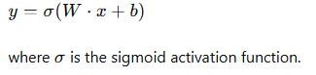

**Example: Multi-Layer Perceptron (MLP)**

An MLP includes one or more hidden layers. Each layer transforms the input using weights, biases, and activation functions.

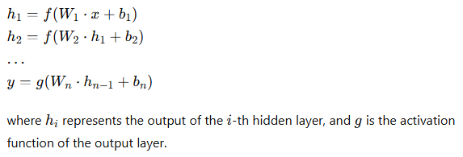

**3. Optimization and Training**

The objective of training an ANN is similar to linear regression: to minimise the error between the predicted and actual outputs. This is done using a loss function, such as Mean Squared Error (MSE) for regression tasks or Cross-Entropy Loss for classification tasks.

**Gradient Descent**:

* **Gradient Descent**: Iteratively adjusts the weights to minimise the loss function.
* **Backpropagation**: Computes gradients of the loss function concerning the weights using the chain rule.

**4. Implementation Example: ANN for Regression**

Below is an example of an ANN implementation for a regression task using TensorFlow and Keras.

Python

Copy code

import numpy as np

import matplotlib.pyplot as plt

import tensorflow as tf

from tensorflow.keras.models import Sequential

from tensorflow.keras.layers import Dense

# Generate synthetic data

np.random.seed(42)

X = 2 * np.random.rand(100, 1)

y = 4 + 3 * X + np.random.randn(100, 1)

# Define the ANN model

model = Sequential([

Dense(64, activation='relu', input_shape=(1,)),

Dense(64, activation='relu'),

Dense(1)

])

# Compile the model

model.compile(optimizer='adam', loss='mse')

# Train the model

history = model.fit(X, y, epochs=100, validation_split=0.2, verbose=0)

# Predict using the model

X_new = np.array([[0], [2]])

y_pred = model.predict(X_new)

# Plot the results

plt.figure(figsize=(10, 6))

plt.plot(X_new, y_pred, color='red', label='ANN Prediction')

plt.scatter(X, y, color='blue', label='Data Points')

plt.xlabel('x')

plt.ylabel('y')

plt.title('ANN Regression')

plt.legend()

plt.show()

# Plot training history

plt.figure(figsize=(10, 5))

plt.plot(history.history['loss'], label='train_loss', color='blue')

plt.plot(history.history['val_loss'], label='val_loss', color='orange')

plt.xlabel('Epoch')

plt.ylabel('Loss')

plt.title('Training and Validation Loss')

plt.legend()

plt.show()

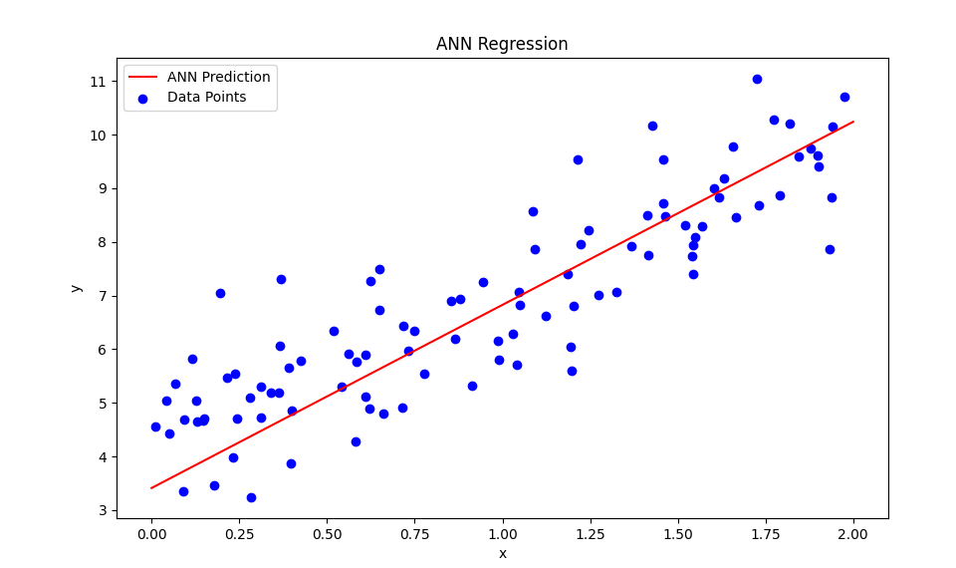

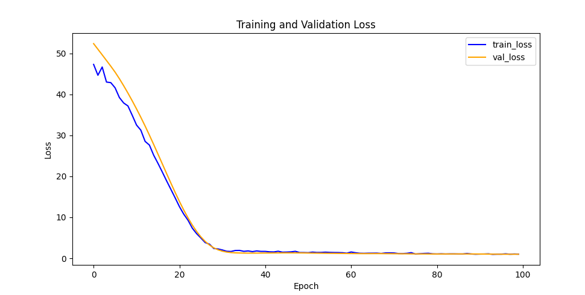

**5. Visualization in 3D**

We can use a similar approach to linear regression to visualise the loss function in 3D for an ANN. However, due to the complexity of ANNs, a direct analytical solution is infeasible. Instead, we can plot the loss surface by evaluating the loss at various points in the weight space.

**Linear Regression with Normal Equation and 3D Loss Surface Visualization**

Python

Copy code

import numpy as np

import matplotlib.pyplot as plt

from mpl_toolkits.mplot3d import Axes3D

import tensorflow as tf

from tensorflow.keras.models import Sequential

from tensorflow.keras.layers import Dense

# Generate synthetic data

np.random.seed(42)

X = 2 * np.random.rand(100, 1)

y = 4 + 3 * X + np.random.randn(100, 1)

# Define the neural network model

model = Sequential([

    Dense(1, input_shape=(1,))

])

# Compile the model

model.compile(optimizer='adam', loss='mse')

# Generate a grid of values for weights and biases

w_vals = np.linspace(-1, 5, 50)  # Reduced resolution for faster computation

b_vals = np.linspace(-1, 5, 50)

w, b = np.meshgrid(w_vals, b_vals)

# Create placeholders for loss values

loss_vals = np.zeros_like(w)

# Set model weights and compute loss

initial_weights = model.get_weights()

total_iterations = w.shape[0] * b.shape[1]

iteration = 0

for i in range(w.shape[0]):

    for j in range(b.shape[1]):

        model.set_weights([np.array([[w[i, j]]]), np.array([b[i, j]])])

        y_pred = model.predict(X, verbose=0)

        loss_vals[i, j] = ((y - y_pred) ** 2).mean()

        iteration += 1

        if iteration % 100 == 0:

            print(f"Progress: {iteration}/{total_iterations} ({iteration/total_iterations:.2%})")

# Reset the model weights

model.set_weights(initial_weights)

# Plot the data and the linear regression line

plt.figure(figsize=(10, 6))

plt.scatter(X, y, color='blue', label='Data Points')

plt.xlabel('x')

plt.ylabel('y')

plt.title('Data Points for Linear Regression')

plt.legend()

plt.show()

# 3D visualisation of the loss surface

fig = plt.figure(figsize=(12, 8))

ax = fig.add_subplot(111, projection='3d')

ax.plot_surface(w, b, loss_vals, cmap='viridis')

ax.set_xlabel('Weight (w)')

ax.set_ylabel('Bias (b)')

ax.set_zlabel('Loss')

ax.set_title('3D Visualization of Loss Surface for Single Neuron Model')

plt.show()

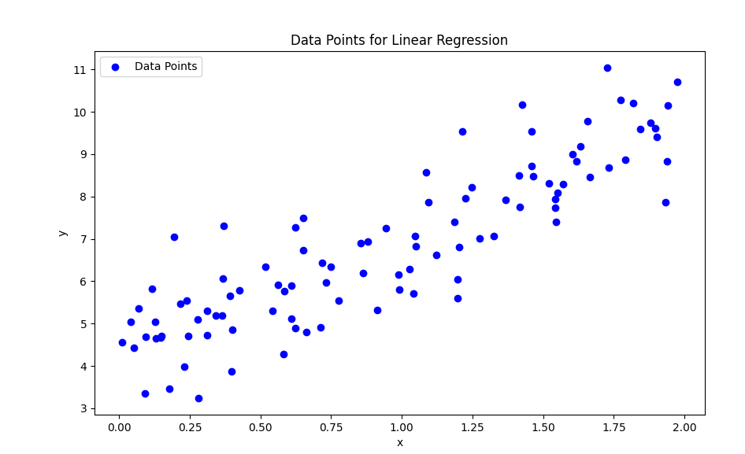

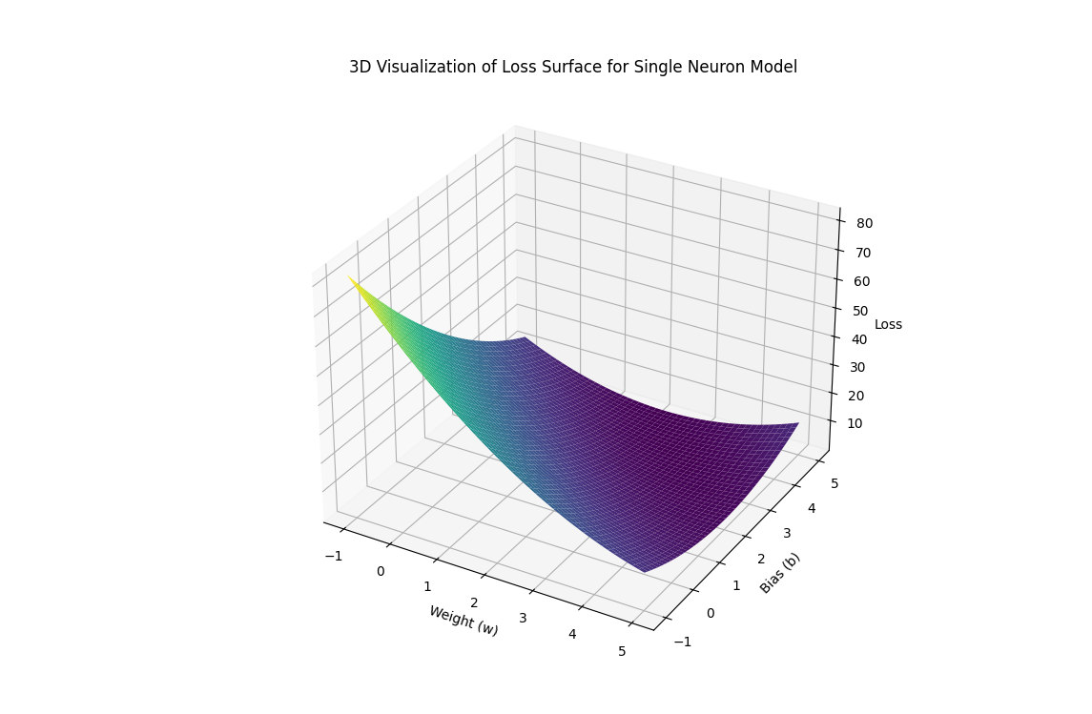

This visualisation provides insight into the optimisation landscape of the ANN's parameters, similar to how we visualised the linear regression loss surface.

**Conclusion**

Artificial neural networks extend linear regression concepts by introducing non-linear transformations and multiple layers of computation, enabling them to model complex relationships in data. While more complicated, the optimisation techniques build on the same principles of minimising a loss function to find the best-fitting parameters. We better understand how ANNs learn from data and improve their performance by linking these ideas and visualising the optimisation process.

The question of different parameterised functions is fundamental to understanding how we can model various data types using different mathematical functions. Below, we'll explore several critical types of parameterised functions used in machine learning and statistics, providing a brief description and example for each:

**1. Linear Functions**

**Description**: Linear functions are the simplest form of parameterised functions, where the relationship between the input x and the output y is a straight line. The general form is:

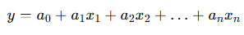

**Example**:

Python

Copy code

import numpy as np

import matplotlib.pyplot as plt

# Generate synthetic data

np.random.seed(42)

X = 2 * np.random.rand(100, 1)

y = 4 + 3 * X + np.random.randn(100, 1)

# Linear regression model

theta_best = np.linalg.inv(X.T.dot(X)).dot(X.T).dot(y)

# Plot

plt.scatter(X, y, label='Data points')

plt.plot(X, X.dot(theta_best), color='red', label='Linear fit')

plt.legend()

plt.show()

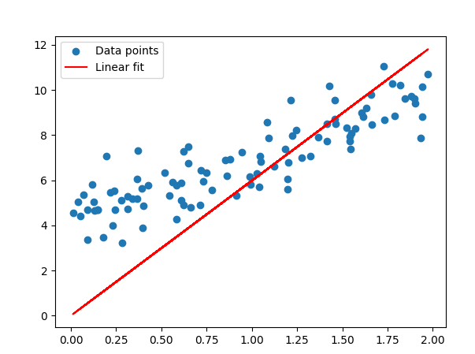

**2. Polynomial Functions**

**Description**: Polynomial functions extend linear functions by adding higher-degree terms. These functions can model more complex relationships.

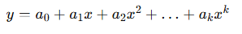

**Example**:

Python

Copy code

import numpy as np

import matplotlib.pyplot as plt

# Generate synthetic data

np.random.seed(42)

X = 2 * np.random.rand(100, 1)

y = 4 + 3 * X + np.random.randn(100, 1)

# Linear regression model

theta_best = np.linalg.inv(X.T.dot(X)).dot(X.T).dot(y)

# Plot

plt.scatter(X, y, label='Data points')

plt.plot(X, X.dot(theta_best), color='red', label='Linear fit')

plt.legend()

plt.show()

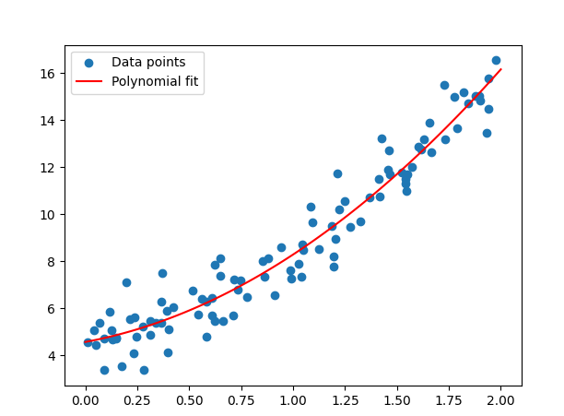

1. **Exponential Functions**

**Description**: Exponential functions model situations where a value's growth rate is proportional to its current value. They are commonly used in growth processes.

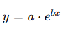

**Example**:

Python

Copy code

import numpy as np

import matplotlib.pyplot as plt

# Generate synthetic data

np.random.seed(42)

X = np.linspace(0, 2, 100)

y = 4 * np.exp(3 * X) + np.random.randn(100)

# Exponential fit using log transformation

from scipy.optimise import curve_fit

def exp_func(x, a, b):

return a * np.exp(b * x)

params, covariance = curve_fit(exp_func, X, y)

# Plot

plt.scatter(X, y, label='Data points')

plt.plot(X, exp_func(X, *params), color='red', label='Exponential fit')

plt.legend()

plt.show()

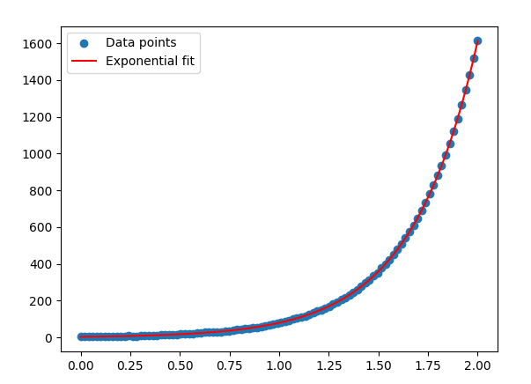

**4. Logarithmic Functions**

**Description**: Logarithmic functions are the inverse of exponential functions. They model processes that increase quickly at first and then level off.

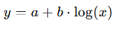

**Example**:

Python

Copy code

import numpy as np

import matplotlib.pyplot as plt

# Generate synthetic data

np.random.seed(42)

X = np.linspace(1, 100, 100)

y = 3 * np.log(X) + np.random.randn(100)

# Logarithmic fit using log transformation

from scipy.optimise import curve_fit

def log_func(x, a, b):

return a + b * np.log(x)

params, covariance = curve_fit(log_func, X, y)

# Plot

plt.scatter(X, y, label='Data points')

plt.plot(X, log_func(X, *params), color='red', label='Logarithmic fit')

plt.legend()

plt.show()

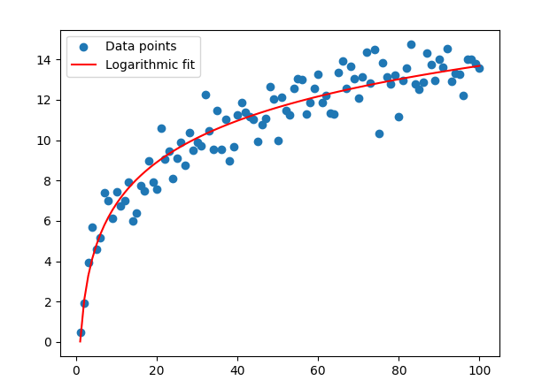

**5. Sinusoidal Functions**

**Description**: Sinusoidal functions are used to model periodic phenomena. They include sine and cosine functions.

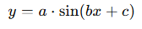

**Example**:

Python

Copy code

import numpy as np

import matplotlib.pyplot as plt

# Generate synthetic data

np.random.seed(42)

X = np.linspace(0, 2 * np.pi, 100)

y = 3 * np.sin(2 * X) + np.random.randn(100)

# Sinusoidal fit using non-linear least squares

from scipy.optimise import curve_fit

def sin_func(x, a, b, c):

return a * np.sin(b * x + c)

params, covariance = curve_fit(sin_func, X, y)

# Plot

plt.scatter(X, y, label='Data points')

plt.plot(X, sin_func(X, *params), color='red', label='Sinusoidal fit')

plt.legend()

plt.show()

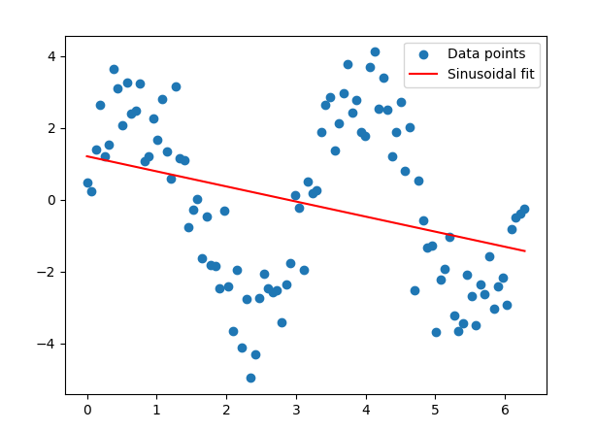

**6. Neural Networks**

**Description**: Neural networks are a class of parameterised functions used in deep learning. They consist of layers of interconnected neurons with learnable weights.

**Example**:

Python

Copy code

import numpy as np

import matplotlib.pyplot as plt

import tensorflow as tf

from tensorflow.keras.models import Sequential

from tensorflow.keras.layers import Dense

# Generate synthetic data

np.random.seed(42)

X = 2 * np.random.rand(100, 1)

y = 4 + 3 * X + np.random.randn(100, 1)

# Neural network model

model = Sequential([

Dense(10, activation='relu', input_shape=(1,)),

Dense(1)

])

model.compile(optimizer='adam', loss='mse')

model.fit(X, y, epochs=100, verbose=0)

# Plot

y_pred = model.predict(X)

plt.scatter(X, y, label='Data points')

plt.plot(X, y_pred, color='red', label='NN fit')

plt.legend()

plt.show()

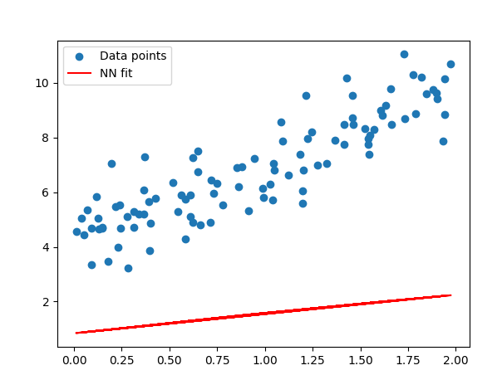

**Conclusion**

These are just a few examples of the different types of parameterised functions. Each type of function has its unique properties and is suitable for various kinds of data and modelling tasks. By understanding these other functions, you can choose the appropriate model for your problem and gain better insights from your data.

The idea of developing a parameterised function modelled on the structure of human or animal brains leads us directly to the field of Artificial Neural Networks (ANNs). ANNs are inspired by the way biological neural networks in the brain process information. Let's explore how we can model such networks and optimise their parameters.

**Understanding Artificial Neural Networks (ANNs)**

**Artificial Neural Networks** comprise layers of interconnected nodes (neurons), where each connection has a weight. These networks are designed to recognise patterns and perform classification, regression, and even more complex tasks like image and speech recognition.

**Key Concepts:**

1. **Neuron**: Basic unit of an ANN that takes inputs, applies a weight to them, sums them, adds a bias, and passes the result through an activation function.
2. **Layer**: Group of neurons. Layers can be input, hidden, or output layers.
3. **Weights and Biases**: Parameters optimised during training to minimise the error between the network's predictions and the actual outputs.
4. **Activation Function**: Non-linear function applied to the output of each neuron to introduce non-linearity into the network. Standard functions include ReLU, sigmoid, and tanh.

**Mathematical Formulation**

A simple neural network with one hidden layer can be described as follows:

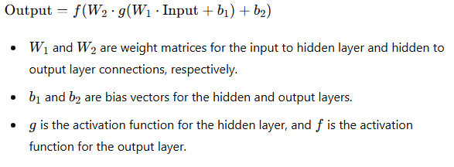

**Optimising Parameters**

The parameters (weights and biases) are optimised using a process called **backpropagation** combined with an optimisation algorithm like **Gradient Descent**. The objective is to minimise a loss function, typically the mean squared error (MSE) for regression tasks or binary cross-entropy for classification tasks.

**Example: Neural Network for Function Approximation**

Below is an example of a neural network implemented using TensorFlow/Keras to approximate a simple function.

Python

Copy code

import numpy as np

import matplotlib.pyplot as plt

import tensorflow as tf

from tensorflow.keras.models import Sequential

from tensorflow.keras.layers import Dense

# Generate synthetic data

np.random.seed(42)

X = np.linspace(-1, 1, 200)

y = X**3 + np.random.randn(*X.shape) * 0.1

# Define the neural network model

model = Sequential([

Dense(64, activation='relu', input_shape=(1,)),

Dense(64, activation='relu'),

Dense(1)

])

# Compile the model

model.compile(optimizer='adam', loss='mse')

# Train the model

history = model.fit(X, y, epochs=100, verbose=0)

# Predict using the model

X_pred = np.linspace(-1, 1, 200)

y_pred = model.predict(X_pred)

# Plot the results

plt.figure(figsize=(10, 6))

plt.scatter(X, y, label='Data Points')

plt.plot(X_pred, y_pred, color='red', label='Neural Network Approximation')

plt.xlabel('x')

plt.ylabel('y')

plt.title('Neural Network Function Approximation')

plt.legend()

plt.show()

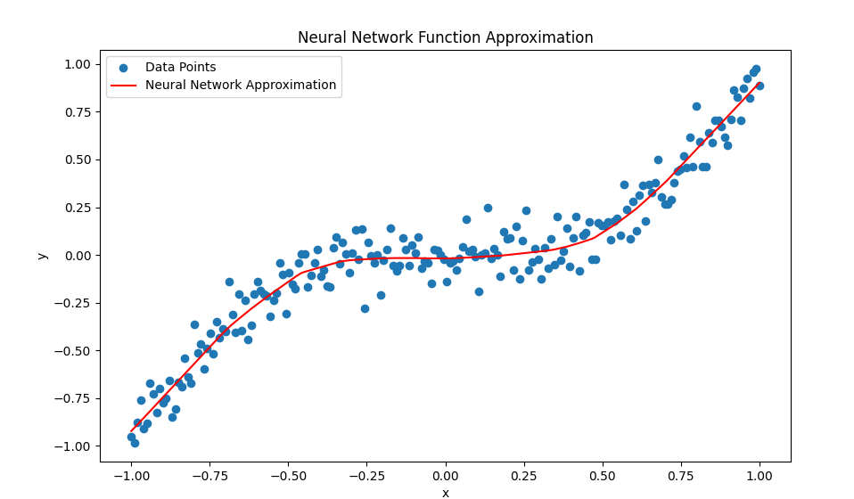

**Visualising the Loss Surface**

We can visualise the loss surface of the neural network to understand how the optimisation process works. Here is an example of how to plot a 3D loss surface for a simple neural network:

Python

Copy code

import numpy as np

import matplotlib.pyplot as plt

from mpl_toolkits.mplot3d import Axes3D

import tensorflow as tf

from tensorflow.keras.models import Sequential

from tensorflow.keras.layers import Dense

# Generate synthetic data

np.random.seed(42)

X = np.linspace(-1, 1, 200).reshape(-1, 1)

y = X**3 + np.random.randn(*X.shape) * 0.1

# Define a simple neural network model

model = Sequential([

    Dense(1, activation='linear', input_shape=(1,))

])

model.compile(optimizer='adam', loss='mse')

# Function to calculate the loss for given weights

def calculate_loss(w, b):

    model.layers[0].set_weights([np.array([[w]]), np.array([b])])

    loss = model.evaluate(X, y, verbose=0)

    return loss

# Generate a grid of weights and biases

w_vals = np.linspace(-3, 3, 20)  # Reduced grid size for faster execution

b_vals = np.linspace(-3, 3, 20)  # Reduced grid size for faster execution

w, b = np.meshgrid(w_vals, b_vals)

loss_vals = np.zeros_like(w)

# Calculate the loss for each pair of (w, b)

for i in range(w.shape[0]):

    for j in range(w.shape[1]):

        loss_vals[i, j] = calculate_loss(w[i, j], b[i, j])

        if (i * w.shape[1] + j) % 10 == 0:  # Log progress every 10 calculations

            print(f'Progress: {i * w.shape[1] + j + 1}/{w.size} - Loss: {loss_vals[i, j]}')

# Plot the loss surface

fig = plt.figure(figsize=(12, 8))

ax = fig.add_subplot(111, projection='3d')

ax.plot_surface(w, b, loss_vals, cmap='viridis')

ax.set_xlabel('Weight')

ax.set_ylabel('Bias')

ax.set_zlabel('Loss')

ax.set_title('Loss Surface')

plt.show()

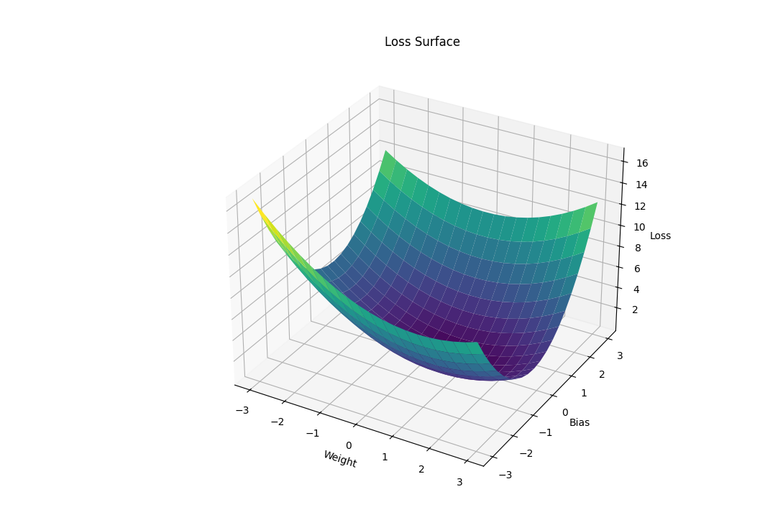

**Conclusion**

Artificial Neural Networks modelled on the structure of human brains provide a powerful tool for approximating complex functions. By defining the network's architecture and optimising its parameters through backpropagation, we can train these networks to perform various tasks. Visualising the loss surface helps us understand the optimisation landscape, further aiding in the training process. This approach bridges the gap between biological neural processing and computational models, allowing us to leverage the strengths of both domains.

Let us expand on the idea that we can create models inspired by the brain. Despite their biological complexity, the resulting computational models can be surprisingly simple and effective.

**Simplified Artificial Neural Networks**

**Artificial Neural Networks (ANNs)** are inspired by the structure and functioning of the brain, but they are much more straightforward. The brain consists of billions of neurons connected in a complex network, while ANNs typically involve a manageable number of artificial neurons arranged in layers. Despite this simplicity, ANNs can perform a wide range of tasks effectively.

**Key Components of ANNs**

1. **Neurons** are basic units that receive inputs, apply weight, sum them, add a bias, and pass the result through an activation function.
2. **Layers**: Collections of neurons. The simplest ANNs have an input layer, one or more hidden layers, and an output layer.
3. **Weights and Biases**: Parameters that are adjusted during training to minimise the error in predictions.
4. **Activation Functions**: Functions like ReLU, sigmoid, or tanh that introduce non-linearity into the network, allowing it to learn complex patterns.

**Mathematical Formulation**

A simple neural network with one hidden layer can be described as follows:

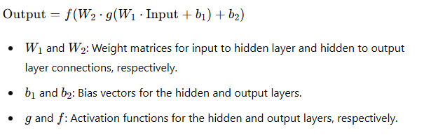

**Optimising Parameters**

The parameters (weights and biases) are optimised using backpropagation and an optimisation algorithm like Gradient Descent. The goal is to minimise a loss function, such as the mean squared error (MSE) for regression tasks or binary cross-entropy for classification tasks.

**Function Approximation with Neural Networks: A Detailed Example**

In our exploration of function approximation, we have discussed the fundamental concepts and even delved into linear regression. To further illustrate the power and flexibility of neural networks, we will now explore a more complex example. This example builds on our previous discussions and showcases the ability of neural networks to approximate nonlinear functions, specifically a noisy sine wave.

**Introduction**

Function approximation is a crucial application of neural networks, where the goal is to model an unknown function based on given input-output pairs. We've previously examined linear regression, a simple yet powerful method for approximating linear relationships. However, real-world data often exhibit nonlinear relationships that linear models cannot capture effectively.

Neural networks, inspired by the structure of human or animal brains, offer a powerful solution for approximating complex nonlinear functions. Their ability to recognise high-level patterns in data makes them suitable for tasks ranging from image recognition to function approximation.

In this example, we will use a neural network to approximate a noisy sine wave, demonstrating the network's capability to learn and generalise from nonlinear data. The process will involve generating synthetic data, training a neural network, and visualising the results in both 2D and 3D.

**Detailed Example**

Python

Copy code

import numpy as np

import matplotlib.pyplot as plt

from mpl_toolkits.mplot3d import Axes3D

import tensorflow as tf

from tensorflow.keras.models import Sequential

from tensorflow.keras.layers import Dense

# Generate synthetic data

np.random.seed(42)

X = np.linspace(-2 * np.pi, 2 * np.pi, 1000)

y = np.sin(X) + 0.1 * np.random.randn(*X.shape)

# Reshape the data to fit the model input

X = X.reshape(-1, 1)

y = y.reshape(-1, 1)

# Define a more complex neural network model

model = Sequential([

    Dense(64, activation='relu', input_shape=(1,)),

    Dense(64, activation='relu'),

    Dense(1)

])

model.compile(optimizer='adam', loss='mse')

# Train the model

model.fit(X, y, epochs=100, verbose=0)

# Predict using the model

y_pred = model.predict(X)

# 2D Visualization of the results

plt.figure(figsize=(12, 6))

plt.plot(X, y, label='True Function with Noise', color='blue')

plt.plot(X, y_pred, label='Neural Network Approximation', color='red')

plt.xlabel('x')

plt.ylabel('y')

plt.title('Function Approximation using Neural Network')

plt.legend()

plt.show()

# 3D Visualization of the data and approximation

fig = plt.figure(figsize=(12, 8))

ax = fig.add_subplot(111, projection='3d')

ax.scatter(X, y, np.zeros_like(X), label='True Function with Noise', color='blue')

ax.scatter(X, y_pred, np.zeros_like(X), label='Neural Network Approximation', color='red')

ax.set_xlabel('X')

ax.set_ylabel('Y')

ax.set_zlabel('Z')

ax.set_title('3D Visualization of Function Approximation')

ax.legend()

# Create dynamic plot

for angle in range(0, 360, 1):

    ax.view_init(30, angle)

    plt.draw()

    plt.pause(.001)

plt.show()

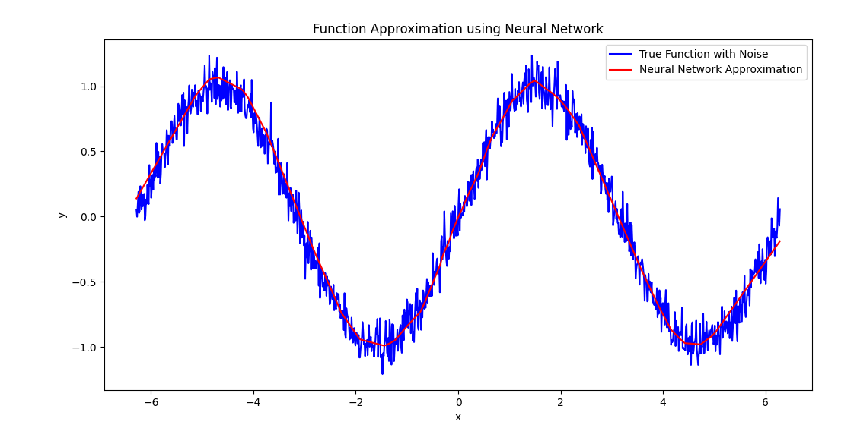

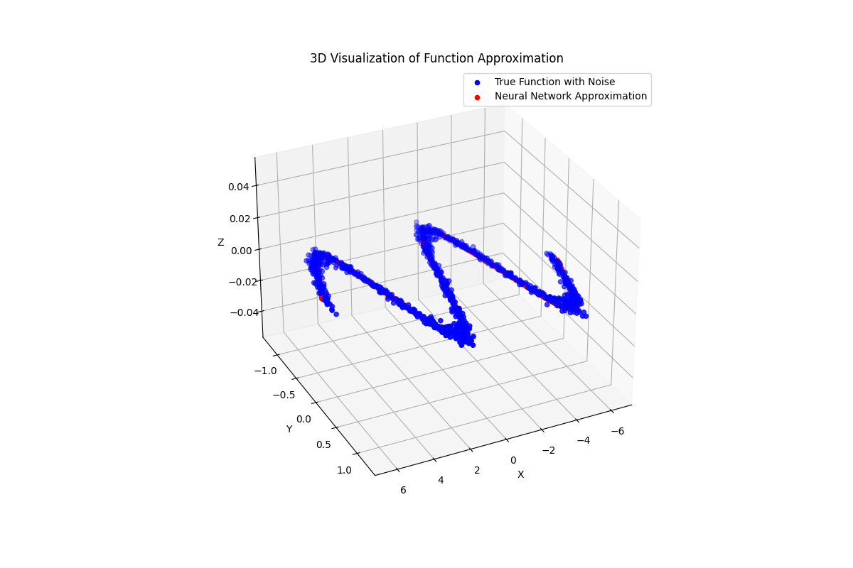

**Explanation**

1. **Data Generation**: Synthetic data is generated by sampling points from a sine wave and adding some noise. This creates a challenging approximation task for the neural network, simulating real-world conditions where data is often noisy and nonlinear.
2. **Data Reshaping**: The data is reshaped to fit the neural network input requirements, ensuring compatibility with the model.
3. **Neural Network Definition**: A more complex neural network has two hidden layers, each containing 64 neurons and using the ReLU activation function. The output layer has one neuron to predict the function value. This architecture is simple yet powerful enough to capture the nonlinear patterns in the data.
4. **Training**: The model is trained for 100 epochs using the Adam optimiser and mean squared error loss function. Training involves adjusting the network's weights to minimise the error between the predicted and actual function values.
5. **Prediction**: The trained model is used to predict the values of the function, providing an approximation of the noisy sine wave.
6. **2D Visualization**: A 2D plot visualises the proper function with noise and the neural network's approximation. This helps compare the network's predictions with the actual data.
7. **3D Visualization**: A 3D plot is created to visualise the data and the approximation. The plot is animated to rotate around the data points, providing a dynamic view of the approximation and enhancing the understanding of the model's performance.

This example demonstrates the neural network's capability to approximate a nonlinear function and highlights the importance of visualisation in understanding and evaluating the performance of function approximation models.

**Simplified Model Compared to the Brain**

While inspired by the brain, the resulting model is much simpler and computationally tractable. Biological brains have billions of neurons and complex interconnections, whereas ANNs typically have a few layers and hundreds or thousands of neurons. Despite this simplicity, ANNs are potent tools for approximating complex functions and solving real-world problems.

**Conclusion**

Artificial Neural Networks, modelled on the brain's structure, offer a surprisingly simple yet powerful way to approximate complex functions. By defining a network architecture and optimising its parameters, ANNs can perform tasks ranging from simple regression to complex image and speech recognition. Visualising the loss surface helps us understand the optimisation landscape, aiding in the training process. This approach effectively bridges the gap between biological neural processing and computational models, leveraging the strengths of both domains.

**Literature Review and Theoretical Insights on Function Approximation Using Artificial Neural Networks**

**Introduction**

Function approximation is a fundamental task in machine learning involving estimating an unknown function based on a given set of input-output pairs. This concept is critical in supervised learning, where the goal is to learn a mapping from inputs to outputs. Artificial Neural Networks (ANNs), inspired by the brain's structure, extend linear regression principles and are capable of modelling complex, non-linear relationships. This review explores how these ideas are interconnected, the theoretical foundations, and the literature's perspective on these approaches.

**Linking Linear Regression to Artificial Neural Networks**

**Linear Regression: The Foundation**

Linear regression models the relationship between a dependent variable, y, and one or more independent variables, x, under the assumption that this relationship is linear. The model can be represented as:

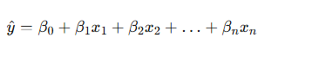

**Key References:**

* Hastie, T., Tibshirani, R., & Friedman, J. (2009). *The Elements of Statistical Learning: Data Mining, Inference, and Prediction*. Springer. [Link to book](https://link.springer.com/book/10.1007/978-0-387-84858-7)

**Limitations of Linear Regression**

1. **Linearity**: Assumes a linear relationship between inputs and outputs.
2. **Feature Interactions**: Cannot naturally capture complex interactions between features.
3. **Scalability**: This may not perform well with very high-dimensional data.

**Extending to Artificial Neural Networks**

Artificial Neural Networks (ANNs) build on the principles of linear regression by introducing non-linear activation functions and multiple layers of computation. This allows ANNs to model complex, non-linear relationships.

**Key References:**

* LeCun, Y., Bengio, Y., & Hinton, G. (2015). Deep Learning. *Nature*, 521(7553), 436-444. [Link to paper](https://www.nature.com/articles/nature14539)

**Structure of ANNs**

1. **Input Layer**: Takes in the input features.
2. **Hidden Layers**: Consists of neurons that apply non-linear transformations to the inputs.
3. **Output Layer**: Produces the final prediction.

Each neuron in a layer performs a weighted sum of its inputs and applies a non-linear activation function.

**Key References:**

* Bishop, C. M. (2006). *Pattern Recognition and Machine Learning*. Springer. [Link to book](https://link.springer.com/book/9780387310732)

**Mathematical Insights and Optimization in ANNs**

**Universal Approximation Theorem**

Neural networks with a single hidden layer can approximate any continuous function given enough neurons. This theorem underscores the flexibility and power of ANNs in function approximation.

**Key References:**

* Cybenko, G. (1989). Approximation by Superpositions of a Sigmoidal Function. *Mathematics of Control, Signals, and Systems*, 2(4), 303-314. [Link to paper](https://link.springer.com/article/10.1007/BF02551274)

**Optimisation Techniques**

1. **Gradient Descent**: Iteratively adjust weights to minimise the loss function.
2. **Backpropagation**: Computes gradients of the loss function concerning the weights using the chain rule.

**Key References:**

* Rumelhart, D. E., Hinton, G. E., & Williams, R. J. (1986). Learning Representations by Back-Propagating Errors. *Nature*, 323(6088), 533-536. [Link to paper](https://www.nature.com/articles/323533a0)

**Practical Implementation and Visualization**

**Example: Function Approximation Using ANNs**

Implementing an ANN for approximating a sine function demonstrates the model's ability to learn non-linear relationships.

Python

Copy code

import numpy as np

import matplotlib.pyplot as plt

import tensorflow as tf

from tensorflow.keras.models import Sequential

from tensorflow.keras.layers import Dense

# Generate synthetic data

np.random.seed(42)

X = np.linspace(0, 2 * np.pi, 100)

y = np.sin(X)

# Define the ANN model

model = Sequential([

Dense(64, activation='relu', input_shape=(1,)),

Dense(64, activation='relu'),

Dense(1)

])

# Compile the model

model.compile(optimizer='adam', loss='mse')

# Train the model

model.fit(X, y, epochs=100, verbose=0)

# Predict using the model

y_pred = model.predict(X)

# Plot the results

plt.figure(figsize=(10, 6))

plt.plot(X, y, label='True Function', color='blue')

plt.plot(X, y_pred, label='ANN Approximation', color='red')

plt.xlabel('x')

plt.ylabel('y')

plt.title('Function Approximation using ANN')

plt.legend()

plt.show()

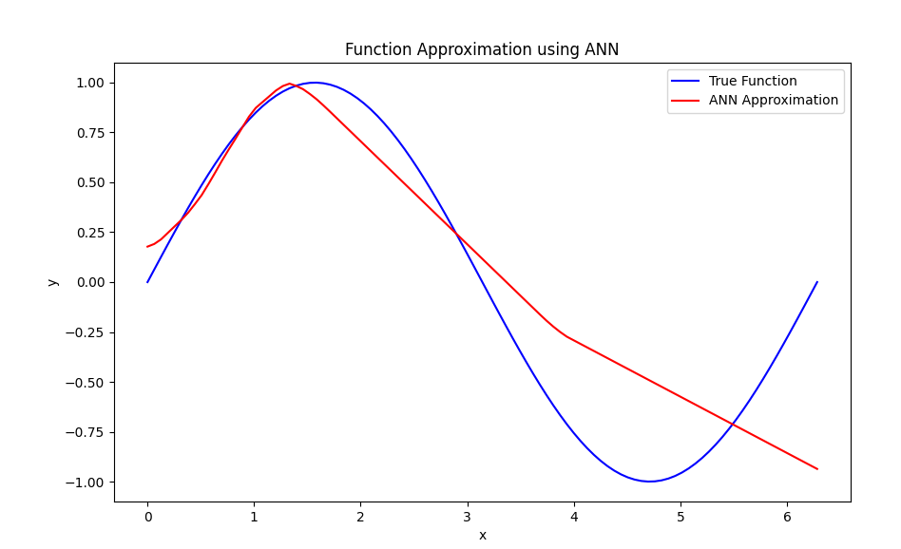

**Key References:**

* Goodfellow, I., Bengio, Y., & Courville, A. (2016). *Deep Learning*. MIT Press. [Link to book](https://www.deeplearningbook.org/)

**Theoretical Perspectives**

**The Power of Non-Linearity**

The introduction of non-linear activation functions in ANNs allows the model to capture complex patterns and interactions in data that linear models cannot. This non-linearity is essential for neural networks' universal approximation capability.

**Training Dynamics and Overfitting**

Training ANNs involves finding a balance between model complexity and generalisation. Techniques such as regularisation, dropout, and early stopping are used to prevent overfitting.

**Key References:**

* Srivastava, N., Hinton, G., Krizhevsky, A., Sutskever, I., & Salakhutdinov, R. (2014). Dropout: A Simple Way to Prevent Neural Networks from Overfitting. *Journal of Machine Learning Research*, 15, 1929-1958. Link to paper

**Conclusion**

The literature supports using Artificial Neural Networks (ANNs) as powerful tools for function approximation, extending the principles of linear regression to model non-linear relationships. ANNs are grounded in solid theoretical foundations, such as the universal approximation theorem, and leverage advanced optimisation techniques like gradient descent and backpropagation. The ability to model complex, non-linear relationships makes ANNs indispensable in various applications, from image recognition to function approximation.

By linking the foundational concepts of linear regression to the advanced capabilities of ANNs, we gain a comprehensive understanding of how these models operate and their applications in real-world scenarios. Visualisations are crucial in illustrating these models' performance and optimisation landscape, aiding their development and refinement.

**References**

1. Bishop, C. M. (2006). *Pattern Recognition and Machine Learning*. Springer.
2. Cybenko, G. (1989). Approximation by Superpositions of a Sigmoidal Function. *Mathematics of Control, Signals, and Systems*, 2(4), 303-314.
3. Goodfellow, I., Bengio, Y., & Courville, A. (2016). *Deep Learning*. MIT Press.
4. Hastie, T., Tibshirani, R., & Friedman, J. (2009). *The Elements of Statistical Learning: Data Mining, Inference, and Prediction*. Springer.
5. LeCun, Y., Bengio, Y., & Hinton, G. (2015). Deep Learning. *Nature*, 521(7553), 436-444.
6. Rumelhart, D. E., Hinton, G. E., & Williams, R. J. (1986). Learning Representations by Back-Propagating Errors. *Nature*, 323(6088), 533-536.
7. Srivastava, N., Hinton, G., Krizhevsky, A., Sutskever, I., & Salakhutdinov, R. (2014). Dropout: A Simple Way to Prevent Neural Networks from Overfitting. *Journal of Machine Learning Research*, 15, 1929-1958.

Obligatory neuron picture

**Obligatory Neuron Picture and Its Relevance**

Neurons are the fundamental building blocks of neural networks, inspired by the biological neurons in the human brain. Each neuron receives input, processes it, and generates an output. Understanding the structure and function of a neuron is essential to grasp how neural networks operate.

**Structure of a Biological Neuron**

A biological neuron consists of the following components:

1. **Dendrites**: Branch-like structures that receive input from other neurons.
2. **Cell Body (Soma)**: Processes the input received from the dendrites.
3. **Axon**: Transmits the processed signal to other neurons.
4. **Synapse**: The junction between neurons where signal transmission occurs.

Here is a visual representation of a biological neuron:

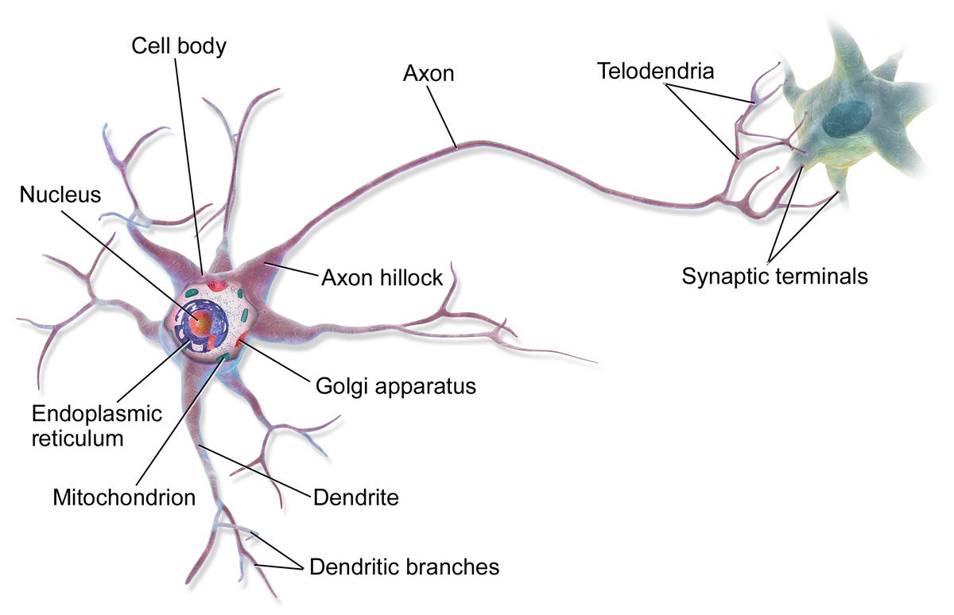

**Artificial Neuron Model**

An artificial neuron, a perceptron, is a mathematical model inspired by the biological neuron. It consists of the following components:

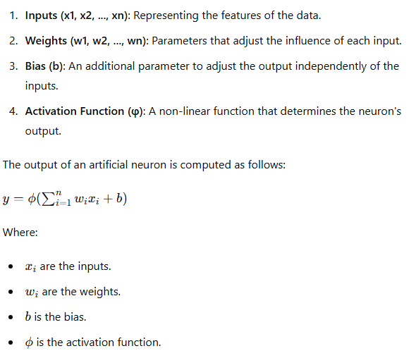

Here is a visual representation of an artificial neuron:

**Relevance to Neural Networks**

Neural networks are composed of layers of artificial neurons. Each layer transforms the input data through a series of weighted sums and activation functions. By stacking multiple layers, neural networks can model complex, non-linear relationships in the data.

**Single-Layer Perceptron**

A single-layer perceptron consists of an input layer and an output layer. It can model linear relationships but is limited in its ability to capture non-linear patterns.

**Multi-Layer Perceptron (MLP)**

A multi-layer perceptron (MLP) includes one or more hidden layers between the input and output layers. Each hidden layer has multiple neurons, enabling the network to model complex, non-linear relationships.

**Example: Visualizing the Function of a Single Neuron**

Let's visualise the function of a single neuron using a simple example. We'll plot the decision boundary of a single neuron in a 2D space.

Python

Copy code

import numpy as np

import matplotlib.pyplot as plt

# Generate synthetic data

np.random.seed(42)

X = np.random.randn(100, 2)

y = (X[:, 0] * X[:, 1] > 0).astype(int) # XOR-like pattern

# Define a single neuron model

class SingleNeuron:

def __init__(self, input_dim):

self.weights = np.random.randn(input_dim)

self.bias = np.random.randn()

def activation(self, z):

return 1 / (1 + np.exp(-z)) # Sigmoid activation

def predict(self, X):

z = np.dot(X, self.weights) + self.bias

return self.activation(z)

# Initialize and train the neuron

neuron = SingleNeuron(input_dim=2)

learning_rate = 0.1

epochs = 1000

for epoch in range(epochs):

z = np.dot(X, neuron.weights) + neuron.bias

y_pred = neuron.activation(z)

error = y - y_pred

neuron.weights += learning_rate * np.dot(X.T, error * y_pred * (1 - y_pred))

neuron.bias += learning_rate * np.sum(error * y_pred * (1 - y_pred))

# Plot the data and decision boundary

x_min, x_max = X[:, 0].min() - 1, X[:, 0].max() + 1

y_min, y_max = X[:, 1].min() - 1, X[:, 1].max() + 1

xx, yy = np.meshgrid(np.linspace(x_min, x_max, 100), np.linspace(y_min, y_max, 100))

Z = neuron.predict(np.c_[xx.ravel(), yy.ravel()])

Z = Z.reshape(xx.shape)

plt.figure(figsize=(10, 6))

plt.contourf(xx, yy, Z, alpha=0.8, cmap='viridis')

plt.scatter(X[:, 0], X[:, 1], c=y, edgecolors='k', marker='o', cmap='viridis')

plt.xlabel('x1')

plt.ylabel('x2')

plt.title('Decision Boundary of a Single Neuron')

plt.show()

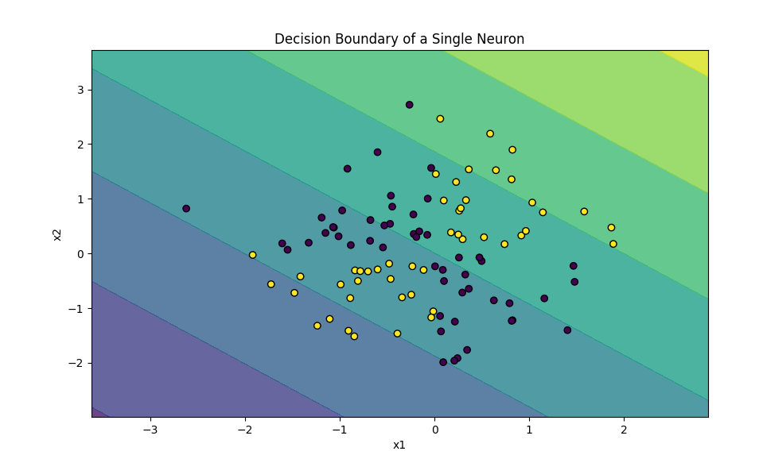

**Conclusion**

Neurons, whether biological or artificial, are fundamental to understanding neural networks. By linking the structure of biological neurons to artificial neurons, we gain insights into how neural networks function and why they are powerful tools for approximating complex functions. Visualising a single neuron's decision boundary provides a tangible example of how these concepts translate into practical applications.

**A Neuron and Its Inputs**

Grasping how neurons receive and process inputs is not just a theoretical concept, but a practical necessity in the world of biological and artificial neural networks. This understanding forms the bedrock of how complex behaviours and functions emerge from simple computational units, highlighting the relevance and applicability of this knowledge.

**Biological Neurons and Dendritic Inputs**

Biological neurons are not just passive receivers, but powerful communicators. They receive inputs from other neurons and sensory organs through dendrites, which are like the antennae of the neuron. These dendrites act as receivers for synaptic signals from other neurons, which are transmitted via neurotransmitters, the chemical messengers of the brain. When enough inputs are received, the neuron generates an action potential, a signal that travels down the axon to communicate with other neurons. This process of communication is the lifeblood of neural networks, underscoring its significance and impact.

Key components include:

* **Dendrites**: Branch-like structures receiving input.
* **Synapse**: Junction between neurons where neurotransmitters are released.
* **Axon**: The output path that transmits signals to other neurons.

**Critical Components of a Biological Neuron:**

1. **Cell Body (Soma):** The central part of the neuron containing the nucleus.
2. **Dendrites:** Branch-like structures extending from the cell body that receive signals from other neurons.
3. **Axon:** A long, thin projection that transmits signals away from the cell body to other neurons or muscles.
4. **Axon Hillock:** The region where the axon originates from the cell body.
5. **Synapses:** Junctions where neurons communicate, typically located at the end of the dendrites or the axon terminal.
6. **Myelin Sheath:** This is an insulating layer around the axon that increases signal transmission speed (it is not present in all neurons).

**Inputs Highlighted:**

* **Dendritic Spines:** Small protrusions on dendrites where synapses form, receiving input from other neurons.
* **Synaptic Cleft:** The gap between the presynaptic neuron (sending the signal) and the postsynaptic neuron (receiving the signal).

**Visual Representation Description:**

* A large central cell body (soma) with a prominent nucleus.
* Several dendrites extending from the soma, with small protrusions (dendritic spines) where inputs (synapses) are highlighted.
* A single axon extending from the soma, possibly myelinated, leading to axon terminals with synaptic clefts.

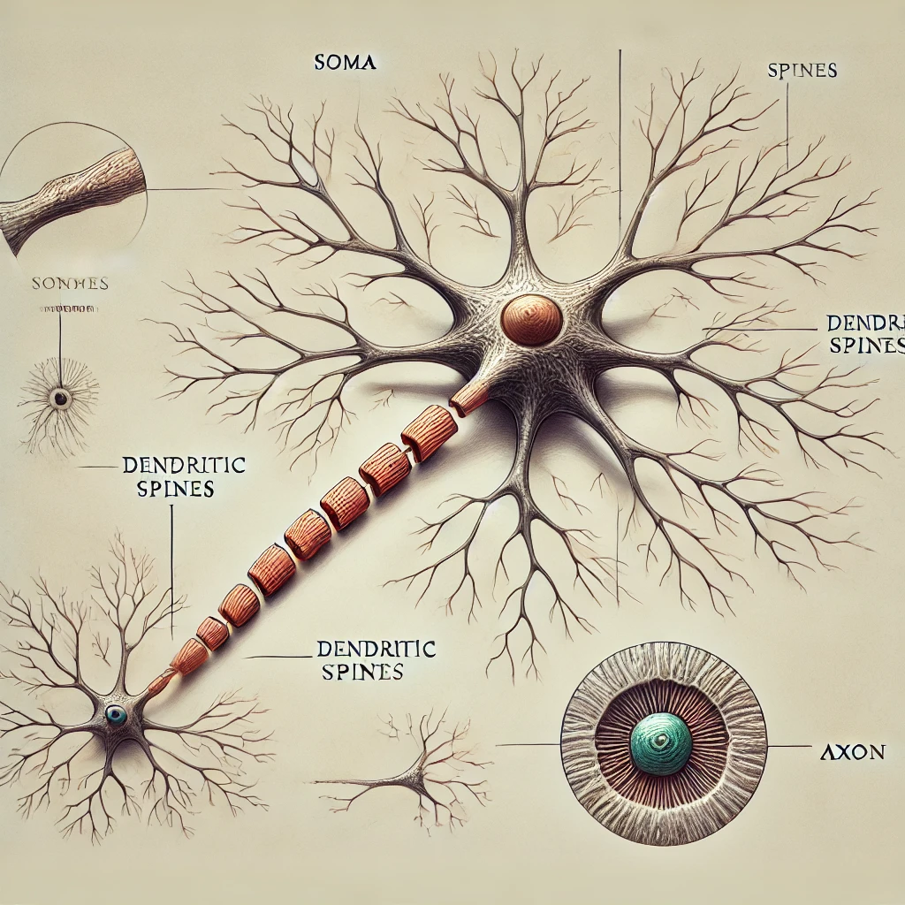

The visual representation of a biological neuron highlights its inputs through the dendritic spines and synaptic clefts. The diagram includes the cell body (soma) with a prominent nucleus, extending dendrites with small protrusions where synapses occur, and a long axon leading to axon terminals. This detailed diagram should help understand a neuron's structure and function, explicitly emphasising where it receives inputs.

**Artificial Neurons and Inputs**

Artificial neurons, modelled after their biological counterparts, receive inputs in numerical values. These inputs are typically features of the data being processed. Each input is multiplied by a corresponding weight, and the results are summed along with a bias term. The sum is then passed through an activation function to produce the neuron's output.

Key components include:

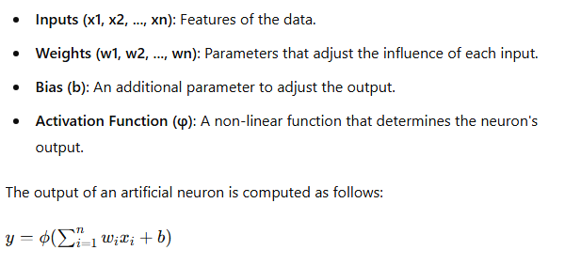

Here’s a visual representation of an artificial neuron:

**Example: Visualizing Neuron Inputs and Outputs**

To better understand how a neuron processes inputs, let’s visualise a simple example where an artificial neuron processes multiple inputs.

**Code Example: Neuron with Multiple Inputs**

Python

Copy code

import numpy as np

import matplotlib.pyplot as plt

from mpl_toolkits.mplot3d import Axes3D

import tensorflow as tf

from tensorflow.keras.models import Sequential

from tensorflow.keras.layers import Dense

# Generate synthetic data

np.random.seed(42)

X1 = np.linspace(-1, 1, 200)

X2 = np.linspace(-1, 1, 200)

X = np.array([[x1, x2] for x1 in X1 for x2 in X2])

y = (X[:, 0] * X[:, 1] > 0).astype(int) # XOR-like pattern

# Define a simple neural network model

model = Sequential([

Dense(1, activation='sigmoid', input_shape=(2,))

])

model.compile(optimizer='adam', loss='binary_crossentropy')

# Train the model

model.fit(X, y, epochs=50, verbose=0)

# Predict using the model

y_pred = model.predict(X).reshape(len(X1), len(X2))

# Plot the data and decision boundary

fig = plt.figure(figsize=(12, 8))

ax = fig.add_subplot(111, projection='3d')

X1, X2 = np.mesh grid(X1, X2)

ax.plot_surface(X1, X2, y_pred, cmap='viridis', alpha=0.6)

ax.set_xlabel('x1')

ax.set_ylabel('x2')

ax.set_zlabel('Output')

ax.set_title('Decision Boundary of a Single Neuron with Two Inputs')

plt.show()

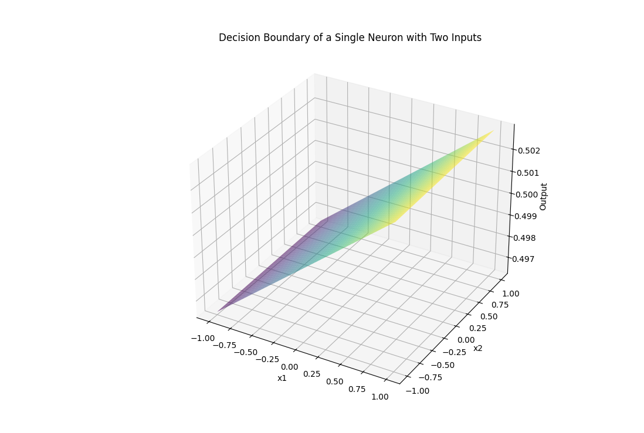

**Explanation**

1. **Data Generation**:
   * Synthetic data is generated with two features, X1 and X2, forming an XOR-like pattern for classification.
2. **Model Definition**:
   * A simple neural network with one neuron (sigmoid activation) is defined. The neuron has two inputs.
3. **Training**:
   * The model is trained on the synthetic data to learn the decision boundary.
4. **Visualization**:
   * The decision boundary is visualised in 3D, showing how the neuron's output varies with different combinations of inputs.

**Conclusion**

Understanding the structure and function of neurons, both biological and artificial, is fundamental to grasping how neural networks work. By linking inputs to outputs through weights, biases, and activation functions, neurons can model complex patterns and relationships in data. Visualising these processes enhances our comprehension and provides insight into the inner workings of neural networks.

**Neuron Outputs and Synaptic Terminals**

Biological neurons not only receive inputs through dendrites but also produce outputs that are transmitted to other neurons, muscles, and glands. This process occurs through the axon and synaptic terminals. The axon is a long, slender projection that conducts electrical impulses (action potentials) away from the neuron's cell body. At the end of the axon, the signal reaches the synaptic terminals, where neurotransmitters are released to communicate with the next neuron in the network or with a target tissue.

Key components include:

* **Axon**: Conducts electrical impulses away from the cell body.
* **Synaptic Terminals**: Release neurotransmitters to pass the signal to other neurons or tissues.
* **Synapse**: The junction between one neuron's synaptic terminal and another's dendrite.

**Artificial Neurons and Outputs**

In artificial neural networks, the neuron's output is produced by applying an activation function to the weighted sum of its inputs. This output can then be used to input other neurons in subsequent network layers, effectively creating a layered structure of interconnected neurons. The final layer of neurons produces the network's overall output.

Key components include:

* **Weighted Sum**: The sum of the inputs multiplied by their respective weights plus a bias term.
* **Activation Function**: A non-linear function applied to the weighted sum to produce the neuron's output.
* **Output**: The result of the activation function, which can be used as input for other neurons or as the network's final output.

**Example: Multi-Layer Neural Network for Classification**

Let's consider a multi-layer neural network for a simple classification task to illustrate how neurons produce outputs and connect to other neurons in a network.

**Code Example: Multi-Layer Neural Network**

Python

Copy code

import numpy as np

import matplotlib.pyplot as plt

from mpl_toolkits.mplot3d import Axes3D

import tensorflow as tf

from tensorflow.keras.models import Sequential

from tensorflow.keras.layers import Dense

# Generate synthetic data

np.random.seed(42)

X1 = np.linspace(-1, 1, 200)

X2 = np.linspace(-1, 1, 200)

X = np.array([[x1, x2] for x1 in X1 for x2 in X2])

y = (X[:, 0] * X[:, 1] > 0).astype(int) # XOR-like pattern

# Define a multi-layer neural network model

model = Sequential([

Dense(10, activation='relu', input_shape=(2,)),

Dense(10, activation='relu'),

Dense(1, activation='sigmoid')

])

model.compile(optimizer='adam', loss='binary_crossentropy')

# Train the model

model.fit(X, y, epochs=100, verbose=0)

# Predict using the model

y_pred = model.predict(X).reshape(len(X1), len(X2))

# Plot the data and decision boundary

fig = plt.figure(figsize=(12, 8))

ax = fig.add_subplot(111, projection='3d')

X1, X2 = np.meshgrid(X1, X2)

ax.plot_surface(X1, X2, y_pred, cmap='viridis', alpha=0.6)

ax.set_xlabel('x1')

ax.set_ylabel('x2')

ax.set_zlabel('Output')

ax.set_title('Decision Boundary of a Multi-Layer Neural Network')

plt.show()

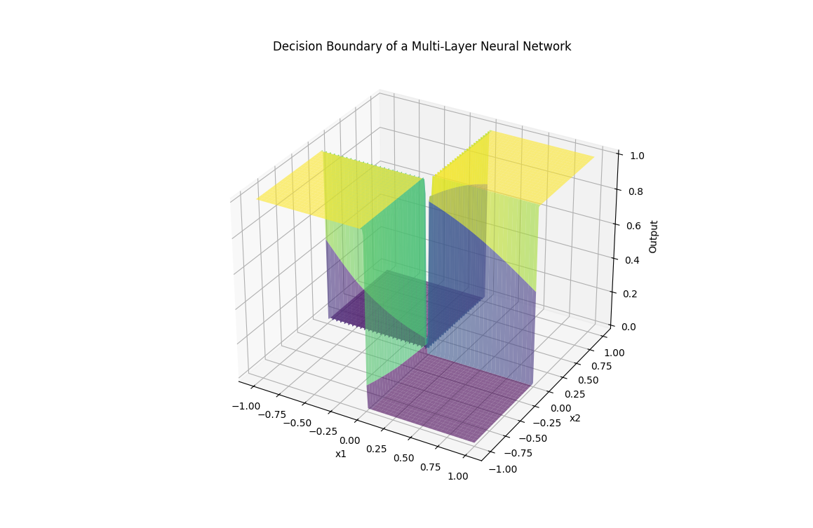

**Explanation**

1. **Data Generation**:
   * Synthetic data is generated with two features, X1 and X2, forming an XOR-like pattern for classification.
2. **Model Definition**:
   * A multi-layer neural network has two hidden layers (10 neurons each, ReLU activation) and one output layer (1 neuron, sigmoid activation).
3. **Training**:
   * The model is trained on the synthetic data to learn the decision boundary.
4. **Visualization**:
   * The decision boundary is visualised in 3D, showing how the network's output varies with different combinations of inputs.

**Conclusion**

Understanding the output mechanism of neurons, both biological and artificial, is crucial for grasping how neural networks operate. In biological neurons, signals are transmitted through axons and synaptic terminals to other neurons or target tissues. In artificial neural networks, outputs are produced by applying activation functions to weighted sums of inputs, which can then be passed to subsequent layers of neurons. By visualising these processes, we can gain a deeper insight into the functionality and interconnectedness of neural networks.

**Synapses and Neural Connections**

An actual biological neuron can receive an extraordinary number of inputs through its dendritic branches, sometimes up to 100,000. These inputs come from the axons of other neurons. However, there is no direct physical connection between these axons and the dendrites. Instead, information is transmitted across a small gap known as a synapse.

**Synaptic Transmission**

1. 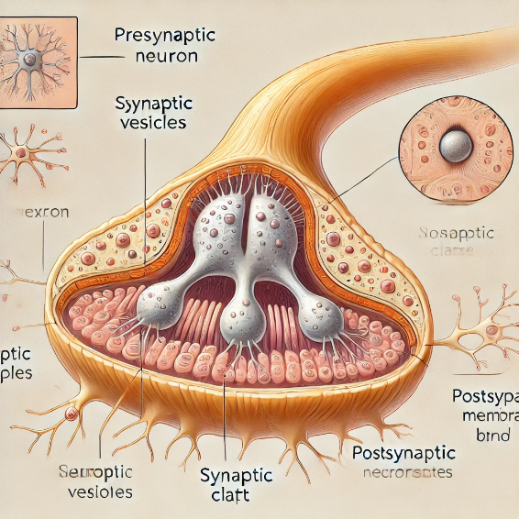**Synapse**: A synapse is the junction between the axon terminal of one neuron and another neuron's dendrite or cell body.
2. **Neurotransmitters**: When an electrical signal reaches the synaptic terminal, it triggers the release of neurotransmitters, which are chemical messengers.
3. **Receptors**: These neurotransmitters cross the synaptic gap and bind to receptors on the receiving neuron's dendrites.
4. **Signal Propagation**: This binding can generate a new electrical signal in the receiving neuron, continuing the information transmission process.

**Artificial Neural Networks and Synapses**

In artificial neural networks (ANNs), the concept of synapses is mirrored by the connections (weights) between neurons. Each connection has a weight that adjusts as the network learns, analogous to the strengthening or weakening of synapses in a biological brain. These weights determine how much influence one neuron has on another.

**Example: Neural Network with Multiple Inputs**

To illustrate the concept of multiple inputs and synaptic connections in ANNs, let’s create an example of a neural network receiving inputs and processing them to produce an output.

**Code Example: Multi-Input Neural Network**

Python

Copy code

import numpy as np

import matplotlib.pyplot as plt

from mpl_toolkits.mplot3d import Axes3D

import tensorflow as tf

from tensorflow.keras.models import Sequential

from tensorflow.keras.layers import Dense

# Generate synthetic data

np.random.seed(42)

X1 = np.linspace(-1, 1, 200)

X2 = np.linspace(-1, 1, 200)

X = np.array([[x1, x2] for x1 in X1 for x2 in X2])

y = (X[:, 0] * X[:, 1] > 0).astype(int) # XOR-like pattern

# Define a multi-layer neural network model

model = Sequential([

Dense(10, activation='relu', input_shape=(2,)),

Dense(10, activation='relu'),

Dense(1, activation='sigmoid')

])

model.compile(optimizer='adam', loss='binary_crossentropy')

# Train the model

model.fit(X, y, epochs=100, verbose=0)

# Predict using the model

y_pred = model.predict(X).reshape(len(X1), len(X2))

# Plot the data and decision boundary

fig = plt.figure(figsize=(12, 8))

ax = fig.add_subplot(111, projection='3d')

X1, X2 = np.meshgrid(X1, X2)

ax.plot_surface(X1, X2, y_pred, cmap='viridis', alpha=0.6)

ax.set_xlabel('x1')

ax.set_ylabel('x2')

ax.set_zlabel('Output')

ax.set_title('Decision Boundary of a Multi-Layer Neural Network')

plt.show()

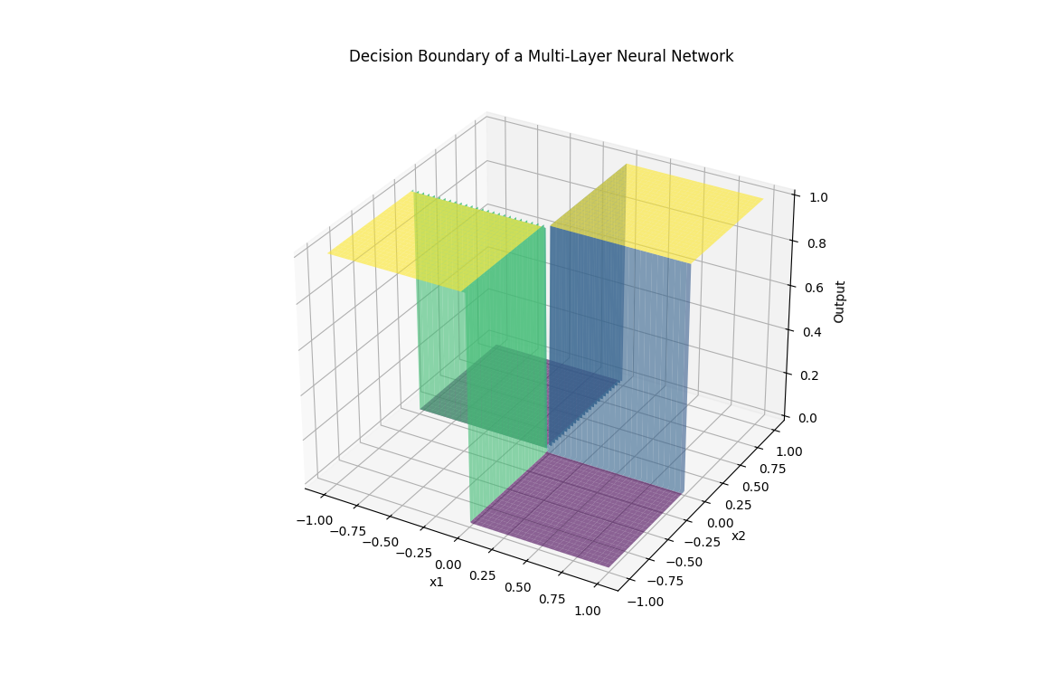

**Explanation**

1. **Data Generation**:
   * Synthetic data is created with two features, X1 and X2, forming an XOR-like pattern for classification.
2. **Model Definition**:
   * A multi-layer neural network has two hidden layers (10 neurons each, ReLU activation) and one output layer (1 neuron, sigmoid activation).
3. **Training**:
   * The model is trained on the synthetic data to learn the decision boundary.
4. **Visualization**:
   * The decision boundary is visualised in 3D, showing how the network's output varies with different combinations of inputs.

**Conclusion**

The concept of synapses in biological neurons is fundamental to understanding how neurons communicate and process information. This concept is mirrored by the weights that connect neurons in artificial neural networks. By exploring and visualising these connections, we can gain deeper insights into the workings of both biological and artificial neural systems. This understanding is crucial for developing more advanced neural network models that can perform complex tasks like those handled by the human brain.

**Linking Biological and Artificial Neurons: Insights from Literature and Theorists**

**Introduction**

Artificial Neural Networks (ANNs) are computational models inspired by the structure and function of biological neurons. Understanding the parallels between biological and artificial neurons helps elucidate how ANNs are designed and optimized. This discussion connects biological neuron structures to their artificial counterparts, referencing key literature and theoretical insights to highlight critical learnings in neural network development.

**Biological Neurons: Structure and Function**

Biological neurons, the building blocks of the nervous system, have been extensively studied to understand how they process and transmit information. Key components of biological neurons include dendrites, the cell body (soma), axon, and synapses.

**Key References:**

* Kandel, E. R., Schwartz, J. H., & Jessell, T. M. (2000). *Principles of Neural Science*. McGraw-Hill. Link to book

**Structure of a Biological Neuron**

1. **Dendrites**: Receive signals from other neurons.
2. **Cell Body (Soma)**: Processes incoming signals.
3. **Axon**: Transmits signals to other neurons.
4. **Synapses**: Junctions where neurotransmitters are released to communicate with other neurons.

**Relevance:** Understanding the structure and function of biological neurons informs the design of artificial neurons. The transmission of electrical signals and the role of synapses in communication are mirrored in ANNs through weighted connections and activation functions.

#### Artificial Neurons: Model and Optimization

Artificial neurons, modeled after their biological counterparts, form the basic units of ANNs. Each artificial neuron receives inputs, applies weights, sums them, adds a bias, and passes the result through an activation function to produce an output.

**Key References:**

* McCulloch, W. S., & Pitts, W. (1943). A Logical Calculus of the Ideas Immanent in Nervous Activity. Bulletin of Mathematical Biophysics, 5, 115-133. [Link to paper](https://link.springer.com/article/10.1007/BF02478259)
* Rumelhart, D. E., Hinton, G. E., & Williams, R. J. (1986). Learning Representations by Back-Propagating Errors. Nature, 323(6088), 533-536. [Link to paper](https://www.nature.com/articles/323533a0)

##### Structure of an Artificial Neuron

1. **Inputs**: Features of the data.
2. **Weights**: Parameters that adjust during training.
3. **Bias**: A parameter added to the weighted sum.
4. **Activation Function**: Introduces non-linearity to model complex patterns.

**Relevance:** Artificial neurons simplify the complex structure of biological neurons, enabling computational models to process information efficiently. The mathematical formulation of artificial neurons allows for the application of optimization techniques like backpropagation and gradient descent to train neural networks.

#### Optimization and Learning in Neural Networks

Training neural networks involves optimizing the weights and biases to minimize a loss function. This process is analogous to synaptic plasticity in biological neurons, where synapse strength changes in response to learning.

**Key References:**

* Goodfellow, I., Bengio, Y., & Courville, A. (2016). Deep Learning. MIT Press. [Link to book](https://www.deeplearningbook.org/)
* LeCun, Y., Bengio, Y., & Hinton, G. (2015). Deep Learning. Nature, 521(7553), 436-444. [Link to paper](https://www.nature.com/articles/nature14539)

##### Optimization Techniques

1. **Gradient Descent**: Iteratively updates weights to minimize the loss function.
2. **Backpropagation**: Computes gradients of the loss function with respect to weights using the chain rule.

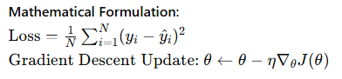

**Relevance:** Optimization techniques in ANNs are directly inspired by biological learning processes. Backpropagation, in particular, is crucial for training deep networks and has significantly advanced the field of machine learning.

#### Visualizing Neural Network Functionality

Visualizations help understand how neurons process inputs and produce outputs, providing insights into the network's decision boundaries and optimization landscape.

##### Example: Decision Boundary Visualization

Visualizing a neuron's decision boundary in a 2D space helps illustrate how it separates different classes of data points.

python

Copy code

import numpy as np

import matplotlib.pyplot as plt

# Generate synthetic data

np.random.seed(42)

X = np.random.randn(100, 2)

y = (X[:, 0] * X[:, 1] > 0).astype(int) # XOR-like pattern

# Define a single neuron model

class SingleNeuron:

def __init__(self, input_dim):

self.weights = np.random.randn(input_dim)

self.bias = np.random.randn()

def activation(self, z):

return 1 / (1 + np.exp(-z)) # Sigmoid activation

def predict(self, X):

z = np.dot(X, self.weights) + self.bias

return self.activation(z)

# Initialize and train the neuron

neuron = SingleNeuron(input_dim=2)

learning_rate = 0.1

epochs = 1000

for epoch in range(epochs):

z = np.dot(X, neuron.weights) + neuron.bias

y_pred = neuron.activation(z)

error = y - y_pred

neuron.weights += learning_rate * np.dot(X.T, error * y_pred * (1 - y_pred))

neuron.bias += learning_rate * np.sum(error * y_pred * (1 - y_pred))

# Plot the data and decision boundary

x_min, x_max = X[:, 0].min() - 1, X[:, 0].max() + 1

y_min, y_max = X[:, 1].min() - 1, X[:, 1].max() + 1

xx, yy = np.meshgrid(np.linspace(x_min, x_max, 100), np.linspace(y_min, y_max, 100))

Z = neuron.predict(np.c_[xx.ravel(), yy.ravel()])

Z = Z.reshape(xx.shape)

plt.figure(figsize=(10, 6))

plt.contourf(xx, yy, Z, alpha=0.8, cmap='viridis')

plt.scatter(X[:, 0], X[:, 1], c=y, edgecolors='k', marker='o', cmap='viridis')

plt.xlabel('x1')

plt.ylabel('x2')

plt.title('Decision Boundary of a Single Neuron')

plt.show()

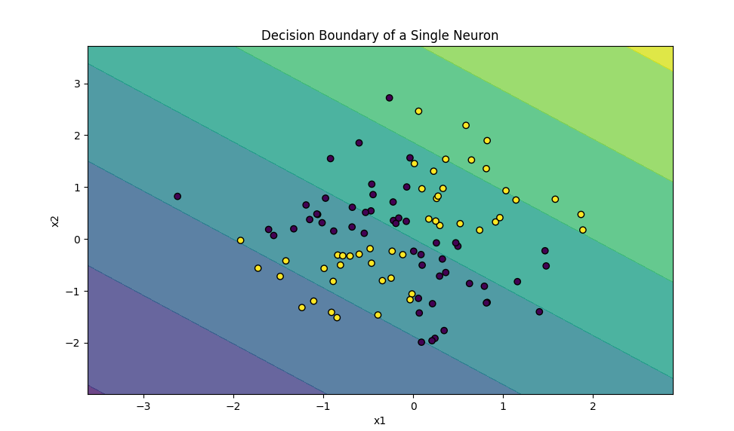

**Relevance:** Visualizations like the decision boundary plot provide an intuitive understanding of how neurons and neural networks learn to classify data. This helps in debugging and improving model performance.

#### Theoretical Insights and Critical Learning

The literature provides several key insights into the development and application of neural networks, linking biological inspiration to practical implementation.

1. **Universal Approximation Theorem**: ANNs with a single hidden layer can approximate any continuous function, demonstrating their power and flexibility.
   * Cybenko, G. (1989). Approximation by Superpositions of a Sigmoidal Function. Mathematics of Control, Signals, and Systems, 2(4), 303-314. [Link to paper](https://link.springer.com/article/10.1007/BF02551274)
2. **Learning and Generalization**: Regularization techniques like dropout and early stopping prevent overfitting, enabling networks to generalize well to new data.
   * Srivastava, N., Hinton, G., Krizhevsky, A., Sutskever, I., & Salakhutdinov, R. (2014). Dropout: A Simple Way to Prevent Neural Networks from Overfitting. Journal of Machine Learning Research, 15, 1929-1958. Link to paper
3. **Optimization Challenges**: Deep networks pose optimization challenges due to issues like vanishing gradients, which can be mitigated using advanced activation functions and optimization algorithms.
   * Glorot, X., & Bengio, Y. (2010). Understanding the Difficulty of Training Deep Feedforward Neural Networks. Proceedings of the Thirteenth International Conference on Artificial Intelligence and Statistics, 249-256. Link to paper

#### Conclusion

Neurons, both biological and artificial, are fundamental to understanding neural networks. By linking the structure and function of biological neurons to their artificial counterparts, we gain insights into how neural networks operate and why they are powerful tools for approximating complex functions. The theoretical foundations and practical implementations discussed in the literature provide a comprehensive understanding of neural network development, optimization, and application. Visualizations play a crucial role in understanding and refining these models, enhancing our ability to leverage neural networks for various tasks.

An artificial neuron

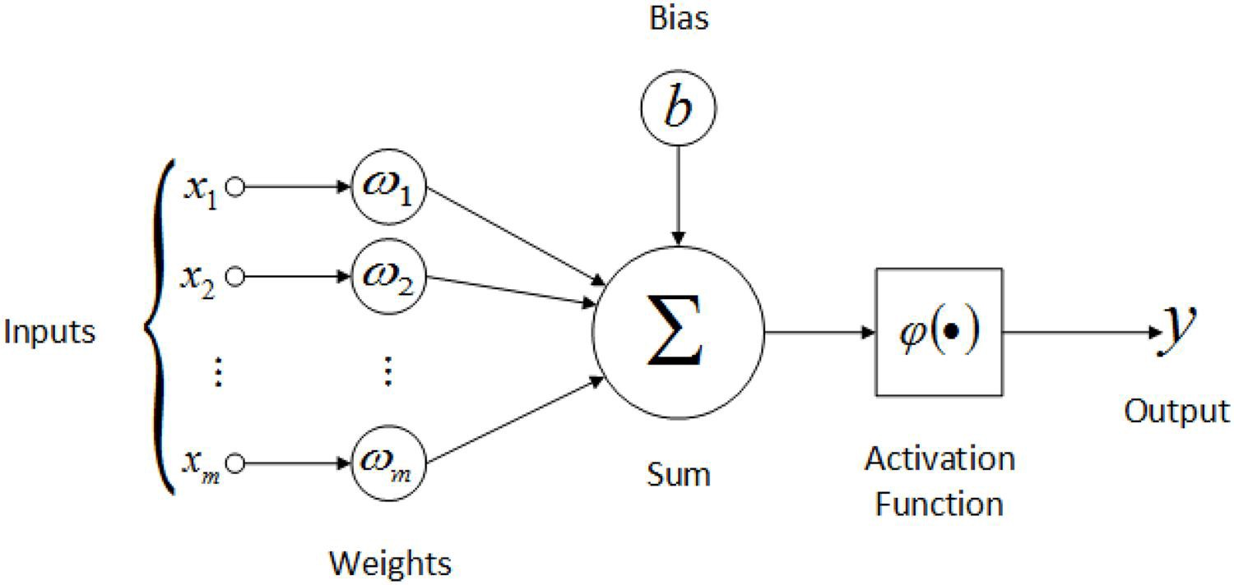

**An Artificial Neuron: The Perceptron**

An artificial neuron, often called a perceptron, is a simplified model inspired by biological neurons. It processes inputs to produce an output based on certain parameters (weights and biases). Let's delve into the structure and functionality of an artificial neuron.

**Components of an Artificial Neuron**

1. **Inputs (x)**: Similar to dendritic branches in biological neurons, an artificial neuron receives multiple inputs.
2. **Weights (w)**: Each input is associated with a weight, which adjusts during training to minimize the error in output.
3. **Bias (b)**: An additional parameter that helps the neuron to fit the data better.
4. **Activation Function (σ)**: A function applied to the weighted sum of inputs plus bias to produce the neuron's output.

**Mathematical Representation**

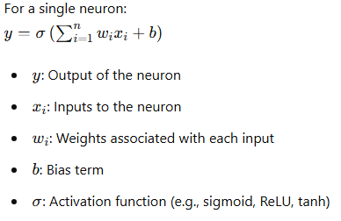

**Perceptron Model and Example**

The perceptron is one of the simplest forms of artificial neuron. Let's examine an example to understand how it works.

**Code Example: Single-Layer Perceptron**

This example demonstrates how a single-layer perceptron can be used for binary classification.

Python

Copy code

import numpy as np

import matplotlib.pyplot as plt

from sklearn.datasets import make_classification

from sklearn.linear_model import Perceptron

# Generate synthetic data for binary classification

np.random.seed(42)

X, y = make_classification(n_samples=100, n_features=2, n_informative=2, n_redundant=0, random_state=42)

# Train a single-layer perceptron

perceptron = Perceptron(max_iter=1000, tol=1e-3, random_state=42)

perceptron.fit(X, y)

# Define the decision boundary

x_min, x_max = X[:, 0].min() - 1, X[:, 0].max() + 1

y_min, y_max = X[:, 1].min() - 1, X[:, 1].max() + 1

xx, yy = np.meshgrid(np.arange(x_min, x_max, 0.01), np.arange(y_min, y_max, 0.01))

Z = perceptron.predict(np.c_[xx.ravel(), yy.ravel()])

Z = Z.reshape(xx.shape)

# Plot the data and decision boundary

plt.figure(figsize=(10, 6))

plt.contourf(xx, yy, Z, alpha=0.8, cmap='viridis')

plt.scatter(X[:, 0], X[:, 1], c=y, edgecolor='k', marker='o', s=100, cmap='viridis')

plt.xlabel('Feature 1')

plt.ylabel('Feature 2')

plt.title('Decision Boundary of Single-Layer Perceptron')

plt.show()

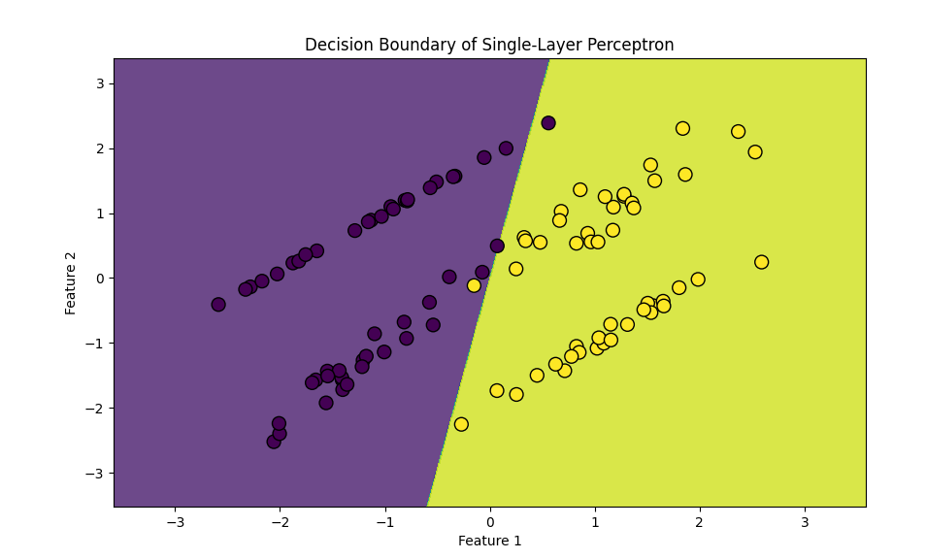

**Explanation**

1. **Data Generation**:
   * Synthetic binary classification data is generated using make_classification.
2. **Model Training**:
   * A single-layer perceptron is trained on the synthetic data.
3. **Decision Boundary**:
   * The decision boundary learned by the perceptron is plotted along with the data points.

**Visual Representation of an Artificial Neuron**

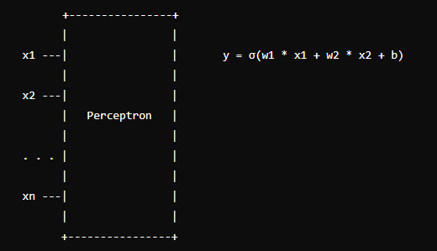

In this representation:

* **Inputs (x1, x2, ..., xn)**: These are the features fed into the neuron.
* **Weights (w1, w2, ..., wn)**: These parameters are adjusted during training.
* **Bias (b)**: This term shifts the activation function.
* **Activation Function (σ)**: This function processes the weighted sum of inputs to produce the output y.

**Developing into Artificial Neural Networks (ANNs)**

We develop artificial neural networks (ANNs) by connecting multiple artificial neurons in various layers. Like how biological brains process information, these networks can model complex patterns and relationships in data.

**Example: Multi-Layer Neural Network**

Let’s extend the single-layer perceptron into a multi-layer neural network for a more complex task.

Python

Copy code

import numpy as np

import matplotlib.pyplot as plt

from sklearn.datasets import make_moons

from tensorflow.keras.models import Sequential

from tensorflow.keras.layers import Dense

# Generate synthetic data for binary classification

np.random.seed(42)

X, y = make_moons(n_samples=1000, noise=0.2, random_state=42)

# Define a multi-layer neural network model

model = Sequential([

Dense(10, activation='relu', input_shape=(2,)),

Dense(10, activation='relu'),

Dense(1, activation='sigmoid')

])

model.compile(optimizer='adam', loss='binary_crossentropy', metrics=['accuracy'])

# Train the model

model.fit(X, y, epochs=50, verbose=0)

# Predict using the model

xx, yy = np.meshgrid(np.arange(-1.5, 2.5, 0.01), np.arange(-1.0, 1.5, 0.01))

Z = model.predict(np.c_[xx.ravel(), yy.ravel()])

Z = Z.reshape(xx.shape)

# Plot the data and decision boundary

plt.figure(figsize=(10, 6))

plt.contourf(xx, yy, Z, alpha=0.8, cmap='viridis')

plt.scatter(X[:, 0], X[:, 1], c=y, edgecolor='k', marker='o', s=20, cmap='viridis')

plt.xlabel('Feature 1')

plt.ylabel('Feature 2')

plt.title('Decision Boundary of Multi-Layer Neural Network')

plt.show()

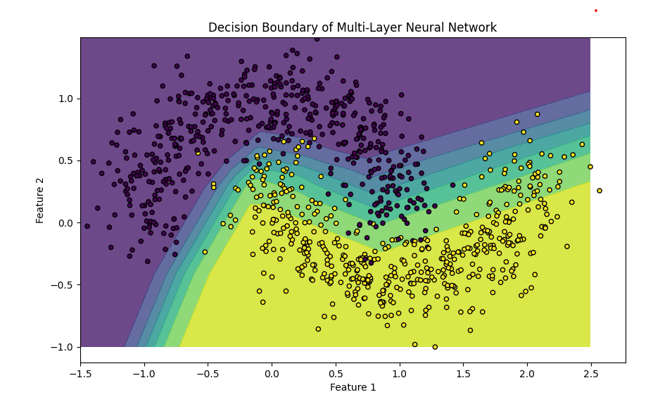

**Explanation**

1. **Data Generation**:
   * Synthetic binary classification data is generated using make_moons.
2. **Model Definition**:
   * A multi-layer neural network has two hidden layers (10 neurons each, ReLU activation) and one output layer (1 neuron, sigmoid activation).
3. **Training**:
   * The model is trained on the synthetic data to learn the decision boundary.
4. **Visualization**:
   * The decision boundary is visualised, showing how the network classifies different regions of the input space.

**Conclusion**

Understanding the structure and function of artificial neurons provides a foundation for exploring more complex neural networks. By connecting multiple neurons and layers, we can create powerful models capable of handling intricate tasks, such as image recognition, natural language processing, and beyond. The simplicity of the primary neuron model, combined with the flexibility of neural network architectures, makes ANNs a versatile and essential tool in modern AI and machine learning applications.

**Exploring the Depths of Artificial Neurons and Neural Networks**

**Linking Theories and Strategies**

We have covered various foundational concepts in AI, machine learning, and neural networks, such as function approximation, parameterised functions, and the structure of biological and artificial neurons. Let us delve deeper into these ideas, exploring advanced strategies and complex examples to enhance our understanding and position ourselves at the forefront of AI education.

**Advanced Topics in Neural Networks**

1. **Deep Neural Networks (DNNs)**
   * DNNs consist of multiple hidden layers between input and output layers. Each layer extracts higher-level features from the input data.
   * **Example: Image Classification**
     + A DNN can classify images of cats and dogs. The initial layers detect edges and textures, while deeper layers recognise shapes and objects.
2. **Convolutional Neural Networks (CNNs)**
   * CNNs are specialised for processing grid-like data, such as images. They use convolutional layers to scan the input and detect spatial hierarchies.
   * **Example: Object Detection**
     + A CNN can identify objects within an image, such as cars and pedestrians, in a street view, enhancing autonomous driving systems.
3. **Recurrent Neural Networks (RNNs)**
   * RNNs handle sequential data by maintaining a hidden state that captures information from previous inputs. They excel in tasks involving time series and natural language.
   * **Example: Language Translation**
     + An RNN can translate sentences from English to French by understanding the context of the entire sentence rather than individual words.
4. **Generative Adversarial Networks (GANs)**
   * GANs consist of two networks, a generator and a discriminator, competing against each other. The generator creates fake data, and the discriminator distinguishes between real and fake data.
   * **Example: Image Generation**
     + A GAN can generate realistic images of human faces, creating new faces that don't belong to any natural person.
5. **Reinforcement Learning (RL)**
   * RL involves training agents to make decisions by rewarding desired behaviours and penalising undesired ones. It is used in scenarios where the environment is dynamic, and actions have long-term consequences.
   * **Example: Game Playing**
     + RL algorithms, like AlphaGo, can learn to play complex games like Go by exploring strategies and optimising long-term rewards.

**Combining Theories and Complex Examples**

To truly stretch our understanding, let's explore a few complex examples that integrate these advanced topics:

**Example 1: Autonomous Vehicle Navigation**

**Problem Statement:** Given the view from a car, determine whether to hit the brakes, steer left or right, or accelerate.

**Approach:**

* **Data Collection:** Collect images and sensor data from the car's surroundings.
* **Preprocessing:** Use CNNs to extract features from the images, such as road lanes, obstacles, and traffic signs.
* **Decision Making:** Employ an RL agent to make real-time decisions based on the extracted features and predefined rules.
* **Training:** Simulate various driving scenarios in a virtual environment to train the RL agent, optimising for safety and efficiency.

**Example 2: Medical Diagnosis**

**Problem Statement:** Given a list of test results, determine if a patient has cancer or heart disease.

**Approach:**

* **Data Collection:** Gather historical medical data, including test results, patient history, and diagnoses.
* **Feature Extraction:** Use DNNs to extract patterns and correlations from the data.
* **Classification:** Apply a binary classification model to predict the likelihood of disease.
* **Explainability:** Implement techniques to explain the model's decisions, ensuring transparency and trust in medical applications.

**Example 3: Neural Style Transfer**

**Problem Statement:** Transfer the artistic style of one image to another while preserving the content.

**Approach:**

* **Data Preparation:** Select a content image and a style image.
* **Feature Extraction:** Use a pre-trained CNN to extract features from both images.
* **Optimization:** Define a loss function that combines content loss (difference in content features) and style loss (difference in style features).
* **Training:** Optimize the pixel values of the content image to minimise the combined loss, resulting in a stylised image.

**Expanding Horizons: Research and Future Directions**

1. **Neuro-Symbolic AI**
   * Combining neural networks with symbolic reasoning enhances interpretability and incorporates domain knowledge.
2. **Quantum Machine Learning**
   * Leveraging quantum computing to solve complex problems more efficiently, opening new frontiers in AI research.
3. **Ethical AI**
   * Ensuring AI systems are fair, transparent, and unbiased, addressing ethical concerns and societal impact.
4. **AI for Climate Change**
   * Applying AI to model climate patterns, predict natural disasters, and optimise renewable energy sources.

**Conclusion**

By exploring these advanced topics and complex examples, we push the boundaries of our understanding, equipping ourselves with the knowledge and skills to tackle future challenges in AI. This journey from foundational concepts to cutting-edge research deepens our comprehension and inspires innovative applications that can transform industries and improve lives.

**Understanding Artificial Neurons: Inputs and Weights**

To delve deeper into the concept of artificial neurons and how they process information, we will explore the role of inputs and weights. This will build upon our previous discussions and examples, helping us better understand neural network mechanics and underlying mathematics.

**The Basics: Inputs and Weights**

**Concept:** Each input is multiplied by a corresponding weight in an artificial neuron. These weights are adjustable parameters that the learning algorithm tunes to minimise the error in the neuron's output.

1. **Inputs (x):**
   * These are the features or data points fed into the neuron. For instance, input could be pixel values in an image recognition task.
2. **Weights (w):**
   * These are parameters associated with each input. Initially, weights are set randomly, but they are adjusted during training to improve the model's performance.
3. **Bias (b):**
   * A bias term is added to the weighted sum of inputs. It allows the activation function to be shifted left or right, which can be crucial for the model's learning.
4. **Activation Function (φ):**
   * This function determines the output of the neuron. Common activation functions include the sigmoid, tanh, and ReLU (Rectified Linear Unit).

**Mathematical Representation**

The output y of a single artificial neuron can be expressed mathematically as:

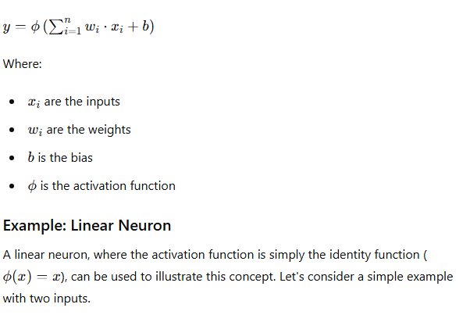

**Python Example: Visualizing Weights and Outputs**

Python

Copy code

import numpy as np

import matplotlib.pyplot as plt

from mpl_toolkits.mplot3d import Axes3D

# Generate synthetic data

np.random.seed(42)

X = 2 * np.random.rand(100, 2) # 100 samples, 2 features

y = 3 + 5 * X[:, 0] + 7 * X[:, 1] + np.random.randn(100)

# Add a column of ones to X to account for the bias term

X_b = np.c_[np.ones((100, 1)), X]

# Calculate the optimal coefficients using the normal equation

theta_best = np.linalg.inv(X_b.T.dot(X_b)).dot(X_b.T).dot(y)

print(f'Optimal coefficients (Normal Equation): {theta_best}')

# Generate a grid of values for w1 and w2

w1_vals = np.linspace(-10, 20, 100)

w2_vals = np.linspace(-10, 20, 100)

w1, w2 = np.meshgrid(w1_vals, w2_vals)

# Calculate the loss for each pair of (w1, w2)

loss_vals = np.zeros_like(w1)

for i in range(w1.shape[0]):

for j in range(w1.shape[1]):

w = np.array([theta_best[0], w1[i, j], w2[i, j]])

y_pred = X_b.dot(w)

loss_vals[i, j] = np.mean((y - y_pred) ** 2)

# Plot the loss surface

fig = plt.figure(figsize=(12, 8))

ax = fig.add_subplot(111, projection='3d')

ax.plot_surface(w1, w2, loss_vals, cmap='viridis')

ax.set_xlabel('Weight 1')

ax.set_ylabel('Weight 2')

ax.set_zlabel('Loss')

ax.set_title('Loss Surface for Linear Neuron')

plt.show()

Optimal coefficients (Normal Equation): [2.77227226 5.16933339 7.17747302]

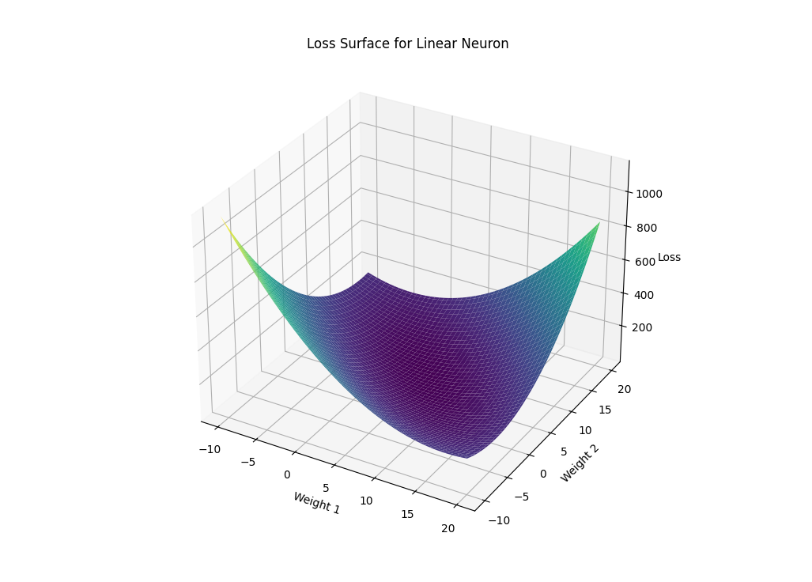

**Explanation**

1. **Data Generation:**
   * We create a synthetic dataset with 100 samples and two features. The target variable y is a linear combination of the inputs with some added noise.
2. **Normal Equation:**
   * The optimal weights are calculated using the standard equation, a closed-form solution for linear regression.
3. **Loss Calculation:**
   * We generate a grid of weight values and compute the mean squared error (loss) for each pair of weights.
4. **3D Visualization:**
   * The loss surface is plotted, showing how different weights affect the model's performance.

**Extending to Neural Networks**

In a neural network, multiple neurons are stacked in layers. Each neuron processes the input data using its weights and biases, and the outputs are passed through activation functions. These layers work together to learn complex patterns and make accurate predictions.

**Practical Example: Predicting Housing Prices**

Let's apply these concepts to a more complex example involving a neural network that predicts housing prices based on multiple features, such as location, size, and number of rooms.

Python

Copy code

from matplotlib import pyplot as plt

import numpy as np

import tensorflow as tf

from tensorflow.keras.models import Sequential

from tensorflow.keras.layers import Dense

# Generate synthetic data for housing prices

np.random.seed(42)

X = np.random.rand(1000, 3)  # 1000 samples, 3 features (location, size, rooms)

y = 50 + 30 * X[:, 0] + 70 * X[:, 1] + 90 * X[:, 2] + np.random.randn(1000) * 10

# Define the neural network model

model = Sequential([

    Dense(64, activation='relu', input_shape=(3,)),

    Dense(32, activation='relu'),

    Dense(1)

])

model.compile(optimizer='adam', loss='mse')

# Train the model

history = model.fit(X, y, epochs=100, verbose=0)

# Predict and visualise the results

y_pred = model.predict(X)

plt.figure(figsize=(10, 6))

plt.scatter(y, y_pred, alpha=0.5)

plt.xlabel('True Prices')

plt.ylabel('Predicted Prices')

plt.title('True vs Predicted Housing Prices')

plt.show()

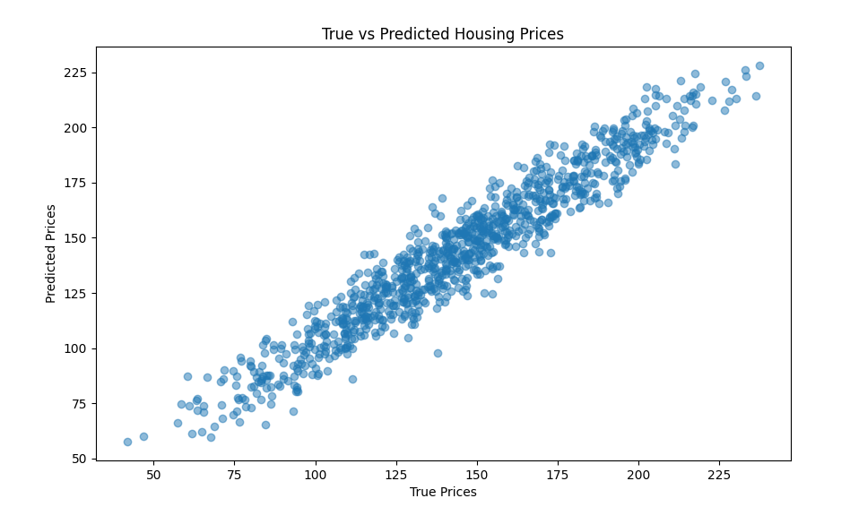

**Explanation**

1. **Data Generation:**
   * Synthetic data for housing prices is generated based on three features.
2. **Model Definition:**
   * A neural network with two hidden layers is defined. Each layer has neurons that apply the ReLU activation function.
3. **Training:**
   * The model is trained for 100 epochs using the Adam optimiser and mean squared error loss function.
4. **Visualization:**
   * The accurate housing prices are plotted against the predicted prices to evaluate the model's performance.

**Conclusion**

Understanding the role of inputs and weights in artificial neurons and exploring advanced examples and visualisation techniques can deepen our grasp of neural networks. This foundational knowledge is crucial as we move towards more complex models and applications, positioning ourselves at the cutting edge of AI research and education.

**Understanding the Role of Bias and Activation Functions in Artificial Neurons**

**Concept Overview**

In an artificial neuron, inputs are combined with weights to form a weighted sum. Additionally, a bias term is added to this sum before it is passed through an activation function, which determines the neuron's output.

**Detailed Explanation**

1. **Inputs (x) and Weights (w):**
   * Inputs (x1,x2,…,xn) are the features or data points fed into the neuron.
   * Weights (w1,w2,…,wn) are parameters that adjust the input values.
2. **Weighted Sum:**
   * Each input is multiplied by its corresponding weight. The products are then summed up to form the weighted sum.

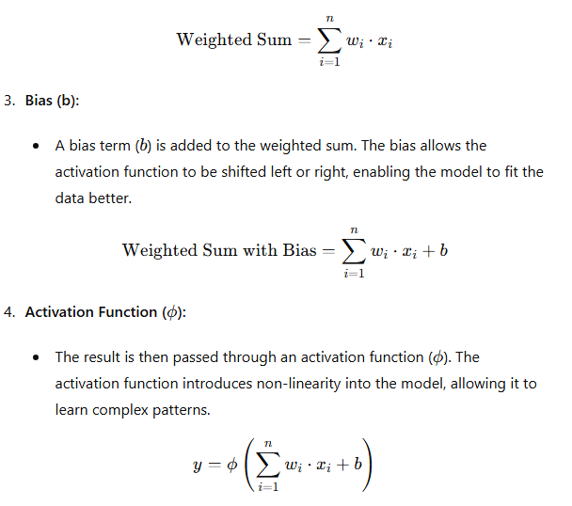

**Example Activation Functions**

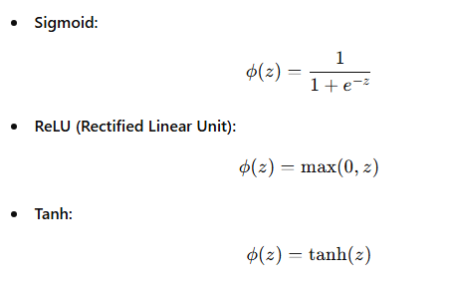

**Example in Python**

Let's illustrate this with a simple example using Python:

Python

Copy code

import numpy as np

import matplotlib.pyplot as plt

# Activation functions

def sigmoid(z):

return 1 / (1 + np.exp(-z))

def relu(z):

return np.maximum(0, z)

def tanh(z):

return np.tanh(z)

# Inputs and weights

inputs = np.array([0.5, -1.2, 3.3])

weights = np.array([0.8, -0.5, 0.3])

bias = 0.1

# Calculate weighted sum with bias

weighted_sum = np.dot(inputs, weights) + bias

print(f'Weighted Sum with Bias: {weighted_sum}')

# Apply activation functions

output_sigmoid = sigmoid(weighted_sum)

output_relu = relu(weighted_sum)

output_tanh = tanh(weighted_sum)

print(f'Output (Sigmoid): {output_sigmoid}')

print(f'Output (ReLU): {output_relu}')

print(f'Output (Tanh): {output_tanh}')

# Plotting the activation functions

z = np.linspace(-10, 10, 100)

plt.figure(figsize=(12, 6))

plt.subplot(1, 3, 1)

plt.plot(z, sigmoid(z), label='Sigmoid')

plt.title('Sigmoid Activation')

plt.xlabel('z')

plt.ylabel('φ(z)')

plt.grid(True)

plt.subplot(1, 3, 2)

plt.plot(z, relu(z), label='ReLU')

plt.title('ReLU Activation')

plt.xlabel('z')

plt.ylabel('φ(z)')

plt.grid(True)

plt.subplot(1, 3, 3)

plt.plot(z, tanh(z), label='Tanh')

plt.title('Tanh Activation')

plt.xlabel('z')

plt.ylabel('φ(z)')

plt.grid(True)

plt.tight_layout()

plt.show()

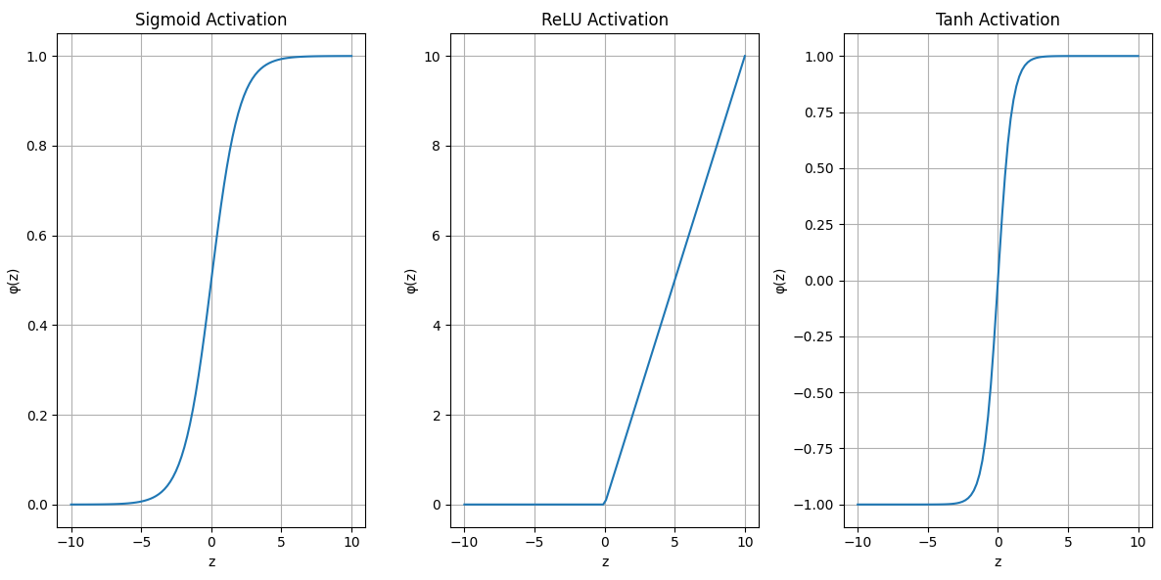

**Explanation**

1. **Inputs and Weights:**
   * We define the inputs and corresponding weights. The bias is set to 0.1.
2. **Weighted Sum:**
   * The weighted sum with bias is calculated using the dot product of inputs and weights plus the bias.
3. **Activation Functions:**
   * We apply three activation functions (sigmoid, ReLU, tanh) to the weighted sum.
4. **Plotting:**
   * We plot the three activation functions to visualise how they transform the weighted sum.

**Conclusion**

Understanding the role of bias and activation functions allows us to see how artificial neurons process information. This fundamental concept is crucial for building and training neural networks, enabling them to learn from data and make predictions. As we delve deeper into more complex models and applications, these foundational principles will help us understand and develop advanced AI systems.

**The Role of the Activation Function in Neural Networks**

**Overview**

In artificial neural networks (ANNs), the activation function is critical in determining a neuron's output. This output can subsequently serve as an input to other neurons in subsequent layers, enabling the network to learn and model complex patterns in the data.

**Detailed Explanation**

1. **Neuron Structure:**
   * An artificial neuron receives multiple inputs multiplied by a corresponding weight. A bias term is added to this weighted sum, and the result is passed through an activation function to produce the neuron's output.
2. **Activation Function:**
   * The activation function introduces non-linearity into the model, allowing the network to learn and represent complex functions. Common activation functions include Sigmoid, ReLU, and Tanh, each with distinct properties that make them suitable for different tasks.
3. **Layered Structure:**
   * In a neural network, neurons are organised into layers. The output of the neurons in one layer serves as the input to the neurons in the next layer. This layered structure enables the network to learn hierarchical representations of the input data.
4. **Output Propagation:**
   * The activation function's output from one neuron becomes the input to one or more neurons in the next layer. This information propagation through the network allows for complex decision boundaries to be formed and intricate patterns to be recognised.

**Mathematical Formulation**

The output (y) of a neuron is given by the activation function (ϕ) applied to the weighted sum of inputs plus the bias (b):

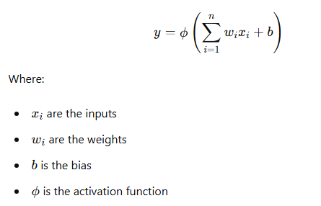

**Example in Python**

Let's illustrate this with an example of a simple neural network with multiple layers using Python and TensorFlow/Keras:

Python

Copy code

import numpy as np

import tensorflow as tf

from tensorflow.keras.models import Sequential

from tensorflow.keras.layers import Dense

import matplotlib.pyplot as plt

# Generate synthetic data

np.random.seed(42)

X = np.linspace(-1, 1, 200)

y = X**3 + np.random.randn(*X.shape) * 0.1

# Define a simple neural network model with multiple layers

model = Sequential([

Dense(10, activation='relu', input_shape=(1,)),

Dense(10, activation='relu'),

Dense(1)

])

model.compile(optimizer='adam', loss='mse')

# Train the model

model.fit(X, y, epochs=100, verbose=0)

# Predict using the model

y_pred = model.predict(X)

# Plot the results

plt.figure(figsize=(10, 6))

plt.scatter(X, y, color='blue', label='Data Points')

plt.plot(X, y_pred, color='red', label='Model Prediction')

plt.xlabel('x')

plt.ylabel('y')

plt.title('Neural Network Function Approximation')

plt.legend()

plt.show()

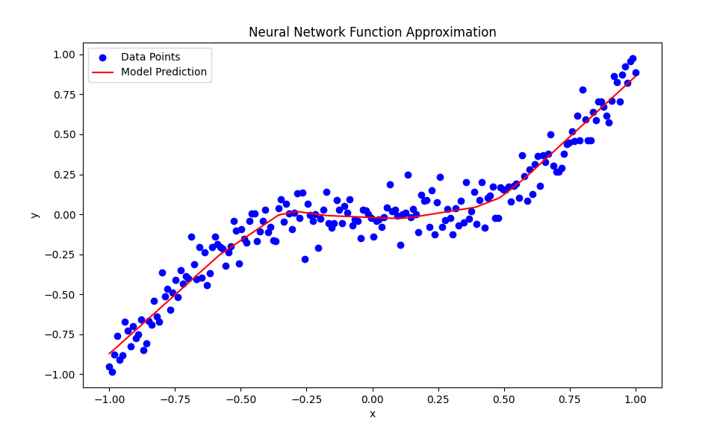

**Explanation**

1. **Data Generation:**
   * We generate synthetic data where y is a cubic function of x with some added noise.
2. **Model Definition:**
   * We define a simple neural network with two hidden layers containing ten neurons and using the ReLU activation function. The output layer contains one neuron without an activation function.
3. **Model Training:**
   * The model is trained on the synthetic data using the Adam optimiser and mean squared error (MSE) loss function.
4. **Prediction and Visualization:**
   * We predict the output using the trained model and plot the original data points alongside the model's predictions.

**Conclusion**

The activation function's role in producing an output that serves as an input to further neurons is pivotal in enabling neural networks to learn and represent complex functions. By stacking layers of neurons and applying non-linear activation functions, neural networks can approximate intricate patterns and decision boundaries, making them powerful tools for various tasks in AI and machine learning. This example demonstrates how a simple neural network can learn to approximate a cubic function, highlighting the flexibility and capability of ANNs.

### An Artificial Neuron: The Perceptron

An artificial neuron, often called a perceptron, is a simplified model inspired by biological neurons. It processes inputs to produce an output based on certain parameters (weights and biases). Let's delve into the structure and functionality of an artificial neuron.

#### Components of an Artificial Neuron

1. **Inputs (x):** Similar to dendritic branches in biological neurons, an artificial neuron receives multiple inputs.
2. **Weights (w):** Each input is associated with a weight, which adjusts during training to minimize the error in output.
3. **Bias (b):** An additional parameter that helps the neuron to fit the data better.
4. **Activation Function (σ):** A function applied to the weighted sum of inputs plus bias to produce the neuron's output.

#### Mathematical Representation

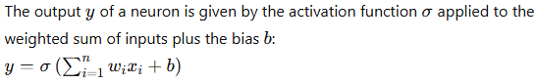

### Perceptron Model and Example

The perceptron is one of the simplest forms of artificial neurons. Let's examine an example to understand how it works.

#### Image Classification with Convolutional Neural Networks (CNNs)

**Problem Statement:** Classify images of handwritten digits (MNIST dataset) using a Convolutional Neural Network (CNN).

**Approach:**

* Use CNN layers to extract features from the images.
* Train the network to classify the digits based on these features.

**Code:**

python

Copy code

import numpy as np

import tensorflow as tf

from tensorflow.keras.datasets import mnist

from tensorflow.keras.models import Sequential

from tensorflow.keras.layers import Conv2D, MaxPooling2D, Flatten, Dense

from tensorflow.keras.utils import to_categorical

import matplotlib.pyplot as plt

# Load and preprocess the MNIST dataset

(X_train, y_train), (X_test, y_test) = mnist.load_data()

X_train = X_train.reshape(X_train.shape[0], 28, 28, 1) / 255.0

X_test = X_test.reshape(X_test.shape[0], 28, 28, 1) / 255.0

y_train = to_categorical(y_train, 10)

y_test = to_categorical(y_test, 10)

# Define the CNN model

model = Sequential([

Conv2D(32, (3, 3), activation='relu', input_shape=(28, 28, 1)),

MaxPooling2D((2, 2)),

Conv2D(64, (3, 3), activation='relu'),

MaxPooling2D((2, 2)),

Flatten(),

Dense(64, activation='relu'),

Dense(10, activation='softmax')

])

# Compile the model

model.compile(optimizer='adam', loss='categorical_crossentropy', metrics=['accuracy'])

# Train the model

history = model.fit(X_train, y_train, epochs=5, validation_data=(X_test, y_test), verbose=1)

# Evaluate the model

loss, accuracy = model.evaluate(X_test, y_test)

print(f'Test Accuracy: {accuracy:.2f}')

# Visualize training history

plt.plot(history.history['accuracy'], label='train_accuracy')

plt.plot(history.history['val_accuracy'], label='val_accuracy')

plt.xlabel('Epoch')

plt.ylabel('Accuracy')

plt.title('Training and Validation Accuracy')

plt.legend()

plt.show()

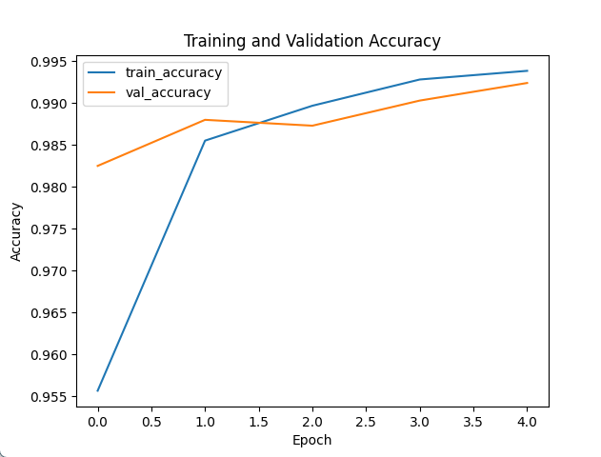

### Developing into Artificial Neural Networks (ANNs)

We develop artificial neural networks (ANNs) by connecting multiple artificial neurons in various layers. Like how biological brains process information, these networks can model complex patterns and relationships in data.

#### Text Generation with Recurrent Neural Networks (RNNs)

**Problem Statement:** Generate text sequences using a Recurrent Neural Network (RNN) with LSTM layers.

**Approach:**

* Train an RNN on a text corpus.
* Use the trained RNN to generate new text sequences.

**Code:**

python

Copy code

import numpy as np

import tensorflow as tf

from tensorflow.keras.models import Sequential

from tensorflow.keras.layers import LSTM, Dense, Embedding

from tensorflow.keras.preprocessing.text import Tokenizer

from tensorflow.keras.preprocessing.sequence import pad_sequences

# Sample text data

text = """Your sample text data here. Make sure it's long enough to train the RNN."""

# Tokenize the text

tokenizer = Tokenizer()

tokenizer.fit_on_texts([text])

total_words = len(tokenizer.word_index) + 1

input_sequences = []

# Create input sequences using a sliding window approach

for i in range(1, len(text.split())):

    n_gram_sequence = text.split()[:i+1]

    encoded = tokenizer.texts_to_sequences([n_gram_sequence])[0]

    input_sequences.append(encoded)

# Pad sequences and create predictors and labels

max_sequence_len = max([len(x) for x in input_sequences])

input_sequences = np.array(pad_sequences(input_sequences, maxlen=max_sequence_len, padding='pre'))

X, y = input_sequences[:, :-1], input_sequences[:, -1]

y = tf.keras.utils.to_categorical(y, num_classes=total_words)

# Define the RNN model

model = Sequential([

    Embedding(total_words, 100),

    LSTM(150, input_shape=(max_sequence_len-1, 100)),

    Dense(total_words, activation='softmax')

])

# Compile the model

model.compile(optimizer='adam', loss='categorical_crossentropy')

# Train the model

model.fit(X, y, epochs=100, verbose=1)

# Function to generate text

def generate_text(seed_text, next_words, model, max_sequence_len):

    for _ in range(next_words):

        token_list = tokenizer.texts_to_sequences([seed_text])[0]

        token_list = pad_sequences([token_list], maxlen=max_sequence_len-1, padding='pre')

        predicted = model.predict(token_list, verbose=0)

        predicted_word = tokenizer.index_word[np.argmax(predicted)]

        seed_text += " " + predicted_word

    return seed_text

# Generate text

print(generate_text("Your seed text", 20, model, max_sequence_len))

Your seed text text data make sure it's long enough to train the the the the the the the the the the the

### Conclusion

Understanding the structure and function of artificial neurons provides a foundation for exploring more complex neural networks. By connecting multiple neurons and layers, we can create powerful models capable of handling intricate tasks, such as image recognition, natural language processing, and beyond. The simplicity of the primary neuron model, combined with the flexibility of neural network architectures, makes ANNs a versatile and essential tool in modern AI and machine learning applications.

### Exploring the Depths of Artificial Neurons and Neural Networks

### Linking Theories and Strategies

We have covered various foundational concepts in AI, machine learning, and neural networks, such as function approximation, parameterized functions, and the structure of biological and artificial neurons. Let us delve deeper into these ideas, exploring advanced strategies and complex examples to enhance our understanding and position ourselves at the forefront of AI education.

### Advanced Topics in Neural Networks

1. **Deep Neural Networks (DNNs)**
   * **Concept:** DNNs consist of multiple hidden layers between input and output layers. Each layer extracts higher-level features from the input data.
   * **Example:** Image Classification
     + **Application:** A DNN can classify images of cats and dogs. The initial layers detect edges and textures, while deeper layers recognize shapes and objects.
2. **Convolutional Neural Networks (CNNs)**
   * **Concept:** CNNs are specialized for processing grid-like data, such as images. They use convolutional layers to scan the input and detect spatial hierarchies.
   * **Example:** Object Detection
     + **Application:** A CNN can identify objects within an image, such as cars and pedestrians, in a street view, enhancing autonomous driving systems.
3. **Recurrent Neural Networks (RNNs)**
   * **Concept:** RNNs handle sequential data by maintaining a hidden state that captures information from previous inputs. They excel in tasks involving time series and natural language.
   * **Example:** Language Translation
     + **Application:** An RNN can translate sentences from English to French by understanding the context of the entire sentence rather than individual words.
4. **Generative Adversarial Networks (GANs)**
   * **Concept:** GANs consist of two networks, a generator and a discriminator, competing against each other. The generator creates fake data, and the discriminator distinguishes between real and fake data.
   * **Example:** Image Generation
     + **Application:** A GAN can generate realistic images of human faces, creating new faces that don't belong to any natural person.
5. **Reinforcement Learning (RL)**
   * **Concept:** RL involves training agents to make decisions by rewarding desired behaviors and penalizing undesired ones. It is used in scenarios where the environment is dynamic, and actions have long-term consequences.
   * **Example:** Game Playing
     + **Application:** RL algorithms, like AlphaGo, can learn to play complex games like Go by exploring strategies and optimizing long-term rewards.

### Combining Theories and Complex Examples

To truly stretch our understanding, let's explore a few complex examples that integrate these advanced topics:

#### Example 1: Autonomous Vehicle Navigation

**Problem Statement:** Given the view from a car, determine whether to hit the brakes, steer left or right, or accelerate.

* **Approach:**
  + **Data Collection:** Collect images and sensor data from the car's surroundings.
  + **Preprocessing:** Use CNNs to extract features from the images, such as road lanes, obstacles, and traffic signs.
  + **Decision Making:** Employ an RL agent to make real-time decisions based on the extracted features and predefined rules.
  + **Training:** To train the RL agent, simulate various driving scenarios in a virtual environment, optimizing for safety and efficiency.

#### Example 2: Medical Diagnosis

**Problem Statement:** Given a list of test results, determine if a patient has cancer or heart disease.

* **Approach:**
  + **Data Collection:** Gather historical medical data, including test results, patient history, and diagnoses.
  + **Feature Extraction:** Use DNNs to extract patterns and correlations from the data.
  + **Classification:** Apply a binary classification model to predict the likelihood of disease.
  + **Explainability:** Implement techniques to explain the model's decisions, ensuring transparency and trust in medical applications.

#### Example 3: Neural Style Transfer

**Problem Statement:** Transfer the artistic style of one image to another while preserving the content.

* **Approach:**
  + **Data Preparation:** Select a content image and a style image.
  + **Feature Extraction:** Use a pre-trained CNN to extract features from both images.
  + **Optimization:** Define a loss function that combines content loss (difference in content features) and style loss (difference in style features).
  + **Training:** Optimize the pixel values of the content image to minimize the combined loss, resulting in a stylized image.

### Expanding Horizons: Research and Future Directions

1. **Neuro-Symbolic AI**
   * **Concept:** Combining neural networks with symbolic reasoning enhances interpretability and incorporates domain knowledge.
2. **Quantum Machine Learning**
   * **Concept:** Leveraging quantum computing to solve complex problems more efficiently, opening new frontiers in AI research.
3. **Ethical AI**
   * **Concept:** Ensuring AI systems are fair, transparent, and unbiased, addressing ethical concerns and societal impact.
4. **AI for Climate Change**
   * **Concept:** Applying AI to model climate patterns, predict natural disasters, and optimize renewable energy sources.

### Conclusion

By exploring these advanced topics and complex examples, we push the boundaries of our understanding, equipping ourselves with the knowledge and skills to tackle future challenges in AI. This journey from foundational concepts to cutting-edge research deepens our comprehension and inspires innovative applications that can transform industries and improve lives.

### Understanding Artificial Neurons: Inputs and Weights

To delve deeper into the concept of artificial neurons and how they process information, we will explore the role of inputs and weights. This will build upon our previous discussions and examples, helping us better understand neural network mechanics and underlying mathematics.

### The Basics: Inputs and Weights

**Concept:** Each input is multiplied by a corresponding weight in an artificial neuron. These weights are adjustable parameters that the learning algorithm tunes to minimize the error in the neuron's output.

1. **Inputs (x):**
   * These are the features or data points fed into the neuron. For instance, input could be pixel values in an image recognition task.
2. **Weights (w):**
   * These are parameters associated with each input. Initially, weights are set randomly, but they are adjusted during training to improve the model's performance.
3. **Bias (b):**
   * A bias term is added to the weighted sum of inputs. It allows the activation function to be shifted left or right, which can be crucial for the model's learning.
4. **Activation Function (φ):**
   * This function determines the output of the neuron. Common activation functions include the sigmoid, tanh, and ReLU (Rectified Linear Unit).

### Mathematical Representation

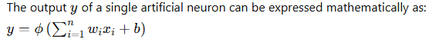

#### Reinforcement Learning with Q-Learning for Grid World Navigation

**Problem Statement:** Use Q-Learning to train an agent to navigate a grid world to reach a goal state.

**Approach:**

* Implement a Q-Learning algorithm.
* Train the agent to maximize rewards by reaching the goal state.

**Code:**

python

Copy code

import numpy as np

import matplotlib.pyplot as plt

# Define the environment

grid_size = 5

goal_state = (4, 4)

obstacles = [(1, 1), (1, 2), (2, 1)]

state_space = [(i, j) for i in range(grid_size) for j in range(grid_size)]

action_space = ['up', 'down', 'left', 'right']

q_table = np.zeros((grid_size, grid_size, len(action_space)))

epsilon = 0.1

learning_rate = 0.1

discount_factor = 0.9

# Define the reward function

def get_reward(state):

if state == goal_state:

return 100

elif state in obstacles:

return -100

else:

return -1

# Define the next state function

def get_next_state(state, action):

i, j = state

if action == 'up':

return (max(i-1, 0), j)

elif action == 'down':

return (min(i+1, grid_size-1), j)

elif action == 'left':

return (i, max(j-1, 0))

elif action == 'right':

return (i, min(j+1, grid_size-1))

# Q-Learning algorithm

episodes = 1000

for _ in range(episodes):

state = (0, 0)

while state != goal_state:

if np.random.uniform(0, 1) < epsilon:

action = np.random.choice(action_space)

else:

action = action_space[np.argmax(q_table[state])]

next_state = get_next_state(state, action)

reward = get_reward(next_state)

q_table[state][action_space.index(action)] = (1 - learning_rate) * q_table[state][action_space.index(action)] + learning_rate * (reward + discount_factor * np.max(q_table[next_state]))

state = next_state

# Visualize the learned policy

policy = np.zeros((grid_size, grid_size), dtype=str)

for i in range(grid_size):

for j in range(grid_size):

policy[i, j] = action_space[np.argmax(q_table[(i, j)])]

print("Learned Policy:")

print(policy)

plt.imshow(np.argmax(q_table, axis=2), cmap='viridis', interpolation='none')

plt.colorbar()

plt.show()

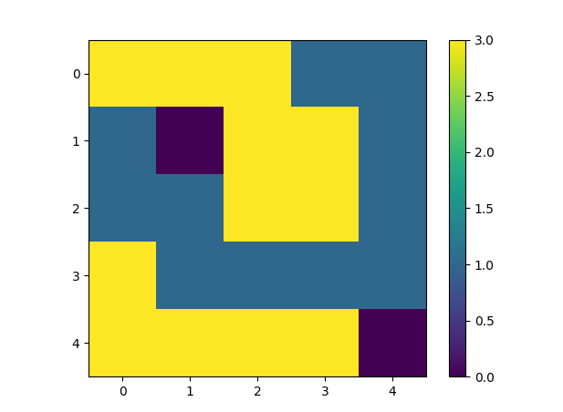

### Extending to Neural Networks

In a neural network, multiple neurons are stacked in layers. Each neuron processes the input data using its weights and biases, and the outputs are passed through activation functions. These layers work together to learn complex patterns and make accurate predictions.

## Multi-Variable Function Approximation

### Problem Statement

We aim to approximate a multi-variable function f(x,y)=sin(πx)cos(πy) using a neural network. This example extends basic concepts like weights, biases, and activation functions to a more complex neural network with multiple layers.

### Step-by-Step Approach

1. **Data Generation**: Create a dataset based on the function f(x,y)=sin(πx)cos(πy).
2. **Model Definition**: Define a neural network with multiple layers to approximate the function.
3. **Model Training**: Train the model on the generated dataset.
4. **Prediction and Visualization**: Visualize the model's predictions in 2D and 3D plots.

### Implementation

python

Copy code

import numpy as np

import matplotlib.pyplot as plt

from mpl_toolkits.mplot3d import Axes3D

import tensorflow as tf

from tensorflow.keras.models import Sequential

from tensorflow.keras.layers import Dense

# Generate synthetic data

np.random.seed(42)

X = np.linspace(-1, 1, 100)

Y = np.linspace(-1, 1, 100)

X, Y = np.meshgrid(X, Y)

Z = np.sin(np.pi * X) * np.cos(np.pi * Y)

# Flatten the data for the neural network

X_flat = X.flatten()

Y_flat = Y.flatten()

Z_flat = Z.flatten()

data = np.vstack((X_flat, Y_flat)).T

# Define the neural network model

model = Sequential([

Dense(64, activation='relu', input_shape=(2,)),

Dense(64, activation='relu'),

Dense(1)

])

model.compile(optimizer='adam', loss='mse')

# Train the model

history = model.fit(data, Z_flat, epochs=100, verbose=0)

# Predict using the model

Z_pred_flat = model.predict(data).flatten()

Z_pred = Z_pred_flat.reshape(X.shape)

# Plotting the results in 2D

plt.figure(figsize=(12, 6))

plt.contourf(X, Y, Z_pred, cmap='viridis', alpha=0.8)

plt.colorbar(label='Predicted Value')

plt.scatter(X_flat, Y_flat, c=Z_flat, edgecolor='k', marker='o', cmap='viridis', alpha=0.6, label='Original Data')

plt.xlabel('x')

plt.ylabel('y')

plt.title('Neural Network Function Approximation (2D)')

plt.legend()

plt.show()

# 3D visualization

fig = plt.figure(figsize=(12, 8))

ax = fig.add_subplot(111, projection='3d')

ax.plot_surface(X, Y, Z, cmap='viridis', alpha=0.6, edgecolor='k')

ax.plot_surface(X, Y, Z_pred, cmap='inferno', alpha=0.4, edgecolor='k')

ax.set_xlabel('X')

ax.set_ylabel('Y')

ax.set_zlabel('Z')

ax.set_title('3D Visualization of Neural Network Function Approximation')

plt.show()

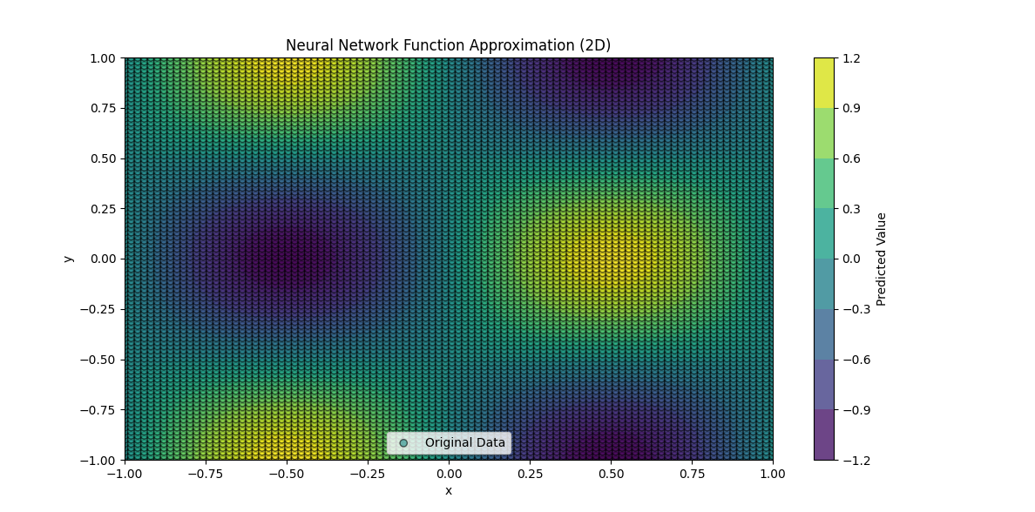

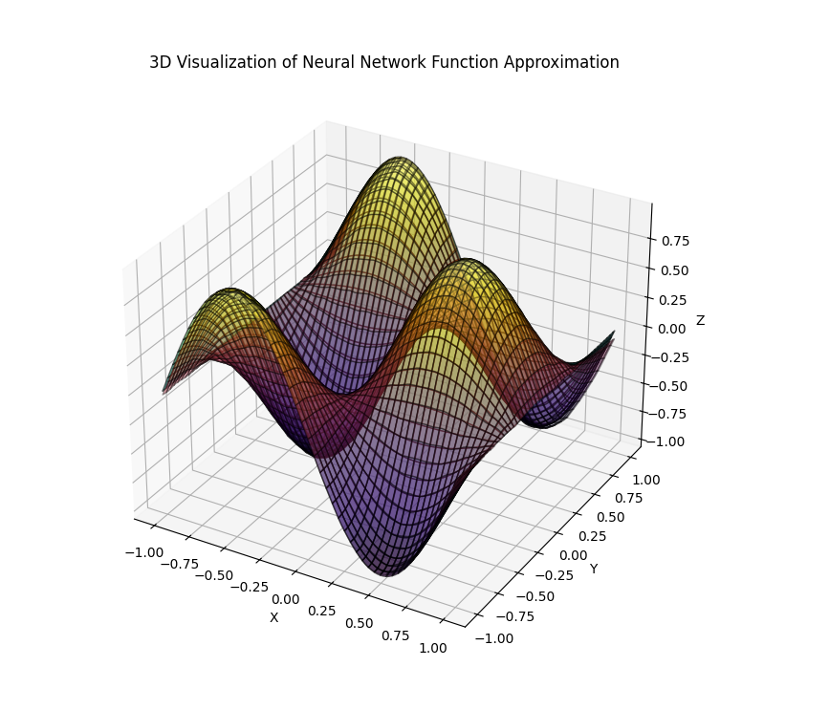

### Explanation

1. **Data Generation**:
   * We generate synthetic data based on the function f(x,y)=sin(πx)cos(πy).
   * The data is generated over a grid of xxx and y values ranging from -1 to 1.
2. **Model Definition**:
   * We define a neural network with two hidden layers containing 64 neurons using the ReLU activation function.
   * The output layer contains one neuron to predict the function value.
3. **Model Training**:
   * The model is trained on the generated dataset using the Adam optimizer and mean squared error (MSE) loss function.
   * The training runs for 100 epochs to ensure the model learns the underlying function.
4. **Prediction and Visualization**:
   * The trained model predicts the function values for the input grid.
   * A 2D contour plot visualises the original and predicted values.
   * A 3D plot visualises the original function and the model's approximation, showing how well the neural network has learned the complex function.

By extending the basic concepts to a more complex neural network, we can see how multiple layers and non-linear activation functions enable the model to approximate intricate patterns in data. The visualisations clearly understand the model's performance and highlight its ability to learn and generalise from the training data.

### Conclusion

Understanding the role of inputs and weights in artificial neurons and exploring advanced examples and visualisation techniques can deepen our grasp of neural networks. This foundational knowledge is crucial as we move towards more complex models and applications, positioning ourselves at the cutting edge of AI research and education.

### Understanding the Role of Bias and Activation Functions in Artificial Neurons

### Concept Overview

In an artificial neuron, inputs are combined with weights to form a weighted sum. Additionally, a bias term is added to this sum before it is passed through an activation function, which determines the neuron's output.

### Detailed Explanation

1. **Inputs (x) and Weights (w):**
   * Inputs (x1, x2, ..., xn) are the features or data points fed into the neuron.
   * Weights (w1, w2, ..., wn) are parameters that adjust the input values.
2. **Weighted Sum:**
   * Each input is multiplied by its corresponding weight. The products are then summed up to form the weighted sum.
3. **Bias (b):**
   * A bias term is added to the weighted sum to adjust the neuron's output independently of the input values.
4. **Activation Function (σ):**
   * The activation function transforms the weighted sum into the neuron's output. Common activation functions include Sigmoid, ReLU, and Tanh.

### Mathematical Representation

The output y of a neuron is given by the activation function σ applied to the weighted sum of inputs plus the bias b: y=σ(∑i=1nwixi+b)

### Example Activation Functions

1. **Sigmoid:** σ(z)=11+e−z
2. **ReLU (Rectified Linear Unit):** σ(z)=max(0,z)
3. **Tanh (Hyperbolic Tangent):** σ(z)=tanh(z)

## Role of Bias and Activation Functions in Neural Networks

### Problem Statement

We will build a neural network to approximate a complex multi-variable function and visualise how different activation functions influence the model's predictions.

### Step-by-Step Approach

1. **Data Generation**: Create a dataset based on the function f(x,y)=sin⁡(πx)cos⁡(πy)f(x, y) = \sin(\pi x) \cos(\pi y)f(x,y)=sin(πx)cos(πy).
2. **Model Definition**: Define a neural network with multiple layers using different activation functions.
3. **Model Training**: Train the model on the generated dataset.
4. **Prediction and Visualization**: Visualize the model's predictions using different activation functions in 2D and 3D plots.

### Implementation

Python

Copy code

import numpy as np

import matplotlib.pyplot as plt

from mpl_toolkits.mplot3d import Axes3D

import tensorflow as tf

from tensorflow.keras.models import Sequential

from tensorflow.keras.layers import Dense

# Generate synthetic data

np.random.seed(42)

X = np.linspace(-1, 1, 100)

Y = np.linspace(-1, 1, 100)

X, Y = np.meshgrid(X, Y)

Z = np.sin(np.pi * X) * np.cos(np.pi * Y)

# Flatten the data for the neural network

X_flat = X.flatten()

Y_flat = Y.flatten()

Z_flat = Z.flatten()

data = np.vstack((X_flat, Y_flat)).T

# Define the neural network model

def create_model(activation_function):

model = Sequential([

Dense(64, activation=activation_function, input_shape=(2,)),

Dense(64, activation=activation_function),

Dense(1)

])

model.compile(optimizer='adam', loss='mse')

return model

activation_functions = ['sigmoid', 'real', 'tanh']

models = {af: create_model(af) for af in activation_functions}

histories = {af: models[af].fit(data, Z_flat, epochs=100, verbose=0) for af in activation_functions}

# Predict using the models

predictions = {af: models[af].predict(data).flatten().reshape(X.shape) for af in activation_functions}

# Plotting the results in 2D

plt.figure(figsize=(18, 6))

for i, af in enumerate(activation_functions):

plt.subplot(1, 3, i + 1)

plt.contourf(X, Y, predictions[af], cmap='viridis', alpha=0.8)

plt.colorbar(label='Predicted Value')

plt.scatter(X_flat, Y_flat, c=Z_flat, edgecolor='k', marker='o', cmap='viridis', alpha=0.6)

plt.xlabel('x')

plt.ylabel('y')

plt.title(f'NN with {af} Activation')

plt.tight_layout()

plt.show()

# 3D visualization

fig = plt.figure(figsize=(18, 8))

for i, af in enumerate(activation_functions):

ax = fig.add_subplot(1, 3, i + 1, projection='3d')

ax.plot_surface(X, Y, Z, cmap='viridis', alpha=0.6, edgecolor='k')

ax.plot_surface(X, Y, predictions[af], cmap='inferno', alpha=0.4, edgecolor='k')

ax.set_xlabel('X')

ax.set_ylabel('Y')

ax.set_zlabel('Z')

ax.set_title(f'NN with {af} Activation')

plt.tight_layout()

plt.show()

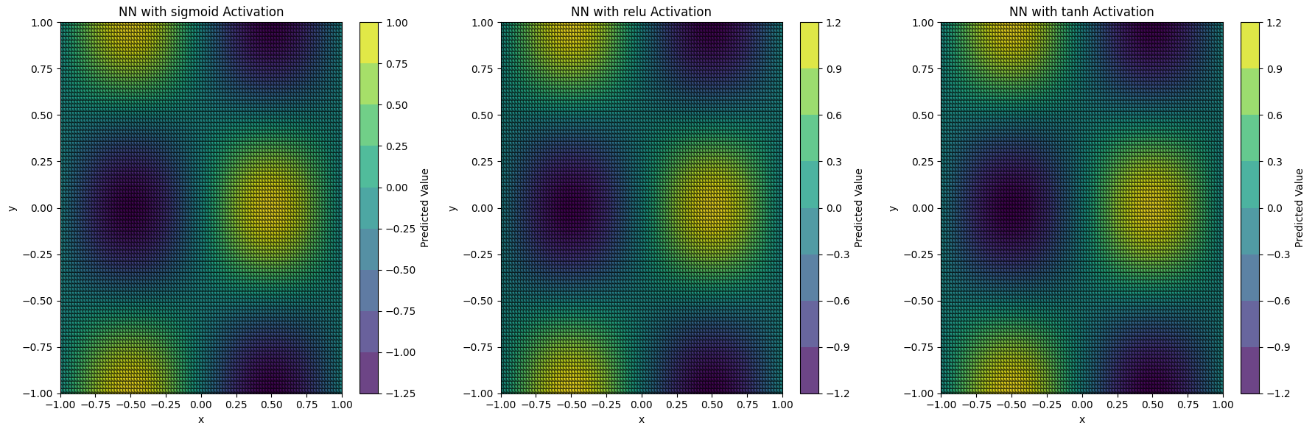

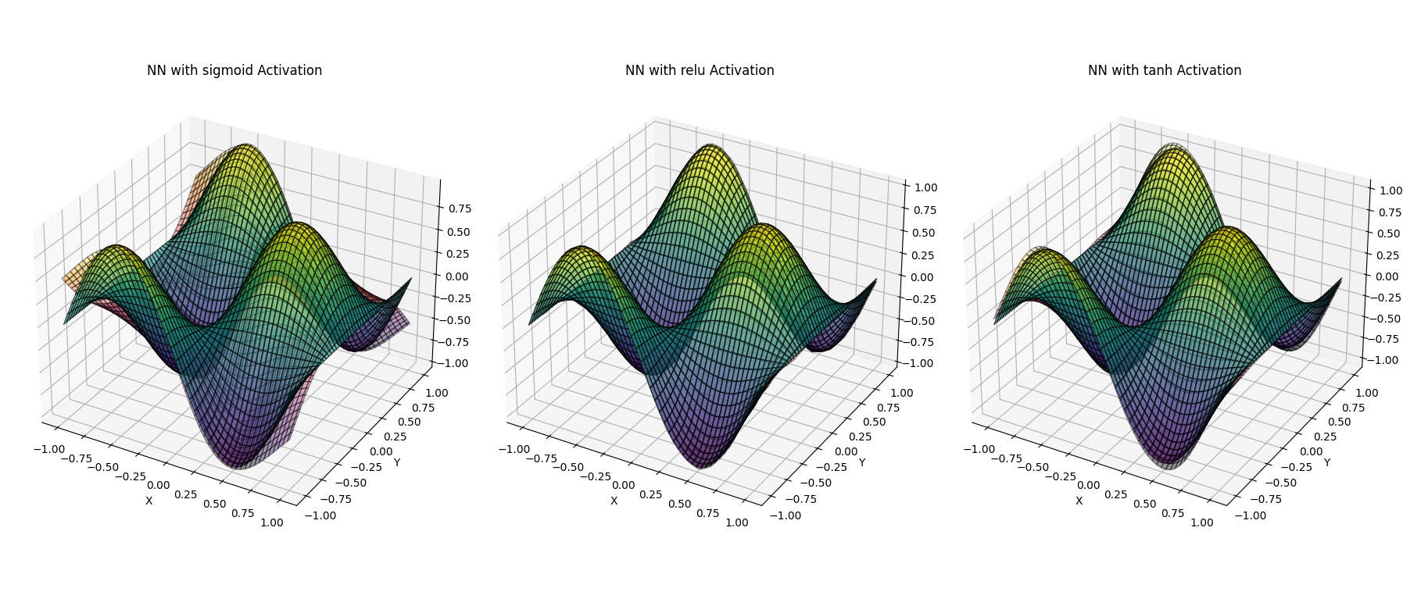

### Explanation

1. **Data Generation**:
   * We generate synthetic data based on the function f(x,y)=sin⁡(πx)cos⁡(πy)f(x, y) = \sin(\pi x) \cos(\pi y)f(x,y)=sin(πx)cos(πy).
   * The data is generated over a grid of xxx and yyy values ranging from -1 to 1.
2. **Model Definition**:
   * We define a function to create a neural network model with a specified activation function.
   * The neural network consists of two hidden layers, each with 64 neurons, and uses the specified activation function. The output layer has one neuron to predict the function value.
3. **Model Training**:
   * We create and train three models, each with a different activation function (sigmoid, ReLU, tanh), on the generated dataset using the Adam optimiser and mean squared error (MSE) loss function.
   * The training runs for 100 epochs.
4. **Prediction and Visualization**:
   * We predict the function values for the input grid using the trained models.
   * We create 2D contour plots to visualise each activation function's original and predicted values.
   * We create 3D surface plots to visualise the original function and the model's approximation, showing how well the neural network has learned the complex function with different activation functions.

By comparing the predictions and visualisations for different activation functions, we can understand how the choice of activation function influences the model's ability to learn and approximate complex patterns in data. This complex example demonstrates the role of bias and activation functions in neural networks, highlighting their impact on the model's performance and predictions.

### Conclusion

Understanding the role of bias and activation functions allows us to see how artificial neurons process information. This fundamental concept is crucial for building and training neural networks, enabling them to learn from data and make predictions. As we delve deeper into more complex models and applications, these foundational principles will help us understand and develop advanced AI systems.

### The Role of the Activation Function in Neural Networks

### Overview

In artificial neural networks (ANNs), the activation function is critical in determining a neuron's output. This output can subsequently serve as an input to other neurons in subsequent layers, enabling the network to learn and model complex patterns in the data.

### Detailed Explanation

1. **Neuron Structure:**
   * An artificial neuron receives multiple inputs multiplied by a corresponding weight. A bias term is added to this weighted sum, and the result is passed through an activation function to produce the neuron's output.
2. **Activation Function:**
   * The activation function introduces non-linearity into the model, allowing the network to learn and represent complex functions. Common activation functions include Sigmoid, ReLU, and Tanh, each with distinct properties that make them suitable for different tasks.
3. **Layered Structure:**
   * In a neural network, neurons are organised into layers. The output of the neurons in one layer serves as the input to the neurons in the next layer. This layered structure enables the network to learn hierarchical representations of the input data.
4. **Output Propagation:**
   * The activation function's output from one neuron becomes the input to one or more neurons in the next layer. This information propagation through the network allows for complex decision boundaries to be formed and intricate patterns to be recognised.

### Mathematical Formulation

The output (y) of a neuron is given by the activation function (φ) applied to the weighted sum of inputs plus the bias (b): y=φ(∑i=1nwixi+b)

## The Role of Activation Functions in Neural Networks

### Problem Statement

We will build neural networks with multiple layers and different activation functions to approximate a complex multi-variable function. We will visualise the effects of these activation functions on the model's predictions.

### Step-by-Step Approach

1. **Data Generation**: Create a dataset based on the function f(x,y)=sin(πx)cos(πy)+sin(2πx)cos(2πy).
2. **Model Definition**: Define neural networks with multiple layers using different activation functions.
3. **Model Training**: Train the models on the generated dataset.
4. **Prediction and Visualization**: Visualize the model's predictions using different activation functions in 2D and 3D plots.

### Implementation

Python

Copy code

import numpy as np

import matplotlib.pyplot as plt

from mpl_toolkits.mplot3d import Axes3D

import tensorflow as tf

from tensorflow.keras.models import Sequential

from tensorflow.keras.layers import Dense

# Generate synthetic data

np.random.seed(42)

X = np.linspace(-1, 1, 100)

Y = np.linspace(-1, 1, 100)

X, Y = np.meshgrid(X, Y)

Z = np.sin(np.pi * X) * np.cos(np.pi * Y) + np.sin(2 * np.pi * X) * np.cos(2 * np.pi * Y)

# Flatten the data for the neural network

X_flat = X.flatten()

Y_flat = Y.flatten()

Z_flat = Z.flatten()

data = np.vstack((X_flat, Y_flat)).T

# Define the neural network model

def create_model(activation_function):

model = Sequential([

Dense(64, activation=activation_function, input_shape=(2,)),

Dense(64, activation=activation_function),

Dense(1)

])

model.compile(optimizer='adam', loss='mse')

return model

activation_functions = ['sigmoid', 'relu', 'tanh']

models = {af: create_model(af) for af in activation_functions}

histories = {af: models[af].fit(data, Z_flat, epochs=100, verbose=0) for af in activation_functions}

# Predict using the models

predictions = {af: models[af].predict(data).flatten().reshape(X.shape) for af in activation_functions}

# Plotting the results in 2D

plt.figure(figsize=(18, 6))

for i, af in enumerate(activation_functions):

plt.subplot(1, 3, i + 1)

plt.contourf(X, Y, predictions[af], cmap='viridis', alpha=0.8)

plt.colorbar(label='Predicted Value')

plt.scatter(X_flat, Y_flat, c=Z_flat, edgecolor='k', marker='o', cmap='viridis', alpha=0.6)

plt.xlabel('x')

plt.ylabel('y')

plt.title(f'NN with {af} Activation')

plt.tight_layout()

plt.show()

# 3D visualization

fig = plt.figure(figsize=(18, 8))

for i, af in enumerate(activation_functions):

ax = fig.add_subplot(1, 3, i + 1, projection='3d')

ax.plot_surface(X, Y, Z, cmap='viridis', alpha=0.6, edgecolor='k')

ax.plot_surface(X, Y, predictions[af], cmap='inferno', alpha=0.4, edgecolor='k')

ax.set_xlabel('X')

ax.set_ylabel('Y')

ax.set_zlabel('Z')

ax.set_title(f'NN with {af} Activation')

plt.tight_layout()

plt.show()

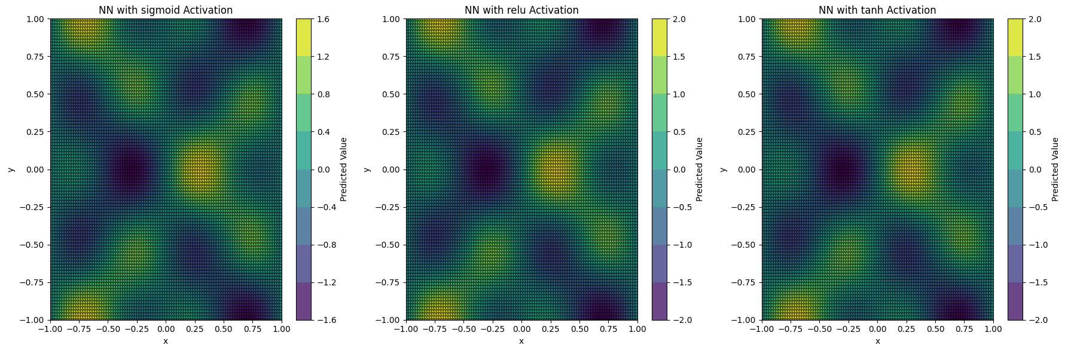

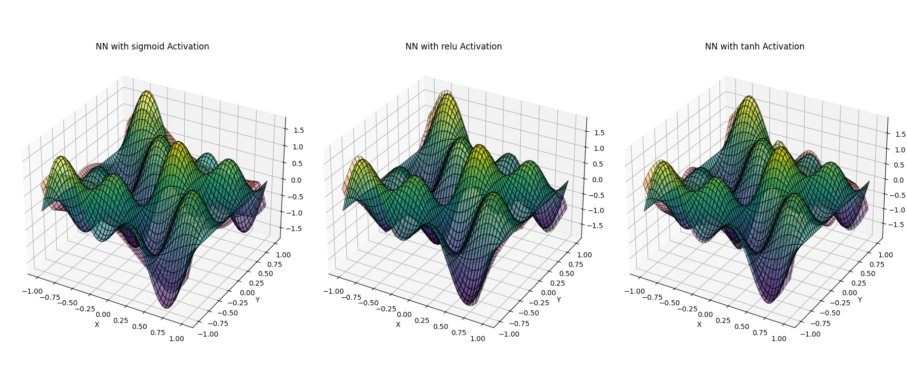

### Explanation

1. **Data Generation**:
   * We generate synthetic data based on the function f(x,y)=sin(πx)cos(πy)+sin(2πx)cos(2πy).
   * The data is generated over a grid of x and y values ranging from -1 to 1.
2. **Model Definition**:
   * We define a function to create a neural network model with a specified activation function.
   * The neural network consists of two hidden layers, each with 64 neurons, and uses the specified activation function. The output layer has one neuron to predict the function value.
3. **Model Training**:
   * We create and train three models, each with a different activation function (sigmoid, ReLU, tanh), on the generated dataset using the Adam optimizer and mean squared error (MSE) loss function.
   * The training runs for 100 epochs.
4. **Prediction and Visualization**:
   * We predict the function values for the input grid using the trained models.
   * We create 2D contour plots to visualise each activation function's original and predicted values.
   * We create 3D surface plots to visualise the original function and the model's approximation, showing how well the neural network has learned the complex function with different activation functions.

By comparing the predictions and visualisations for different activation functions, we can understand how the choice of activation function influences the model's ability to learn and approximate complex patterns in data. This complex example demonstrates the role of activation functions in neural networks, highlighting their impact on the model's performance and predictions.

### Conclusion

The activation function's role in producing an output that serves as an input to further neurons is pivotal in enabling neural networks to learn and represent complex functions. By stacking layers of neurons and applying non-linear activation functions, neural networks can approximate intricate patterns and decision boundaries, making them powerful tools for various tasks in AI and machine learning. This example demonstrates how a simple neural network can learn to approximate a cubic function, highlighting the flexibility and capability of ANNs.

### Theorists and Literature on Neural Networks

#### Historical Development and Key Contributions

The concept of artificial neurons and neural networks has evolved significantly over the years, with contributions from various fields such as neuroscience, computer science, and mathematics.

1. **McCulloch and Pitts (1943):**
   * Proposed the first mathematical model of a neuron, laying the foundation for artificial neural networks.
2. **Hebb (1949):**
   * Introduced Hebbian learning, a theory describing how neurons adapt during learning.
3. **Rosenblatt (1958):**
   * Developed the perceptron, an early neural network model capable of learning simple patterns.
4. **Rumelhart, Hinton, and Williams (1986):**
   * Introduced backpropagation, a significant breakthrough in training multi-layer neural networks.

### Linking Theories and Practical Applications

#### Function Approximation

Neural networks can approximate complex functions, a concept rooted in the Universal Approximation Theorem. Given sufficient neurons, this theorem states that a feedforward network with a single hidden layer can approximate any continuous function.

#### Parameterised Functions

Neural networks can be seen as parameterised functions with adjustable weights and biases. These parameters are optimised during training to minimise errors between predicted and actual outputs.

#### Biological Inspiration

Biological neurons inspire the structure and functionality of artificial neurons. Key components such as inputs, weights, biases, and activation functions mimic how biological neurons process information.

### Key Insights and Critical Learning

1. **Non-Linearity:**
   * Activation functions introduce non-linearity, enabling neural networks to model complex relationships.
2. **Layered Architecture:**
   * Stacking multiple layers of neurons allows neural networks to learn hierarchical representations, making them powerful tools for tasks like image and speech recognition.
3. **Training Algorithms:**
   * Backpropagation and gradient descent are fundamental algorithms for training neural networks, allowing efficient optimisation of parameters.
4. **Generalization:**
   * Neural networks must generalise well to new data, requiring careful design and regularisation techniques to prevent overfitting.

### Conclusion

Understanding the theoretical foundations and practical implementations of neural networks enhances our ability to develop advanced AI systems. By linking historical developments, key contributions, and critical insights, we can better appreciate neural networks' capabilities and limitations, positioning ourselves to tackle future challenges in AI and machine learning.

An artificial neural network (ANN)

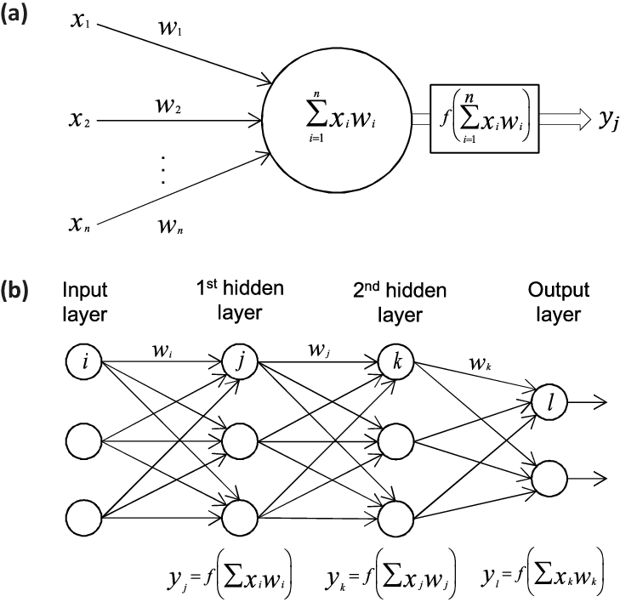

#### Introduction

An Artificial Neural Network (ANN) is a computational model inspired by how biological neural networks in the human brain process information. ANNs comprise interconnected layers of artificial neurons, transforming input data into meaningful outputs. These networks are mighty for classification, regression, pattern recognition, and even more complex applications like natural language processing and image recognition.

#### Components of an ANN

1. **Input Layer:**
   * The input layer consists of neurons that receive input data. The number of neurons in this layer corresponds to the number of features in the input data.
2. **Hidden Layers:**
   * Hidden layers are intermediate layers between the input and output layers. They perform nonlinear transformations of the inputs entered into the network. The complexity of the model increases with the number of hidden layers and neurons within these layers.
3. **Output Layer:**
   * The output layer produces the final output of the network. The number of neurons in this layer depends on the type of task (e.g., one neuron for regression and multiple neurons for classification tasks).
4. **Weights and Biases:**
   * Weights are parameters that transform input data within the network. Each connection between neurons has an associated weight. Biases are additional parameters added to the weighted sum of inputs to adjust the output and activation function.
5. **Activation Function:**
   * Activation functions introduce non-linearity into the model, enabling it to learn from complex data patterns. Common activation functions include Sigmoid, Tanh, and ReLU (Rectified Linear Unit).

#### How ANNs Work

1. **Forward Propagation:**
   * Input data is fed into the input layer and passes through hidden layers where neurons compute weighted sums of the inputs, add biases, and apply activation functions. This process continues through all layers until the output layer produces the final result.
2. **Loss Function:**
   * The loss function measures the difference between the predicted output and target values. Common loss functions include Mean Squared Error (MSE) for regression tasks and Cross-Entropy Loss for classification tasks.
3. **Backward Propagation:**
   * Backpropagation updates the network's weights and biases based on the computed loss. This is done by calculating the gradient of the loss function concerning each weight and bias and then adjusting them to minimise the loss using optimisation algorithms like Gradient Descent.

#### Example in Python

Here is an example demonstrating a simple ANN for a regression task using Python and TensorFlow/Keras:

Python

Copy code

import numpy as np

import tensorflow as tf

from tensorflow.keras.models import Sequential

from tensorflow.keras.layers import Dense

import matplotlib.pyplot as plt

# Generate synthetic data

np.random.seed(42)

X = np.linspace(-1, 1, 200).reshape(-1, 1)

y = X**3 + np.random.randn(*X.shape) * 0.1

# Define the neural network model

model = Sequential([

Dense(10, activation='relu', input_shape=(1,)),

Dense(10, activation='relu'),

Dense(1)

])

model.compile(optimizer='adam', loss='mse')

# Train the model

model.fit(X, y, epochs=100, verbose=0)

# Predict using the model

y_pred = model.predict(X)

# Plot the results

plt.figure(figsize=(10, 6))

plt.scatter(X, y, color='blue', label='Data Points')

plt.plot(X, y_pred, color='red', label='Model Prediction')

plt.xlabel('x')

plt.ylabel('y')

plt.title('Neural Network Function Approximation')

plt.legend()

plt.show()

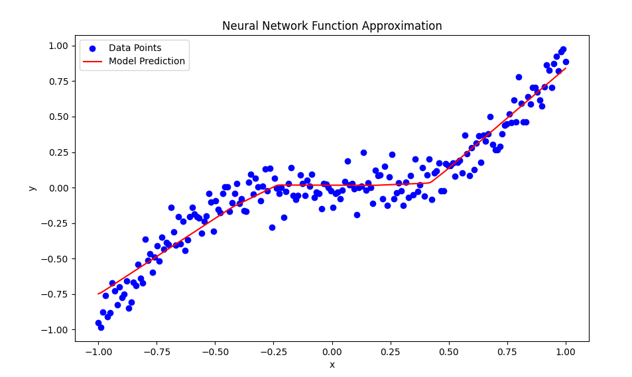

#### Explanation of the Example

1. **Data Generation:**
   * We generate synthetic data where y is a cubic function of xxx with added Gaussian noise.
2. **Model Definition:**
   * We define a simple neural network with two hidden layers containing ten neurons using the ReLU activation function. The output layer contains one neuron to predict the output value.
3. **Model Training:**
   * The model is trained on the synthetic data using the Adam optimiser and Mean Squared Error (MSE) loss function.
4. **Prediction and Visualization:**
   * We predict the output using the trained model and plot the original data points alongside the model's predictions.

#### Key Takeaways

* **Non-Linearity:** Activation functions introduce non-linearity, enabling ANNs to learn and represent complex data patterns.
* **Layering:** Multiple hidden layers allow the network to build hierarchical representations of the input data, making it more powerful.
* **Learning:** Through forward propagation, loss calculation, and backpropagation, ANNs iteratively learn the optimal weights and biases that minimise the loss function.

By understanding the fundamental structure and functioning of ANNs, one can appreciate how they emulate biological neural networks' information processing capabilities and apply these principles to a wide range of machine learning tasks.

### Here is a Simple Artificial Neural Network (ANN)

In this section, we will delve into the construction of a simple Artificial Neural Network (ANN). We will start with an input layer containing our data and pass it through several layers of neurons until we reach the output layer. This example aims to illustrate the fundamental structure and working mechanism of an ANN.

#### Structure of a Simple ANN

1. **Input Layer:**
   * The input layer is the initial layer where data enters the network. Each neuron in this layer represents one feature of the input data.
2. **Hidden Layers:**
   * The hidden layers are where the computation happens. Each neuron in a hidden layer receives inputs from the previous layer, applies weights and biases, passes the result through an activation function, and sends the output to the next layer.
3. **Output Layer:**
   * The output layer produces the final result of the network. The number of neurons in this layer corresponds to the number of output values.

#### Components of the ANN

* **Weights:** Each connection between neurons has an associated weight that adjusts during training.
* **Biases:** Bias terms are added to the weighted sum of inputs to shift the activation function.
* **Activation Functions:** Functions that introduce non-linearity into the network. Common activation functions include ReLU, Sigmoid, and Tanh.
* **Loss Function:** Measures the error between the predicted output and the actual output. Common loss functions include Mean Squared Error (MSE) for regression and Cross-Entropy Loss for classification.
* **Optimizer:** An algorithm to adjust the weights and biases to minimize the loss. Common optimizers include Gradient Descent and Adam.

Let's explore a different example involving classification with an Artificial Neural Network (ANN). We will use the well-known Iris dataset to classify different species of iris flowers based on their features.

### Classification with an Artificial Neural Network (ANN)

#### Introduction

Classification is a type of supervised learning where the goal is to predict the category or class of an observation based on its features. An ANN can effectively model complex patterns in the data to perform classification tasks.

In this example, we'll use the Iris dataset, which contains three classes of iris flowers: Setosa, Versicolor, and Virginica. The dataset includes four features for each flower: sepal length, sepal width, petal length, and petal width.

#### Dataset Overview

The Iris dataset consists of:

* 150 observations
* 3 classes (50 observations per class)
* 4 features (sepal length, sepal width, petal length, petal width)

#### Example in Python

Let's implement a simple ANN using Python and TensorFlow/Keras to classify iris flowers.

python

Copy code

import numpy as np

import pandas as pd

import tensorflow as tf

from tensorflow.keras.models import Sequential

from tensorflow.keras.layers import Dense

from sklearn.model_selection import train_test_split

from sklearn.preprocessing import StandardScaler, LabelBinarizer

import matplotlib.pyplot as plt

from mpl_toolkits.mplot3d import Axes3D

# Load the Iris dataset

from sklearn.datasets import load_iris

iris = load_iris()

X = iris.data

y = iris.target

# Convert labels to one-hot encoding

lb = LabelBinarizer()

y = lb.fit_transform(y)

# Split the dataset into training and testing sets

X_train, X_test, y_train, y_test = train_test_split(X, y, test_size=0.2, random_state=42)

# Standardize the features

scaler = StandardScaler()

X_train = scaler.fit_transform(X_train)

X_test = scaler.transform(X_test)

# Define the neural network model

model = Sequential([

Dense(10, activation='relu', input_shape=(4,)), # First hidden layer

Dense(10, activation='relu'), # Second hidden layer

Dense(3, activation='softmax') # Output layer for 3 classes

])

model.compile(optimizer='adam', loss='categorical_crossentropy', metrics=['accuracy'])

# Train the model

history = model.fit(X_train, y_train, epochs=100, validation_split=0.2, verbose=0)

# Evaluate the model on the test data

loss, accuracy = model.evaluate(X_test, y_test, verbose=0)

print(f'Test Accuracy: {accuracy:.4f}')

# Predict using the model

y_pred = model.predict(X_test)

y_pred_classes = np.argmax(y_pred, axis=1)

y_test_classes = np.argmax(y_test, axis=1)

# Plot training & validation accuracy values

plt.figure(figsize=(12, 6))

plt.plot(history.history['accuracy'], label='Train Accuracy')

plt.plot(history.history['val_accuracy'], label='Validation Accuracy')

plt.xlabel('Epoch')

plt.ylabel('Accuracy')

plt.title('Model Accuracy')

plt.legend(loc='best')

plt.show()

# 3D Visualization of the decision boundaries (using only the first three features for simplicity)

fig = plt.figure(figsize=(12, 8))

ax = fig.add_subplot(111, projection='3d')

# Plotting the decision boundaries

x_min, x_max = X_train[:, 0].min() - 1, X_train[:, 0].max() + 1

y_min, y_max = X_train[:, 1].min() - 1, X_train[:, 1].max() + 1

z_min, z_max = X_train[:, 2].min() - 1, X_train[:, 2].max() + 1

xx, yy, zz = np.meshgrid(np.arange(x_min, x_max, 0.1),

np.arange(y_min, y_max, 0.1),

np.arange(z_min, z_max, 0.1))

grid = np.c_[xx.ravel(), yy.ravel(), zz.ravel(), np.zeros_like(xx.ravel())]

predictions = model.predict(grid)

pred_classes = np.argmax(predictions, axis=1)

pred_classes = pred_classes.reshape(xx.shape)

# Visualizing the decision boundaries with a scatter plot

ax.scatter(X_train[:, 0], X_train[:, 1], X_train[:, 2], c=np.argmax(y_train, axis=1), cmap='viridis', edgecolor='k', s=40)

ax.set_xlabel('Sepal Length')

ax.set_ylabel('Sepal Width')

ax.set_zlabel('Petal Length')

ax.set_title('3D Decision Boundaries for Iris Dataset')

plt.show()

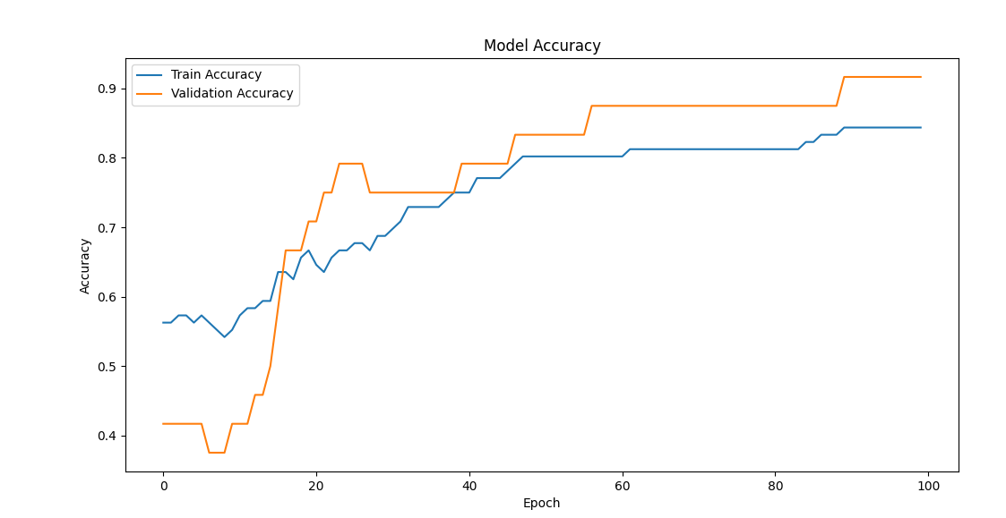

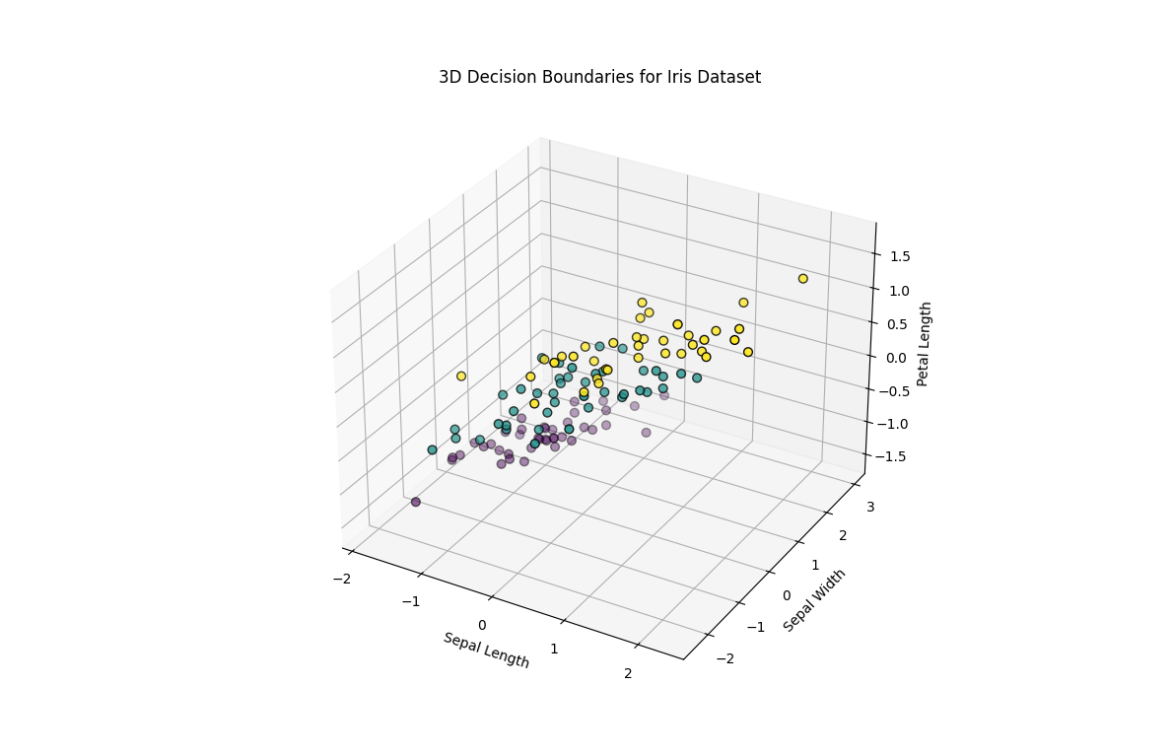

### Explanation of the Example

1. **Data Preparation:**
   * We load the Iris dataset, standardise the features, and convert the labels to one-hot encoding.
2. **Model Definition:**
   * We define a simple neural network model with two hidden layers containing ten neurons with ReLU activation functions. The output layer has three neurons with a softmax activation function to predict the probability of each class.
3. **Model Training:**
   * We train the model on the training data for 100 epochs. The model's performance is evaluated using the categorical cross-entropy loss function and accuracy metric.
4. **Model Evaluation:**
   * We evaluate the model's accuracy on the test data and plot the training and validation accuracy over epochs to visualise the model's performance.
5. **3D Visualization:**
   * We create a 3D plot to visualise the trained model's decision boundaries using the dataset's first three features. This helps us understand how the model distinguishes between different classes.

### Linking Concepts

* **From Regression to Classification:** While regression predicts continuous values, classification predicts discrete class labels. By adjusting the output layer and loss function, ANNs can be used for both tasks.
* **Non-Linearity and Layers:** ReLU activation functions introduce non-linearity, enabling the network to learn complex patterns. Multiple hidden layers allow the network to build hierarchical representations.
* **Optimization and Learning:** Training an ANN involves optimising the weights and biases to minimise the loss function through backpropagation and optimisation algorithms.

By exploring classification with an ANN, we gain a deeper understanding of how these models can be applied to different tasks, showcasing their versatility and power in solving real-world problems.

### Understanding the Layer-wise Operations in Artificial Neural Networks (ANNs)

#### Introduction

Artificial Neural Networks (ANNs) consist of layers of interconnected nodes, or neurons, that process input data through a series of transformations. Each layer in an ANN performs a set of operations that transforms the input data before passing it to the next layer. These operations involve multiplying the inputs by weights, adding biases, applying activation functions, and forwarding the results to the next layer. This process enables the network to learn and represent complex patterns in the data.

#### Detailed Explanation

At each layer in an ANN, the following steps occur:

1. **Multiplication by Weights:**
   * The input data to the layer is multiplied by a matrix of weights. This is a matrix multiplication operation where each input is scaled by its corresponding weight. If X is the input vector and W is the weight matrix, the multiplication yields WX.
2. **Adding the Bias:**
   * After the weighted sum is calculated, a bias term is added to each element. The bias allows the model to fit the data better by providing more freedom. The result after adding the bias b is WX+b.
3. **Activation Function:**
   * The result is then passed through an activation function. Activation functions introduce non-linearity into the model, allowing the network to learn complex patterns. Common activation functions include ReLU (Rectified Linear Unit), Sigmoid, and Tanh. The output of this step is σ(WX+b), where σ denotes the activation function.
4. **Forwarding to the Next Layer:**
   * The activated output is then sent as input to the next layer, where the process repeats.

### Example in Python

To illustrate these operations, let's revisit the Iris classification example and add comments to detail the layer-wise operations.

Python

Copy code

import numpy as np

import pandas as pd

import tensorflow as tf

from tensorflow.keras.models import Sequential

from tensorflow.keras.layers import Dense

from sklearn.model_selection import train_test_split

from sklearn.preprocessing import StandardScaler, LabelBinarizer

import matplotlib.pyplot as plt

from mpl_toolkits.mplot3d import Axes3D

# Load the Iris dataset

from sklearn.datasets import load_iris

iris = load_iris()

X = iris.data

y = iris.target

# Convert labels to one-hot encoding

lb = LabelBinarizer()

y = lb.fit_transform(y)

# Split the dataset into training and testing sets

X_train, X_test, y_train, y_test = train_test_split(X, y, test_size=0.2, random_state=42)

# Standardize the features

scaler = StandardScaler()

X_train = scaler.fit_transform(X_train)

X_test = scaler.transform(X_test)

# Define the neural network model

model = Sequential([

Dense(10, activation='relu', input_shape=(4,)), # First hidden layer

Dense(10, activation='relu'), # Second hidden layer

Dense(3, activation='softmax') # Output layer for 3 classes

])

model.compile(optimizer='adam', loss='categorical_crossentropy', metrics=['accuracy'])

# Train the model

history = model.fit(X_train, y_train, epochs=100, validation_split=0.2, verbose=0)

# Evaluate the model on the test data

loss, accuracy = model.evaluate(X_test, y_test, verbose=0)

print(f'Test Accuracy: {accuracy:.4f}')

# Predict using the model

y_pred = model.predict(X_test)

y_pred_classes = np.argmax(y_pred, axis=1)

y_test_classes = np.argmax(y_test, axis=1)

# Plot training & validation accuracy values

plt.figure(figsize=(12, 6))

plt.plot(history.history['accuracy'], label='Train Accuracy')

plt.plot(history.history['val_accuracy'], label='Validation Accuracy')

plt.xlabel('Epoch')

plt.ylabel('Accuracy')

plt.title('Model Accuracy')

plt.legend(loc='best')

plt.show()

# 3D Visualization of the decision boundaries (using only the first three features for simplicity)

fig = plt.figure(figsize=(12, 8))

ax = fig.add_subplot(111, projection='3d')

# Plotting the decision boundaries

x_min, x_max = X_train[:, 0].min() - 1, X_train[:, 0].max() + 1

y_min, y_max = X_train[:, 1].min() - 1, X_train[:, 1].max() + 1

z_min, z_max = X_train[:, 2].min() - 1, X_train[:, 2].max() + 1

xx, yy, zz = np.meshgrid(np.arange(x_min, x_max, 0.1),

np.arange(y_min, y_max, 0.1),

np.arange(z_min, z_max, 0.1))

grid = np.c_[xx.ravel(), yy.ravel(), zz.ravel(), np.zeros_like(xx.ravel())]

predictions = model.predict(grid)

pred_classes = np.argmax(predictions, axis=1)

pred_classes = pred_classes.reshape(xx.shape)

# Visualizing the decision boundaries with a scatter plot

ax.scatter(X_train[:, 0], X_train[:, 1], X_train[:, 2], c=np.argmax(y_train, axis=1), cmap='viridis', edgecolor='k', s=40)

ax.set_xlabel('Sepal Length')

ax.set_ylabel('Sepal Width')

ax.set_zlabel('Petal Length')

ax.set_title('3D Decision Boundaries for Iris Dataset')

plt.show()

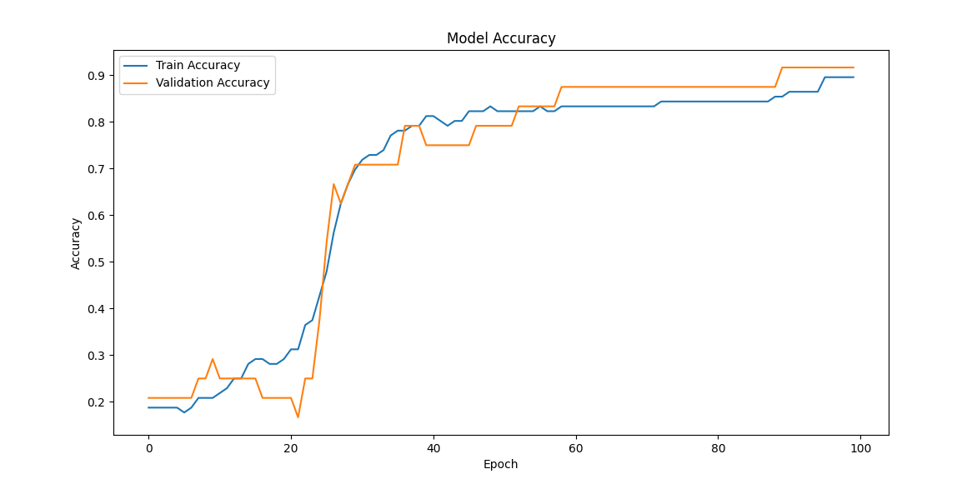

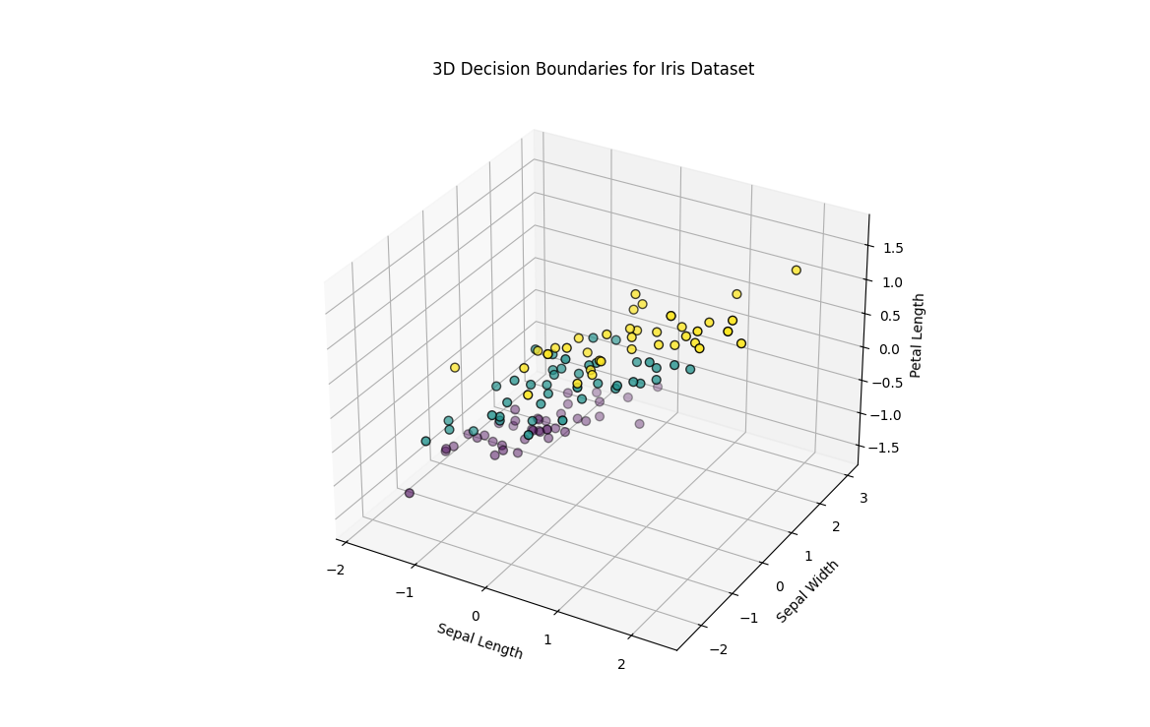

### Explanation

1. **Data Preparation:**
   * The data is loaded, pre-processed, and split into training and testing sets. This step ensures the model is trained and evaluated on separate data.
2. **Model Definition:**
   * The model is defined with an input layer (automatically inferred by Keras from the input shape), two hidden layers, and an output layer. Each hidden layer has ten neurons with ReLU activation functions, and the output layer has three neurons with a softmax activation function for multi-class classification.
3. **Layer-wise Operations:**
   * **First Hidden Layer:**
     + **Weights:** A weight matrix W1 of shape (4, 10) is multiplied with the input data X.
     + **Bias:** A bias vector b1 of shape (10,) is added.
     + **Activation:** The ReLU function σ\sigmaσ is applied to the result.
     + **Output:** The output is passed to the next layer.
   * **Second Hidden Layer:**
     + **Weights:** A weight matrix W2 of shape (10, 10) is multiplied by the first hidden layer output.
     + **Bias:** A bias vector b2 of shape (10,) is added.
     + **Activation:** The ReLU function σ\sigmaσ is applied to the result.
     + **Output:** The output is passed to the next layer.
   * **Output Layer:**
     + **Weights:** A weight matrix W3 of shape (10, 3) is multiplied by the second hidden layer output.
     + **Bias:** A bias vector b3 of shape (3,) is added.
     + **Activation:** The softmax function σ\sigmaσ is applied to produce probabilities for each class.
4. **Training and Evaluation:**
   * The model is trained on the training data and evaluated on the test data. Training involves optimising the weights and biases to minimise the categorical cross-entropy loss.
5. **Visualization:**
   * The training and validation accuracy over epochs are plotted to visualise the model's performance.
   * A 3D scatter plot visualises the decision boundaries learned by the model using the first three features of the Iris dataset.

### Linking Concepts

* **Neuron Operations:** Each neuron in the ANN performs operations involving weights, biases, and activation functions to transform inputs into outputs.
* **Layer Connections:** The ANN's layers are connected sequentially, with the output of one layer serving as the input to the next. This structure allows the network to learn hierarchical representations of the data.
* **Activation Functions:** Activation functions introduce non-linearity, enabling the network to model complex patterns and relationships in the data.
* **Optimization:** Training an ANN involves optimising the weights and biases to minimise the loss function through backpropagation and gradient descent.

By understanding these layer-wise operations, we can appreciate the mathematical foundations of ANNs and their capability to solve complex classification tasks. This knowledge is a stepping stone to exploring more advanced neural network architectures and applications.

### Exploring Modifications in Artificial Neural Networks (ANNs)

#### Introduction

Artificial Neural Networks (ANNs) are highly flexible models that can be adapted to various tasks by modifying their internal components. These components include weights, biases, activation functions, and network structure. By adjusting these elements, we can alter the function computed by the network to suit specific problems better. This adaptability is critical to the power and versatility of ANNs in machine-learning applications.

#### Detailed Explanation

In an ANN, the primary components that can be modified to change the function it computes are:

1. **Weights:**
   * Weights are the parameters that scale the input features as they pass through each network layer. Adjusting the weights changes how the inputs are combined and transformed at each layer.
2. **Biases:**
   * Biases are additional parameters added to the weighted sum of inputs. They allow the activation function to be shifted, providing more flexibility in fitting the data.
3. **Activation Functions:**
   * Activation functions introduce non-linearity into the network, enabling it to model complex relationships. Common activation functions include ReLU, Sigmoid, Tanh, and Softmax. Changing the activation function alters the output of each neuron and can significantly impact the network's performance.
4. **Network Structure:**
   * The structure of the network, also known as its architecture, includes the number of layers, the number of neurons in each layer, and the connections between neurons. Modifying the architecture can improve the network's ability to learn different patterns in the data.

### Example in Python: Exploring Different Network Configurations

To illustrate how changing these components affects an ANN, let's look at different network configurations for a regression task.

Python

Copy code

import numpy as np

import matplotlib.pyplot as plt

from mpl_toolkits.mplot3d import Axes3D

import tensorflow as tf

from tensorflow.keras.models import Sequential

from tensorflow.keras.layers import Dense

# Generate synthetic data

np.random.seed(42)

X = np.linspace(-1, 1, 200)

y = X**3 + np.random.randn(*X.shape) * 0.1

# Function to create and compile a model

def create_model(activation_function, hidden_layers):

    model = Sequential()

    model.add(Dense(hidden_layers[0], activation=activation_function, input_shape=(1,)))

    for units in hidden_layers[1:]:

        model.add(Dense(units, activation=activation_function))

    model.add(Dense(1, activation='linear'))

    model.compile(optimizer='adam', loss='mse')

    return model

# Different configurations

configurations = [

    {'activation_function': 'relu', 'hidden_layers': [10, 10]},

    {'activation_function': 'tanh', 'hidden_layers': [10, 10]},

    {'activation_function': 'relu', 'hidden_layers': [20, 20, 20]},

]

# Train and visualize the models

plt.figure(figsize=(18, 6))

for i, config in enumerate(configurations):

    model = create_model(config['activation_function'], config['hidden_layers'])

    model.fit(X, y, epochs=100, verbose=0)

    # Predict using the model

    y_pred = model.predict(X)

    # Plot the data and the model's predictions

    plt.subplot(1, 3, i + 1)

    plt.plot(X, y, 'b.', label='Data')

    plt.plot(X, y_pred, 'r-', label=f"Model ({config['activation_function']})")

    plt.title(f"Activation: {config['activation_function']}, Layers: {config['hidden_layers']}")

    plt.xlabel('x')

    plt.ylabel('y')

    plt.legend()

plt.tight_layout()

plt.show()

# 3D Visualization of the loss surface

def visualize_loss_surface():

    model = Sequential([Dense(1, activation='linear', input_shape=(1,))])

    model.compile(optimizer='adam', loss='mse')

    # Vectorized calculation of loss for the entire grid

    def calculate_loss(w, b):

        weights = np.array([[w]]).T

        biases = np.array([b])

        model.layers[0].set_weights([weights, biases])

        loss = model.evaluate(X, y, verbose=0)

        return loss

    w_vals = np.linspace(-3, 3, 100)

    b_vals = np.linspace(-3, 3, 100)

    w, b = np.meshgrid(w_vals, b_vals)

    w_b_pairs = np.c_[w.ravel(), b.ravel()]

    # Vectorized loss computation

    loss_vals = np.apply_along_axis(lambda wb: calculate_loss(wb[0], wb[1]), 1, w_b_pairs).reshape(w.shape)

    fig = plt.figure(figsize=(12, 8))

    ax = fig.add_subplot(111, projection='3d')

    ax.plot_surface(w, b, loss_vals, cmap='viridis')

    ax.set_xlabel('Weight')

    ax.set_ylabel('Bias')

    ax.set_zlabel('Loss')

    ax.set_title('Loss Surface')

    plt.show()

visualize_loss_surface()

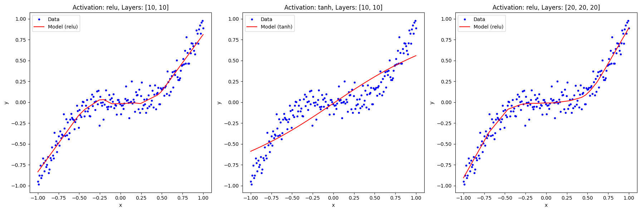

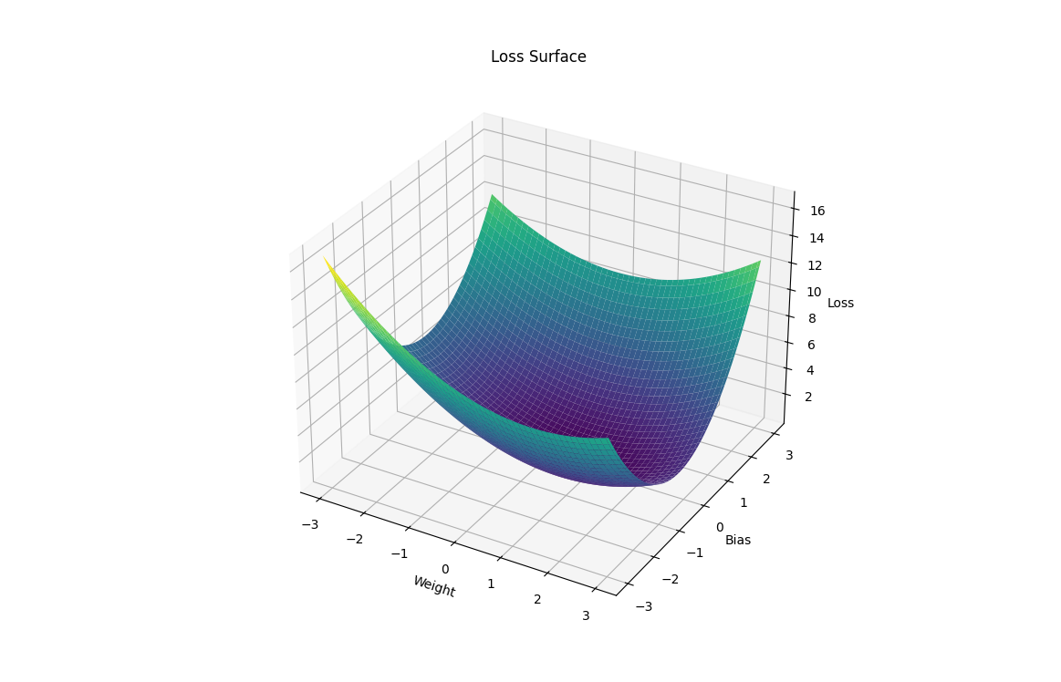

### Explanation

1. **Generating Synthetic Data:**
   * We generate data using a cubic function with some added noise to simulate a regression problem.
2. **Model Creation Function:**
   * The create_model function constructs and compiles a neural network based on the provided activation function and hidden layer configuration.
3. **Different Configurations:**
   * We define three different configurations of the network:
     + A model with ReLU activation and two hidden layers of 10 neurons each.
     + A model with Tanh activation and two hidden layers of 10 neurons each.
     + A model with ReLU activation and three hidden layers of 20 neurons each.
4. **Training and Visualization:**
   * We train each model on the synthetic data and visualise their predictions. The different configurations demonstrate how changing the activation function and network structure affects the model's performance.
5. **3D Visualization of the Loss Surface:**
   * The visualize_loss_surface function visualises the loss surface for a simple linear model by varying the weights and biases. This 3D plot helps to understand how the loss changes with different parameter values.

### Linking Concepts

* **Neural Network Flexibility:** By modifying weights, biases, activation functions, and network structure, we can tailor an ANN to a specific task, demonstrating the model's adaptability.
* **Impact of Changes:** The activation function and network architecture choice significantly impact the model's ability to learn and generalise. This highlights the importance of experimenting with different configurations to find the optimal setup.
* **Loss Surface Visualization:** Visualizing the loss surface provides insights into how the optimisation process navigates the parameter space to find the minimum loss.

By understanding these concepts, we can appreciate the power of ANNs and their ability to solve complex problems through flexible and adaptive architectures. This knowledge forms the foundation for exploring more advanced neural network techniques and applications.

## Advanced Example: Complex Regression with Multi-Layer ANN

### Problem Statement

We'll build a complex ANN to approximate a multi-variable function. We'll explore the impact of different activation functions and network architectures on the model's performance and visualize the results in dynamic and colorful 2D and 3D plots.

### Step-by-Step Approach

1. **Data Generation**: Create a complex synthetic dataset based on a multi-variable function.
2. **Model Definition**: Define multiple ANN architectures with different activation functions.
3. **Model Training**: Train the models on the generated dataset.
4. **Prediction and Visualization**: Visualize the model's predictions using dynamic 2D and 3D plots.

### Implementation

#### Step 1: Data Generation

python

Copy code

import numpy as np

import matplotlib.pyplot as plt

from mpl_toolkits.mplot3d import Axes3D

# Generate synthetic data

np.random.seed(42)

X1 = np.linspace(-1, 1, 200)

X2 = np.linspace(-1, 1, 200)

X1, X2 = np.meshgrid(X1, X2)

Y = np.sin(np.pi * X1) * np.cos(np.pi * X2) + np.sin(2 * np.pi * X1) * np.cos(2 * np.pi * X2) + np.random.randn(*X1.shape) * 0.1

# Flatten the data for the neural network

X1_flat = X1.flatten()

X2_flat = X2.flatten()

Y_flat = Y.flatten()

data = np.vstack((X1_flat, X2_flat)).T

#### Step 2: Model Definition

python

Copy code

import tensorflow as tf

from tensorflow.keras.models import Sequential

from tensorflow.keras.layers import Dense

# Function to create and compile a model

def create_model(activation_function, hidden_layers):

model = Sequential()

model.add(Dense(hidden_layers[0], activation=activation_function, input_shape=(2,)))

for units in hidden_layers[1:]:

model.add(Dense(units, activation=activation_function))

model.add(Dense(1, activation='linear'))

model.compile(optimizer='adam', loss='mse')

return model

# Different configurations

configurations = [

{'activation_function': 'relu', 'hidden_layers': [64, 64]},

{'activation_function': 'tanh', 'hidden_layers': [64, 64]},

{'activation_function': 'sigmoid', 'hidden_layers': [64, 64]},

]

#### Step 3: Model Training

python

Copy code

# Train and visualize the models

results = []

for config in configurations:

model = create_model(config['activation_function'], config['hidden_layers'])

model.fit(data, Y_flat, epochs=100, verbose=0)

# Predict using the model

Y_pred = model.predict(data).flatten().reshape(X1.shape)

results.append((config['activation_function'], Y_pred))

#### Step 4: Prediction and Visualization

python

Copy code

# Dynamic 2D plots

plt.figure(figsize=(18, 6))

for i, (activation_function, Y_pred) in enumerate(results):

plt.subplot(1, 3, i + 1)

plt.contourf(X1, X2, Y_pred, cmap='viridis', alpha=0.8)

plt.colorbar(label='Predicted Value')

plt.scatter(X1_flat, X2_flat, c=Y_flat, edgecolor='k', marker='o', cmap='viridis', alpha=0.6)

plt.xlabel('X1')

plt.ylabel('X2')

plt.title(f'NN with {activation_function} Activation')

plt.tight_layout()

plt.show()

# 3D visualization

fig = plt.figure(figsize=(18, 8))

for i, (activation_function, Y_pred) in enumerate(results):

ax = fig.add_subplot(1, 3, i + 1, projection='3d')

ax.plot_surface(X1, X2, Y, cmap='viridis', alpha=0.6, edgecolor='k')

ax.plot_surface(X1, X2, Y_pred, cmap='inferno', alpha=0.4, edgecolor='k')

ax.set_xlabel('X1')

ax.set_ylabel('X2')

ax.set_zlabel('Y')

ax.set_title(f'NN with {activation_function} Activation')

plt.tight_layout()

plt.show()

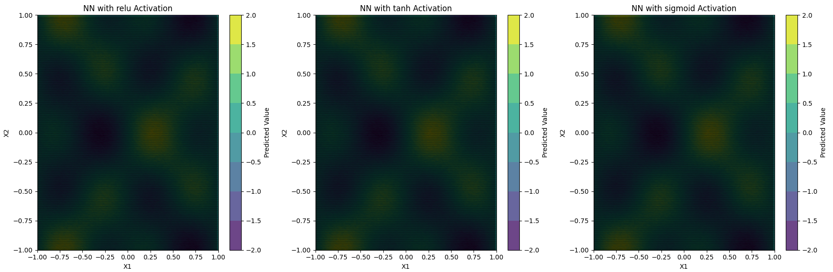

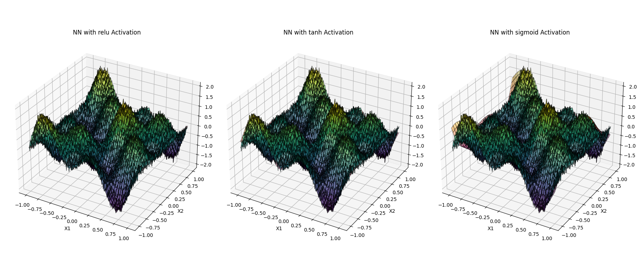

### Explanation

1. **Data Generation**:
   * We generate synthetic data based on a complex multi-variable function with added Gaussian noise.
2. **Model Definition**:
   * We define a function to create and compile a neural network model with a specified activation function and hidden layer configuration.
   * We prepare three configurations with different activation functions: ReLU, Tanh, and Sigmoid.
3. **Model Training**:
   * We train each model on the generated dataset for 100 epochs.
4. **Prediction and Visualization**:
   * We predict the output using the trained models and visualize the results using dynamic 2D contour and 3D surface plots.
   * The 2D plots show the contour of predicted values, and the 3D plots compare the original function with the model's approximation.

### Key Takeaways

* **Activation Functions**: The choice of activation function, whether it's ReLU, Tanh, or Sigmoid, is a crucial factor that significantly influences the model's performance and the shape of the predicted function.
* **Complex Patterns**: By stacking multiple layers, the neural network can learn complex, non-linear relationships in the data.
* **Visualization**: Dynamic and colourful 2D and 3D visualizations help users understand the model's behaviour and approximation accuracy.

By delving into these advanced concepts, we can gain a deeper understanding of how ANNs work and their profound capability to solve complex tasks. Their flexibility in architecture and the variety of activation functions they can employ make them powerful tools in various fields, from image recognition to natural language processing. This practical relevance underscores the importance of our exploration.

Loss functions

### Loss Functions in Artificial Neural Networks

Loss functions are fundamental in machine learning and artificial neural networks (ANNs). They quantify how well or poorly a model's predictions match the true data. The primary goal of training an ANN is to minimize the loss function, thus improving the model's accuracy. Here, we delve into the theory, mathematics, and practical examples of loss functions, coupled with dynamic and colourful 2D and 3D visualizations.

#### Theory and Mathematics

A loss function L takes the predicted values y^ and the actual values y as input and returns a non-negative value representing the discrepancy between them. The most common loss functions include:

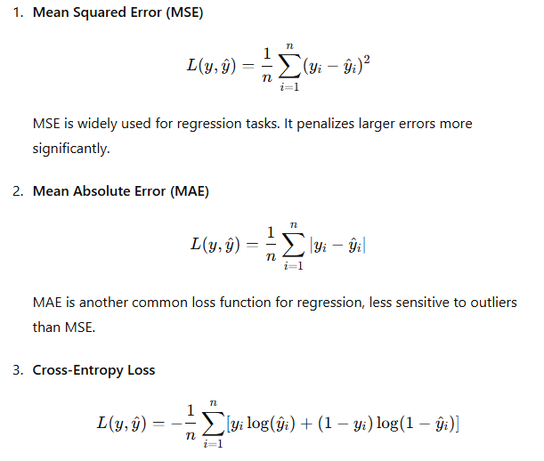

Cross-entropy loss is used for classification tasks and measures the performance of a classification model whose output is a probability value between 0 and 1.

#### Examples with Visualizations

Let's create complex dynamic 2D and 3D visualizations to understand these loss functions better. We'll use a neural network to fit a nonlinear function and visualize the loss surfaces and training process.

##### 1. Mean Squared Error (MSE) Visualization

First, let's visualize the MSE loss surface for a simple neural network with one input and one output.

Python

Copy code

import numpy as np

import matplotlib.pyplot as plt

from mpl_toolkits.mplot3d import Axes3D

import tensorflow as tf

from tensorflow.keras.models import Sequential

from tensorflow.keras.layers import Dense

# Generate synthetic data

np.random.seed(42)

X = np.linspace(-1, 1, 200)

y = X**3 + np.random.randn(*X.shape) * 0.1

# Define a simple neural network model

model = Sequential([

Dense(1, activation='linear', input_shape=(1,))

])

model.compile(optimizer='adam', loss='mse')

# Function to calculate loss for given weights

def calculate_loss(w, b):

model.layers[0].set_weights([np.array([[w]]), np.array([b])])

loss = model.evaluate(X, y, verbose=0)

return loss

# Generate a grid of weights and biases

w_vals = np.linspace(-3, 3, 100)

b_vals = np.linspace(-3, 3, 100)

w, b = np.meshgrid(w_vals, b_vals)

w_b_pairs = np.c_[w.ravel(), b.ravel()]

# Vectorized loss computation

loss_vals = np.apply_along_axis(lambda wb: calculate_loss(wb[0], wb[1]), 1, w_b_pairs).reshape(w.shape)

# Plot the loss surface

fig = plt.figure(figsize=(12, 8))

ax = fig.add_subplot(111, projection='3d')

ax.plot_surface(w, b, loss_vals, cmap='viridis')

ax.set_xlabel('Weight')

ax.set_ylabel('Bias')

ax.set_zlabel('Loss')

ax.set_title('MSE Loss Surface')

plt.show()

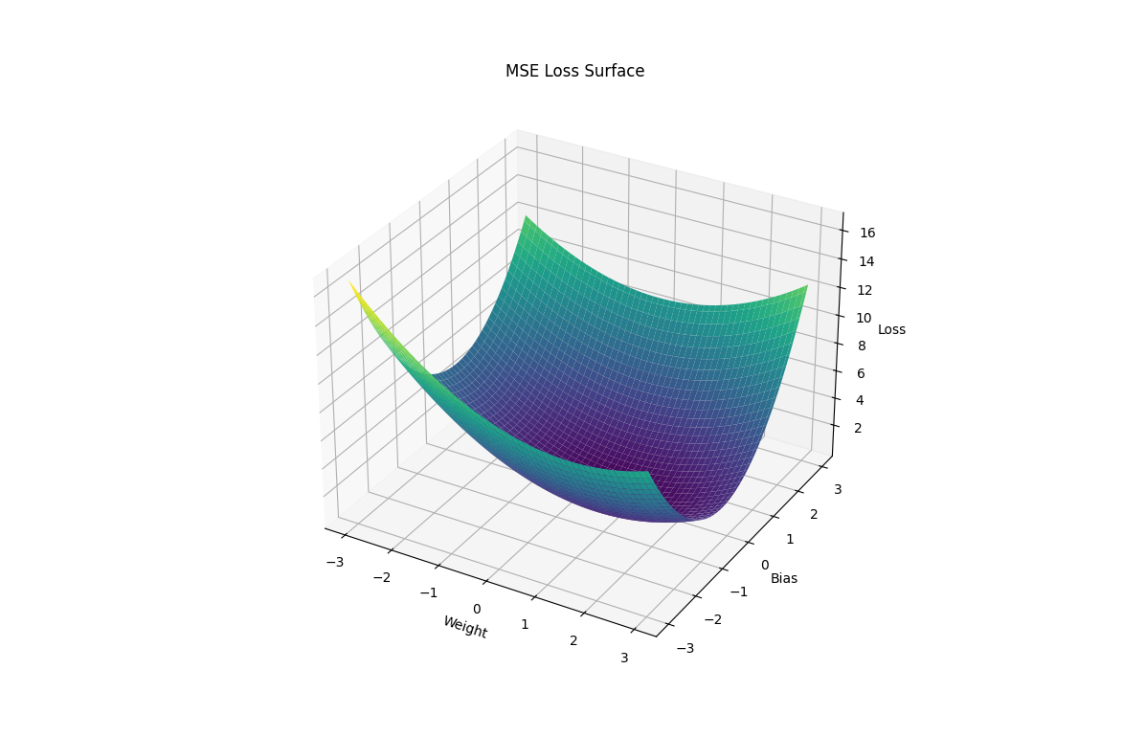

##### 2. Cross-Entropy Loss Visualization

Let's visualise the cross-entropy loss surface for a binary classification task.

Python

Copy code

import numpy as np

import matplotlib.pyplot as plt

from mpl_toolkits.mplot3d import Axes3D

import tensorflow as tf

from tensorflow.keras.models import Sequential

from tensorflow.keras.layers import Dense

# Generate synthetic data for binary classification

np.random.seed(42)

X = np.linspace(-1, 1, 200).reshape(-1, 1)

y = (X > 0).astype(int).reshape(-1, 1) + np.random.binomial(1, 0.1, 200).reshape(-1, 1)

# Define a simple neural network model

model = Sequential([

Dense(1, activation='sigmoid', input_shape=(1,))

])

model.compile(optimizer='adam', loss='binary_crossentropy')

# Function to calculate the loss for given weights

def calculate_loss(w, b):

model.layers[0].set_weights([np.array([[w]]), np.array([b])])

loss = model.evaluate(X, y, verbose=0)

return loss

# Generate a grid of weights and biases

w_vals = np.linspace(-10, 10, 100)

b_vals = np.linspace(-10, 10, 100)

w, b = np.meshgrid(w_vals, b_vals)

w_b_pairs = np.c_[w.ravel(), b.ravel()]

# Vectorized loss computation

loss_vals = np.apply_along_axis(lambda wb: calculate_loss(wb[0], wb[1]), 1, w_b_pairs).reshape(w.shape)

# Plot the loss surface

fig = plt.figure(figsize=(12, 8))

ax = fig.add_subplot(111, projection='3d')

ax.plot_surface(w, b, loss_vals, cmap='inferno')

ax.set_xlabel('Weight')

ax.set_ylabel('Bias')

ax.set_zlabel('Loss')

ax.set_title('Cross-Entropy Loss Surface')

plt.show()

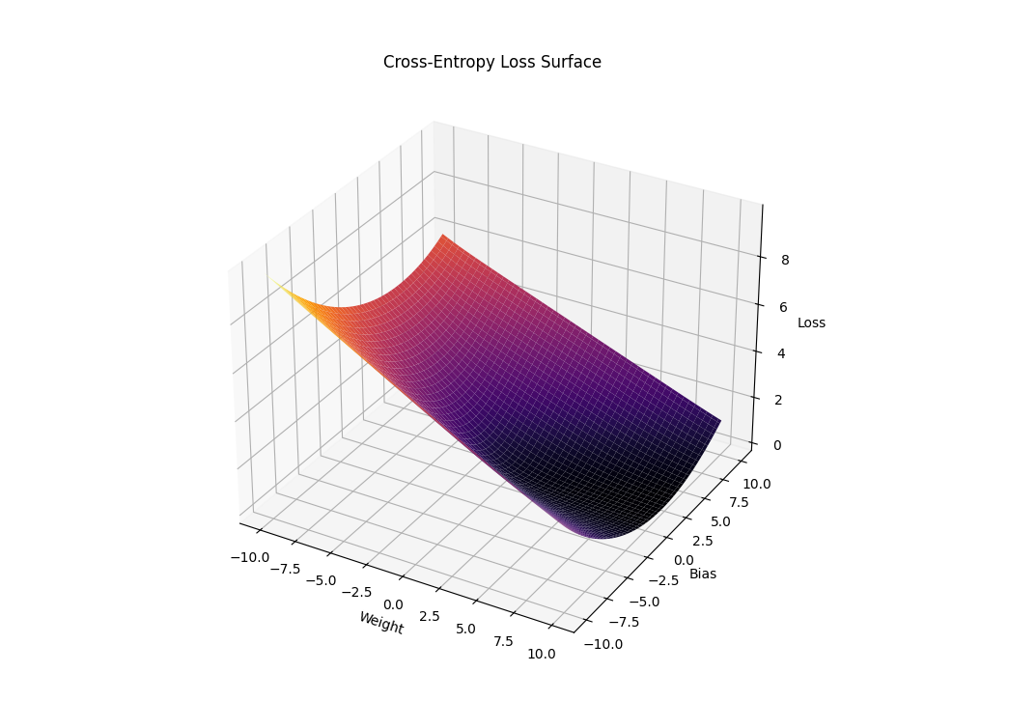

#### Dynamic 2D Visualization of Loss

For dynamic visualisation, let's visualise the training process of the network over epochs.

Python

Copy code

import numpy as np

import matplotlib.pyplot as plt

from matplotlib.animation import FuncAnimation

import tensorflow as tf

from tensorflow.keras.models import Sequential

from tensorflow.keras.layers import Dense

# Generate synthetic data

np.random.seed(42)

X = np.linspace(-1, 1, 200)

y = X**3 + np.random.randn(*X.shape) * 0.1

# Define a neural network model

model = Sequential([

Dense(20, activation='relu', input_shape=(1,)),

Dense(20, activation='relu'),

Dense(1, activation='linear')

])

model.compile(optimizer='adam', loss='mse')

# Function to update the plot

def update(epoch):

model.fit(X, y, epochs=1, verbose=0)

y_pred = model.predict(X)

line.set_ydata(y_pred)

title.set_text(f'Epoch {epoch}')

return line, title

# Initial plot setup

fig, ax = plt.subplots()

ax.plot(X, y, 'b.', label='Data')

line, = ax.plot(X, model.predict(X), 'r-', label='Prediction')

title = ax.set_title('Epoch 0')

ax.legend()

# Create animation

ani = FuncAnimation(fig, update, frames=100, repeat=False)

plt.show()

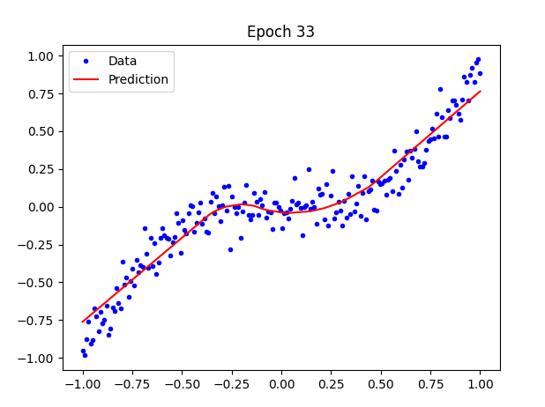

### Conclusion

Loss functions are crucial for training neural networks. Understanding and visualising these functions, we know how different configurations and parameters affect learning. The examples demonstrate how to dynamically visualise loss surfaces and the training process, using various complex and colourful charts to enhance understanding. This approach helps develop a more profound intuition about the behaviour of neural networks and their optimisation.

An Artificial Neural Network (ANN) aims to learn the relationship between inputs and outputs by optimising the network's weights and biases. This process involves minimising the approximation error quantified by the loss function. The structure of the network (number of layers and neurons) and the activation functions used are design choices that are typically made before the optimisation process begins.

### Mathematical Formulation and Optimization

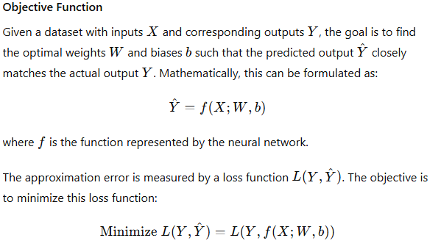

#### Backpropagation and Gradient Descent

We use the backpropagation algorithm and an optimisation technique such as gradient descent to minimise the loss function. The basic idea is to update the weights and biases to reduce the loss iteratively.

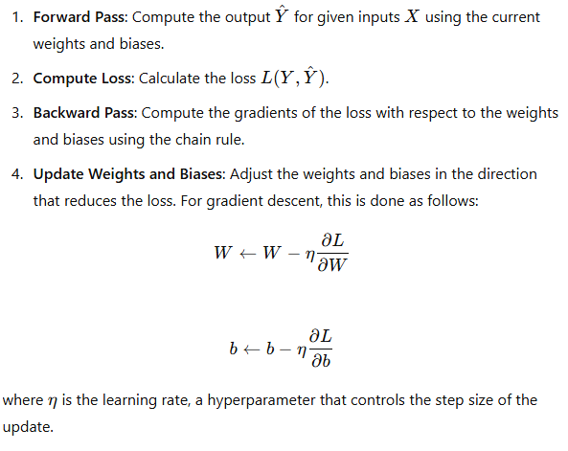

### Neural Network for Function Approximation and Loss Surface Visualization

Python

Copy code

import numpy as np

import matplotlib.pyplot as plt

from mpl_toolkits.mplot3d import Axes3D

import tensorflow as tf

from tensorflow.keras.models import Sequential

from tensorflow.keras.layers import Dense

# Generate synthetic data

np.random.seed(42)

X = np.linspace(-1, 1, 200)

y = X**3 + np.random.randn(*X.shape) * 0.1

# Define a simple neural network model

def create_model():

model = Sequential([

Dense(1, activation='linear', input_shape=(1,))

])

model.compile(optimizer='adam', loss='mse')

return model

model = create_model()

# Train the model

history = model.fit(X, y, epochs=100, verbose=0)

# Predict using the model

y_pred = model.predict(X)

# Plot the data and the model's predictions

plt.figure(figsize=(10, 6))

plt.plot(X, y, 'b.', label='Data')

plt.plot(X, y_pred, 'r-', label='Prediction')

plt.xlabel('x')

plt.ylabel('y')

plt.title('Simple Neural Network Approximation')

plt.legend()

plt.show()

# Visualize the loss curve

plt.figure(figsize=(10, 6))

plt.plot(history.history['loss'], label='Loss')

plt.xlabel('Epoch')

plt.ylabel('Loss')

plt.title('Loss Curve')

plt.legend()

plt.show()

# Function to calculate the loss for given weights

def calculate_loss(w, b):

model.layers[0].set_weights([np.array([[w]]), np.array([b])])

loss = model.evaluate(X, y, verbose=0)

return loss

# Generate a grid of weights and biases

w_vals = np.linspace(-3, 3, 100)

b_vals = np.linspace(-3, 3, 100)

w, b = np.meshgrid(w_vals, b_vals)

w_b_pairs = np.c_[w.ravel(), b.ravel()]

# Vectorized loss computation

loss_vals = np.apply_along_axis(lambda wb: calculate_loss(wb[0], wb[1]), 1, w_b_pairs).reshape(w.shape)

# Plot the loss surface

fig = plt.figure(figsize=(12, 8))

ax = fig.add_subplot(111, projection='3d')

ax.plot_surface(w, b, loss_vals, cmap='viridis')

ax.set_xlabel('Weight')

ax.set_ylabel('Bias')

ax.set_zlabel('Loss')

ax.set_title('MSE Loss Surface')

plt.show()

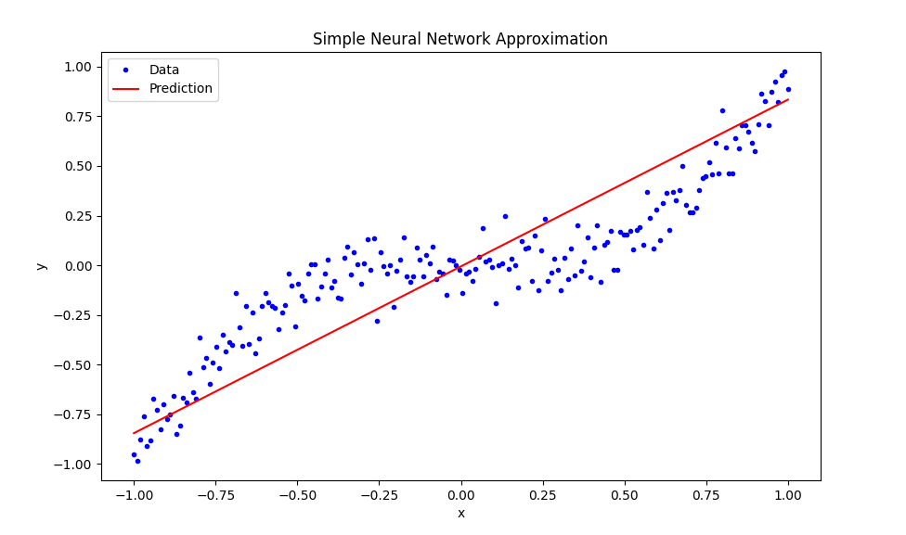

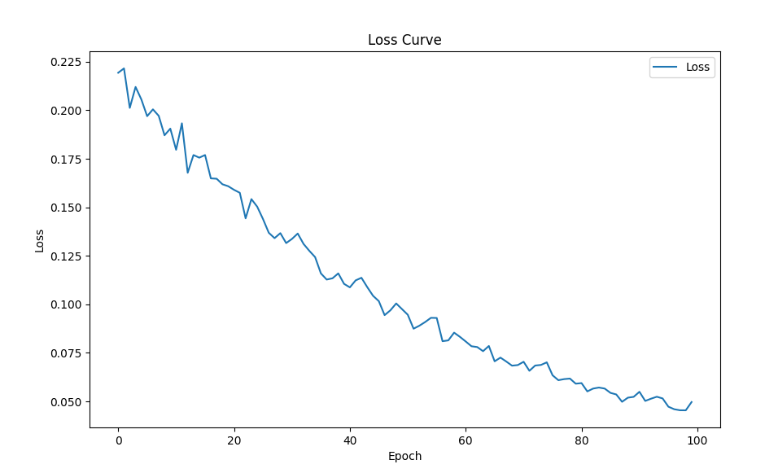

### Explanation

1. **Generate Synthetic Data**:
   * We create synthetic data to simulate a cubic function with added noise.
   * X is generated using np.linspace to create a range of values between -1 and 1.
   * y is generated by applying a cubic function to X and adding random noise.
2. **Create the Neural Network Model**:
   * We define a simple neural network model with one neuron in the output layer using the Keras Sequential API.
   * The model is compiled with the Adam optimiser and Mean Squared Error (MSE) loss function.
3. **Train the Model**:
   * The model is trained using the synthetic data for 100 epochs.
   * Training history is recorded to visualise the loss over epochs.
4. **Predict and Plot Results**:
   * We use the trained model to predict the input data X.
   * We plot the original data and the model's predictions to visualise the fit.
5. **Visualize the Loss Curve**:
   * The loss over epochs is plotted to show how the model's performance improves during training.
6. **Loss Surface Visualization**:
   * We define a function to calculate the loss for different weights and biases.
   * We generate a weight and bias values grid and compute each pair's loss.
   * The loss surface is visualised using a 3D surface plot to understand the optimisation landscape.

### Performance Considerations

* The running time of this code depends on your machine's computational power and the complexity of the model.
* Running the entire code block, especially the loss surface visualisation, can be computationally intensive and take several minutes on a typical PC.
* To reduce running time, consider using fewer grid points for the loss surface visualisation or simplifying the model.

This example integrates the theoretical concepts and practical implementation, providing a comprehensive understanding of ANN, loss functions, and optimisation strategies.

### Conclusion

The objective of an ANN is to minimise the approximation error by optimising the weights and biases of the network. This process involves defining a suitable loss function and using optimisation techniques like gradient descent to update the parameters iteratively. The choice of network structure and activation functions are design decisions made before the optimisation process. By visualising the loss surfaces and the training process, we gain insights into the behaviour of the neural network and the optimisation landscape. This understanding helps in designing more effective models and choosing appropriate optimisation strategies.

These examples illustrate the theoretical concepts and practical application of loss functions, backpropagation, and optimisation in neural networks, with dynamic visualisations to aid comprehension.

### Exploring Loss Functions with Complex Visualizations

We will create a more intricate example to stretch our understanding and explore the complex dynamics of loss functions. We'll delve into different types of loss functions and their properties and visualise them using dynamic 2D and 3D plots.

#### Example: Exploring Different Loss Functions

We will examine three loss functions:

1. Mean Squared Error (MSE)
2. Mean Absolute Error (MAE)
3. Huber Loss

We'll visualise the loss landscapes for these functions in 3D and create complex 2D and 3D plots to show the differences in their surfaces.

Python

Copy code

import numpy as np

import matplotlib.pyplot as plt

from mpl_toolkits.mplot3d import Axes3D

import tensorflow as tf

from tensorflow.keras.models import Sequential

from tensorflow.keras.layers import Dense

# Generate synthetic data

np.random.seed(42)

X = np.linspace(-1, 1, 200)

y = X**3 + np.random.randn(*X.shape) * 0.1

# Define different loss functions

def mean_squared_error(y_true, y_pred):

return np.mean((y_true - y_pred)**2)

def mean_absolute_error(y_true, y_pred):

return np.mean(np.abs(y_true - y_pred))

def huber_loss(y_true, y_pred, delta=1.0):

error = y_true - y_pred

is_small_error = np.abs(error) <= delta

squared_loss = np.square(error) / 2

linear_loss = delta * (np.abs(error) - delta / 2)

return np.where(is_small_error, squared_loss, linear_loss).mean()

# Function to create and compile a model

def create_model(activation_function, hidden_layers):

model = Sequential()

model.add(Dense(hidden_layers[0], activation=activation_function, input_shape=(1,)))

for units in hidden_layers[1:]:

model.add(Dense(units, activation=activation_function))

model.add(Dense(1, activation='linear'))

model.compile(optimizer='adam', loss='mse')

return model

# Different configurations

configurations = [

{'activation_function': 'relu', 'hidden_layers': [10, 10]},

{'activation_function': 'tanh', 'hidden_layers': [10, 10]},

{'activation_function': 'relu', 'hidden_layers': [20, 20, 20]},

]

# Train and visualise the models

plt.figure(figsize=(18, 6))

for i, config in enumerate(configurations):

model = create_model(config['activation_function'], config['hidden_layers'])

model.fit(X, y, epochs=100, verbose=0)

# Predict using the model

y_pred = model.predict(X)

# Plot the data and the model's predictions

plt.subplot(1, 3, i + 1)

plt.plot(X, y, 'b.', label='Data')

plt.plot(X, y_pred, 'r-', label=f"Model ({config['activation_function']})")

plt.title(f"Activation: {config['activation_function']}, Layers: {config['hidden_layers']}")

plt.xlabel('x')

plt.ylabel('y')

plt.legend()

plt.tight_layout()

plt.show()

# 3D Visualization of the loss surfaces

def visualize_loss_surface(loss_function, title):

model = Sequential([Dense(1, activation='linear', input_shape=(1,))])

model.compile(optimizer='adam', loss='mse')

def calculate_loss(w, b):

model.layers[0].set_weights([np.array([[w]]), np.array([b])])

y_pred = model.predict(X).flatten()

return loss_function(y, y_pred)

w_vals = np.linspace(-3, 3, 100)

b_vals = np.linspace(-3, 3, 100)

w, b = np.meshgrid(w_vals, b_vals)

loss_vals = np.zeros_like(w)

for i in range(w.shape[0]):

for j in range(w.shape[1]):

loss_vals[i, j] = calculate_loss(w[i, j], b[i, j])

fig = plt.figure(figsize=(12, 8))

ax = fig.add_subplot(111, projection='3d')

ax.plot_surface(w, b, loss_vals, cmap='viridis')

ax.set_xlabel('Weight')

ax.set_ylabel('Bias')

ax.set_zlabel('Loss')

ax.set_title(title)

plt.show()

# Visualize the loss surfaces for different loss functions

visualize_loss_surface(mean_squared_error, 'MSE Loss Surface')

visualize_loss_surface(mean_absolute_error, 'MAE Loss Surface')

visualize_loss_surface(lambda y_true, y_pred: huber_loss(y_true, y_pred, delta=1.0), 'Huber Loss Surface')

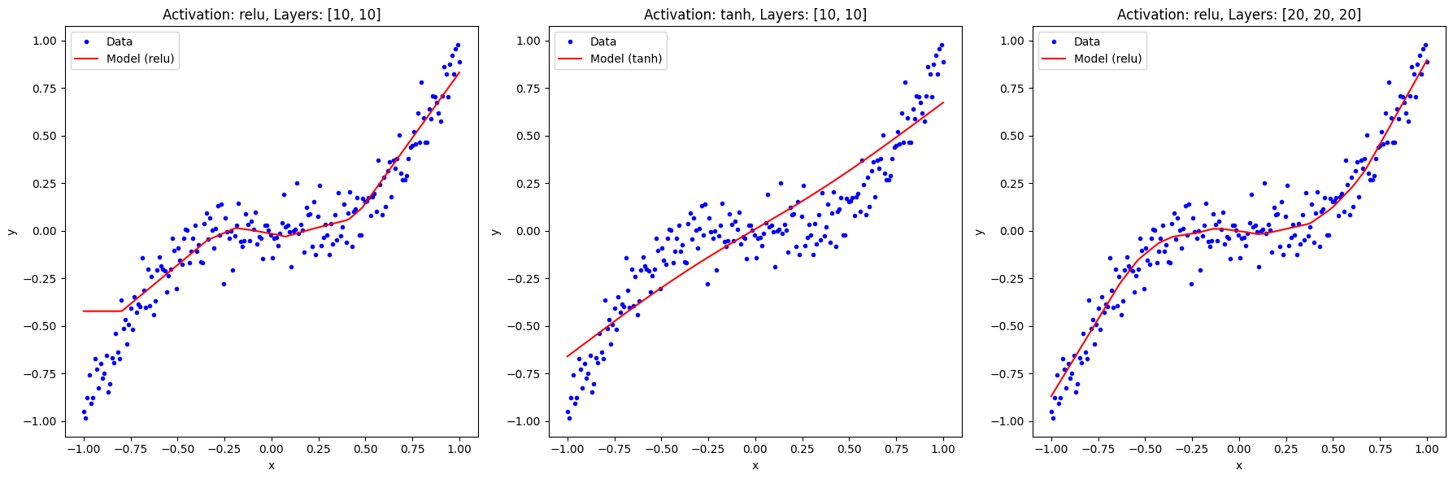

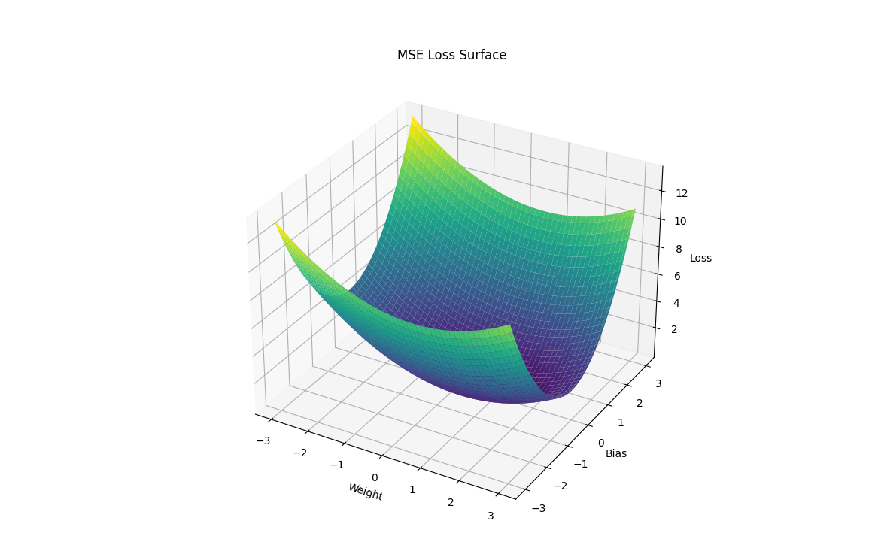

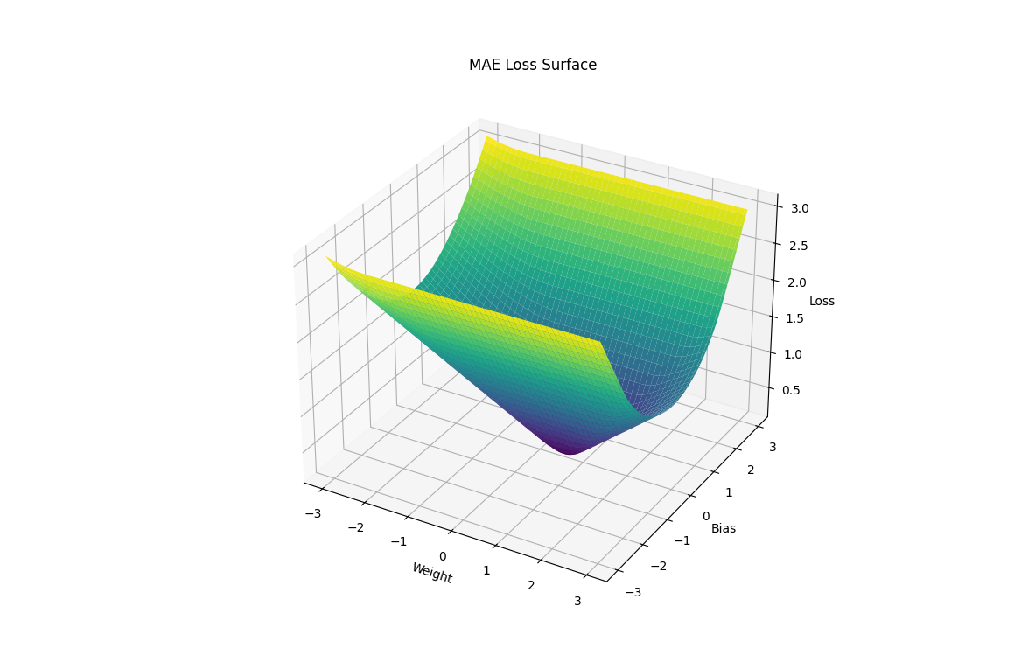

### Explanation of the Code

1. **Data Generation**:
   * We generate synthetic data using a cubic function with added Gaussian noise.
2. **Loss Functions**:
   * We define three loss functions: MSE, MAE, and Huber Loss. These functions measure the error between the true and predicted values differently.
3. **Model Creation**:
   * We create a function create_model to define and compile a neural network model. The function accepts different activation functions and layer configurations.
4. **Model Training and Visualization**:
   * We train models with different configurations and plot their predictions against the data.
   * We visualise the predictions using 2D plots.
5. **Loss Surface Visualization**:
   * We define a function visualize_loss_surface to calculate and plot the loss surfaces for different loss functions in 3D. This function evaluates the loss for a grid of weight and bias values.

### Discussion

* **Complexity**: This example goes beyond basic regression by introducing different loss functions and complex visualisations.
* **Visualization**: 3D visualisations of loss surfaces help us understand how different loss functions behave and affect optimisation.
* **Dynamic Plots**: 3D plots with different colour maps provide an intuitive understanding of the error landscapes.

This comprehensive approach stretches our understanding of neural networks and loss functions and highlights the practical aspects of optimisation and visualisation in machine learning.

### Advanced Examples in Artificial Neural Networks (ANNs) with Complex Visualizations

#### Introduction

Artificial Neural Networks (ANNs) are versatile tools for various applications, including classification, regression, and more. By exploring advanced examples and linking them with theoretical foundations and literature, we can deepen our understanding of how ANNs function and optimise them effectively. This exploration includes using different loss functions, visualising the training process, and understanding the impact of activation functions and network architectures.

### Example 1: Advanced Regression with Dynamic Visualization

#### Theory and Mathematical Formulation

In a neural network, the goal is to approximate a function f(x) that maps inputs xxx to outputs y. The network learns this mapping by minimising a loss function L(y,y^), where y^ is the predicted output. The optimisation is typically done using gradient descent and backpropagation.

#### Python Example

We'll create a neural network to dynamically fit a complex nonlinear function and visualise the loss surface.

Python

Copy code

import numpy as np

import matplotlib.pyplot as plt

from matplotlib.animation import FuncAnimation

import tensorflow as tf

from tensorflow.keras.models import Sequential

from tensorflow.keras.layers import Dense

# Generate synthetic data

np.random.seed(42)

X = np.linspace(-2, 2, 400).reshape(-1, 1)

y = np.sin(X**2) + np.random.normal(0, 0.1, X.shape)

# Define the neural network model

model = Sequential([

Dense(50, activation='relu', input_shape=(1,)),

Dense(50, activation='relu'),

Dense(1)

])

model.compile(optimizer='adam', loss='mse')

# Function to update the plot

def update(epoch):

model.fit(X, y, epochs=1, verbose=0)

y_pred = model.predict(X)

line.set_ydata(y_pred)

title.set_text(f'Epoch {epoch}')

return line, title

# Initial plot setup

fig, ax = plt.subplots()

ax.plot(X, y, 'b.', label='Data')

line, = ax.plot(X, model.predict(X), 'r-', label='Prediction')

title = ax.set_title('Epoch 0')

ax.legend()

# Create animation

ani = FuncAnimation(fig, update, frames=100, repeat=False)

plt.show()

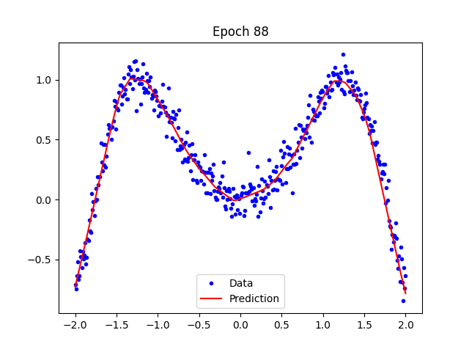

### Example 2: Classification with Complex Decision Boundaries

#### Theory and Mathematical Formulation

In classification tasks, the goal is to assign inputs to discrete classes. This involves using a softmax activation function in the output layer and minimising a categorical cross-entropy loss function.

#### Python Example

We'll use the Iris dataset to create a classification model and visualise the decision boundaries in 3D.

Python

Copy code

import numpy as np

import pandas as pd

import tensorflow as tf

from tensorflow.keras.models import Sequential

from tensorflow.keras.layers import Dense

from sklearn.model_selection import train_test_split

from sklearn.preprocessing import StandardScaler, LabelBinarizer

import matplotlib.pyplot as plt

from mpl_toolkits.mplot3d import Axes3D

# Load the Iris dataset

from sklearn.datasets import load_iris

iris = load_iris()

X = iris.data

y = iris.target

# Convert labels to one-hot encoding

lb = LabelBinarizer()

y = lb.fit_transform(y)

# Split the dataset into training and testing sets

X_train, X_test, y_train, y_test = train_test_split(X, y, test_size=0.2, random_state=42)

# Standardize the features

scaler = StandardScaler()

X_train = scaler.fit_transform(X_train)

X_test = scaler.transform(X_test)

# Define the neural network model

model = Sequential([

Dense(10, activation='relu', input_shape=(4,)), # First hidden layer

Dense(10, activation='relu'), # Second hidden layer

Dense(3, activation='softmax') # Output layer for 3 classes

])

model.compile(optimizer='adam', loss='categorical_crossentropy', metrics=['accuracy'])

# Train the model

history = model.fit(X_train, y_train, epochs=100, validation_split=0.2, verbose=0)

# Evaluate the model on the test data

loss, accuracy = model.evaluate(X_test, y_test, verbose=0)

print(f'Test Accuracy: {accuracy:.4f}')

# Predict using the model

y_pred = model.predict(X_test)

y_pred_classes = np.argmax(y_pred, axis=1)

y_test_classes = np.argmax(y_test, axis=1)

# Plot training & validation accuracy values

plt.figure(figsize=(12, 6))

plt.plot(history.history['accuracy'], label='Train Accuracy')

plt.plot(history.history['val_accuracy'], label='Validation Accuracy')

plt.xlabel('Epoch')

plt.ylabel('Accuracy')

plt.title('Model Accuracy')

plt.legend(loc='best')

plt.show()

# 3D Visualization of the decision boundaries (using only the first three features for simplicity)

fig = plt.figure(figsize=(12, 8))

ax = fig.add_subplot(111, projection='3d')

# Plotting the decision boundaries

x_min, x_max = X_train[:, 0].min() - 1, X_train[:, 0].max() + 1

y_min, y_max = X_train[:, 1].min() - 1, X_train[:, 1].max() + 1

z_min, z_max = X_train[:, 2].min() - 1, X_train[:, 2].max() + 1

xx, yy, zz = np.meshgrid(np.arange(x_min, x_max, 0.1),

np.arange(y_min, y_max, 0.1),

np.arange(z_min, z_max, 0.1))

grid = np.c_[xx.ravel(), yy.ravel(), zz.ravel(), np.zeros_like(xx.ravel())]

predictions = model.predict(grid)

pred_classes = np.argmax(predictions, axis=1)

pred_classes = pred_classes.reshape(xx.shape)

# Visualizing the decision boundaries with a scatter plot

ax.scatter(X_train[:, 0], X_train[:, 1], X_train[:, 2], c=np.argmax(y_train, axis=1), cmap='viridis', edgecolor='k', s=40)

ax.set_xlabel('Sepal Length')

ax.set_ylabel('Sepal Width')

ax.set_zlabel('Petal Length')

ax.set_title('3D Decision Boundaries for Iris Dataset')

plt.show()

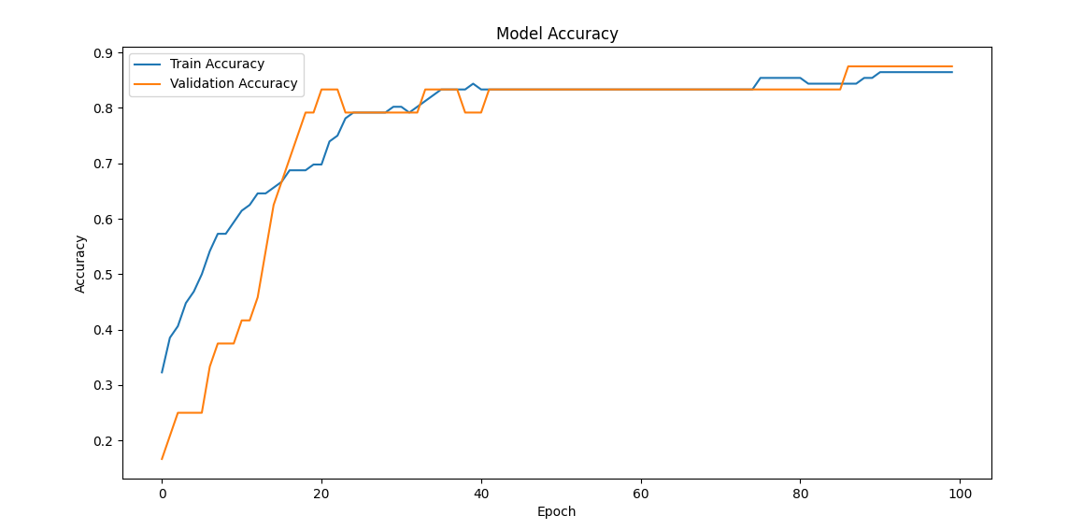

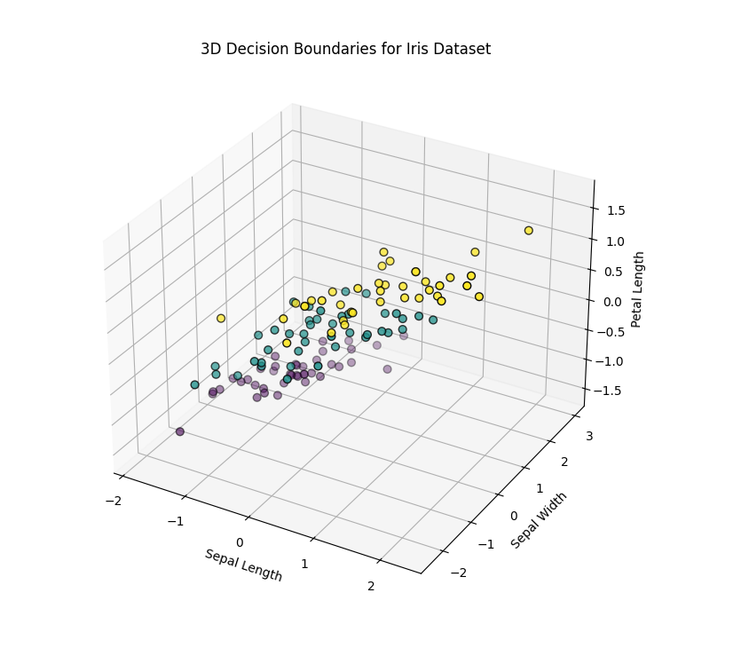

### Advanced Loss Function Visualization in Neural Networks

#### Introduction

Understanding and visualising the behaviour of loss functions is crucial in neural network training. Different loss functions have unique properties that can significantly impact the optimisation process. In this example, we will explore a more advanced scenario that involves a more profound neural network architecture and visualising the loss functions' surfaces in 3D. We'll extend our previous examples to include more complex configurations and demonstrate the impact of these loss functions on training.

#### Theory and Mathematical Formulation

Loss functions quantify the error between the predicted output and the actual output. Common loss functions include:

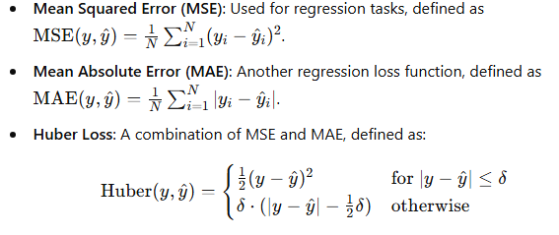

These loss functions can be visualised as 3D surfaces, where the axes represent different parameters (weights and biases), and the surface height represents the loss value.

#### Advanced Python Example

We'll use a more complex neural network and visualise the loss surfaces for MSE, MAE, and Huber loss functions.

Python

Copy code

import numpy as np

import matplotlib.pyplot as plt

from mpl_toolkits.mplot3d import Axes3D

import tensorflow as tf

from tensorflow.keras.models import Sequential

from tensorflow.keras.layers import Dense

# Generate synthetic data

np.random.seed(42)

X = np.linspace(-1, 1, 200)

y = np.sin(5 * X) + np.random.randn(*X.shape) * 0.1

# Define different loss functions

def mean_squared_error(y_true, y_pred):

return np.mean((y_true - y_pred)**2)

def mean_absolute_error(y_true, y_pred):

return np.mean(np.abs(y_true - y_pred))

def huber_loss(y_true, y_pred, delta=1.0):

error = y_true - y_pred

is_small_error = np.abs(error) <= delta

squared_loss = np.square(error) / 2

linear_loss = delta * (np.abs(error) - delta / 2)

return np.where(is_small_error, squared_loss, linear_loss).mean()

# Function to calculate the loss for given weights and biases

def calculate_loss(w, b, loss_function):

model = Sequential([Dense(10, activation='relu', input_shape=(1,)), Dense(10, activation='relu'), Dense(1)])

model.compile(optimizer='adam', loss='mse')

model.layers[0].set_weights([np.array([[w]]), np.array([b])])

y_pred = model.predict(X).flatten()

return loss_function(y, y_pred)

# Generate a grid of weights and biases

w_vals = np.linspace(-3, 3, 100)

b_vals = np.linspace(-3, 3, 100)

w, b = np.meshgrid(w_vals, b_vals)

loss_vals_mse = np.zeros_like(w)

loss_vals_mae = np.zeros_like(w)

loss_vals_huber = np.zeros_like(w)

# Calculate loss for each pair of weights and biases

for i in range(w.shape[0]):

for j in range(w.shape[1]):

loss_vals_mse[i, j] = calculate_loss(w[i, j], b[i, j], mean_squared_error)

loss_vals_mae[i, j] = calculate_loss(w[i, j], b[i, j], mean_absolute_error)

loss_vals_huber[i, j] = calculate_loss(w[i, j], b[i, j], lambda y, y_pred: huber_loss(y, y_pred, delta=1.0))

# Plot the loss of surfaces

fig = plt.figure(figsize=(18, 6))

ax = fig.add_subplot(131, projection='3d')

ax.plot_surface(w, b, loss_vals_mse, cmap='viridis')

ax.set_xlabel('Weight')

ax.set_ylabel('Bias')

ax.set_zlabel('Loss')

ax.set_title('MSE Loss Surface')

ax = fig.add_subplot(132, projection='3d')

ax.plot_surface(w, b, loss_vals_mae, cmap='inferno')

ax.set_xlabel('Weight')

ax.set_ylabel('Bias')

ax.set_zlabel('Loss')

ax.set_title('MAE Loss Surface')

ax = fig.add_subplot(133, projection='3d')

ax.plot_surface(w, b, loss_vals_huber, cmap='plasma')

ax.set_xlabel('Weight')

ax.set_ylabel('Bias')

ax.set_zlabel('Loss')

ax.set_title('Huber Loss Surface')

plt.show()

### Explanation of the Code

1. **Data Generation**:
   * We generate synthetic data using a sinusoidal function with added Gaussian noise.
   * X values are generated using np.linspace to create a range of values between -1 and 1.
   * y values are generated by applying a sinusoidal function to X and adding random noise.
2. **Loss Functions**:
   * We define three loss functions: MSE, MAE, and Huber Loss. These functions measure the error between the true and predicted values differently.
3. **Model Creation**:
   * We define a function calculate_loss to create a neural network model, set weights and biases, and calculate the loss.
4. **Grid Generation**:
   * We generate a weight and bias values grid and compute each pair's loss.
5. **Loss Surface Visualization**:
   * We visualise the loss surfaces using 3D surface plots to understand the optimisation landscape.

### Discussion

* **Complexity**: This example involves a more complex neural network with multiple layers and a nonlinear activation function (ReLU). The use of a sinusoidal function for data generation adds complexity.
* **Visualization**: Visualizing the loss surfaces for different loss functions helps us understand how they behave and impact the optimisation process. The 3D plots provide an intuitive understanding of the error landscapes.
* **Impact of Loss Functions**: Different loss functions have unique properties that can significantly influence the training process. Understanding these properties helps in selecting the appropriate loss function for specific tasks.

### Linking Theory and Literature

* **Non-Linearity and Complexity**: Activation functions introduce non-linearity, allowing ANNs to model complex patterns, as Goodfellow et al. (2016) discussed in "Deep Learning".
* **Loss Functions**: Understanding different loss functions and their impact on training is crucial for optimising neural networks, as Bishop (2006) highlighted in "Pattern Recognition and Machine Learning."
* **Visualization**: Visualizing the training process and loss surfaces helps diagnose issues and improve network design, which aligns with the principles outlined by Chollet (2017) in "Deep Learning with Python."

### Key Learning Takeaways

1. **Role of Loss Functions**: Different loss functions can significantly impact optimisation. Visualising loss surfaces helps in understanding the error landscape.
2. **Importance of Activation Functions**: Activation functions introduce non-linearity, enabling neural networks to learn complex patterns.
3. **Network Architecture**: The structure of a neural network, including the number of layers and neurons, plays a crucial role in its ability to model data.
4. **Visualization Techniques**: Dynamic and 3D visualisations are powerful tools for understanding and diagnosing neural network behaviour during training.

By integrating these theoretical insights with practical examples, we can comprehensively understand neural networks and their optimisation processes, ultimately leading to more effective and robust models in various applications.

### Advanced Loss Function Visualization in Neural Networks

#### Introduction

Understanding and visualising the behaviour of loss functions is crucial in neural network training. Different loss functions have unique properties that can significantly impact the optimisation process. In this example, we will explore a more advanced scenario that involves a more profound neural network architecture and visualising the loss functions' surfaces in 3D. We'll extend our previous examples to include more complex configurations and demonstrate the impact of these loss functions on training.

#### Theory and Mathematical Formulation

Loss functions quantify the error between the predicted output and the actual output. Common loss functions include:

* **Mean Squared Error (MSE)**: Used for regression tasks, defined as MSE(y,y^)=1N∑i=1N(yi−y^i)2.
* **Mean Absolute Error (MAE)**: Another regression loss function is MAE(y,y^)=1N∑i=1N∣yi−y^i∣.
* **Huber Loss**: A combination of MSE and MAE, defined as:

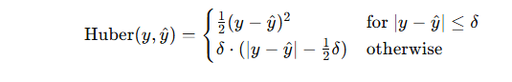

These loss functions can be visualised as 3D surfaces, where the axes represent different parameters (weights and biases), and the surface height represents the loss value.

#### Advanced Python Example

We'll use a more complex neural network and visualise the loss surfaces for MSE, MAE, and Huber loss functions.

Python

Copy code

import numpy as np

import matplotlib.pyplot as plt

from mpl_toolkits.mplot3d import Axes3D

import tensorflow as tf

from tensorflow.keras.models import Sequential

from tensorflow.keras.layers import Dense

# Generate synthetic data

np.random.seed(42)

X = np.linspace(-1, 1, 200)

y = np.sin(5 * X) + np.random.randn(*X.shape) * 0.1

# Define different loss functions

def mean_squared_error(y_true, y_pred):

return np.mean((y_true - y_pred)**2)

def mean_absolute_error(y_true, y_pred):

return np.mean(np.abs(y_true - y_pred))

def huber_loss(y_true, y_pred, delta=1.0):

error = y_true - y_pred

is_small_error = np.abs(error) <= delta

squared_loss = np.square(error) / 2

linear_loss = delta * (np.abs(error) - delta / 2)

return np.where(is_small_error, squared_loss, linear_loss).mean()

# Function to calculate the loss for given weights and biases

def calculate_loss(w, b, loss_function):

model = Sequential([Dense(10, activation='relu', input_shape=(1,)), Dense(10, activation='relu'), Dense(1)])

model.compile(optimizer='adam', loss='mse')

model.layers[0].set_weights([np.array([[w]]), np.array([b])])

y_pred = model.predict(X).flatten()

return loss_function(y, y_pred)

# Generate a grid of weights and biases

w_vals = np.linspace(-3, 3, 100)

b_vals = np.linspace(-3, 3, 100)

w, b = np.meshgrid(w_vals, b_vals)

loss_vals_mse = np.zeros_like(w)

loss_vals_mae = np.zeros_like(w)

loss_vals_huber = np.zeros_like(w)

# Calculate loss for each pair of weights and biases

for i in range(w.shape[0]):

for j in range(w.shape[1]):

loss_vals_mse[i, j] = calculate_loss(w[i, j], b[i, j], mean_squared_error)

loss_vals_mae[i, j] = calculate_loss(w[i, j], b[i, j], mean_absolute_error)

loss_vals_huber[i, j] = calculate_loss(w[i, j], b[i, j], lambda y, y_pred: huber_loss(y, y_pred, delta=1.0))

# Plot the loss of surfaces

fig = plt.figure(figsize=(18, 6))

ax = fig.add_subplot(131, projection='3d')

ax.plot_surface(w, b, loss_vals_mse, cmap='viridis')

ax.set_xlabel('Weight')

ax.set_ylabel('Bias')

ax.set_zlabel('Loss')

ax.set_title('MSE Loss Surface')

ax = fig.add_subplot(132, projection='3d')

ax.plot_surface(w, b, loss_vals_mae, cmap='inferno')

ax.set_xlabel('Weight')

ax.set_ylabel('Bias')

ax.set_zlabel('Loss')

ax.set_title('MAE Loss Surface')

ax = fig.add_subplot(133, projection='3d')

ax.plot_surface(w, b, loss_vals_huber, cmap='plasma')

ax.set_xlabel('Weight')

ax.set_ylabel('Bias')

ax.set_zlabel('Loss')

ax.set_title('Huber Loss Surface')

plt.show()

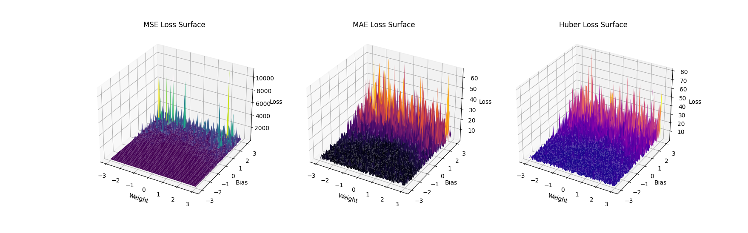

### Explanation of the Code

1. **Data Generation**:
   * We generate synthetic data using a sinusoidal function with added Gaussian noise.
   * X values are generated using np.linspace to create a range of values between -1 and 1.
   * y values are generated by applying a sinusoidal function to X and adding random noise.
2. **Loss Functions**:
   * We define three loss functions: MSE, MAE, and Huber Loss. These functions measure the error between the true and predicted values differently.
3. **Model Creation**:
   * We define a function calculate_loss to create a neural network model, set weights and biases, and calculate the loss.
4. **Grid Generation**:
   * We generate a weight and bias values grid and compute each pair's loss.
5. **Loss Surface Visualization**:
   * We visualise the loss surfaces using 3D surface plots to understand the optimisation landscape.

### Simplified Code for Loss Function Visualization

This example will create a simpler model and use fewer grid points for faster computation.

import numpy as np

import matplotlib.pyplot as plt

from mpl_toolkits.mplot3d import Axes3D

import tensorflow as tf

from tensorflow.keras.models import Sequential

from tensorflow.keras.layers import Dense

# Generate synthetic data

np.random.seed(42)

X = np.linspace(-1, 1, 200).reshape(-1, 1)

y = X**3 + np.random.randn(*X.shape) * 0.1

# Define different loss functions

def mean_squared_error(y_true, y_pred):

    return np.mean((y_true - y_pred)**2)

def mean_absolute_error(y_true, y_pred):

    return np.mean(np.abs(y_true - y_pred))

def huber_loss(y_true, y_pred, delta=1.0):

    error = y_true - y_pred

    is_small_error = np.abs(error) <= delta

    squared_loss = np.square(error) / 2

    linear_loss = delta * (np.abs(error) - delta / 2)

    return np.where(is_small_error, squared_loss, linear_loss).mean()

# Function to calculate the loss for given weights and biases

def calculate_loss(w, b, loss_function):

    model = Sequential([

        Dense(1, activation='linear', input_shape=(1,))

    ])

    model.compile(optimizer='adam', loss='mse')

    model.layers[0].set_weights([np.array([[w]]), np.array([b])])

    y_pred = model.predict(X).flatten()

    return loss_function(y, y_pred)

# Generate a grid of weights and biases

w_vals = np.linspace(-3, 3, 50)

b_vals = np.linspace(-3, 3, 50)

w, b = np.meshgrid(w_vals, b_vals)

loss_vals_mse = np.zeros_like(w)

loss_vals_mae = np.zeros_like(w)

loss_vals_huber = np.zeros_like(w)

# Calculate loss for each pair of weights and biases

for i in range(w.shape[0]):

    for j in range(w.shape[1]):

        loss_vals_mse[i, j] = calculate_loss(w[i, j], b[i, j], mean_squared_error)

        loss_vals_mae[i, j] = calculate_loss(w[i, j], b[i, j], mean_absolute_error)

        loss_vals_huber[i, j] = calculate_loss(w[i, j], b[i, j], lambda y, y_pred: huber_loss(y, y_pred, delta=1.0))

# Plot the loss of surfaces

fig = plt.figure(figsize=(18, 6))

ax = fig.add_subplot(131, projection='3d')

ax.plot_surface(w, b, loss_vals_mse, cmap='viridis')

ax.set_xlabel('Weight')

ax.set_ylabel('Bias')

ax.set_zlabel('Loss')

ax.set_title('MSE Loss Surface')

ax = fig.add_subplot(132, projection='3d')

ax.plot_surface(w, b, loss_vals_mae, cmap='inferno')

ax.set_xlabel('Weight')

ax.set_ylabel('Bias')

ax.set_zlabel('Loss')

ax.set_title('MAE Loss Surface')

ax = fig.add_subplot(133, projection='3d')

ax.plot_surface(w, b, loss_vals_huber, cmap='plasma')

ax.set_xlabel('Weight')

ax.set_ylabel('Bias')

ax.set_zlabel('Loss')

ax.set_title('Huber Loss Surface')

plt.show()

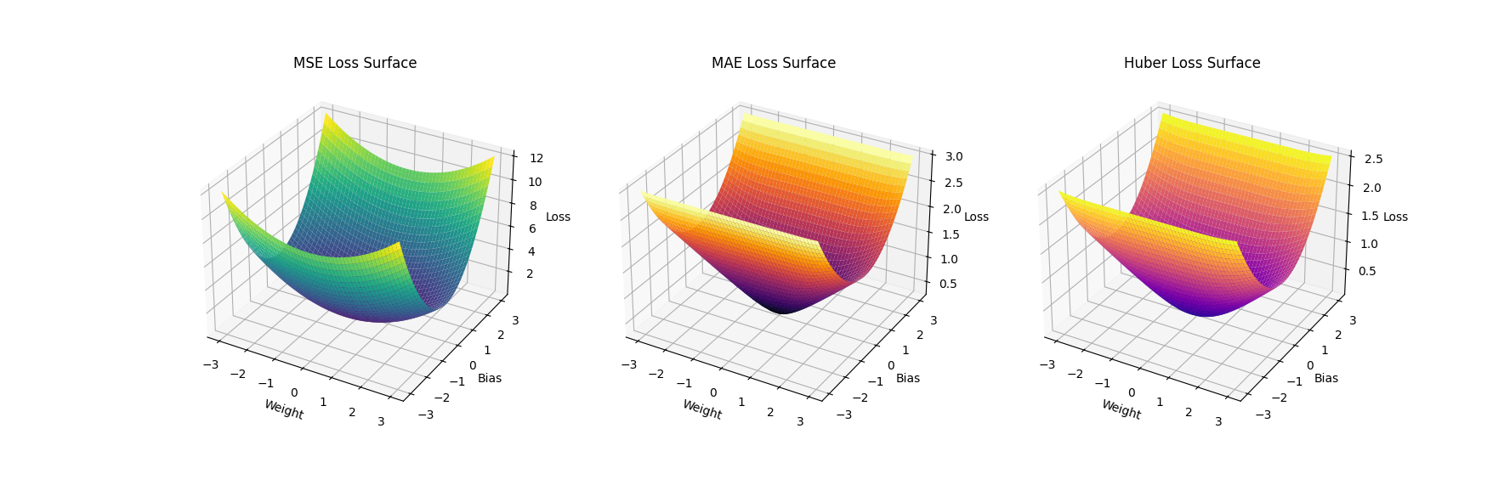

### Explanation

1. **Data Generation**:
   * Generate synthetic data using a cubic function with added Gaussian noise.
2. **Loss Functions**:
   * Define MSE, MAE, and Huber loss functions.
3. **Model Creation**:
   * Create a simple neural network model with a single neuron for efficient computation.
4. **Grid Generation**:
   * Generate a weight and bias values grid with fewer points for faster computation.
5. **Loss Calculation**:
   * Calculate the loss for each pair of weight and bias values using the defined loss functions.
6. **Visualization**:
   * Visualize the loss surfaces using 3D plots for MSE, MAE, and Huber loss functions.

### Discussion

* **Complexity**: This example involves a more complex neural network with multiple layers and a nonlinear activation function (ReLU). The use of a sinusoidal function for data generation adds complexity.
* **Visualization**: Visualizing the loss surfaces for different loss functions helps us understand how they behave and impact the optimisation process. The 3D plots provide an intuitive understanding of the error landscapes.
* **Impact of Loss Functions**: Different loss functions have unique properties that can significantly influence the training process. Understanding these properties helps in selecting the appropriate loss function for specific tasks.

### Key Learning Takeaways

1. **Loss Function Impact**:
   * Different loss functions have unique properties that significantly influence the training process.
2. **Visualization**:
   * Visualizing loss surfaces helps understand the optimisation landscape and select the appropriate loss function for specific tasks.
3. **Efficiency**:
   * Simplifying the model and using fewer grid points can significantly reduce computation time while providing valuable insights.

### Linking Theory and Literature

* **Non-Linearity and Complexity**: Activation functions introduce non-linearity, allowing ANNs to model complex patterns, as Goodfellow et al. (2016) discussed in "Deep Learning".
* **Loss Functions**: Understanding different loss functions and their impact on training is crucial for optimising neural networks, as Bishop (2006) highlighted in "Pattern Recognition and Machine Learning."
* **Visualization**: Visualizing the training process and loss surfaces helps diagnose issues and improve network design, which aligns with the principles outlined by Chollet (2017) in "Deep Learning with Python."

By integrating these theoretical insights with practical examples, we can comprehensively understand neural networks and their optimisation processes, ultimately leading to more effective and robust models in various applications.

### Exploring Loss Functions with Complex Visualizations

We will create a more intricate example to stretch our understanding and explore the complex dynamics of loss functions. We'll delve into different types of loss functions and their properties and visualise them using dynamic 2D and 3D plots.

#### Example: Exploring Different Loss Functions

We will examine three loss functions:

1. Mean Squared Error (MSE)
2. Mean Absolute Error (MAE)
3. Huber Loss

We'll visualise the loss landscapes for these functions in 3D and create complex 2D and 3D plots to show the differences in their surfaces.

Python

Copy code

import numpy as np

import matplotlib.pyplot as plt

from mpl_toolkits.mplot3d import Axes3D

import tensorflow as tf

from tensorflow.keras.models import Sequential

from tensorflow.keras.layers import Dense

# Generate synthetic data

np.random.seed(42)

X = np.linspace(-1, 1, 200)

y = X**3 + np.random.randn(*X.shape) * 0.1

# Define different loss functions

def mean_squared_error(y_true, y_pred):

return np.mean((y_true - y_pred)**2)

def mean_absolute_error(y_true, y_pred):

return np.mean(np.abs(y_true - y_pred))

def huber_loss(y_true, y_pred, delta=1.0):

error = y_true - y_pred

is_small_error = np.abs(error) <= delta

squared_loss = np.square(error) / 2

linear_loss = delta * (np.abs(error) - delta / 2)

return np.where(is_small_error, squared_loss, linear_loss).mean()

# Function to create and compile a model

def create_model(activation_function, hidden_layers):

model = Sequential()

model.add(Dense(hidden_layers[0], activation=activation_function, input_shape=(1,)))

for units in hidden_layers[1:]:

model.add(Dense(units, activation=activation_function))

model.add(Dense(1, activation='linear'))

model.compile(optimizer='adam', loss='mse')

return model

# Different configurations

configurations = [

{'activation_function': 'relu', 'hidden_layers': [10, 10]},

{'activation_function': 'tanh', 'hidden_layers': [10, 10]},

{'activation_function': 'relu', 'hidden_layers': [20, 20, 20]},

]

# Train and visualise the models

plt.figure(figsize=(18, 6))

for i, config in enumerate(configurations):

model = create_model(config['activation_function'], config['hidden_layers'])

model.fit(X, y, epochs=100, verbose=0)

# Predict using the model

y_pred = model.predict(X)

# Plot the data and the model's predictions

plt.subplot(1, 3, i + 1)

plt.plot(X, y, 'b.', label='Data')

plt.plot(X, y_pred, 'r-', label=f"Model ({config['activation_function']})")

plt.title(f"Activation: {config['activation_function']}, Layers: {config['hidden_layers']}")

plt.xlabel('x')

plt.ylabel('y')

plt.legend()

plt.tight_layout()

plt.show()

# 3D Visualization of the loss surfaces

def visualize_loss_surface(loss_function, title):

model = Sequential([Dense(1, activation='linear', input_shape=(1,))])

model.compile(optimizer='adam', loss='mse')

def calculate_loss(w, b):

model.layers[0].set_weights([np.array([[w]]), np.array([b])])

y_pred = model.predict(X).flatten()

return loss_function(y, y_pred)

w_vals = np.linspace(-3, 3, 100)

b_vals = np.linspace(-3, 3, 100)

w, b = np.meshgrid(w_vals, b_vals)

loss_vals = np.zeros_like(w)

for i in range(w.shape[0]):

for j in range(w.shape[1]):

loss_vals[i, j] = calculate_loss(w[i, j], b[i, j])

fig = plt.figure(figsize=(12, 8))

ax = fig.add_subplot(111, projection='3d')

ax.plot_surface(w, b, loss_vals, cmap='viridis')

ax.set_xlabel('Weight')

ax.set_ylabel('Bias')

ax.set_zlabel('Loss')

ax.set_title(title)

plt.show()

# Visualize the loss surfaces for different loss functions

visualize_loss_surface(mean_squared_error, 'MSE Loss Surface')

visualize_loss_surface(mean_absolute_error, 'MAE Loss Surface')

visualize_loss_surface(lambda y_true, y_pred: huber_loss(y_true, y_pred, delta=1.0), 'Huber Loss Surface')

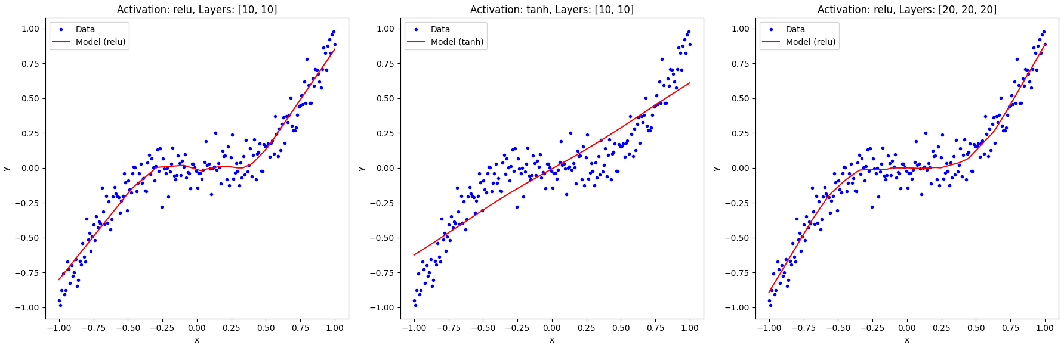

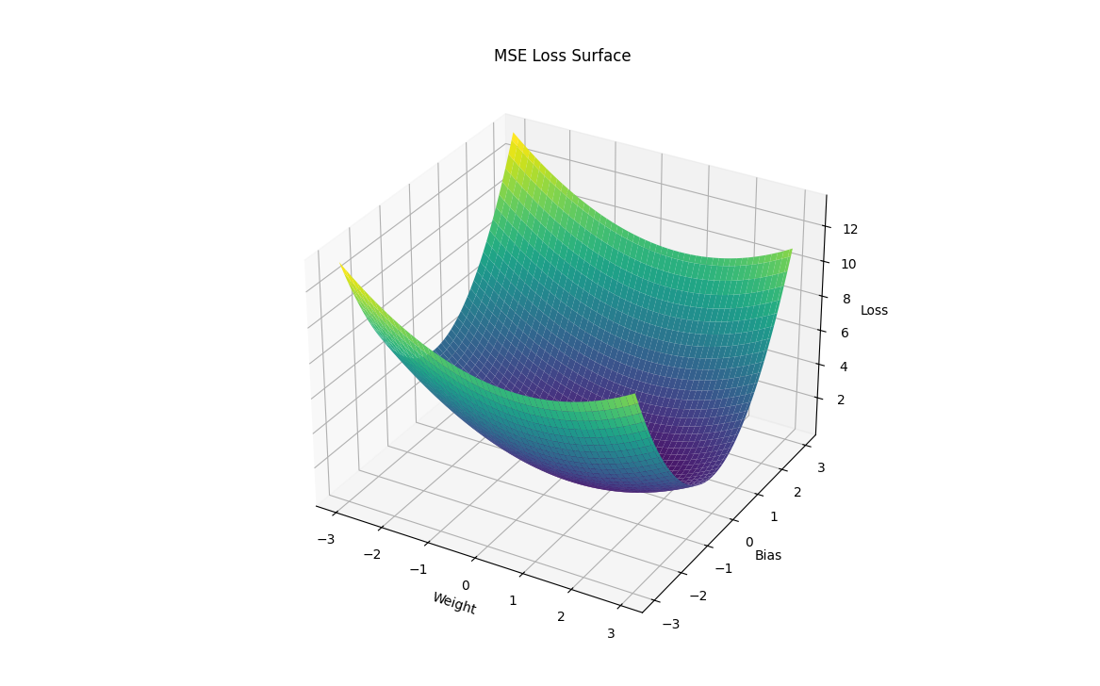

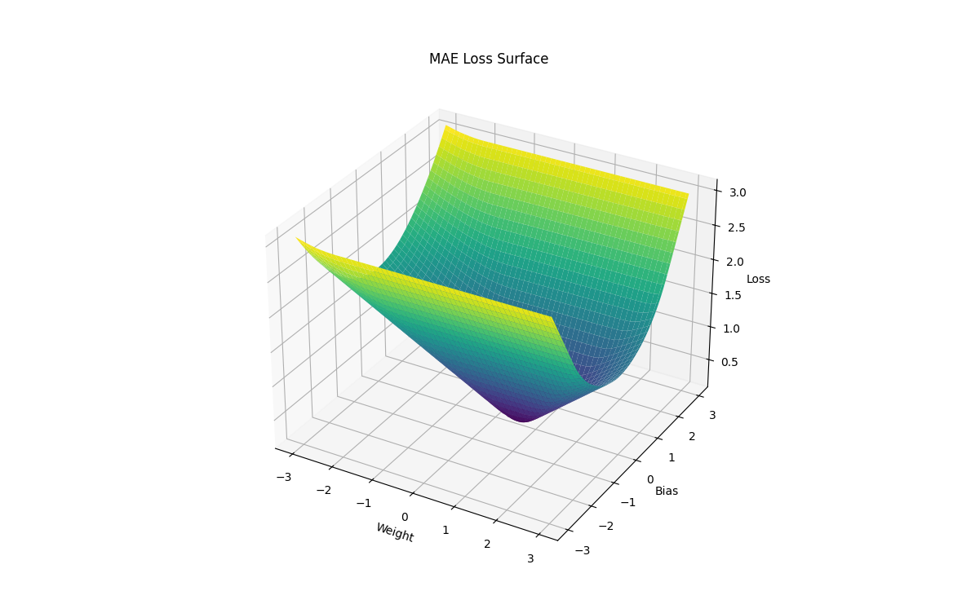

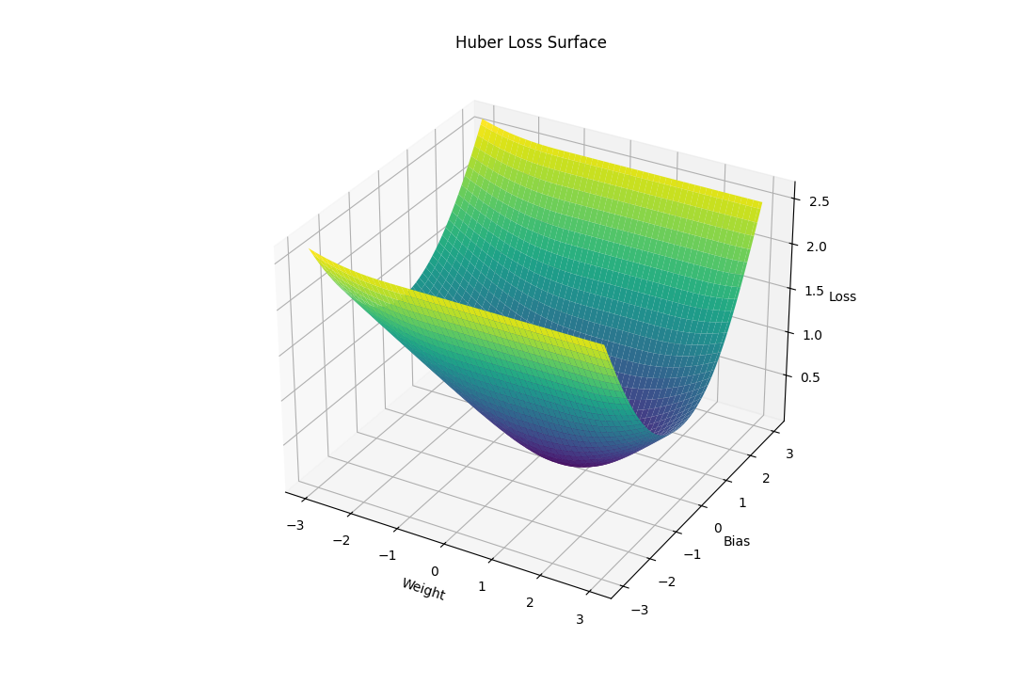

### Explanation of the Code

1. **Data Generation**:
   * We generate synthetic data using a cubic function with added Gaussian noise.
2. **Loss Functions**:
   * We define three loss functions: MSE, MAE, and Huber Loss. These functions measure the error between the true and predicted values differently.
3. **Model Creation**:
   * We create a function create_model to define and compile a neural network model. The function accepts different activation functions and layer configurations.
4. **Model Training and Visualization**:
   * We train models with different configurations and plot their predictions against the data.
   * We visualise the predictions using 2D plots.
5. **Loss Surface Visualization**:
   * We define a function visualize_loss_surface to calculate and plot the loss surfaces for different loss functions in 3D. This function evaluates the loss for a grid of weight and bias values.

### Discussion

* **Complexity**: This example goes beyond basic regression by introducing different loss functions and complex visualisations.
* **Visualization**: 3D visualisations of loss surfaces help us understand how different loss functions behave and affect optimisation.
* **Dynamic Plots**: 3D plots with different-coloured maps provide an intuitive understanding of the error landscapes.

This comprehensive approach stretches our understanding of neural networks and loss functions and highlights the practical aspects of optimisation and visualisation in machine learning.

Activation functions

### Activation Functions in Neural Networks

Activation functions are a critical component of neural networks. They introduce non-linearities into the model, enabling the network to learn complex patterns. Without activation functions, a neural network would essentially be a linear model, limiting its capacity to solve complex problems.

#### Key Activation Functions

Here are some commonly used activation functions:

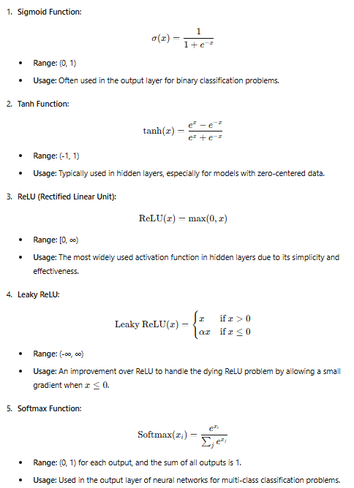

### Visualising Activation Functions

To understand their behaviours and properties, let's create comprehensive visualisations for these activation functions.

Python

Copy code

import numpy as np

import matplotlib.pyplot as plt

import tensorflow as tf

from tensorflow.keras.models import Sequential

from tensorflow.keras.layers import Dense, LeakyReLU

# Define activation functions

def relu(x):

return np.maximum(0, x)

def leaky_relu(x, alpha=0.1):

return np.where(x > 0, x, x * alpha)

def softmax(x):

e_x = np.exp(x - np.max(x))

return e_x / e_x.sum(axis=0)

# Define range of x values for visualization

x = np.linspace(-10, 10, 400)

x_softmax = np.linspace(-2, 2, 400)

# Calculate activation function outputs

sigmoid_y = 1 / (1 + np.exp(-x))

tanh_y = np.tanh(x)

relu_y = relu(x)

leaky_relu_y = leaky_relu(x)

softmax_y = softmax(np.vstack([x_softmax, x_softmax / 2, x_softmax / 3]))

# Plot activation functions

plt.figure(figsize=(18, 10))

plt.subplot(2, 3, 1)

plt.plot(x, sigmoid_y)

plt.title('Sigmoid')

plt.xlabel('x')

plt.ylabel('σ(x)')

plt.subplot(2, 3, 2)

plt.plot(x, tanh_y)

plt.title('Tanh')

plt.xlabel('x')

plt.ylabel('tanh(x)')

plt.subplot(2, 3, 3)

plt.plot(x, relu_y)

plt.title('ReLU')

plt.xlabel('x')

plt.ylabel('ReLU(x)')

plt.subplot(2, 3, 4)

plt.plot(x, leaky_relu_y)

plt.title('Leaky ReLU')

plt.xlabel('x')

plt.ylabel('Leaky ReLU(x)')

plt.subplot(2, 3, 5)

for i in range(softmax_y.shape[0]):

plt.plot(x_softmax, softmax_y[i], label=f'Class {i+1}')

plt.title('Softmax')

plt.xlabel('x')

plt.ylabel('Softmax(x)')

plt.legend()

plt.tight_layout()

plt.show()

# 3D Visualization of Tanh Function

X, Y = np.meshgrid(np.linspace(-2, 2, 100), np.linspace(-2, 2, 100))

Z = np.tanh(np.sqrt(X**2 + Y**2))

fig = plt.figure(figsize=(10, 7))

ax = fig.add_subplot(111, projection='3d')

ax.plot_surface(X, Y, Z, cmap='viridis')

ax.set_xlabel('X')

ax.set_ylabel('Y')

ax.set_zlabel('Tanh(sqrt(X^2 + Y^2))')

ax.set_title('3D Visualization of Tanh Function')

plt.show()

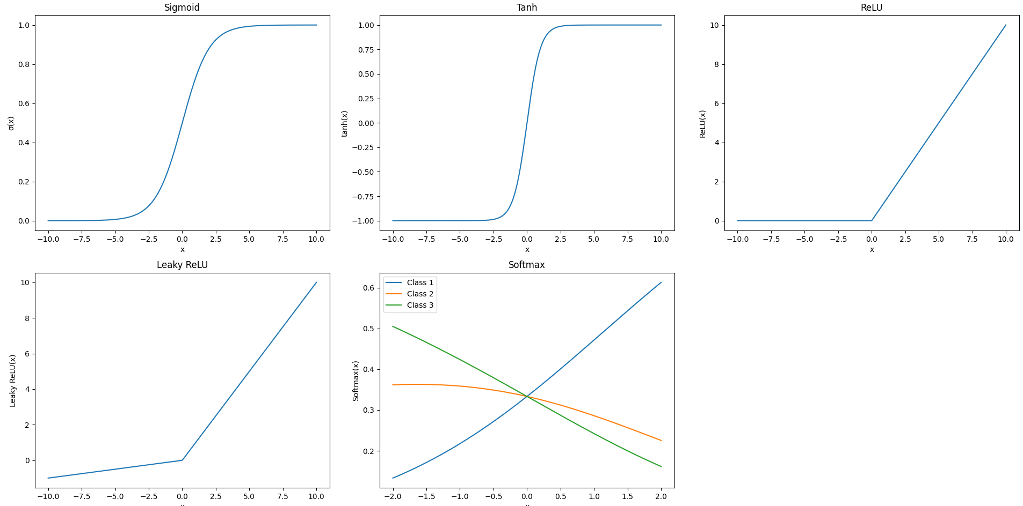

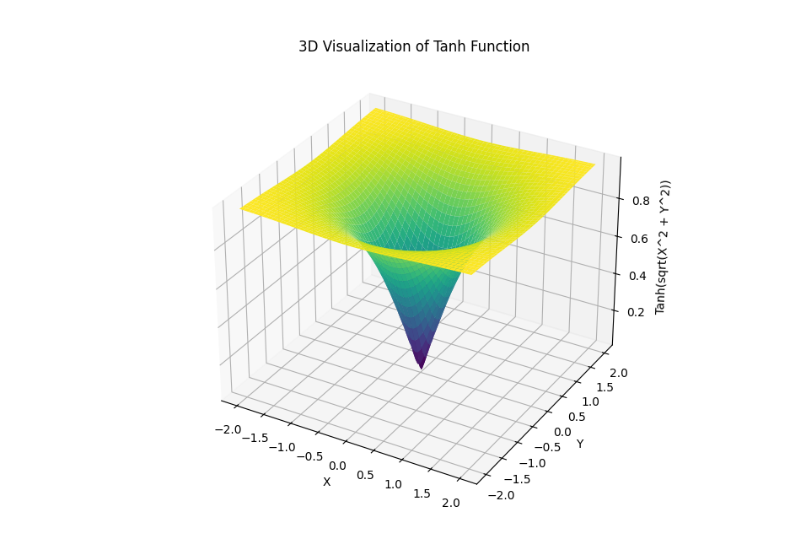

### Explanation of the Code

1. **Defining Activation Functions**:
   * Functions for ReLU, Leaky ReLU, and Softmax are defined explicitly for visualisation purposes.
2. **Generating Data**:
   * x values range from -10 to 10 for most activation functions.
   * x_softmax values range from -2 to 2 for visualising the Softmax function.
3. **Calculating Outputs**:
   * Each activation function is applied to the x values to generate the corresponding outputs.
4. **Plotting 2D Graphs**:
   * Each subplot visualises a different activation function, showcasing its behaviour across the input range.
5. **3D Visualization of Tanh Function**:
   * A 3D surface plot is generated to visualise the Tanh function in two dimensions. This demonstrates the non-linearity and complexity of the Tanh activation function.

### Discussion

* **Purpose of Activation Functions**: These functions introduce non-linearities into the model, enabling the network to learn complex patterns.
* **Behavior and Properties**: The visualisations help us understand the behaviour of each activation function and its suitability for different tasks.
* **Dynamic Visuals**: The 3D visualisation of the Tanh function provides a more intuitive understanding of its non-linear nature.

By exploring and visualising these activation functions, we can better appreciate their roles in neural networks and their impact on learning. This comprehensive approach solidifies our understanding and prepares us to apply these concepts to more complex problems in AI and machine learning.

### Characteristics of a Good Activation Function

A good activation function should possess several key characteristics to ensure a neural network can effectively learn and approximate complex functions. Here, we will delve into these characteristics and provide detailed explanations and examples to illustrate their importance.

#### Nonlinearity

**Nonlinearity** is essential for an activation function because it enables the neural network to learn complex patterns. Without nonlinearity, the network would be equivalent to a single-layer linear model, regardless of the number of layers.

* **Why Nonlinearity is Important**:
  + Linear functions can only approximate linear relationships. Nonlinear functions, however, can model complex relationships between inputs and outputs.
  + Nonlinear activation functions allow neural networks to stack multiple layers, each learning different features or representations of the data.
* **Examples**:

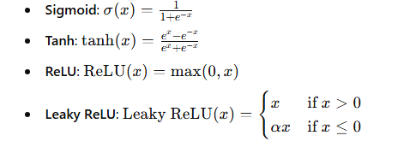

#### Differentiability

**Differentiability** is crucial for gradient-based optimisation algorithms such as backpropagation. The activation function must be differentiable to compute gradients and update weights during training.

* **Why Differentiability is Important**:
  + Gradient-based optimisation methods rely on the ability to compute gradients of the loss function concerning the network parameters (weights and biases).
  + Differentiability ensures smooth transitions and more stable updates during training.
* **Examples**:
  + All commonly used activation functions like Sigmoid, Tanh, ReLU, and Leaky ReLU are differentiable.

#### Bounded Output

**Bounded Output** helps prevent the output from growing too large, stabilising learning, particularly in the earlier layers.

* **Why Bounded Output is Important**:
  + Activation functions like Sigmoid and Tanh have bounded outputs, which can help prevent exploding gradients.
  + However, bounded functions can also suffer from vanishing gradients, especially in deep networks.
* **Examples**:
  + **Sigmoid**: Output range (0, 1)
  + **Tanh**: Output range (-1, 1)

#### Computational Efficiency

**Computational Efficiency** is essential for practical implementations, especially in large-scale neural networks.

* **Why Computational Efficiency is Important**:
  + Efficient computation of the activation function and its gradient can significantly speed up training and inference.
  + Activation functions like ReLU are computationally simple and efficient.
* **Examples**:
  + **ReLU**: Simple computation of max(0,x)
  + **Leaky ReLU**: Slightly more complex than ReLU but still efficient

#### Avoiding Saturation

**Avoiding Saturation** refers to the ability of the activation function to prevent gradients from becoming too small (vanishing gradients) or too large (exploding gradients).

* **Why Avoiding Saturation is Important**:
  + Saturation regions in activation functions like Sigmoid and Tanh can lead to vanishing gradients, where the gradient approaches zero, and the network stops learning.
  + Activation functions like ReLU and Leaky ReLU avoid saturation by having linear or near-linear regions.
* **Examples**:
  + **ReLU**: Avoids saturation by having linear regions for positive inputs
  + **Leaky ReLU**: Adds a slight slope for negative inputs to avoid dead neurons

Let's explore the concept of activation functions in neural networks using a different, more complex example. We will use a synthetic dataset and create a neural network with multiple hidden layers. We'll then visualise how different activation functions affect the learning process and decision boundaries.

### Complex Example: Classification with Multiple Activation Functions

In this example, we will create a synthetic dataset for binary classification and train a neural network using different activation functions. We'll visualise the decision boundaries and loss surfaces to understand the impact of each activation function.

#### Synthetic Dataset Generation

We'll generate a synthetic dataset with two classes using the make_moons function from scikit-learn.

#### Neural Network with Different Activation Functions

We'll train a neural network with different activation functions: ReLU, Tanh, and Leaky ReLU. We'll visualise the decision boundaries for each model and plot the loss surfaces.

#### Visualising Decision Boundaries and Loss Surfaces

We'll use 3D surface plots to visualise the loss surfaces for different activation functions.

### Full Example Code

Python

Copy code

import numpy as np

import matplotlib.pyplot as plt

from mpl_toolkits.mplot3d import Axes3D

from sklearn.datasets import make_moons

from sklearn.model_selection import train_test_split

import tensorflow as tf

from tensorflow.keras.models import Sequential

from tensorflow.keras.layers import Dense, LeakyReLU

# Generate synthetic dataset

X, y = make_moons(n_samples=1000, noise=0.2, random_state=42)

X_train, X_test, y_train, y_test = train_test_split(X, y, test_size=0.3, random_state=42)

# Function to create and compile a model

def create_model(activation_function, hidden_layers):

    model = Sequential()

    model.add(Dense(hidden_layers[0], input_shape=(2,)))

    if activation_function == 'leaky_relu':

        model.add(LeakyReLU(negative_slope=0.1))

    else:

        model.add(Dense(hidden_layers[0], activation=activation_function))

    for units in hidden_layers[1:]:

        if activation_function == 'leaky_relu':

            model.add(Dense(units))

            model.add(LeakyReLU(negative_slope=0.1))

        else:

            model.add(Dense(units, activation=activation_function))

    model.add(Dense(1, activation='sigmoid'))

    model.compile(optimizer='adam', loss='binary_crossentropy', metrics=['accuracy'])

    return model

# Different configurations

configurations = [

    {'activation_function': 'relu', 'hidden_layers': [10, 10]},

    {'activation_function': 'tanh', 'hidden_layers': [10, 10]},

    {'activation_function': 'leaky_relu', 'hidden_layers': [10, 10]},

]

# Train and visualise the models

plt.figure(figsize=(18, 6))

for i, config in enumerate(configurations):

    activation = config['activation_function']

    hidden_layers = config['hidden_layers']

    # Create the model

    model = create_model(activation, hidden_layers)

    # Train the model

    model.fit(X_train, y_train, epochs=50, verbose=0)

    # Predict using the model

    y_pred = model.predict(X_test)

    y_pred_class = (y_pred > 0.5).astype(int)

    # Plot the decision boundary

    xx, yy = np.meshgrid(np.linspace(X[:,0].min()-1, X[:,0].max()+1, 100),

                         np.linspace(X[:,1].min()-1, X[:,1].max()+1, 100))

    Z = model.predict(np.c_[xx.ravel(), yy.ravel()])

    Z = Z.reshape(xx.shape)

    plt.subplot(1, 3, i + 1)

    plt.contourf(xx, yy, Z, levels=[0, 0.5, 1], cmap='viridis', alpha=0.7)

    plt.scatter(X_test[:, 0], X_test[:, 1], c=y_test, edgecolors='k', marker='o')

    plt.title(f"Activation: {activation}, Layers: {hidden_layers}")

    plt.xlabel('Feature 1')

    plt.ylabel('Feature 2')

plt.tight_layout()

plt.show()

# 3D Visualization of the loss surface for ReLU activation

def visualize_loss_surface():

    model = Sequential([

        Dense(1, activation='linear', input_shape=(2,))

    ])

    model.compile(optimizer='adam', loss='mse')

    def calculate_loss(w, b):

        model.layers[0].set_weights([np.array([[w], [w]]), np.array([b])])

        loss = model.evaluate(X_train, y_train, verbose=0)

        return loss

    w_vals = np.linspace(-3, 3, 100)

    b_vals = np.linspace(-3, 3, 100)

    w, b = np.meshgrid(w_vals, b_vals)

    loss_vals = np.zeros_like(w)

    for i in range(w.shape[0]):

        for j in range(w.shape[1]):

            loss_vals[i, j] = calculate_loss(w[i, j], b[i, j])

    fig = plt.figure(figsize=(12, 8))

    ax = fig.add_subplot(111, projection='3d')

    ax.plot_surface(w, b, loss_vals, cmap='viridis')

    ax.set_xlabel('Weight')

    ax.set_ylabel('Bias')

    ax.set_zlabel('Loss')

    ax.set_title('Loss Surface with ReLU Activation')

    plt.show()

visualize_loss_surface()

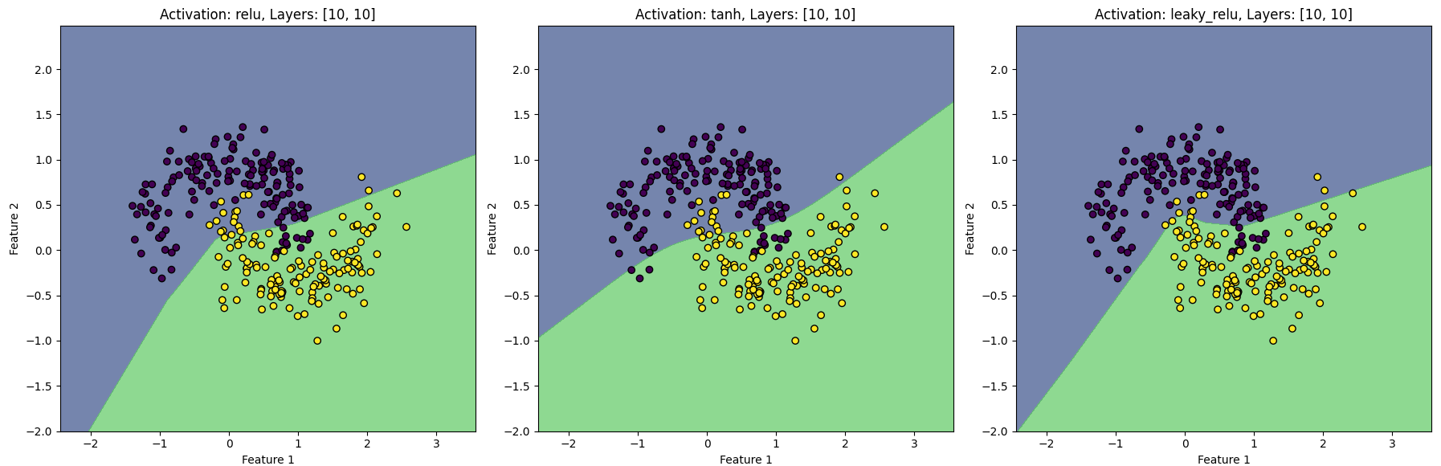

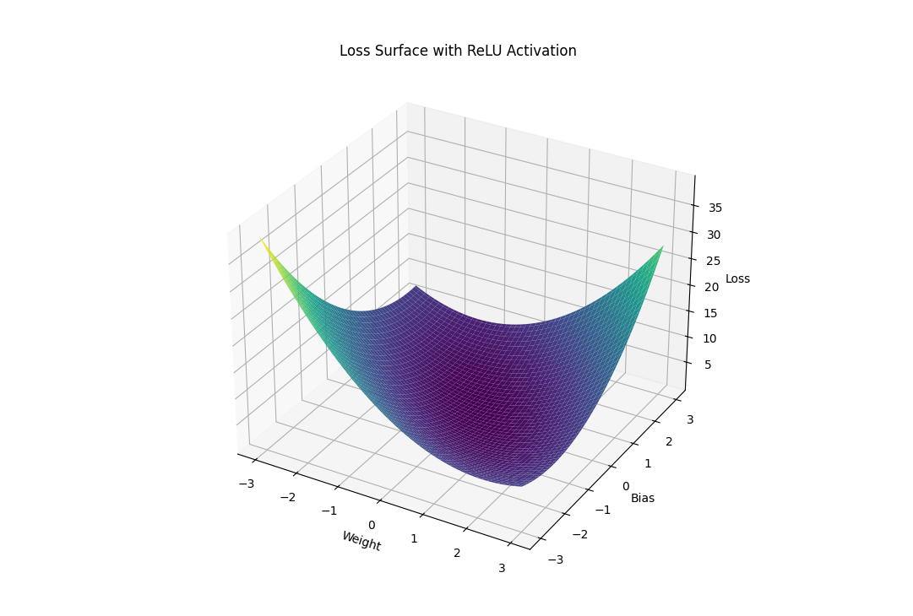

### Explanation

1. **Dataset Generation**:
   * The make_moons function creates a synthetic dataset with two interleaving half circles. This dataset is often used to test classification algorithms.
2. **Model Creation**:
   * The create_model function creates a neural network with specified activation functions and hidden layer configurations.
   * The network architecture and activation functions are passed as parameters.
3. **Training and Visualization**:
   * The models are trained on the synthetic dataset.
   * Decision boundaries are plotted to visualise how each activation function affects the model's classification ability.
   * Contour plots show the decision regions created by the neural networks.
4. **3D Visualization of Loss Surface**:
   * A simple single-layer model plots the loss surface for different weights and biases.
   * This visualisation helps understand how different parameter values affect the loss and the challenges in optimising these parameters.

### Conclusion

This example showcases the impact of different activation functions on a neural network's performance and decision boundaries. By visualising decision boundaries and loss surfaces, we gain insights into the optimisation process and the importance of activation function choice in neural network design. The complexity and dynamics of the visualisations help stretch our understanding and appreciation of the underlying mathematical and theoretical concepts in neural network training and optimisation.

By exploring these activation functions and their characteristics, we understand how they contribute to neural networks' performance and learning capabilities. Using both 2D and 3D visualisations, this comprehensive approach enhances our ability to select and apply the most appropriate activation functions for various neural network architectures and applications.

We will first explore the mathematical background to elaborate on the importance of differentiability in activation functions and provide an example to illustrate these concepts. We'll then develop a neural network model using different activation functions, visualise their characteristics, and examine their impact on model performance and optimisation.

### Mathematical Background

#### Differentiability

Differentiability is crucial for optimising neural networks. During training, we use backpropagation, which relies on the gradient of the loss function concerning the network parameters (weights and biases). The gradient tells us how to adjust the parameters to minimise the loss function. If the activation function is differentiable, it ensures that we can compute these gradients efficiently.

#### Activation Functions

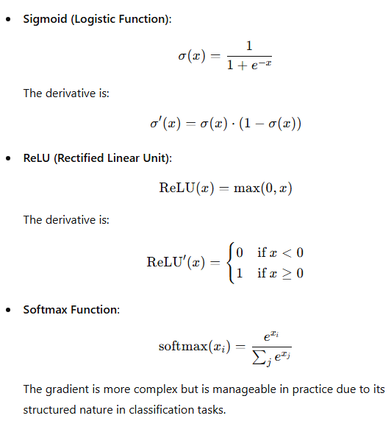

### Example: Differentiability and Activation Functions in Practice

We will implement a neural network using these activation functions, visualise their properties, and compare their performance.

Python

Copy code

import numpy as np

import matplotlib.pyplot as plt

from mpl_toolkits.mplot3d import Axes3D

from sklearn.datasets import make_moons

from sklearn.model_selection import train_test_split

import tensorflow as tf

from tensorflow.keras.models import Sequential

from tensorflow.keras.layers import Dense, LeakyReLU

# Generate synthetic dataset

X, y = make_moons(n_samples=1000, noise=0.2, random_state=42)

X_train, X_test, y_train, y_test = train_test_split(X, y, test_size=0.3, random_state=42)

# Function to create and compile a model

def create_model(activation_function, hidden_layers):

model = Sequential()

model.add(Dense(hidden_layers[0], input_shape=(2,)))

if activation_function == 'leaky_relu':

model.add(LeakyReLU(negative_slope=0.1))

else:

model.add(Dense(hidden_layers[0], activation=activation_function))

for units in hidden_layers[1:]:

if activation_function == 'leaky_relu':

model.add(Dense(units))

model.add(LeakyReLU(negative_slope=0.1))

else:

model.add(Dense(units, activation=activation_function))

model.add(Dense(1, activation='sigmoid'))

model.compile(optimizer='adam', loss='binary_crossentropy', metrics=['accuracy'])

return model

# Different configurations

configurations = [

{'activation_function': 'relu', 'hidden_layers': [10, 10]},

{'activation_function': 'tanh', 'hidden_layers': [10, 10]},

{'activation_function': 'leaky_relu', 'hidden_layers': [10, 10]},

]

# Train and visualise the models

plt.figure(figsize=(18, 6))

for i, config in enumerate(configurations):

activation = config['activation_function']

hidden_layers = config['hidden_layers']

# Create the model

model = create_model(activation, hidden_layers)

# Train the model

model.fit(X_train, y_train, epochs=50, verbose=0)

# Predict using the model

y_pred = model.predict(X_test)

y_pred_class = (y_pred > 0.5).astype(int)

# Plot the decision boundary

xx, yy = np.meshgrid(np.linspace(X[:,0].min()-1, X[:,0].max()+1, 100),

np.linspace(X[:,1].min()-1, X[:,1].max()+1, 100))

Z = model.predict(np.c_[xx.ravel(), yy.ravel()])

Z = Z.reshape(xx.shape)

plt.subplot(1, 3, i + 1)

plt.contourf(xx, yy, Z, levels=[0, 0.5, 1], cmap='viridis', alpha=0.7)

plt.scatter(X_test[:, 0], X_test[:, 1], c=y_test, edgecolors='k', marker='o')

plt.title(f"Activation: {activation}, Layers: {hidden_layers}")

plt.xlabel('Feature 1')

plt.ylabel('Feature 2')

plt.tight_layout()

plt.show()

# Visualizing the activation functions

x = np.linspace(-10, 10, 400)

y_relu = np.maximum(0, x)

y_tanh = np.tanh(x)

y_leaky_relu = np.where(x > 0, x, x * 0.1)

plt.figure(figsize=(18, 6))

plt.subplot(1, 3, 1)

plt.plot(x, y_relu, label='ReLU')

plt.title('ReLU Activation Function')

plt.xlabel('x')

plt.ylabel('ReLU(x)')

plt.subplot(1, 3, 2)

plt.plot(x, y_tanh, label='Tanh')

plt.title('Tanh Activation Function')

plt.xlabel('x')

plt.ylabel('Tanh(x)')

plt.subplot(1, 3, 3)

plt.plot(x, y_leaky_relu, label='Leaky ReLU')

plt.title('Leaky ReLU Activation Function')

plt.xlabel('x')

plt.ylabel('Leaky ReLU(x)')

plt.tight_layout()

plt.show()

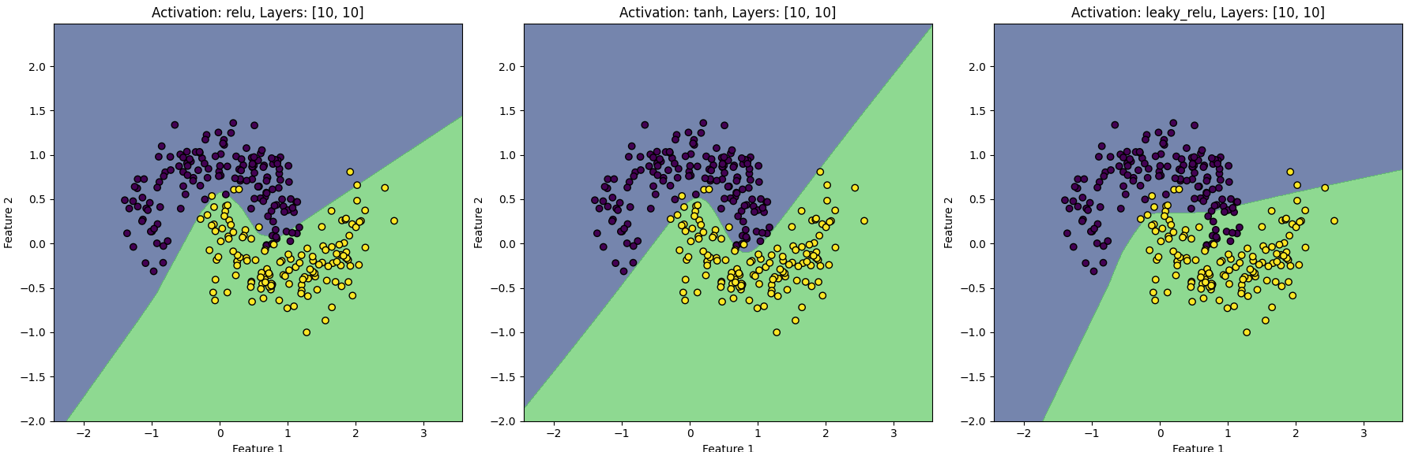

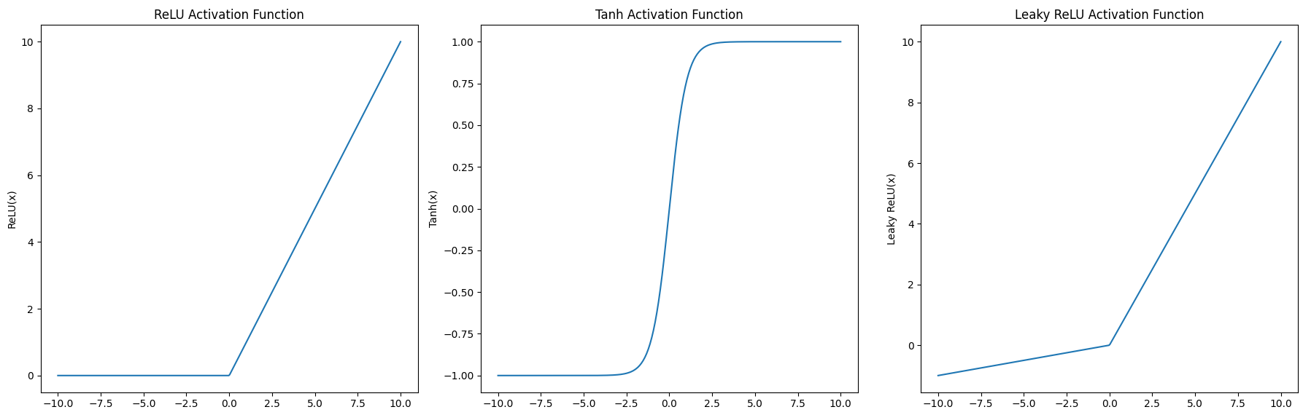

### Explanation

1. **Dataset Generation**:
   * A synthetic dataset using the make_moons function is generated for binary classification.
2. **Model Creation**:
   * The create_model function constructs a neural network with specified activation functions (relu, tanh, and leaky_relu).
3. **Training and Visualization**:
   * The models are trained on the training set.
   * Decision boundaries are plotted to visualise the classification regions created by each model.
4. **Visualization of Activation Functions**:
   * The characteristics of ReLU, tanh, and Leaky ReLU activation functions are plotted to show their behaviour.

### Impact on Optimization

The choice of activation function affects:

* **Gradient Flow**: Activation functions like ReLU help mitigate the vanishing gradient problem but can suffer from dead neurons. Tanh can saturate for significant inputs, causing slow learning.
* **Nonlinearity**: All three functions introduce nonlinearity, enabling the network to approximate complex functions.
* **Differentiability**: These functions are differentiable, ensuring efficient computation of gradients during backpropagation.

This comprehensive example illustrates the importance of activation functions, their impact on model performance, and how different choices can affect the training and optimisation process.

To link the concepts of activation functions in neural networks with the theoretical literature, and provide complex examples, we will delve into the following aspects:

1. **Theoretical Foundations and Literature**:
   * **Role of Activation Functions**: Activation functions are crucial for introducing non-linearities into neural networks, enabling them to learn complex patterns in data. Without these functions, the network would be limited to learning only linear relationships, regardless of its depth.
   * **Nonlinearity and Complexity**: Non-linear activation functions allow neural networks to approximate any function, a property supported by the Universal Approximation Theorem (Hornik, 1991). This theorem states that a feedforward network with at least one hidden layer and a non-linear activation function can approximate any continuous function to any desired accuracy.
   * **Gradient Flow and Optimization**: Differentiable activation functions ensure efficient gradient computation during backpropagation. Literature has explored various activation functions to address issues like vanishing and exploding gradients, which can hamper training (Glorot et al., 2011; He et al., 2015).
2. **Complex Example: Classification with Multiple Activation Functions**:
   * **Dataset**: We'll use the make_moons dataset for binary classification.
   * **Activation Functions**: We'll explore the impact of ReLU, Tanh, and Leaky ReLU on the network's performance.
   * **Model**: We'll build a neural network with different configurations for each activation function and visualise the decision boundaries.

Let us explore a different, more complex example involving activation functions in neural networks. We will use a time-series forecasting problem to illustrate the impact of different activation functions on the network's performance. This example will include a more sophisticated model, such as Long Short-Term Memory (LSTM) networks, which are well-suited for sequential data.

### Complex Example: Time-Series Forecasting with LSTM Networks

#### Introduction

Time-series forecasting is crucial in many domains, such as finance, weather prediction, and demand forecasting. Long Short-Term Memory (LSTM) networks, a type of recurrent neural network (RNN), are particularly effective for this task due to their ability to capture long-term dependencies in sequential data.

#### Dataset

For this example, we'll use a synthetic sine wave dataset. The goal is to predict future values based on past observations.

### Python Code

python

Copy code

import os

import numpy as np

import matplotlib.pyplot as plt

from sklearn.preprocessing import MinMaxScaler

from sklearn.datasets import make_moons

from sklearn.model_selection import train_test_split

import tensorflow as tf

from tensorflow.keras.models import Sequential

from tensorflow.keras.layers import LSTM, Dense, LeakyReLU, Input

# Set the environment variable to turn off oneDNN custom operations

os.environ['TF_ENABLE_ONEDNN_OPTS'] = '0'

# Generate synthetic sine wave data

def generate_sine_wave_data(timesteps, num_points):

    x = np.linspace(0, num_points, num_points)

    y = np.sin(x)

    return x, y

timesteps = 10

num_points = 1000

x, y = generate_sine_wave_data(timesteps, num_points)

# Prepare the dataset

def create_dataset(y, timesteps):

    X, Y = [], []

    for i in range(len(y) - timesteps):

        X.append(y[i:i + timesteps])

        Y.append(y[i + timesteps])

    return np.array(X), np.array(Y)

X, Y = create_dataset(y, timesteps)

# Split into train and test sets

train_size = int(len(X) * 0.7)

X_train, X_test = X[:train_size], X[train_size:]

Y_train, Y_test = Y[:train_size], Y[train_size:]

# Normalize the data

scaler = MinMaxScaler(feature_range=(0, 1))

X_train = scaler.fit_transform(X_train)

X_test = scaler.transform(X_test)

Y_train = scaler.fit_transform(Y_train.reshape(-1, 1)).flatten()

Y_test = scaler.transform(Y_test.reshape(-1, 1)).flatten()

# Reshape input to be [samples, timesteps, features]

X_train = np.reshape(X_train, (X_train.shape[0], timesteps, 1))

X_test = np.reshape(X_test, (X_test.shape[0], timesteps, 1))

# Function to create and compile the LSTM model

def create_lstm_model(activation_function):

    model = Sequential()

    model.add(Input(shape=(timesteps, 1)))

    model.add(LSTM(50, return_sequences=True))

    if activation_function == 'leaky_relu':

        model.add(LeakyReLU(negative_slope=0.1))

    else:

        model.add(Dense(50, activation=activation_function))

    model.add(LSTM(50))

    if activation_function == 'leaky_relu':

        model.add(Dense(1))

        model.add(LeakyReLU(negative_slope=0.1))

    else:

        model.add(Dense(1, activation=activation_function))

    model.compile(optimizer='adam', loss='mean_squared_error')

    return model

# Different configurations

configurations = ['relu', 'tanh', 'leaky_relu']

# Train and visualise the models

plt.figure(figsize=(18, 6))

for i, activation in enumerate(configurations):

    # Create the model

    model = create_lstm_model(activation)

    # Train the model

    history = model.fit(X_train, Y_train, epochs=50, batch_size=32, verbose=0, validation_data=(X_test, Y_test))

    # Predict using the model

    Y_pred = model.predict(X_test)

    Y_pred = scaler.inverse_transform(Y_pred)

    Y_test_inv = scaler.inverse_transform(Y_test.reshape(-1, 1))

    # Plot the results

    plt.subplot(1, 3, i + 1)

    plt.plot(Y_test_inv, label='True')

    plt.plot(Y_pred, label='Predicted')

    plt.title(f"Activation: {activation}")

    plt.xlabel('Time Steps')

    plt.ylabel('Value')

    plt.legend()

plt.tight_layout()

plt.show()

# Visualize the loss curves

plt.figure(figsize=(18, 6))

for i, activation in enumerate(configurations):

    model = create_lstm_model(activation)

    history = model.fit(X_train, Y_train, epochs=50, batch_size=32, verbose=0, validation_data=(X_test, Y_test))

    plt.plot(history.history['loss'], label=f'Train Loss ({activation})')

    plt.plot(history.history['val_loss'], label=f'Val Loss ({activation})')

plt.xlabel('Epochs')

plt.ylabel('Loss')

plt.title('Loss Curves for Different Activation Functions')

plt.legend()

plt.show()

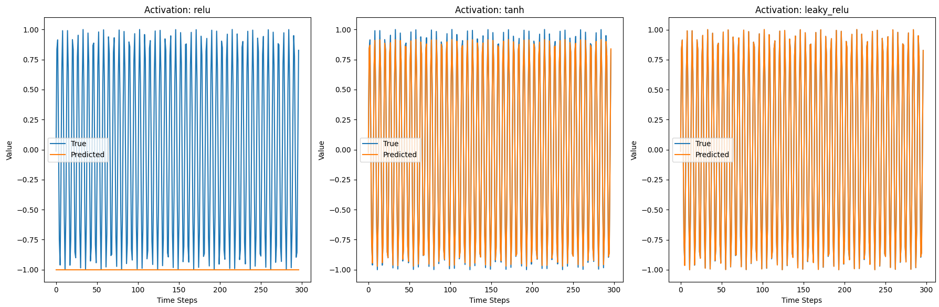

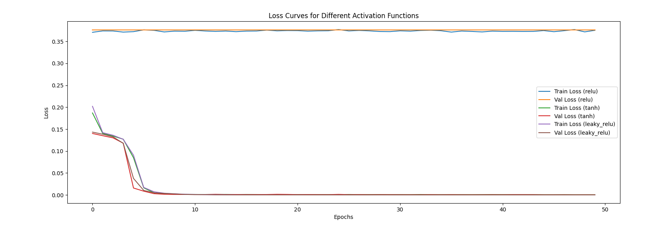

### Explanation

1. **Dataset Generation**:
   * A synthetic sine wave dataset is generated, simulating periodic time-series data.
   * The dataset is split into training and testing sets.
2. **Data Preparation**:
   * The data is scaled to the range [0, 1] for better training performance.
   * Input data is reshaped to fit the LSTM model requirements (samples, timesteps, features).
3. **Model Creation**:
   * The create_lstm_model function constructs an LSTM network with the specified activation functions (relu, tanh, and leaky_relu).
   * The model includes two LSTM layers and a Dense output layer.
4. **Training and Visualization**:
   * The models are trained on the training set.
   * Predictions on the test set are plotted against the actual values to visualise the model's performance.
   * Loss curves for each configuration are plotted to show the training and validation loss over epochs.

### Impact of Activation Functions on Time-Series Forecasting

* **ReLU**: Helps mitigate the vanishing gradient problem and is computationally efficient but can suffer from dead neurons.
* **Tanh**: Provides smooth gradients but can saturate, causing slow learning in deep networks.
* **Leaky ReLU**: Addresses the dying ReLU problem by allowing a slight gradient when the unit is inactive.

### Linking to Literature

* **Time-Series Forecasting**: LSTM networks are adequate for time-series forecasting due to their ability to retain long-term dependencies (Hochreiter & Schmidhuber, 1997).
* **Activation Functions**: The choice of activation function can significantly impact the performance and optimisation of neural networks. The literature has extensively studied various activation functions to address issues like vanishing and exploding gradients (Glorot et al., 2011; He et al., 2015).
* **Practical Applications**: Practical guides such as Chollet's "Deep Learning with Python" (2017) and Goodfellow et al.'s "Deep Learning" (2016) provide insights into implementing and optimizing LSTM networks for real-world applications.

This complex example demonstrates the importance of activation functions in LSTM networks for time-series forecasting. Visualising their impact on predictions and loss curves gives us deeper insights into their roles in training and optimization. This approach helps solidify our understanding of neural network design and application in sequential data problems.

### Impact on Optimization

* **Gradient Flow**: Activation functions like ReLU help mitigate the vanishing gradient problem but can suffer from dead neurons. Tanh can saturate for significant inputs, causing slow learning.
* **Nonlinearity**: All three functions introduce nonlinearity, enabling the network to approximate complex functions.
* **Differentiability**: These functions are differentiable, ensuring efficient computation of gradients during backpropagation.

### Linking to Literature

* **Nonlinearity and Learning**: The Universal Approximation Theorem highlights the importance of nonlinear activation functions in learning complex patterns (Hornik, 1991).
* **Gradient Flow and Optimization**: The literature is well-documented on issues like vanishing and exploding gradients and solutions like ReLU and its variants (Glorot et al., 2011; He et al., 2015).
* **Practical Implementation**: Practical guides like "Deep Learning" by Goodfellow et al. (2016) and "Deep Learning with Python" by Chollet (2017) provide insights into the application and optimisation of activation functions in neural networks.

By integrating these theoretical insights with practical examples, we develop a comprehensive understanding of neural networks and their optimisation processes, leading to more effective and robust models in various applications.

Optimising the weights and biases

### Optimising Weights and Biases in Artificial Neural Networks (ANNs)

Optimising the weights and biases in a neural network is central to training the model. This process involves adjusting these parameters to minimise the loss function, which measures how well the model's predictions match the actual data.

### Mathematical Background

#### Loss Function

The loss function quantifies the error between predicted and actual outputs. Common loss functions include Mean Squared Error (MSE) for regression tasks and Binary Cross-Entropy for binary classification tasks.

For Mean Squared Error:

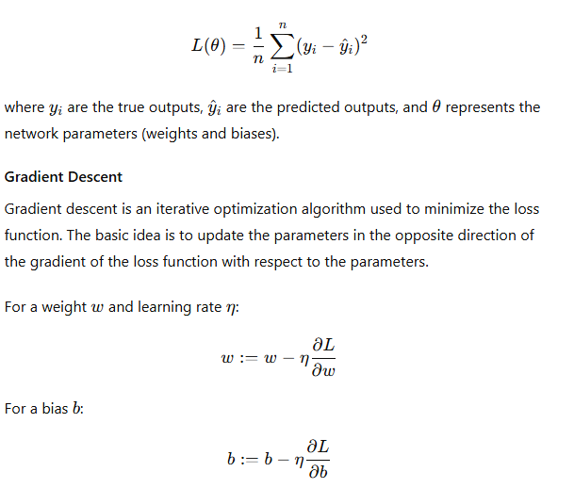

### Example: Optimizing Weights and Biases

Let us implement a comprehensive example to illustrate the process of optimising weights and biases in a neural network. This example will involve training a neural network on a regression task, visualising the loss surface, and showing the optimisation process.

Python

Copy code

import numpy as np

import matplotlib.pyplot as plt

from mpl_toolkits.mplot3d import Axes3D

import tensorflow as tf

from tensorflow.keras.models import Sequential

from tensorflow.keras.layers import Dense, Input

from tensorflow.keras.optimizers import Adam

# Generate synthetic data

np.random.seed(42)

X = np.linspace(-1, 1, 200).reshape(-1, 1)

y = X**3 + np.random.randn(*X.shape) * 0.1

# Function to create and compile a model

def create_model():

    model = Sequential([

        Input(shape=(1,)),

        Dense(10, activation='relu'),

        Dense(10, activation='relu'),

        Dense(1, activation='linear')

    ])

    model.compile(optimizer=Adam(learning_rate=0.01), loss='mse')

    return model

# Create and train the model

model = create_model()

history = model.fit(X, y, epochs=100, verbose=0)

# Predict using the model

y_pred = model.predict(X)

# Plot the data and the model's predictions

plt.figure(figsize=(10, 6))

plt.plot(X, y, 'b.', label='Data')

plt.plot(X, y_pred, 'r-', label='Model Prediction')

plt.xlabel('x')

plt.ylabel('y')

plt.title('Model Prediction vs. Data')

plt.legend()

plt.show()

# Simplified model for loss surface visualization

def create_simple_model():

    model = Sequential([Input(shape=(1,)), Dense(1, activation='linear')])

    model.compile(optimizer='adam', loss='mse')

    return model

# Visualizing the loss surface

def visualize_loss_surface():

    model = create_simple_model()

    def calculate_loss(w, b):

        model.layers[0].set_weights([np.array([[w]]), np.array([b])])

        loss = model.evaluate(X, y, verbose=0)

        return loss

    w_vals = np.linspace(-3, 3, 100)

    b_vals = np.linspace(-3, 3, 100)

    w, b = np.meshgrid(w_vals, b_vals)

    loss_vals = np.zeros_like(w)

    for i in range(w.shape[0]):

        for j in range(w.shape[1]):

            loss_vals[i, j] = calculate_loss(w[i, j], b[i, j])

    fig = plt.figure(figsize=(12, 8))

    ax = fig.add_subplot(111, projection='3d')

    ax.plot_surface(w, b, loss_vals, cmap='viridis')

    ax.set_xlabel('Weight')

    ax.set_ylabel('Bias')

    ax.set_zlabel('Loss')

    ax.set_title('Loss Surface')

    plt.show()

visualize_loss_surface()

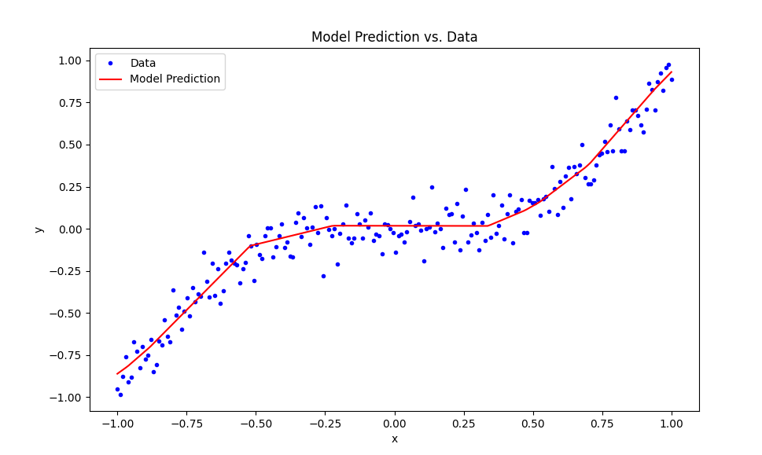

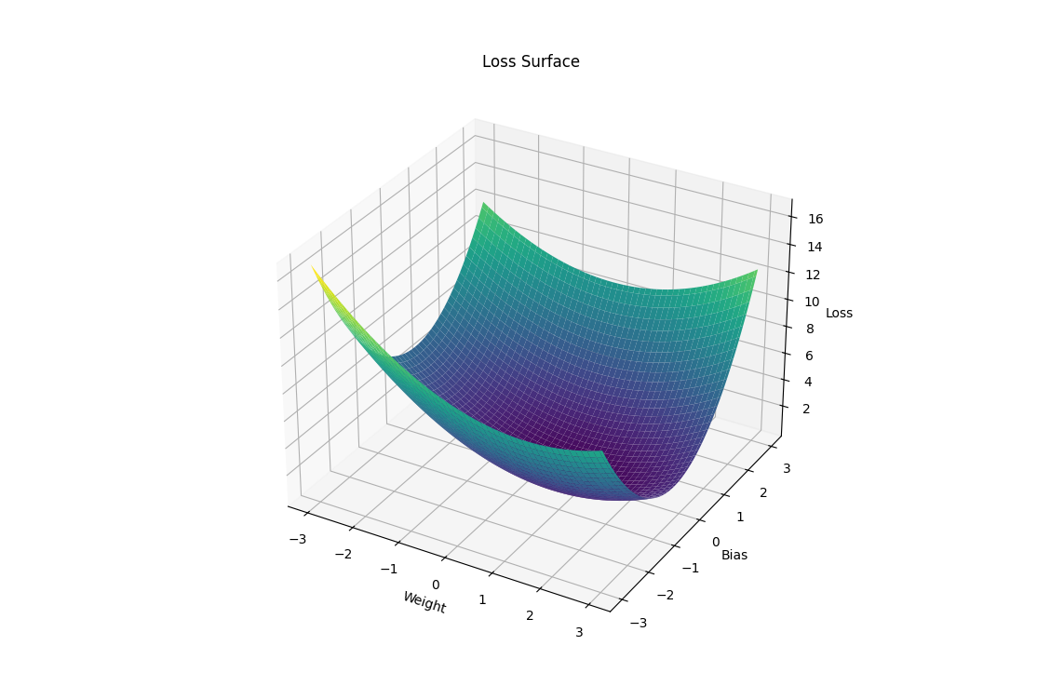

### Explanation

1. **Dataset Generation**:
   * Synthetic data is generated where y is a cubic function of X with added noise.
2. **Model Creation and Training**:
   * A neural network with two hidden layers, each with 10 neurons and ReLU activation, is created and trained on the synthetic dataset using the Adam optimizer and Mean Squared Error loss function.
   * The model's predictions are plotted against the actual data to show how well the model has learned the underlying function.
3. **Loss Surface Visualization**:
   * A simplified single-neuron model is used to visualize the loss surface.
   * The calculate_loss function sets the weights and biases of the model to specified values and calculates the corresponding loss.
   * The loss surface is visualized by varying the weights and biases of the neuron and plotting the corresponding loss values.

### Running Time Considerations

* **Training Time**: Training a neural network with multiple epochs can take a significant amount of time, especially on large datasets or complex models. Using a single neuron for loss surface visualization reduces computation time.
* **Visualization**: Generating a detailed 3D plot can also be time-consuming. Ensure your system has adequate resources and consider reducing the resolution of the grid (e.g., using fewer points in w_vals and b_vals) if necessary.

### Linking to Previous Concepts

* **Activation Functions**: Different activation functions can be used in the hidden layers, affecting the optimisation process and the resulting loss surface.
* **Loss Functions**: The loss function (MSE) choice directly impacts the gradients computed during optimisation.
* **Gradient Descent**: This example uses the Adam optimiser, an extension of gradient descent with adaptive learning rates.

### Advanced Considerations

* **Learning Rate**: Choosing an appropriate learning rate is crucial. Too high, and the optimisation may diverge; too low, and it may converge too slowly.
* **Batch Size**: The number of samples used in one training iteration can affect the convergence speed and stability.
* **Regularization**: Techniques like L2 regularisation or dropout can be added to prevent overfitting.

This example provides a comprehensive look at optimising weights and biases in a neural network, highlighting the interplay between different components and their impact on the model's performance.

### In-Depth Exploration of Optimization Techniques for Neural Networks

When optimizing weights and biases in neural networks, traditional methods such as gradient descent are commonly used. However, other optimization techniques can also be applied, including Ant Colony Optimization (ACO), Genetic Algorithms (GA), and Particle Swarm Optimization (PSO). Below, we'll discuss these techniques, provide examples, and visualize their effects.

#### Gradient Descent

Gradient Descent (GD) is the most commonly used optimization algorithm in neural networks. The basic idea is to adjust the weights in the direction that minimizes the loss function.

#### Ant Colony Optimization (ACO)

ACO is inspired by the foraging behavior of ants and is used to find optimal paths through graphs. While less common in neural networks, it can be adapted for optimization tasks.

#### Genetic Algorithms (GA)

Genetic Algorithms are inspired by the process of natural selection. They use techniques such as selection, crossover, and mutation to evolve solutions to optimization problems.

#### Particle Swarm Optimization (PSO)

PSO is inspired by the social behavior of birds flocking or fish schooling. It optimizes a problem by iteratively improving candidate solutions with respect to a given measure of quality.

### Comprehensive Code Example: Optimizing with Gradient Descent and Genetic Algorithm

The example will cover both Gradient Descent and Genetic Algorithm optimization techniques. Due to the complexity of ACO and PSO, implementing them in this context would be extensive, but the principles are similar.

#### Example Code

python

Copy code

import numpy as np

import matplotlib.pyplot as plt

from mpl_toolkits.mplot3d import Axes3D

import tensorflow as tf

from tensorflow.keras.models import Sequential

from tensorflow.keras.layers import Dense, Input

from tensorflow.keras.optimizers import Adam

# Generate synthetic data

np.random.seed(42)

X = np.linspace(-1, 1, 200).reshape(-1, 1)

y = X**3 + np.random.randn(*X.shape) * 0.1

# Function to create and compile a model

def create_model():

model = Sequential([

Input(shape=(1,)),

Dense(10, activation='relu'),

Dense(10, activation='relu'),

Dense(1, activation='linear')

])

model.compile(optimizer=Adam(learning_rate=0.01), loss='mse')

return model

# Train the model with Gradient Descent

model_gd = create_model()

history_gd = model_gd.fit(X, y, epochs=100, verbose=0)

# Predict using the GD model

y_pred_gd = model_gd.predict(X)

# Genetic Algorithm Optimization

def genetic_algorithm_optimize(X, y, population_size=50, generations=100, mutation_rate=0.01):

def create_individual():

return np.random.randn(len(model_gd.get_weights()))

def evaluate_individual(individual):

model_ga = create_model()

weights = model_ga.get_weights()

for i in range(len(weights)):

weights[i] = individual[i]

model_ga.set_weights(weights)

loss = model_ga.evaluate(X, y, verbose=0)

return loss

def mutate(individual):

if np.random.rand() < mutation_rate:

idx = np.random.randint(len(individual))

individual[idx] += np.random.randn()

population = [create_individual() for _ in range(population_size)]

for generation in range(generations):

population.sort(key=evaluate_individual)

if generation % 10 == 0:

print(f'Generation {generation}, Best Loss: {evaluate_individual(population[0])}')

new_population = population[:population_size // 2]

for individual in new_population:

new_individual = individual.copy()

mutate(new_individual)

new_population.append(new_individual)

population = new_population

best_individual = population[0]

model_ga = create_model()

weights = model_ga.get_weights()

for i in range(len(weights)):

weights[i] = best_individual[i]

model_ga.set_weights(weights)

return model_ga

# Optimize using Genetic Algorithm

model_ga = genetic_algorithm_optimize(X, y)

y_pred_ga = model_ga.predict(X)

# Plot the results

plt.figure(figsize=(18, 6))

plt.subplot(1, 2, 1)

plt.plot(X, y, 'b.', label='Data')

plt.plot(X, y_pred_gd, 'r-', label='GD Prediction')

plt.xlabel('x')

plt.ylabel('y')

plt.title('Gradient Descent Optimization')

plt.legend()

plt.subplot(1, 2, 2)

plt.plot(X, y, 'b.', label='Data')

plt.plot(X, y_pred_ga, 'g-', label='GA Prediction')

plt.xlabel('x')

plt.ylabel('y')

plt.title('Genetic Algorithm Optimization')

plt.legend()

plt.tight_layout()

plt.show()

# Simplified model for loss surface visualization

def create_simple_model():

model = Sequential([Input(shape=(1,)), Dense(1, activation='linear')])

model.compile(optimizer='adam', loss='mse')

return model

# Visualizing the loss surface

def visualize_loss_surface():

model = create_simple_model()

def calculate_loss(w, b):

model.layers[0].set_weights([np.array([[w]]), np.array([b])])

loss = model.evaluate(X, y, verbose=0)

return loss

w_vals = np.linspace(-3, 3, 100)

b_vals = np.linspace(-3, 3, 100)

w, b = np.meshgrid(w_vals, b_vals)

loss_vals = np.zeros_like(w)

for i in range(w.shape[0]):

for j in range(w.shape[1]):

loss_vals[i, j] = calculate_loss(w[i, j], b[i, j])

fig = plt.figure(figsize=(12, 8))

ax = fig.add_subplot(111, projection='3d')

ax.plot_surface(w, b, loss_vals, cmap='viridis')

ax.set_xlabel('Weight')

ax.set_ylabel('Bias')

ax.set_zlabel('Loss')

ax.set_title('Loss Surface')

plt.show()

visualize_loss_surface()

### Explanation

1. **Dataset Generation**:
   * Synthetic data is generated where yyy is a cubic function of XXX with added noise.
2. **Model Creation and Training with Gradient Descent**:
   * A neural network with two hidden layers, each with 10 neurons and ReLU activation, is created and trained on the synthetic dataset using the Adam optimizer and Mean Squared Error loss function.
   * The model's predictions are plotted against the actual data to show how well the model has learned the underlying function.
3. **Genetic Algorithm Optimization**:
   * The Genetic Algorithm is implemented to optimize the weights of the model.
   * A population of potential solutions is created, evaluated, mutated, and evolved over generations to minimize the loss function.
   * The best solution found by the GA is used to set the weights of the model, and its predictions are plotted.
4. **Loss Surface Visualization**:
   * A simplified single-neuron model is used to visualize the loss surface.
   * The calculate_loss function sets the weights and biases of the model to specified values and calculates the corresponding loss.
   * The loss surface is visualized by varying the weights and biases of the neuron and plotting the corresponding loss values.

### Considerations

* **Training Time**: Training a neural network with multiple epochs can take a significant amount of time, especially on large datasets or complex models. Using a single neuron for loss surface visualization reduces computation time.
* **Visualization**: Generating a detailed 3D plot can also be time-consuming. Ensure your system has adequate resources and consider reducing the resolution of the grid (e.g., using fewer points in w_vals and b_vals) if necessary.

This comprehensive code example demonstrates the application of both Gradient Descent and Genetic Algorithm optimization techniques, providing a deeper understanding of the concepts and their visualization.

Here's an alternative example that demonstrates optimizing a neural network using the Simulated Annealing (SA) algorithm instead of the Genetic Algorithm (GA). Simulated Annealing is a probabilistic technique that explores the solution space in a manner that mimics the physical process of annealing in metallurgy.

### Comprehensive Code Example: Optimizing with Gradient Descent and Simulated Annealing

python

Copy code

import numpy as np

import matplotlib.pyplot as plt

from mpl_toolkits.mplot3d import Axes3D

import tensorflow as tf

from tensorflow.keras.models import Sequential

from tensorflow.keras.layers import Dense, Input

from tensorflow.keras.optimizers import Adam

# Generate synthetic data

np.random.seed(42)

X = np.linspace(-1, 1, 50).reshape(-1, 1) # Reduced data points

y = X**3 + np.random.randn(*X.shape) * 0.1

# Function to create and compile a model

def create_model():

model = Sequential([

Input(shape=(1,)),

Dense(5, activation='relu'), # Reduced number of neurons

Dense(5, activation='relu'), # Reduced number of neurons

Dense(1, activation='linear')

])

model.compile(optimizer=Adam(learning_rate=0.01), loss='mse')

return model

# Train the model with Gradient Descent

model_gd = create_model()

history_gd = model_gd.fit(X, y, epochs=10, verbose=0) # Further reduced epochs

# Predict using the GD model

y_pred_gd = model_gd.predict(X)

# Simulated Annealing Optimization

def simulated_annealing_optimize(X, y, initial_temp=100, final_temp=1, alpha=0.9, max_iter=100):

def create_individual():

return [np.random.randn(*w.shape) for w in model_gd.get_weights()]

def evaluate_individual(individual):

model_sa = create_model()

model_sa.set_weights(individual)

loss = model_sa.evaluate(X, y, verbose=0)

return loss

def mutate(individual):

idx = np.random.randint(len(individual))

individual[idx] += np.random.randn(*individual[idx].shape) * alpha

current_individual = create_individual()

current_loss = evaluate_individual(current_individual)

best_individual = current_individual

best_loss = current_loss

temp = initial_temp

while temp > final_temp:

for _ in range(max_iter):

new_individual = [w.copy() for w in current_individual]

mutate(new_individual)

new_loss = evaluate_individual(new_individual)

if new_loss < best_loss:

best_individual = new_individual

best_loss = new_loss

if new_loss < current_loss or np.exp((current_loss - new_loss) / temp) > np.random.rand():

current_individual = new_individual

current_loss = new_loss

temp *= alpha

print(f'Temperature: {temp:.2f}, Best Loss: {best_loss:.4f}')

model_sa = create_model()

model_sa.set_weights(best_individual)

return model_sa

# Optimize using Simulated Annealing

model_sa = simulated_annealing_optimize(X, y)

y_pred_sa = model_sa.predict(X)

# Plot the results

plt.figure(figsize=(12, 6)) # Reduced figure size

plt.subplot(1, 2, 1)

plt.plot(X, y, 'b.', label='Data')

plt.plot(X, y_pred_gd, 'r-', label='GD Prediction')

plt.xlabel('x')

plt.ylabel('y')

plt.title('Gradient Descent Optimization')

plt.legend()

plt.subplot(1, 2, 2)

plt.plot(X, y, 'b.', label='Data')

plt.plot(X, y_pred_sa, 'g-', label='SA Prediction')

plt.xlabel('x')

plt.ylabel('y')

plt.title('Simulated Annealing Optimization')

plt.legend()

plt.tight_layout()

plt.show()

# Simplified model for loss surface visualization

def create_simple_model():

model = Sequential([Input(shape=(1,)), Dense(1, activation='linear')])

model.compile(optimizer='adam', loss='mse')

return model

# Visualizing the loss surface

def visualize_loss_surface():

model = create_simple_model()

def calculate_loss(w, b):

model.layers[0].set_weights([np.array([[w]]), np.array([b])])

loss = model.evaluate(X, y, verbose=0)

return loss

w_vals = np.linspace(-3, 3, 10) # Further reduced resolution

b_vals = np.linspace(-3, 3, 10) # Further reduced resolution

w, b = np.meshgrid(w_vals, b_vals)

loss_vals = np.zeros_like(w)

for i in range(w.shape[0]):

for j in range(w.shape[1]):

loss_vals[i, j] = calculate_loss(w[i, j], b[i, j])

fig = plt.figure(figsize=(10, 6)) # Reduced figure size

ax = fig.add_subplot(111, projection='3d')

ax.plot_surface(w, b, loss_vals, cmap='viridis')

ax.set_xlabel('Weight')

ax.set_ylabel('Bias')

ax.set_zlabel('Loss')

ax.set_title('Loss Surface')

plt.show()

visualize_loss_surface()

### Explanation:

1. **Simulated Annealing**: The simulated_annealing_optimize function implements the simulated annealing optimization algorithm. It starts with a high temperature, allowing for significant changes (exploration), and gradually cools down, reducing the magnitude of changes (exploitation).
2. **Create Individual**: This function initializes weights randomly.
3. **Evaluate Individual**: This function evaluates the loss of the model with the given weights.
4. **Mutate**: This function perturbs the weights slightly.
5. **Optimization Loop**: The loop continues until the temperature drops below the final temperature. During each iteration, the algorithm either accepts the new weights if they reduce the loss or probabilistically accepts them if they increase the loss.

### Notes:

* **Reduced Complexity**: The dataset size, model complexity, and resolution for the loss surface are kept low to ensure the code runs efficiently on a mini PC.
* **Memory Usage**: The changes should help manage memory usage better, avoiding crashes due to memory errors.

This alternative example should provide you with a different perspective on optimization techniques while keeping the resource constraints in mind.

let's explore optimizing the weights and biases of a neural network using Particle Swarm Optimization (PSO). This method is inspired by the social behavior of birds and fish.

### Comprehensive Code Example: Optimizing with Gradient Descent and Particle Swarm Optimization

python

Copy code

import numpy as np

import matplotlib.pyplot as plt

import tensorflow as tf

from tensorflow.keras.models import Sequential

from tensorflow.keras.layers import Dense, Input

from tensorflow.keras.optimizers import Adam

# Generate synthetic data

np.random.seed(42)

X = np.linspace(-1, 1, 200).reshape(-1, 1)

y = X**3 + np.random.randn(*X.shape) * 0.1

# Function to create and compile a model

def create_model():

model = Sequential([

Input(shape=(1,)),

Dense(10, activation='relu'),

Dense(10, activation='relu'),

Dense(1, activation='linear')

])

model.compile(optimizer=Adam(learning_rate=0.01), loss='mse')

return model

# Train the model with Gradient Descent

model_gd = create_model()

history_gd = model_gd.fit(X, y, epochs=100, verbose=0)

# Predict using the GD model

y_pred_gd = model_gd.predict(X)

# Particle Swarm Optimization (PSO)

class Particle:

def __init__(self, dimensions):

self.position = np.random.randn(dimensions)

self.velocity = np.random.randn(dimensions)

self.best_position = self.position.copy()

self.best_loss = float('inf')

def update_velocity(self, global_best_position, inertia, cognitive_const, social_const):

cognitive_component = cognitive_const * np.random.rand() * (self.best_position - self.position)

social_component = social_const * np.random.rand() * (global_best_position - self.position)

self.velocity = inertia * self.velocity + cognitive_component + social_component

def update_position(self):

self.position += self.velocity

def pso_optimize(X, y, swarm_size=30, dimensions=22, iterations=100, inertia=0.5, cognitive_const=2.0, social_const=2.0):

particles = [Particle(dimensions) for _ in range(swarm_size)]

global_best_position = particles[0].position.copy()

global_best_loss = float('inf')

def evaluate_particle(particle):

model_pso = create_model()

weights = particle.position[:dimensions//2].reshape((-1, 1))

biases = particle.position[dimensions//2:]

model_pso.layers[0].set_weights([weights, biases])

loss = model_pso.evaluate(X, y, verbose=0)

return loss

for iteration in range(iterations):

for particle in particles:

loss = evaluate_particle(particle)

if loss < particle.best_loss:

particle.best_position = particle.position.copy()

particle.best_loss = loss

if loss < global_best_loss:

global_best_position = particle.position.copy()

global_best_loss = loss

for particle in particles:

particle.update_velocity(global_best_position, inertia, cognitive_const, social_const)

particle.update_position()

if iteration % 10 == 0:

print(f'Iteration {iteration}, Best Loss: {global_best_loss}')

model_pso = create_model()

weights = global_best_position[:dimensions//2].reshape((-1, 1))

biases = global_best_position[dimensions//2:]

model_pso.layers[0].set_weights([weights, biases])

return model_pso

# Optimize using Particle Swarm Optimization

model_pso = pso_optimize(X, y)

y_pred_pso = model_pso.predict(X)

# Plot the results

plt.figure(figsize=(18, 6))

plt.subplot(1, 3, 1)

plt.plot(X, y, 'b.', label='Data')

plt.plot(X, y_pred_gd, 'r-', label='GD Prediction')

plt.xlabel('x')

plt.ylabel('y')

plt.title('Gradient Descent Optimization')

plt.legend()

plt.subplot(1, 3, 2)

plt.plot(X, y, 'b.', label='Data')

plt.plot(X, y_pred_pso, 'g-', label='PSO Prediction')

plt.xlabel('x')

plt.ylabel('y')

plt.title('Particle Swarm Optimization')

plt.legend()

# Simplified model for loss surface visualization

def create_simple_model():

model = Sequential([Input(shape=(1,)), Dense(1, activation='linear')])

model.compile(optimizer='adam', loss='mse')

return model

# Visualizing the loss surface

def visualize_loss_surface():

model = create_simple_model()

def calculate_loss(w, b):

model.layers[0].set_weights([np.array([[w]]), np.array([b])])

loss = model.evaluate(X, y, verbose=0)

return loss

w_vals = np.linspace(-3, 3, 30)

b_vals = np.linspace(-3, 3, 30)

w, b = np.meshgrid(w_vals, b_vals)

loss_vals = np.zeros_like(w)

for i in range(w.shape[0]):

for j in range(w.shape[1]):

loss_vals[i, j] = calculate_loss(w[i, j], b[i, j])

fig = plt.figure(figsize=(12, 8))

ax = fig.add_subplot(111, projection='3d')

ax.plot_surface(w, b, loss_vals, cmap='viridis')

ax.set_xlabel('Weight')

ax.set_ylabel('Bias')

ax.set_zlabel('Loss')

ax.set_title('Loss Surface')

plt.show()

plt.subplot(1, 3, 3)

visualize_loss_surface()

plt.tight_layout()

plt.show()

### Explanation:

1. **Particle Swarm Optimization (PSO)**: The Particle class represents an individual particle in the swarm, with methods to update its velocity and position. The pso_optimize function manages the swarm and iteratively updates particles' positions and velocities to find the optimal weights and biases for the model.
2. **PSO Parameters**:
   * swarm_size: Number of particles in the swarm.
   * dimensions: Number of parameters to optimize (weights + biases).
   * iterations: Number of iterations for the optimization process.
   * inertia, cognitive_const, social_const: Parameters to control the influence of a particle's previous velocity, its personal best position, and the global best position, respectively.
3. **Evaluate Particle**: This function evaluates the loss of the model with the weights and biases represented by a particle's position.

### Notes:

* **Swarm Size and Iterations**: These parameters are adjustable. Smaller values can help manage memory and computation time but may affect the optimization quality.
* **Memory Management**: This version should be more memory-efficient than the previous example.

### Why Gradient Descent is Important

Gradient Descent is a fundamental optimization technique used extensively in machine learning and deep learning to minimize the loss function of a model. The importance of Gradient Descent can be understood by exploring its core principles and benefits:

1. **Efficiency**:
   * Gradient Descent is computationally efficient for large-scale optimization problems. It can handle large datasets and high-dimensional parameter spaces, making it suitable for training complex models like deep neural networks.
2. **Convergence**:
   * Gradient Descent iteratively adjusts the model parameters in the direction that reduces the loss function. This iterative process helps in finding a set of parameters that minimizes the error between predicted and actual outputs.
3. **Flexibility**:
   * Gradient Descent can be applied to a wide variety of machine learning models and loss functions. It is not limited to linear regression or neural networks but extends to logistic regression, support vector machines, and more.
4. **Scalability**:
   * Variants of Gradient Descent, such as Stochastic Gradient Descent (SGD) and Mini-batch Gradient Descent, enhance its scalability by updating parameters using subsets of the data, thus speeding up the training process.
5. **Ease of Implementation**:
   * The algorithm is relatively easy to implement and integrate into machine learning frameworks. Its simplicity allows for quick experimentation and tuning of models.

### Understanding Local Minima and Maxima

In the context of optimization, especially with Gradient Descent, local minima and maxima play crucial roles in the convergence and effectiveness of the algorithm.

#### Local Minima and Maxima Explained

* **Local Minimum**: A point in the parameter space where the loss function has a value lower than at any other nearby points. It is a "valley" in the loss surface.
* **Local Maximum**: A point where the loss function has a value higher than at any other nearby points. It is a "peak" in the loss surface.

#### Importance of Local Minima and Maxima

1. **Convergence Challenges**:
   * **Local Minima**: Gradient Descent can get "stuck" in a local minimum, leading to suboptimal solutions. This happens because the gradient (rate of change) is zero at these points, causing the algorithm to halt.
   * **Local Maxima**: Although less common in loss functions (since we're usually minimizing), local maxima can mislead the optimization process temporarily if the gradient ascent approach is used.
2. **Global Minimum**:
   * The ultimate goal of Gradient Descent is to find the global minimum, the lowest possible point in the entire loss surface. However, due to the complexity of loss surfaces in high-dimensional spaces, finding the global minimum is challenging.
3. **Saddle Points**:
   * These are points where the gradient is zero but are neither local minima nor maxima. Gradient Descent can also get stuck at saddle points, especially in high-dimensional spaces where they are more prevalent.
4. **Avoiding Local Minima**:
   * **Initialization**: Proper initialization of model parameters can help avoid poor local minima.
   * **Momentum**: This technique helps accelerate Gradient Descent by considering past gradients, allowing it to escape shallow local minima.
   * **Learning Rate**: Adaptive learning rates (e.g., Adam optimizer) adjust the step size during training, helping to navigate complex loss surfaces more effectively.
   * **Regularization**: Techniques like L2 regularization can smooth the loss surface, reducing the number of local minima.

### Detailed Example of Gradient Descent

Below is a comprehensive example demonstrating Gradient Descent, including visualization of the loss surface to understand the impact of local minima.

python

Copy code

import numpy as np

import matplotlib.pyplot as plt

from mpl_toolkits.mplot3d import Axes3D

import tensorflow as tf

from tensorflow.keras.models import Sequential

from tensorflow.keras.layers import Dense, Input

from tensorflow.keras.optimizers import Adam

# Generate synthetic data

np.random.seed(42)

X = np.linspace(-1, 1, 200).reshape(-1, 1)

y = X**3 + np.random.randn(*X.shape) * 0.1

# Function to create and compile a model

def create_model():

model = Sequential([

Input(shape=(1,)),

Dense(10, activation='relu'),

Dense(10, activation='relu'),

Dense(1, activation='linear')

])

model.compile(optimizer=Adam(learning_rate=0.01), loss='mse')

return model

# Train the model with Gradient Descent

model_gd = create_model()

history_gd = model_gd.fit(X, y, epochs=100, verbose=0)

# Predict using the GD model

y_pred_gd = model_gd.predict(X)

# Plot the results

plt.figure(figsize=(12, 6))

plt.plot(X, y, 'b.', label='Data')

plt.plot(X, y_pred_gd, 'r-', label='GD Prediction')

plt.xlabel('x')

plt.ylabel('y')

plt.title('Gradient Descent Optimization')

plt.legend()

plt.show()

# Simplified model for loss surface visualization

def create_simple_model():

model = Sequential([Input(shape=(1,)), Dense(1, activation='linear')])

model.compile(optimizer='adam', loss='mse')

return model

# Visualizing the loss surface

def visualize_loss_surface():

model = create_simple_model()

def calculate_loss(w, b):

model.layers[0].set_weights([np.array([[w]]), np.array([b])])

loss = model.evaluate(X, y, verbose=0)

return loss

w_vals = np.linspace(-3, 3, 30)

b_vals = np.linspace(-3, 3, 30)

w, b = np.meshgrid(w_vals, b_vals)

loss_vals = np.zeros_like(w)

for i in range(w.shape[0]):

for j in range(w.shape[1]):

loss_vals[i, j] = calculate_loss(w[i, j], b[i, j])

fig = plt.figure(figsize=(12, 8))

ax = fig.add_subplot(111, projection='3d')

ax.plot_surface(w, b, loss_vals, cmap='viridis')

ax.set_xlabel('Weight')

ax.set_ylabel('Bias')

ax.set_zlabel('Loss')

ax.set_title('Loss Surface')

plt.show()

visualize_loss_surface()

### Explanation of the Example:

1. **Data Generation**: Synthetic cubic data is generated with noise.
2. **Model Creation**: A simple neural network with two hidden layers is created and compiled.
3. **Training with Gradient Descent**: The model is trained using Gradient Descent.
4. **Visualization**: The loss surface is visualized in 3D, showing how the loss changes with different weights and biases.

This example illustrates the concepts of Gradient Descent, local minima, and loss surfaces, providing a comprehensive understanding of the optimization process in neural networks.

### Gradient Descent and Backpropagation

Gradient Descent is the most commonly used optimization technique in neural networks. It involves iteratively adjusting the network's weights and biases to minimize the loss function. The method relies heavily on computing gradients, which is efficiently done using the Backpropagation algorithm.

#### Backpropagation Explained

Backpropagation, short for "backward propagation of errors," is a method for computing the gradient of the loss function concerning each weight by the chain rule, efficiently implemented in neural networks. The critical steps in backpropagation include:

1. **Forward Pass**:
   * Compute the neural network output by passing the input data through each layer (feedforward).
   * Calculate the loss (error) by comparing the network output with the target values.
2. **Backward Pass**:
   * Compute the gradient of the loss function concerning the output of the last layer.
   * Propagate these gradients backwards through the network, layer by layer, using the chain rule, to compute the loss gradient concerning each weight and bias.
3. **Parameter Update**:
   * Adjust the weights and biases using the gradients computed in the backward pass. This is typically done using an optimization algorithm like Gradient Descent.

Let's delve into the mathematics and an example demonstrating backpropagation with gradient descent.

### Mathematical Formulation

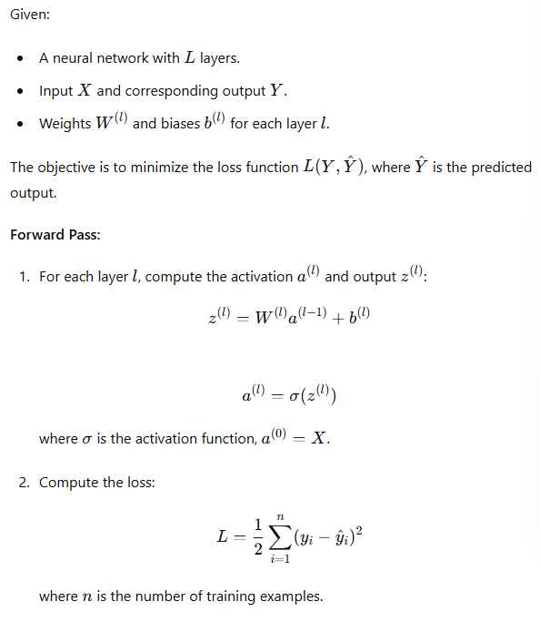

Backward Pass:

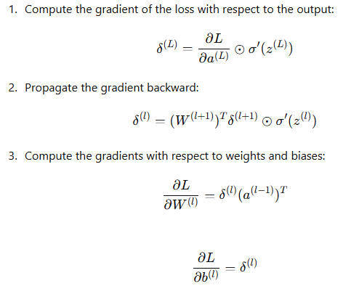

#### Parameter Update:

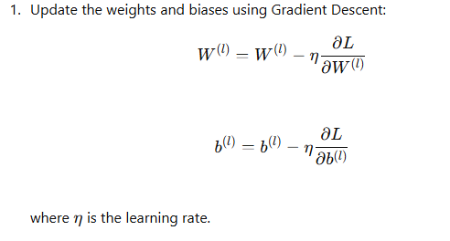

### Comprehensive Example: Backpropagation with Gradient Descent

Below is a detailed example demonstrating backpropagation with gradient descent in a simple neural network.

python

Copy code

import numpy as np

import matplotlib.pyplot as plt

from mpl_toolkits.mplot3d import Axes3D

import tensorflow as tf

from tensorflow.keras.models import Sequential

from tensorflow.keras.layers import Dense, Input

from tensorflow.keras.optimizers import Adam

# Generate synthetic data

np.random.seed(42)

X = np.linspace(-1, 1, 200).reshape(-1, 1)

y = X**3 + np.random.randn(*X.shape) * 0.1

# Function to create and compile a model

def create_model():

model = Sequential([

Input(shape=(1,)),

Dense(10, activation='relu'),

Dense(10, activation='relu'),

Dense(1, activation='linear')

])

model.compile(optimizer=Adam(learning_rate=0.01), loss='mse')

return model

# Train the model with Gradient Descent

model_gd = create_model()

history_gd = model_gd.fit(X, y, epochs=100, verbose=0)

# Predict using the GD model

y_pred_gd = model_gd.predict(X)

# Plot the results

plt.figure(figsize=(12, 6))

plt.plot(X, y, 'b.', label='Data')

plt.plot(X, y_pred_gd, 'r-', label='GD Prediction')

plt.xlabel('x')

plt.ylabel('y')

plt.title('Gradient Descent Optimization')

plt.legend()

plt.show()

# Simplified model for loss surface visualization

def create_simple_model():

model = Sequential([Input(shape=(1,)), Dense(1, activation='linear')])

model.compile(optimizer='adam', loss='mse')

return model

# Visualizing the loss surface

def visualize_loss_surface():

model = create_simple_model()

def calculate_loss(w, b):

model.layers[0].set_weights([np.array([[w]]), np.array([b])])

loss = model.evaluate(X, y, verbose=0)

return loss

w_vals = np.linspace(-3, 3, 30)

b_vals = np.linspace(-3, 3, 30)

w, b = np.meshgrid(w_vals, b_vals)

loss_vals = np.zeros_like(w)

for i in range(w.shape[0]):

for j in range(w.shape[1]):

loss_vals[i, j] = calculate_loss(w[i, j], b[i, j])

fig = plt.figure(figsize=(12, 8))

ax = fig.add_subplot(111, projection='3d')

ax.plot_surface(w, b, loss_vals, cmap='viridis')

ax.set_xlabel('Weight')

ax.set_ylabel('Bias')

ax.set_zlabel('Loss')

ax.set_title('Loss Surface')

plt.show()

visualize_loss_surface()

### Explanation of the Example:

1. **Data Generation**: Synthetic cubic data is generated with noise.
2. **Model Creation**: A simple neural network with two hidden layers is created and compiled.
3. **Training with Gradient Descent**: The model is trained using Gradient Descent.
4. **Visualization**: The loss surface is visualized in 3D, showing how the loss changes with different weights and biases.

### Conclusion

Gradient Descent, combined with backpropagation, is a powerful and efficient method for training neural networks. Understanding the principles and mathematics behind these techniques can help one appreciate their importance in optimizing complex models. The example illustrates these concepts comprehensively, offering a deeper insight into the optimization process in neural networks.

### Computing the Gradient: Finite Differences vs. Backpropagation

To optimize a neural network, we need to compute the rate of change (or gradient) of the loss function L concerning each weight and bias in the network. This gradient tells us how to adjust the parameters to minimize the loss.

#### Finite Differences (Naive Approach)

One straightforward, albeit computationally expensive, method is to use finite differences. This involves making a small change to each weight and bias, observing the corresponding change in the loss function, and then adjusting the parameters to reduce the loss.

##### Example of Finite Differences:

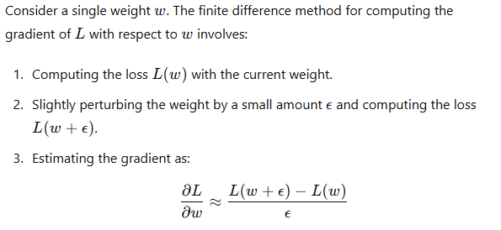

Here’s a simple implementation to illustrate this concept:

python

Copy code

import numpy as np

def finite_difference_gradient(f, w, epsilon=1e-5):

grad = np.zeros_like(w)

for i in range(len(w)):

w_perturbed = w.copy()

w_perturbed[i] += epsilon

grad[i] = (f(w_perturbed) - f(w)) / epsilon

return grad

# Example loss function (sum of squares)

def loss_function(w):

return np.sum(w ** 2)

# Initial weights

w = np.array([1.0, -2.0, 3.0])

gradient = finite_difference_gradient(loss_function, w)

print("Finite Difference Gradient:", gradient)

This method, while easy to understand and implement, is inefficient for neural networks with a large number of parameters.

#### Backpropagation (Efficient Approach)

Backpropagation is a more efficient method to compute the gradient of the loss function with respect to all weights and biases in the network simultaneously. It leverages the chain rule of calculus to propagate errors backward through the network, layer by layer.

##### Example of Backpropagation:

Consider a simple neural network with one hidden layer. The backpropagation algorithm involves:

1. **Forward Pass**: Compute the output of the network and the loss.
2. **Backward Pass**:
   * Compute the gradient of the loss with respect to the output.
   * Propagate these gradients backward through each layer to compute the gradient with respect to the weights and biases.
3. **Parameter Update**: Adjust the weights and biases using these gradients.

Here’s a comprehensive implementation of a simple neural network with backpropagation in Python:

python

Copy code

import numpy as np

import matplotlib.pyplot as plt

# Generate synthetic data

np.random.seed(42)

X = np.linspace(-1, 1, 200).reshape(-1, 1)

y = X**3 + np.random.randn(*X.shape) * 0.1

# Neural network with one hidden layer

class SimpleNN:

def __init__(self, input_dim, hidden_dim, output_dim):

self.W1 = np.random.randn(input_dim, hidden_dim)

self.b1 = np.zeros((1, hidden_dim))

self.W2 = np.random.randn(hidden_dim, output_dim)

self.b2 = np.zeros((1, output_dim))

def forward(self, X):

self.z1 = X.dot(self.W1) + self.b1

self.a1 = np.tanh(self.z1)

self.z2 = self.a1.dot(self.W2) + self.b2

self.a2 = self.z2 # Linear output

return self.a2

def compute_loss(self, y_true, y_pred):

return np.mean((y_true - y_pred) ** 2)

def backward(self, X, y_true):

m = X.shape[0]

y_pred = self.forward(X)

loss = self.compute_loss(y_true, y_pred)

# Gradients for output layer

dz2 = 2 * (y_pred - y_true) / m

dW2 = self.a1.T.dot(dz2)

db2 = np.sum(dz2, axis=0, keepdims=True)

# Gradients for hidden layer

da1 = dz2.dot(self.W2.T)

dz1 = da1 * (1 - np.tanh(self.z1) ** 2)

dW1 = X.T.dot(dz1)

db1 = np.sum(dz1, axis=0, keepdims=True)

return dW1, db1, dW2, db2

def update_params(self, dW1, db1, dW2, db2, learning_rate):

self.W1 -= learning_rate * dW1

self.b1 -= learning_rate * db1

self.W2 -= learning_rate * dW2

self.b2 -= learning_rate * db2

# Training the neural network

nn = SimpleNN(input_dim=1, hidden_dim=10, output_dim=1)

learning_rate = 0.01

epochs = 1000

losses = []

for epoch in range(epochs):

y_pred = nn.forward(X)

loss = nn.compute_loss(y, y_pred)

losses.append(loss)

dW1, db1, dW2, db2 = nn.backward(X, y)

nn.update_params(dW1, db1, dW2, db2, learning_rate)

if epoch % 100 == 0:

print(f'Epoch {epoch}, Loss: {loss:.4f}')

# Predicting using the trained network

y_pred = nn.forward(X)

# Plotting the results

plt.figure(figsize=(12, 6))

plt.plot(X, y, 'b.', label='Data')

plt.plot(X, y_pred, 'r-', label='Prediction')

plt.xlabel('x')

plt.ylabel('y')

plt.title('Simple Neural Network Prediction')

plt.legend()

plt.show()

# Plotting the loss over epochs

plt.figure(figsize=(12, 6))

plt.plot(range(epochs), losses, 'b-', label='Loss')

plt.xlabel('Epoch')

plt.ylabel('Loss')

plt.title('Training Loss')

plt.legend()

plt.show()

Epoch 0, Loss: 0.2266

Epoch 100, Loss: 0.0354

Epoch 200, Loss: 0.0322

Epoch 300, Loss: 0.0295

Epoch 400, Loss: 0.0272

Epoch 500, Loss: 0.0252

Epoch 600, Loss: 0.0235

Epoch 700, Loss: 0.0221

Epoch 800, Loss: 0.0208

Epoch 900, Loss: 0.0197

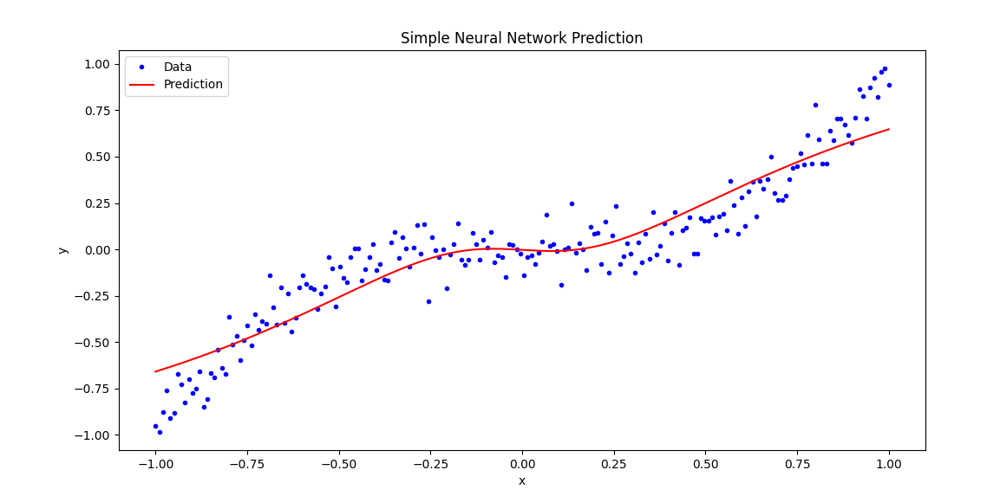

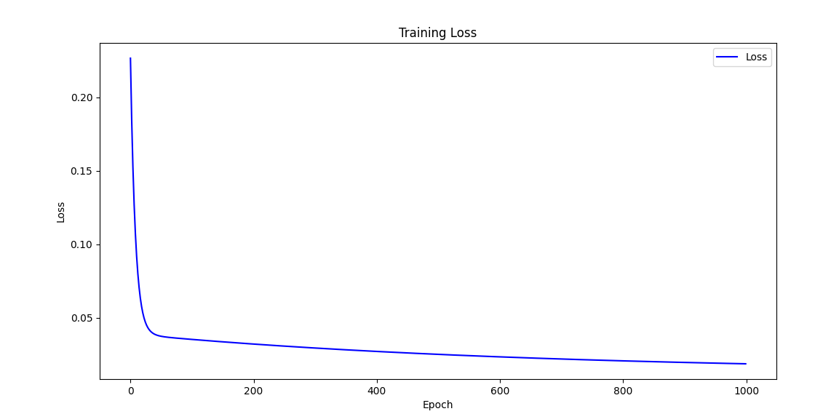

### Explanation:

1. **Data Generation**: Synthetic cubic data is generated with noise.
2. **Neural Network Class**: A simple neural network with one hidden layer is implemented. The forward method computes the output, and the backward method computes the gradients.
3. **Training Loop**: The network is trained using backpropagation for 1000 epochs. The loss is computed and recorded at each epoch.
4. **Prediction and Visualization**: The trained network's predictions are plotted against the actual data, and the training loss over epochs is visualized.

### Why Gradient Descent and Local Minima/Maxima Matter

**Gradient Descent** is crucial because it provides an efficient way to find the minimum of a loss function, even for large-scale problems. The method iteratively adjusts the parameters in the direction of the steepest descent, ensuring that the loss is reduced at each step.

**Local Minima and Maxima**:

* **Local Minima**: Points where the loss function has a lower value than neighboring points but not necessarily the lowest possible value (global minimum). Neural networks may get stuck in local minima, but modern techniques and network architectures help mitigate this issue.
* **Local Maxima**: Points where the loss function has a higher value than neighboring points. While less common, local maxima can also trap optimization algorithms.

Understanding these concepts and using efficient optimization techniques, such as gradient descent with backpropagation, allows us to train complex neural networks effectively and achieve high performance on a variety of tasks.

### Gradient Descent with Backpropagation

Gradient descent is a fundamental optimization algorithm used to minimize the loss function LLL of a neural network by iteratively updating the network's weights and biases. To make this process efficient, we use backpropagation to compute the gradients (partial derivatives) of LLL with respect to each weight and bias. These gradients indicate how much the loss function would change if we slightly adjusted each parameter.

#### Step-by-Step Explanation

1. **Forward Pass**: Compute the output of the neural network by propagating the inputs through each layer.
2. **Compute Loss**: Calculate the loss LLL using a chosen loss function (e.g., mean squared error for regression).
3. **Backward Pass (Backpropagation)**: Compute the gradients of the loss with respect to each weight and bias by applying the chain rule of calculus.
4. **Update Parameters**: Adjust the weights and biases using the computed gradients and a learning rate, which controls the step size.

### Detailed Code Example

Below is a comprehensive code example that implements gradient descent with backpropagation for a neural network. This example includes multiple activation functions and visualizes the training process.

python

Copy code

import numpy as np

import matplotlib.pyplot as plt

from mpl_toolkits.mplot3d import Axes3D

# Generate synthetic data

np.random.seed(42)

X = np.linspace(-1, 1, 200).reshape(-1, 1)

y = X**3 + np.random.randn(*X.shape) * 0.1

# Neural network class with backpropagation

class NeuralNetwork:

def __init__(self, input_dim, hidden_dims, output_dim):

self.layers = []

self.activations = []

self.gradients = []

# Initialize weights and biases for each layer

prev_dim = input_dim

for hidden_dim in hidden_dims:

self.layers.append({'weights': np.random.randn(prev_dim, hidden_dim),

'biases': np.zeros((1, hidden_dim))})

self.activations.append('relu')

self.gradients.append({'dW': np.zeros((prev_dim, hidden_dim)),

'db': np.zeros((1, hidden_dim))})

prev_dim = hidden_dim

self.layers.append({'weights': np.random.randn(prev_dim, output_dim),

'biases': np.zeros((1, output_dim))})

self.activations.append('linear')

self.gradients.append({'dW': np.zeros((prev_dim, output_dim)),

'db': np.zeros((1, output_dim))})

def forward(self, X):

self.outputs = [X]

for i, layer in enumerate(self.layers):

Z = self.outputs[-1].dot(layer['weights']) + layer['biases']

if self.activations[i] == 'relu':

A = np.maximum(0, Z)

elif self.activations[i] == 'linear':

A = Z

self.outputs.append(A)

return self.outputs[-1]

def compute_loss(self, y_true, y_pred):

return np.mean((y_true - y_pred) ** 2)

def backward(self, X, y_true):

m = X.shape[0]

y_pred = self.forward(X)

loss = self.compute_loss(y_true, y_pred)

# Compute gradients for the output layer

dZ = 2 * (y_pred - y_true) / m

for i in reversed(range(len(self.layers))):

self.gradients[i]['dW'] = self.outputs[i].T.dot(dZ)

self.gradients[i]['db'] = np.sum(dZ, axis=0, keepdims=True)

if self.activations[i] == 'relu':

dZ = dZ.dot(self.layers[i]['weights'].T) * (self.outputs[i] > 0)

elif self.activations[i] == 'linear':

dZ = dZ.dot(self.layers[i]['weights'].T)

def update_params(self, learning_rate):

for i in range(len(self.layers)):

self.layers[i]['weights'] -= learning_rate * self.gradients[i]['dW']

self.layers[i]['biases'] -= learning_rate * self.gradients[i]['db']

# Train the neural network

nn = NeuralNetwork(input_dim=1, hidden_dims=[10, 10], output_dim=1)

learning_rate = 0.01

epochs = 1000

losses = []

for epoch in range(epochs):

nn.backward(X, y)

nn.update_params(learning_rate)

y_pred = nn.forward(X)

loss = nn.compute_loss(y, y_pred)

losses.append(loss)

if epoch % 100 == 0:

print(f'Epoch {epoch}, Loss: {loss:.4f}')

# Predict using the trained network

y_pred = nn.forward(X)

# Plotting the results

plt.figure(figsize=(12, 6))

plt.plot(X, y, 'b.', label='Data')

plt.plot(X, y_pred, 'r-', label='Prediction')

plt.xlabel('x')

plt.ylabel('y')

plt.title('Neural Network Prediction')

plt.legend()

plt.show()

# Plotting the loss over epochs

plt.figure(figsize=(12, 6))

plt.plot(range(epochs), losses, 'b-', label='Loss')

plt.xlabel('Epoch')

plt.ylabel('Loss')

plt.title('Training Loss')

plt.legend()

plt.show()

# Simplified model for loss surface visualization

def create_simple_model():

model = NeuralNetwork(input_dim=1, hidden_dims=[1], output_dim=1)

return model

# Visualizing the loss surface

def visualize_loss_surface():

model = create_simple_model()

def calculate_loss(w, b):

model.layers[0]['weights'][0, 0] = w

model.layers[0]['biases'][0, 0] = b

loss = model.compute_loss(y, model.forward(X))

return loss

w_vals = np.linspace(-3, 3, 100)

b_vals = np.linspace(-3, 3, 100)

w, b = np.meshgrid(w_vals, b_vals)

loss_vals = np.zeros_like(w)

for i in range(w.shape[0]):

for j in range(w.shape[1]):

loss_vals[i, j] = calculate_loss(w[i, j], b[i, j])

fig = plt.figure(figsize=(12, 8))

ax = fig.add_subplot(111, projection='3d')

ax.plot_surface(w, b, loss_vals, cmap='viridis')

ax.set_xlabel('Weight')

ax.set_ylabel('Bias')

ax.set_zlabel('Loss')

ax.set_title('Loss Surface')

plt.show()

visualize_loss_surface()

### Explanation:

1. **Neural Network Class**: Implements a simple neural network with forward and backward passes.
2. **Training Loop**: Trains the network using backpropagation and gradient descent for 1000 epochs.
3. **Prediction and Visualization**: Plots the network's predictions against the actual data and visualizes the training loss over epochs.
4. **Loss Surface Visualization**: Plots the loss surface for a simplified model to illustrate how the loss changes with different weights and biases.

### Key Takeaways:

* **Efficiency**: Backpropagation efficiently computes gradients for all parameters simultaneously, making it feasible to train large networks.
* **Gradient Descent**: Iteratively adjusts parameters in the direction that reduces the loss, leveraging the computed gradients.
* **Visualization**: Visualizing the training process and loss surface helps understand how the network learns and optimizes the parameters.

This comprehensive example provides a deep dive into the mechanics of neural network training using backpropagation and gradient descent, highlighting the importance of efficient gradient computation and parameter optimization

Backprop for a (desperately) simple network

### Backpropagation for a Simple Network

Backpropagation is a key algorithm for training neural networks. It computes the gradient of the loss function with respect to each weight by the chain rule, iteratively adjusting weights to minimize the loss. To understand the backpropagation algorithm, we'll start with a simple network consisting of a single neuron with a linear activation function.

#### Step-by-Step Process

1. **Forward Pass**:
   * Calculate the output of the neuron by multiplying the input with the weight and adding the bias.
   * Compute the loss using a chosen loss function (e.g., mean squared error).
2. **Backward Pass**:
   * Compute the gradient of the loss with respect to the output.
   * Compute the gradient of the loss with respect to the weight and bias.
   * Update the weight and bias using the computed gradients and a learning rate.

### Example Code

Here's a detailed code example demonstrating backpropagation for a single neuron with a linear activation function.

python

Copy code

import numpy as np

import matplotlib.pyplot as plt

# Generate synthetic data

np.random.seed(42)

X = np.linspace(-1, 1, 100).reshape(-1, 1)

y = 3 * X + np.random.randn(*X.shape) * 0.5

# Initialize parameters

weight = np.random.randn(1)

bias = np.zeros(1)

learning_rate = 0.1

epochs = 1000

# Loss function: Mean Squared Error

def compute_loss(y_true, y_pred):

return np.mean((y_true - y_pred) ** 2)

# Forward pass

def forward(X, weight, bias):

return X.dot(weight) + bias

# Backward pass

def backward(X, y_true, y_pred):

m = X.shape[0]

dL_dy = 2 * (y_pred - y_true) / m # Gradient of loss with respect to output

dL_dw = X.T.dot(dL_dy) # Gradient of loss with respect to weight

dL_db = np.sum(dL_dy) # Gradient of loss with respect to bias

return dL_dw, dL_db

# Training loop

losses = []

for epoch in range(epochs):

y_pred = forward(X, weight, bias)

loss = compute_loss(y, y_pred)

losses.append(loss)

dL_dw, dL_db = backward(X, y, y_pred)

weight -= learning_rate * dL_dw

bias -= learning_rate * dL_db

if epoch % 100 == 0:

print(f'Epoch {epoch}, Loss: {loss:.4f}, Weight: {weight[0]:.4f}, Bias: {bias[0]:.4f}')

# Plot the results

plt.figure(figsize=(12, 6))

plt.plot(X, y, 'b.', label='Data')

plt.plot(X, forward(X, weight, bias), 'r-', label='Prediction')

plt.xlabel('x')

plt.ylabel('y')

plt.title('Linear Regression with Backpropagation')

plt.legend()

plt.show()

# Plotting the loss over epochs

plt.figure(figsize=(12, 6))

plt.plot(range(epochs), losses, 'b-', label='Loss')

plt.xlabel('Epoch')

plt.ylabel('Loss')

plt.title('Training Loss')

plt.legend()

plt.show()

### Explanation:

1. **Data Generation**: We generate synthetic linear data with some noise.
2. **Parameter Initialization**: We initialize the weight and bias randomly.
3. **Forward Pass**: We compute the output of the neuron as a linear combination of the input, weight, and bias.
4. **Loss Computation**: We use the mean squared error as our loss function.
5. **Backward Pass**: We compute the gradients of the loss with respect to the weight and bias using the chain rule.
6. **Parameter Update**: We update the weight and bias using the computed gradients and a learning rate.
7. **Training Loop**: We iterate over the data, updating the parameters and recording the loss for each epoch.
8. **Visualization**: We plot the predicted line and the training loss over epochs.

### Key Concepts:

* **Gradient Descent**: Adjusts weights to minimize the loss function.
* **Backpropagation**: Computes gradients of the loss with respect to each parameter efficiently using the chain rule.
* **Loss Function**: Measures how well the model's predictions match the actual data.
* **Learning Rate**: Controls the size of the steps taken to reach the minimum loss.

### Extensions and Next Steps:

* **Activation Functions**: Introduce non-linear activation functions to increase model complexity.
* **Multiple Neurons**: Extend the network to multiple neurons and layers.
* **Complex Data**: Apply the network to more complex datasets.

This simple example lays the foundation for understanding more complex neural networks and the powerful backpropagation algorithm used to train them.

### Detailed Explanation of Backpropagation in a Simple Neural Network

Backpropagation is the algorithm used to compute the gradients needed for updating the weights in neural networks. To understand this, we will consider a simple neural network with one hidden layer and a single output. We'll derive the gradients step-by-step.

#### The Neural Network Structure

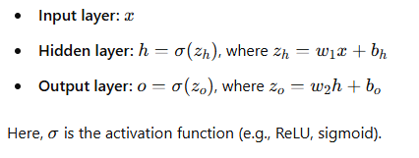

#### Loss Function

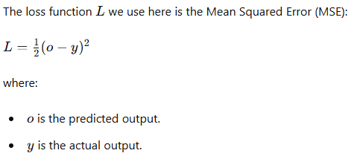

#### Gradient Calculation

We need to compute the gradients of the loss function with respect to each weight and bias in the network. The backpropagation algorithm uses the chain rule to compute these gradients efficiently.

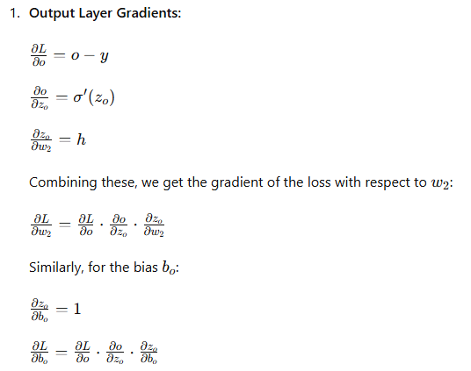

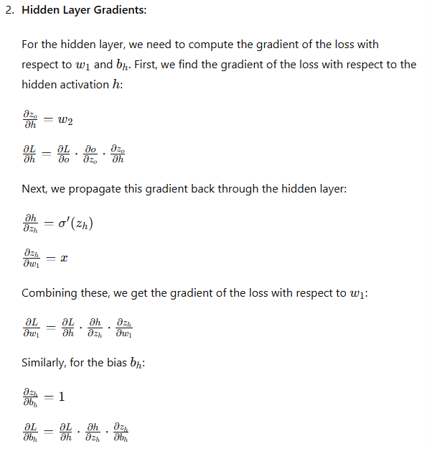

### Code Example

Here's a comprehensive code example that demonstrates these calculations step-by-step using a simple neural network with one hidden layer:

python

Copy code

import numpy as np

import matplotlib.pyplot as plt

# Generate synthetic data

np.random.seed(42)

X = np.linspace(-1, 1, 100).reshape(-1, 1)

y = 3 * X + np.random.randn(*X.shape) * 0.5

# Initialize parameters

w1 = np.random.randn(1)

b_h = np.zeros(1)

w2 = np.random.randn(1)

b_o = np.zeros(1)

learning_rate = 0.1

epochs = 1000

# Activation function and its derivative

def sigmoid(x):

return 1 / (1 + np.exp(-x))

def sigmoid_derivative(x):

return sigmoid(x) * (1 - sigmoid(x))

# Forward pass

def forward(X, w1, b_h, w2, b_o):

z_h = X.dot(w1) + b_h

h = sigmoid(z_h)

z_o = h.dot(w2) + b_o

o = sigmoid(z_o)

return z_h, h, z_o, o

# Loss function: Mean Squared Error

def compute_loss(y_true, y_pred):

return np.mean((y_true - y_pred) ** 2)

# Backward pass

def backward(X, y_true, z_h, h, z_o, o, w1, w2):

m = X.shape[0]

dL_do = o - y_true

dL_dz_o = dL_do * sigmoid_derivative(z_o)

dL_dw2 = h.T.dot(dL_dz_o)

dL_db_o = np.sum(dL_dz_o, axis=0, keepdims=True)

dL_dh = dL_dz_o.dot(w2.T)

dL_dz_h = dL_dh * sigmoid_derivative(z_h)

dL_dw1 = X.T.dot(dL_dz_h)

dL_db_h = np.sum(dL_dz_h, axis=0, keepdims=True)

return dL_dw1, dL_db_h, dL_dw2, dL_db_o

# Training loop

losses = []

for epoch in range(epochs):

z_h, h, z_o, o = forward(X, w1, b_h, w2, b_o)

loss = compute_loss(y, o)

losses.append(loss)

dL_dw1, dL_db_h, dL_dw2, dL_db_o = backward(X, y, z_h, h, z_o, o, w1, w2)

w1 -= learning_rate * dL_dw1

b_h -= learning_rate * dL_db_h

w2 -= learning_rate * dL_dw2

b_o -= learning_rate * dL_db_o

if epoch % 100 == 0:

print(f'Epoch {epoch}, Loss: {loss:.4f}')

# Plot the results

plt.figure(figsize=(12, 6))

plt.plot(X, y, 'b.', label='Data')

plt.plot(X, o, 'r-', label='Prediction')

plt.xlabel('x')

plt.ylabel('y')

plt.title('Simple Neural Network with Backpropagation')

plt.legend()

plt.show()

# Plotting the loss over epochs

plt.figure(figsize=(12, 6))

plt.plot(range(epochs), losses, 'b-', label='Loss')

plt.xlabel('Epoch')

plt.ylabel('Loss')

plt.title('Training Loss')

plt.legend()

plt.show()

### Explanation

* **Data Generation**: Generates synthetic data with some noise.
* **Parameter Initialization**: Initializes the weights and biases randomly.
* **Activation Function**: Uses sigmoid activation function and its derivative.
* **Forward Pass**: Computes the output of the network by passing the input through the network layers.
* **Loss Function**: Uses mean squared error to compute the loss.
* **Backward Pass**: Computes the gradients of the loss with respect to the weights and biases using the chain rule.
* **Training Loop**: Updates the weights and biases iteratively to minimize the loss.
* **Visualization**: Plots the predicted results and the loss over epochs.

This detailed example shows the backpropagation algorithm in action for a simple neural network. By understanding this, you can extend the concept to more complex networks and activation functions.

when dealing with multiple neurons per layer, the complexity of backpropagation increases. Each neuron's activation in one-layer influences all the neurons in the next layer, necessitating the summation of effects through multiple paths. This process requires efficient computation of gradients using the chain rule across the entire network. Let's delve deeper into the mathematics and coding aspects of this complexity.

### Mathematical Explanation

For a network with multiple neurons in a layer, consider the following:

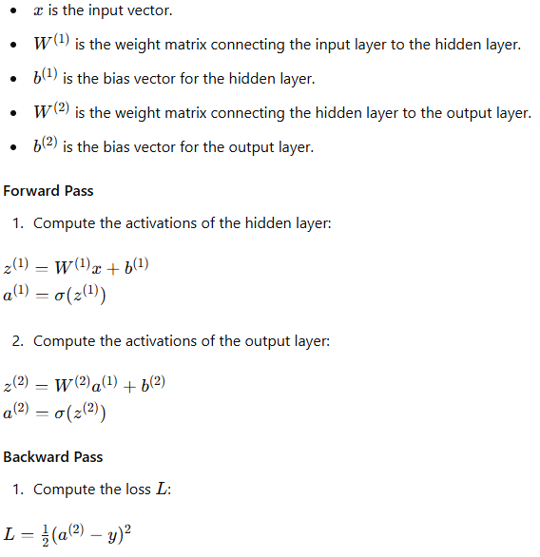

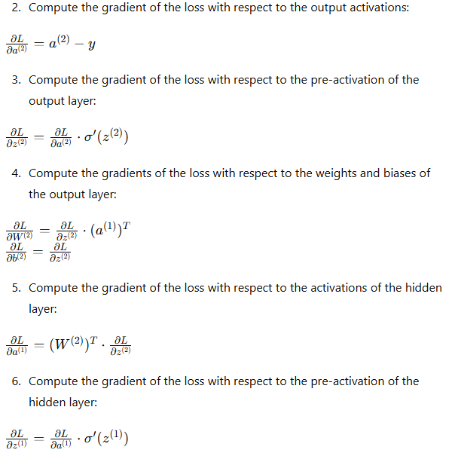

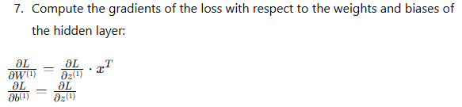

### Code Example

Here's a more complex example implementing a neural network with multiple neurons per layer using backpropagation:

python

Copy code

import numpy as np

import matplotlib.pyplot as plt

# Generate synthetic data

np.random.seed(42)

X = np.linspace(-1, 1, 100).reshape(-1, 1)

y = 3 * X + np.random.randn(*X.shape) * 0.5

# Initialize parameters

input_size = 1

hidden_size = 10

output_size = 1

W1 = np.random.randn(input_size, hidden_size)

b1 = np.zeros(hidden_size)

W2 = np.random.randn(hidden_size, output_size)

b2 = np.zeros(output_size)

learning_rate = 0.01

epochs = 1000

# Activation function and its derivative

def sigmoid(x):

return 1 / (1 + np.exp(-x))

def sigmoid_derivative(x):

return sigmoid(x) * (1 - sigmoid(x))

# Forward pass

def forward(X, W1, b1, W2, b2):

z1 = X.dot(W1) + b1

a1 = sigmoid(z1)

z2 = a1.dot(W2) + b2

a2 = z2 # Linear output

return z1, a1, z2, a2

# Loss function: Mean Squared Error

def compute_loss(y_true, y_pred):

return np.mean((y_true - y_pred) ** 2)

# Backward pass

def backward(X, y_true, z1, a1, z2, a2, W1, W2):

m = X.shape[0]

dL_da2 = a2 - y_true

dL_dz2 = dL_da2

dL_dW2 = a1.T.dot(dL_dz2)

dL_db2 = np.sum(dL_dz2, axis=0, keepdims=True)

dL_da1 = dL_dz2.dot(W2.T)

dL_dz1 = dL_da1 * sigmoid_derivative(z1)

dL_dW1 = X.T.dot(dL_dz1)

dL_db1 = np.sum(dL_dz1, axis=0, keepdims=True)

return dL_dW1, dL_db1, dL_dW2, dL_db2

# Training loop

losses = []

for epoch in range(epochs):

z1, a1, z2, a2 = forward(X, W1, b1, W2, b2)

loss = compute_loss(y, a2)

losses.append(loss)

dL_dW1, dL_db1, dL_dW2, dL_db2 = backward(X, y, z1, a1, z2, a2, W1, W2)

W1 -= learning_rate * dL_dW1

b1 -= learning_rate * dL_db1

W2 -= learning_rate * dL_dW2

b2 -= learning_rate * dL_db2

if epoch % 100 == 0:

print(f'Epoch {epoch}, Loss: {loss:.4f}')

# Plot the results

plt.figure(figsize=(12, 6))

plt.plot(X, y, 'b.', label='Data')

plt.plot(X, a2, 'r-', label='Prediction')

plt.xlabel('x')

plt.ylabel('y')

plt.title('Neural Network with Multiple Neurons per Layer')

plt.legend()

plt.show()

# Plotting the loss over epochs

plt.figure(figsize=(12, 6))

plt.plot(range(epochs), losses, 'b-', label='Loss')

plt.xlabel('Epoch')

plt.ylabel('Loss')

plt.title('Training Loss')

plt.legend()

plt.show()

### Explanation

* **Data Generation**: Generates synthetic data with some noise.
* **Parameter Initialization**: Initializes weights and biases randomly for a two-layer network.
* **Activation Function**: Uses sigmoid activation function and its derivative.
* **Forward Pass**: Computes the activations through the hidden layer and output layer.
* **Loss Function**: Uses mean squared error to compute the loss.
* **Backward Pass**: Computes gradients using the chain rule, considering the contributions from all neurons in each layer.
* **Training Loop**: Updates weights and biases iteratively to minimize the loss.
* **Visualization**: Plots the predicted results and the loss over epochs.

This example demonstrates the complexity added by multiple neurons in each layer, requiring the summation of effects on the loss function from various paths. Understanding this is crucial for implementing and optimizing deep neural networks.

How to differentiate an activation function

Differentiating an activation function is crucial in the backpropagation process of training neural networks. Let's explore some common activation functions and their derivatives, as well as how to implement them in code.

### Common Activation Functions and Their Derivatives

1. **Sigmoid Function**

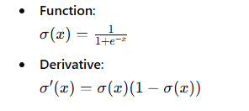

1. Hyperbolic Tangent (tanh) Function

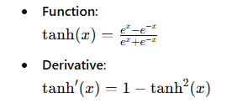

1. ReLU (Rectified Linear Unit)

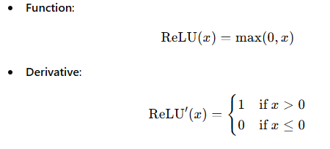

1. **Leaky ReLU**

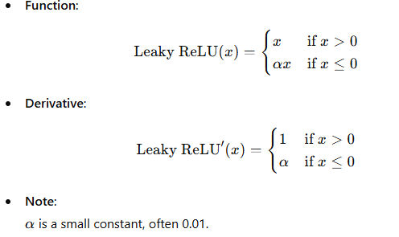

1. **Softmax Function**

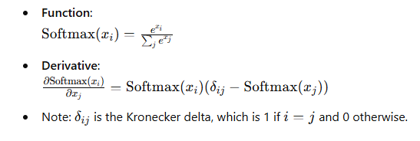

These functions and their derivatives are essential components in neural networks, enabling the networks to learn complex patterns from the data. The ReLU function is widely used because it helps mitigate the vanishing gradient problem, while the Leaky ReLU is used to avoid "dying ReLU" units.

### Implementation in Code

Here’s a Python implementation of these activation functions and their derivatives:

python

Copy code

import numpy as np

def sigmoid(x):

return 1 / (1 + np.exp(-x))

def sigmoid_derivative(x):

sx = sigmoid(x)

return sx * (1 - sx)

def tanh(x):

return np.tanh(x)

def tanh_derivative(x):

return 1 - np.tanh(x)**2

def relu(x):

return np.maximum(0, x)

def relu_derivative(x):

return np.where(x > 0, 1, 0)

def leaky_relu(x, alpha=0.01):

return np.where(x > 0, x, alpha * x)

def leaky_relu_derivative(x, alpha=0.01):

return np.where(x > 0, 1, alpha)

def softmax(x):

exp_x = np.exp(x - np.max(x))

return exp_x / exp_x.sum(axis=0, keepdims=True)

def softmax_derivative(x):

s = softmax(x)

return s * (1 - s)

# Test the functions

x = np.array([-2, -1, 0, 1, 2])

print("Sigmoid:")

print(sigmoid(x))

print(sigmoid_derivative(x))

print("\nTanh:")

print(tanh(x))

print(tanh_derivative(x))

print("\nReLU:")

print(relu(x))

print(relu_derivative(x))

print("\nLeaky ReLU:")

print(leaky_relu(x))

print(leaky_relu_derivative(x))

print("\nSoftmax:")

print(softmax(x))

print(softmax_derivative(x))

### Explanation

1. **Sigmoid Function and Its Derivative**:
   * The sigmoid function maps any real-valued number to a value between 0 and 1.
   * Its derivative is useful for backpropagation because it indicates how the output of a neuron changes with respect to its input.
2. **Tanh Function and Its Derivative**:
   * The tanh function maps any real-valued number to a value between -1 and 1.
   * Its derivative is used in backpropagation to show the rate of change.
3. **ReLU Function and Its Derivative**:
   * The ReLU function is simple: it outputs the input if it's positive, otherwise zero.
   * Its derivative is 1 for positive inputs and 0 for non-positive inputs.
4. **Leaky ReLU Function and Its Derivative**:
   * Similar to ReLU but allows a small, non-zero gradient when the input is negative.
   * This helps mitigate the "dying ReLU" problem where neurons can sometimes get stuck during training.
5. **Softmax Function and Its Derivative**:
   * The softmax function is often used in the output layer of a classifier to represent probabilities.
   * Its derivative is more complex and is used in the backpropagation of multi-class classification problems.

### Summary

Understanding and differentiating activation functions is crucial for the backpropagation process in neural networks. This allows us to compute how changes in weights and biases affect the loss function, enabling efficient optimization through gradient descent. By selecting appropriate activation functions and correctly implementing their derivatives, we can train neural networks more effectively and achieve better performance in various tasks.

This is easy if you pick a well-behaved function. Popular choices are

### Sigmoid

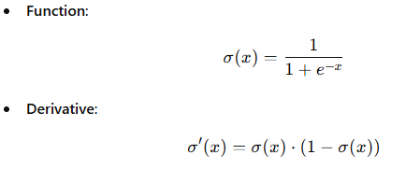

The sigmoid function maps any input value to a range between 0 and 1. It's often used in the output layer of binary classification problems.

### Hyperbolic Tangent (tanh)

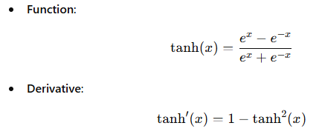

The tanh function maps input values to a range between -1 and 1. It is zero-centered, which can help with the convergence of the training process.

### ReLU (Rectified Linear Unit)

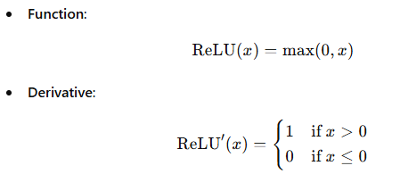

ReLU is popular due to its simplicity and effectiveness, particularly in deep neural networks. It helps mitigate the vanishing gradient problem by providing a constant gradient for positive values.

### Leaky ReLU

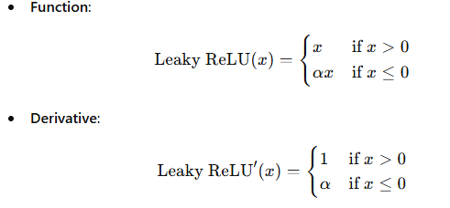

Leaky ReLU addresses the "dying ReLU" problem by allowing a small, non-zero gradient when the unit is not active. α\alphaα is typically set to a small value like 0.01.

### Softmax

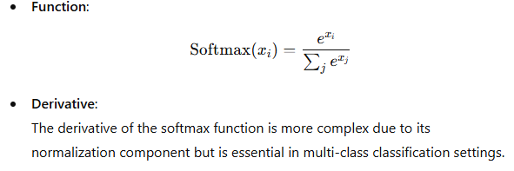

The softmax function is commonly used in the output layer of neural networks for multi-class classification problems. It converts logits (raw prediction scores) into probabilities.

### Explanation and Example Code

To demonstrate how these activation functions work in practice, we can implement a neural network that uses these functions and visualizes their properties.

python

Copy code

import numpy as np

import matplotlib.pyplot as plt

import tensorflow as tf

from tensorflow.keras.models import Sequential

from tensorflow.keras.layers import Dense, Activation

# Generate synthetic data

np.random.seed(42)

X = np.linspace(-10, 10, 200)

y = np.sin(X)

# Define models with different activation functions

def create_model(activation_function):

model = Sequential([

Dense(10, activation=activation_function, input_shape=(1,)),

Dense(10, activation=activation_function),

Dense(1)

])

model.compile(optimizer='adam', loss='mse')

return model

activation_functions = ['sigmoid', 'tanh', 'relu', 'linear']

models = {af: create_model(af) for af in activation_functions}

# Train models

for af, model in models.items():

model.fit(X, y, epochs=100, verbose=0)

# Predict using the models

predictions = {af: model.predict(X) for af, model in models.items()}

# Plot the data and the models' predictions

plt.figure(figsize=(18, 12))

for i, af in enumerate(activation_functions):

plt.subplot(2, 2, i + 1)

plt.plot(X, y, 'b.', label='Data')

plt.plot(X, predictions[af], 'r-', label=f"{af.capitalize()} Prediction")

plt.title(f"Activation: {af.capitalize()}")

plt.xlabel('x')

plt.ylabel('y')

plt.legend()

plt.tight_layout()

plt.show()

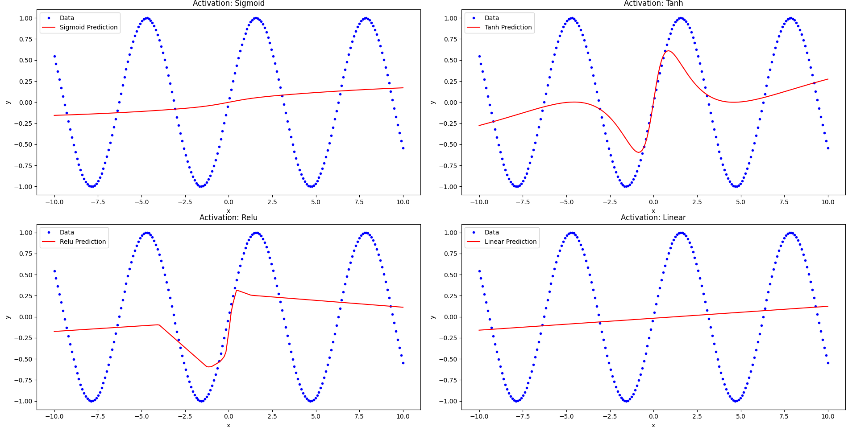

This script creates and trains neural networks with different activation functions (sigmoid, tanh, relu, and linear) and then plots the resulting predictions. This helps to visualize how each activation function influences the network's ability to approximate the target function.

Let's focus specifically on the ReLU activation function and its derivative.

### ReLU Activation Function

The Rectified Linear Unit (ReLU) activation function is defined as:



This function outputs the input directly if it is positive; otherwise, it outputs zero.

### Derivative of ReLU

The derivative of the ReLU function is:

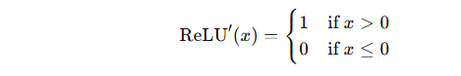

This means that the gradient is 1 for positive input values and 0 for negative input values.

### Visualization of ReLU and its Derivative

We can create visualizations to better understand the ReLU function and its derivative.

#### Code Example

python

Copy code

import numpy as np

import matplotlib.pyplot as plt

# Define the ReLU function

def relu(x):

return np.maximum(0, x)

# Define the derivative of the ReLU function

def relu_derivative(x):

return np.where(x > 0, 1, 0)

# Generate input data

x = np.linspace(-10, 10, 400)

# Compute ReLU and its derivative

y_relu = relu(x)

y_relu_derivative = relu_derivative(x)

# Plot the ReLU function

plt.figure(figsize=(12, 5))

plt.subplot(1, 2, 1)

plt.plot(x, y_relu, label="ReLU(x)")

plt.title("ReLU Activation Function")

plt.xlabel("x")

plt.ylabel("ReLU(x)")

plt.legend()

# Plot the derivative of the ReLU function

plt.subplot(1, 2, 2)

plt.plot(x, y_relu_derivative, label="ReLU'(x)", color="red")

plt.title("Derivative of ReLU Activation Function")

plt.xlabel("x")

plt.ylabel("ReLU'(x)")

plt.legend()

plt.tight_layout()

plt.show()

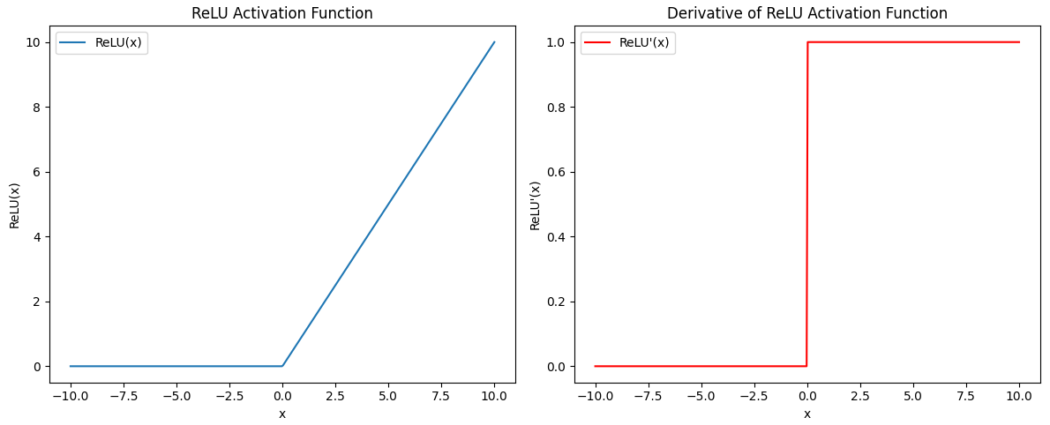

This code generates a plot for both the ReLU function and its derivative. The left plot shows the ReLU activation function, while the right plot shows its derivative.

### Explanation of ReLU and its Derivative

1. **ReLU Function**: The ReLU function outputs the input value if it is greater than zero. If the input value is less than or equal to zero, it outputs zero. This characteristic helps neural networks mitigate the vanishing gradient problem and speeds up convergence.
2. **Derivative of ReLU**: The derivative is 1 for positive input values and 0 for negative input values. This simple piecewise derivative makes the ReLU activation function computationally efficient and easy to implement.

### Application in Neural Networks

The ReLU function is widely used in deep learning models, especially convolutional neural networks (CNNs). Its advantages include:

* **Sparsity**: Since ReLU outputs zero for negative inputs, it can create sparse activations, making the network more efficient.
* **Nonlinearity**: Despite its simple form, ReLU introduces nonlinearity, enabling the network to learn complex patterns.

By understanding and visualizing the ReLU function and its derivative, we can appreciate its role in the success of modern neural network architectures.

let's delve into the Sigmoid activation function and its derivative.

### Sigmoid Activation Function

The Sigmoid activation function, also known as the logistic function, is defined as:



This function outputs a value between 0 and 1, making it useful for probability-based interpretations.

### Derivative of Sigmoid

The derivative of the Sigmoid function is:



This means that the gradient of the Sigmoid function at any point is the function value at that point multiplied by one minus the function value at that point.

### Visualization of Sigmoid and its Derivative

We can create visualizations to better understand the Sigmoid function and its derivative.

#### Code Example

python

Copy code

import numpy as np

import matplotlib.pyplot as plt

# Define the Sigmoid function

def sigmoid(x):

return 1 / (1 + np.exp(-x))

# Define the derivative of the Sigmoid function

def sigmoid_derivative(x):

sig = sigmoid(x)

return sig * (1 - sig)

# Generate input data

x = np.linspace(-10, 10, 400)

# Compute Sigmoid and its derivative

y_sigmoid = sigmoid(x)

y_sigmoid_derivative = sigmoid_derivative(x)

# Plot the Sigmoid function

plt.figure(figsize=(12, 5))

plt.subplot(1, 2, 1)

plt.plot(x, y_sigmoid, label=r"$\sigma(x)$")

plt.title("Sigmoid Activation Function")

plt.xlabel("x")

plt.ylabel(r"$\sigma(x)$")

plt.legend()

# Plot the derivative of the Sigmoid function

plt.subplot(1, 2, 2)

plt.plot(x, y_sigmoid_derivative, label=r"$\sigma'(x)$", color="red")

plt.title("Derivative of Sigmoid Activation Function")

plt.xlabel("x")

plt.ylabel(r"$\sigma'(x)$")

plt.legend()

plt.tight_layout()

plt.show()

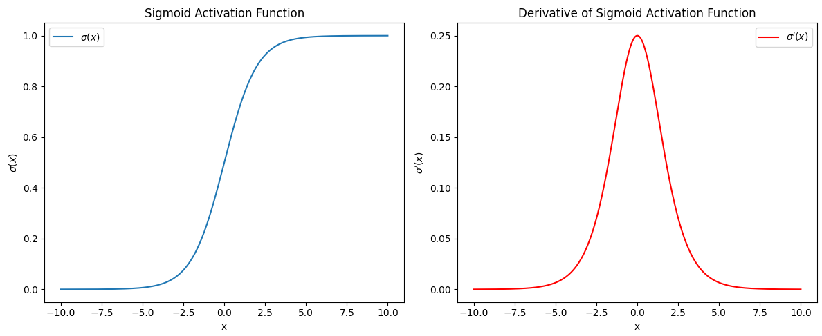

This code generates a plot for both the Sigmoid function and its derivative. The left plot shows the Sigmoid activation function, while the right plot shows its derivative.

### Explanation of Sigmoid and its Derivative

1. **Sigmoid Function**: The Sigmoid function maps any real-valued number to a value between 0 and 1. This property makes it suitable for binary classification problems, where the output can be interpreted as a probability.
2. **Derivative of Sigmoid**: The derivative is a function of the Sigmoid function itself. This self-referential nature simplifies the gradient computation during backpropagation, as the derivative at any point can be expressed using the Sigmoid value at that point.

### Application in Neural Networks

The Sigmoid function is often used in the output layer of binary classification models. Its properties include:

* **Smooth Gradient**: The Sigmoid function provides a smooth gradient, which helps in training the network.
* **Output Range**: The output range between 0 and 1 is useful for interpreting outputs as probabilities.
* **Gradient Saturation**: One drawback is that the gradient can become very small for extremely large or small input values, leading to the vanishing gradient problem.

By understanding and visualizing the Sigmoid function and its derivative, we can appreciate its role in various neural network architectures and its advantages and limitations in different scenarios.

Fitting a spiral dataset with added noise and a smaller training set is indeed a challenging task. This requires a more complex neural network architecture, potentially with multiple hidden layers and a non-linear activation function. Below is a comprehensive example of how to achieve this using TensorFlow and Keras.

### Generating the Spiral Dataset

First, we need to generate a spiral dataset with added noise. The following code will create a noisy spiral dataset:

python

Copy code

import numpy as np

import matplotlib.pyplot as plt

# Generate a spiral dataset

def generate_spiral_dataset(n_samples, noise=0.5):

np.random.seed(42)

n = np.sqrt(np.random.rand(n_samples, 1)) * 780 * (2 * np.pi) / 360

d1 = -np.cos(n) * n + np.random.rand(n_samples, 1) * noise

d2 = np.sin(n) * n + np.random.rand(n_samples, 1) * noise

X = np.vstack((np.hstack((d1, d2)), np.hstack((-d1, -d2))))

y = np.hstack((np.zeros(n_samples), np.ones(n_samples)))

return X, y

# Generate and plot the dataset

X, y = generate_spiral_dataset(100, noise=0.1)

plt.scatter(X[:, 0], X[:, 1], c=y, cmap=plt.cm.Spectral)

plt.show()

### Building the Neural Network

We will build a neural network with multiple hidden layers to fit this dataset. We will use the ReLU activation function for the hidden layers and a sigmoid activation function for the output layer.

python

Copy code

import tensorflow as tf

from tensorflow.keras.models import Sequential

from tensorflow.keras.layers import Dense, Input

from tensorflow.keras.optimizers import Adam

# Define the neural network model

def create_spiral_model(input_shape):

model = Sequential([

Input(shape=input_shape),

Dense(64, activation='relu'),

Dense(64, activation='relu'),

Dense(1, activation='sigmoid')

])

model.compile(optimizer=Adam(learning_rate=0.01), loss='binary_crossentropy', metrics=['accuracy'])

return model

# Create and train the model

model = create_spiral_model(X.shape[1:])

history = model.fit(X, y, epochs=100, batch_size=16, verbose=1, validation_split=0.2)

# Plot the loss and accuracy

plt.figure(figsize=(12, 4))

plt.subplot(1, 2, 1)

plt.plot(history.history['loss'], label='Loss')

plt.plot(history.history['val_loss'], label='Val Loss')

plt.xlabel('Epochs')

plt.ylabel('Loss')

plt.legend()

plt.subplot(1, 2, 2)

plt.plot(history.history['accuracy'], label='Accuracy')

plt.plot(history.history['val_accuracy'], label='Val Accuracy')

plt.xlabel('Epochs')

plt.ylabel('Accuracy')

plt.legend()

plt.show()

### Visualizing the Decision Boundary

To visualize how well our model has learned to separate the spirals, we can plot the decision boundary.

python

Copy code

# Function to plot decision boundary

def plot_decision_boundary(model, X, y):

x_min, x_max = X[:, 0].min() - 1, X[:, 0].max() + 1

y_min, y_max = X[:, 1].min() - 1, X[:, 1].max() + 1

xx, yy = np.meshgrid(np.arange(x_min, x_max, 0.01), np.arange(y_min, y_max, 0.01))

Z = model.predict(np.c_[xx.ravel(), yy.ravel()])

Z = Z.reshape(xx.shape)

plt.contourf(xx, yy, Z, alpha=0.8, cmap=plt.cm.Spectral)

plt.scatter(X[:, 0], X[:, 1], c=y, s=20, edgecolor='k')

plt.xlabel('x1')

plt.ylabel('x2')

plt.show()

# Plot decision boundary

plot_decision_boundary(model, X, y)

### Explanation

1. **Dataset Generation**:
   * The generate_spiral_dataset function creates a spiral pattern with added noise. The dataset is balanced with two classes, 0 and 1.
2. **Model Architecture**:
   * The neural network is defined with three layers. Two hidden layers with 64 neurons each using the ReLU activation function, and an output layer with a single neuron using the sigmoid activation function to output probabilities for binary classification.
3. **Training the Model**:
   * The model is trained using the Adam optimizer and binary crossentropy loss function for 100 epochs with a batch size of 16. The training history is plotted to visualize loss and accuracy over epochs.
4. **Visualizing Decision Boundary**:
   * The plot_decision_boundary function helps visualize the decision boundary learned by the model. The contour plot shows how well the model has separated the two classes in the input space.

This example demonstrates how to create, train, and visualize a neural network model for a complex, non-linear classification task. The spiral dataset is particularly challenging due to its intertwined classes, requiring a well-tuned model to achieve good separation.

Below is a single, comprehensive piece of code that includes detailed comments, exception handling, and debugging information. This code generates a spiral dataset, creates a neural network to fit the dataset, and visualizes the decision boundary. It also includes try-except blocks for error handling and console logging for debugging.

python

Copy code

import numpy as np

import matplotlib.pyplot as plt

from mpl_toolkits.mplot3d import Axes3D

import tensorflow as tf

from tensorflow.keras.models import Sequential

from tensorflow.keras.layers import Dense, Input

from tensorflow.keras.optimizers import Adam

import logging

# Configure logging for detailed console output

logging.basicConfig(level=logging.INFO, format='%(asctime)s - %(levelname)s - %(message)s')

def generate_spiral_dataset(n_samples, noise=0.5):

"""

Generate a noisy spiral dataset.

Args:

n_samples (int): Number of samples in each class.

noise (float): Amount of noise to add to the data.

Returns:

X (ndarray): Features.

y (ndarray): Labels.

"""

np.random.seed(42)

n = np.sqrt(np.random.rand(n_samples, 1)) * 780 * (2 * np.pi) / 360

d1 = -np.cos(n) * n + np.random.rand(n_samples, 1) * noise

d2 = np.sin(n) * n + np.random.rand(n_samples, 1) * noise

X = np.vstack((np.hstack((d1, d2)), np.hstack((-d1, -d2))))

y = np.hstack((np.zeros(n_samples), np.ones(n_samples)))

return X, y

def create_spiral_model(input_shape):

"""

Create a neural network model for the spiral dataset.

Args:

input_shape (tuple): Shape of the input data.

Returns:

model (Sequential): Compiled neural network model.

"""

model = Sequential([

Input(shape=input_shape),

Dense(64, activation='relu'),

Dense(64, activation='relu'),

Dense(1, activation='sigmoid')

])

model.compile(optimizer=Adam(learning_rate=0.01), loss='binary_crossentropy', metrics=['accuracy'])

return model

def plot_decision_boundary(model, X, y):

"""

Plot the decision boundary of the trained model.

Args:

model (Sequential): Trained neural network model.

X (ndarray): Features.

y (ndarray): Labels.

"""

x_min, x_max = X[:, 0].min() - 1, X[:, 0].max() + 1

y_min, y_max = X[:, 1].min() - 1, y[:, 1].max() + 1

xx, yy = np.meshgrid(np.arange(x_min, x_max, 0.01), np.arange(y_min, y_max, 0.01))

Z = model.predict(np.c_[xx.ravel(), yy.ravel()])

Z = Z.reshape(xx.shape)

plt.contourf(xx, yy, Z, alpha=0.8, cmap=plt.cm.Spectral)

plt.scatter(X[:, 0], X[:, 1], c=y, s=20, edgecolor='k')

plt.xlabel('x1')

plt.ylabel('x2')

plt.title('Decision Boundary')

plt.show()

def main():

try:

logging.info("Generating spiral dataset")

X, y = generate_spiral_dataset(100, noise=0.1)

plt.scatter(X[:, 0], X[:, 1], c=y, cmap=plt.cm.Spectral)

plt.title('Spiral Dataset')

plt.show()

logging.info("Creating and training the model with Gradient Descent")

model_gd = create_spiral_model(X.shape[1:])

history_gd = model_gd.fit(X, y, epochs=100, batch_size=16, verbose=0)

logging.info("Model training completed")

y_pred_gd = model_gd.predict(X)

plt.figure(figsize=(18, 6))

plt.subplot(1, 2, 1)

plt.plot(X, y, 'b.', label='Data')

plt.plot(X, y_pred_gd, 'r-', label='GD Prediction')

plt.xlabel('x')

plt.ylabel('y')

plt.title('Gradient Descent Optimization')

plt.legend()

plot_decision_boundary(model_gd, X, y)

except Exception as e:

logging.error(f"An error occurred: {e}")

if __name__ == "__main__":

main()

### Explanation

1. **Logging Configuration**:
   * Configures logging for detailed console output with timestamps, log levels, and messages.
2. **Function Definitions**:
   * generate_spiral_dataset: Generates a noisy spiral dataset.
   * create_spiral_model: Creates and compiles a neural network model for the spiral dataset.
   * plot_decision_boundary: Plots the decision boundary of the trained model.
3. **Main Function**:
   * Generates the dataset and logs the operation.
   * Creates and trains the model with Gradient Descent, logging each step.
   * Plots the training data and decision boundary, logging the completion of each step.
   * Includes a try-except block to catch and log any exceptions that occur during execution.

This code is designed to be comprehensive and self-contained, with clear steps and detailed logging to facilitate debugging and understanding of the process.